AI Workbench
Technical Architecture & Implementation Plan
Version 1.1 • May 2026 • Web + Desktop
Confidential — Internal Use Only

Table of Contents

1. Executive Summary
The AI Workbench is a modular, extensible platform for AI-powered workflows. It runs as both a web application (React SPA served via FastAPI) and a desktop application (Electron + React) from a single shared backend and frontend codebase. All AI capabilities — Agentic AI, Skills, MCP Server integrations, RAG, and Memory — are available in both deployment modes.

MongoDB stores all RAG chunks, memory, skill configurations, agent logs, and user data. The platform is designed to be plug-and-play: adding a new skill, MCP server, LLM provider, or knowledge base requires only a configuration file change.

2. Goals & Design Principles

2.1 Goals
- Provide a unified AI-assisted workspace accessible from both a browser (web) and a native desktop application.
- Allow desktop users to access local file system, OS notifications, and system tray; web users get the same AI capabilities via a browser.
- Enable engineers to add new skills, agents, MCP servers, and knowledge bases without touching the core framework.
- Persist all knowledge (RAG) and session context (Memory) in MongoDB for reliability across sessions and devices.
- Support multiple LLM providers through a single abstraction layer (LiteLLM).

2.2 Design Principles
Principle | Description
Web + Desktop parity | Every feature available in the web app is available in the desktop app. The desktop adds OS-level capabilities on top.
Shared backend | A single FastAPI server powers both the web SPA and the Electron frontend. No duplicate logic.
Plug-and-play extensibility | New skills, agents, MCPs, and data connectors are self-contained modules loaded via a registry pattern.
Provider agnosticism | All LLM calls go through LiteLLM so any provider can be swapped with a config change.
MongoDB as source of truth | RAG chunks, memory, skill configs, agent state, and logs all live in MongoDB.

3. Technology Stack
Layer | Technology | Rationale
Backend API | Python 3.11+ / FastAPI | Async; best ecosystem for AI/ML; serves both web and desktop clients.
Web frontend | React (TypeScript) SPA | Served by FastAPI static files or CDN; same React codebase as Electron.
Desktop shell | Electron | Wraps the React SPA in a native window; adds file system, OS tray, and shell access.
LLM abstraction | LiteLLM | Single API for 100+ providers: Claude, GPT-4, Gemini, Ollama, and more.
Agent orchestration | Custom Agent Runner | Full control; plug-and-play agent strategies (ReAct, Plan-and-Execute).
RAG pipeline | LlamaIndex + MongoDB Atlas Vector Search | Mature retrieval; no separate vector DB required.
Memory store | MongoDB (motor async driver) | Unified store for memory, RAG, configs, and logs.
MCP integration | anthropic-mcp-sdk | Standard protocol for external tool servers.
Real-time comms | WebSocket (FastAPI + React) | Streaming token responses to both web and desktop clients.
Task queue | Celery + Redis (optional) | Background agent runs, scheduled tasks.
Packaging (desktop) | PyInstaller + electron-builder | Single installer for Mac, Windows, Linux.
Packaging (web) | Docker + Nginx / Cloud Run | Containerised deployment behind a reverse proxy.

4. Deployment Modes

4.1 Web Deployment
The React SPA is served as static files. The FastAPI backend is deployed as a containerised service (Docker). Both communicate over HTTPS REST and secure WebSocket. Users access the app from any browser with no installation required.

Component | Web deployment
Frontend | React SPA — served from CDN or FastAPI static mount
Backend | FastAPI container (Docker) — Cloud Run, ECS, or self-hosted VM
Database | MongoDB Atlas (cloud) or self-hosted MongoDB
Auth | OAuth 2.0 / JWT tokens
Comms | HTTPS REST + WSS WebSocket
File access | User uploads via browser file picker; no local file system access

4.2 Desktop Deployment
The same React frontend is bundled inside an Electron shell. The FastAPI backend runs as a local process spawned by Electron on startup (PyInstaller bundle). Communication is over localhost, so no external network is required for core features.

Component | Desktop deployment
Frontend | Same React SPA, embedded in Electron BrowserWindow
Backend | FastAPI process spawned by Electron main process (localhost:8000)
Database | Local MongoDB or MongoDB Atlas (configurable)
Auth | Local session token or SSO (optional)
Comms | HTTP localhost REST + WS localhost WebSocket
File access | Full local file system via Electron IPC + Node.js fs
OS extras | System tray icon, desktop notifications, shell command execution

4.3 Shared Codebase Strategy
- One React codebase. Feature flags (VITE_MODE=web | desktop) enable/disable desktop-only UI (tray settings, local file browser).
- Electron injects a window.electronAPI bridge for IPC. Web builds provide a no-op stub so shared components compile in both modes.
- The FastAPI backend is identical in both deployments. Web users connect over the network; desktop users connect over localhost.

5. System Architecture

5.1 Conceptual Architecture Diagram
The diagram below shows all five layers of the platform and how data flows between them. Both the Web App and Desktop App connect to the same FastAPI backend, which routes requests through the Orchestration Engine before reading from MongoDB and calling external integrations.

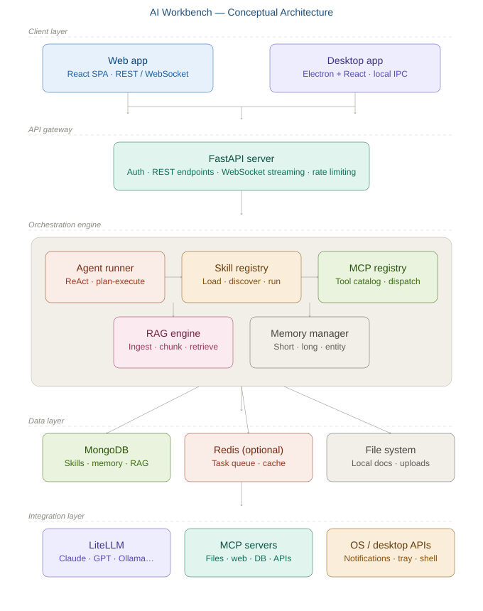

5.2 Five-Layer Model
Layer | Components
Client layer | Web: React SPA in browser. Desktop: React SPA in Electron window.
API gateway | FastAPI server — REST endpoints, WebSocket streaming, auth middleware, rate limiting.
Orchestration layer | Agent Runner, Skill Registry, MCP Registry, RAG Engine, Memory Manager.
Data layer | MongoDB (skills, agents, memory, RAG chunks, logs) + Redis (task queue, cache).
Integration layer | LiteLLM (LLM providers), MCP Servers (tools), OS APIs (desktop only).

5.3 End-to-End Request Flow
The diagram below traces exactly what happens from the moment a user submits a task to when they receive a streamed response — including the RAG and Memory enrichment steps and the tool-use loop.

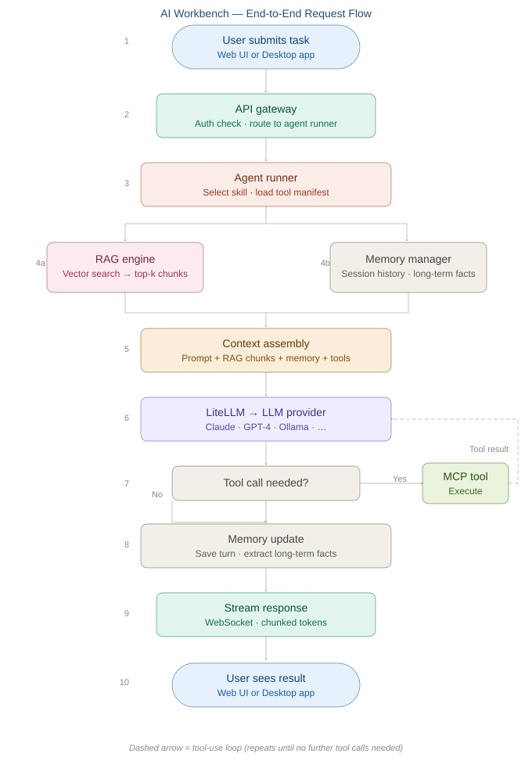

5.4 Core Components

5.4.1 Agent Runner
The execution engine. Accepts a task and skill, assembles context (RAG + memory + tools), calls the LLM via LiteLLM, and loops on tool calls until a final response is ready. Implements ReAct and Plan-and-Execute strategies.

5.4.2 Skill Registry
Discovers and loads skills from /skills at startup. Each skill is a folder with skill.yaml (name, description, prompt template, required tools, default model) and an optional handler.py. Skills are stored in MongoDB for runtime querying and UI display.

5.4.3 MCP Registry
Maintains a catalog of connected MCP servers and their tool manifests. New servers are added via mcp_servers.yaml. All tools are merged into a single namespace for the Agent Runner.

5.4.4 RAG Engine
Ingests documents (chunk, embed, store in MongoDB), retrieves top-k chunks by vector similarity at query time, and injects them into the agent context. Supports multiple named namespaces (knowledge bases).

5.4.5 Memory Manager
Three tiers: short-term (in-session conversation history), long-term (extracted facts persisted across sessions), and entity memory (structured records for people, projects, and concepts). All stored in MongoDB.

6. Project Folder Structure
ai-workbench/
├── backend/ # Python FastAPI server (shared)
│ ├── core/
│ │ ├── agent_runner.py
│ │ ├── skill_registry.py
│ │ ├── mcp_registry.py
│ │ ├── rag_engine.py
│ │ └── memory_manager.py
│ ├── skills/
│ ├── mcp_servers/
│ ├── models/
│ ├── api/
│ ├── db/
│ └── main.py
├── frontend/ # React SPA (web + desktop)
│ ├── src/
│ │ ├── components/
│ │ ├── pages/
│ │ ├── hooks/
│ │ └── electron-bridge.ts
│ └── package.json
├── electron/ # Electron main process
│ ├── main.ts
│ ├── preload.ts
│ └── ipc-handlers.ts
├── config/
│ ├── skills_manifest.yaml
│ ├── mcp_servers.yaml
│ └── settings.yaml
├── docker/
│ ├── Dockerfile
│ └── docker-compose.yml
├── docs/
├── tests/
└── .env.example

7. MongoDB Data Models
Collection | Purpose | Key Fields
skills | Registered skill configs | name, description, prompt_template, tools, model, enabled
mcp_servers | Connected MCP server registry | name, endpoint, tools[], auth_type, enabled
rag_chunks | Document chunks + embeddings | doc_id, chunk_text, embedding[], metadata, namespace
memory_short | In-session conversation history | session_id, messages[], created_at, user_id
memory_long | Persistent extracted facts | user_id, key, value, embedding[], updated_at
memory_entities | Structured entity records | name, type, attributes{}, last_seen
agent_runs | Execution logs | run_id, skill, steps[], input, output, duration, status
users | User profiles and preferences | user_id, name, preferences{}, default_model, deployment_mode

8. Plug-and-Play Extension Guide

8.1 Adding a New Skill
- Create a folder under backend/skills/your_skill_name/.
- Add skill.yaml with: name, description, prompt_template, required_tools, and default_model.
- Optionally add handler.py for custom pre/post-processing logic.
- Restart the backend — the Skill Registry auto-discovers and loads it into MongoDB.

8.2 Adding a New MCP Server
- Add a server entry to config/mcp_servers.yaml with name, endpoint, and auth type.
- The MCP Registry fetches the server tool manifest at startup and merges all tools.

8.3 Adding a New LLM Provider
- All LLM calls go through LiteLLM. Add a provider entry to settings.yaml.
- No code changes required — any LiteLLM-supported provider is immediately available.

9. Implementation Roadmap
Phase | Focus | Key Deliverables | Est.
Phase 1: Foundation | Core infrastructure | FastAPI, MongoDB, LiteLLM, Skill Registry, 2 starter skills | 2–3 wks
Phase 2: Agents + MCP | Agent execution | Agent Runner (ReAct), MCP Registry, 3+ MCP servers, WebSocket streaming | 2–3 wks
Phase 3: RAG + Memory | Knowledge & context | RAG pipeline, short- and long-term memory, MongoDB vector search | 2–3 wks
Phase 4a: Web UI | Browser deployment | React SPA, chat UI, Skill launcher, Settings, Docker packaging | 2–3 wks
Phase 4b: Desktop UI | Electron shell | Electron wrapper, IPC bridge, local file browser, tray, installer | 2–3 wks
Phase 5: Polish & Ship | Production readiness | Auth, logging, telemetry, auto-update, end-to-end tests, CI/CD | 2–3 wks

10. Security Considerations
- All API keys and MongoDB credentials live in environment variables or the OS keychain — never hard-coded.
- Web deployment: FastAPI behind Nginx/reverse proxy with HTTPS; JWT auth on all endpoints.
- Desktop deployment: FastAPI binds to localhost only; Electron communicates over loopback.
- File system access (desktop) is limited to user-approved directories via Electron IPC.
- All agent tool calls are logged to MongoDB for auditability.

11. Recommended Next Steps
- Approve this architecture and dual-deployment strategy.
- Scaffold the monorepo (backend/ + frontend/ + electron/ + docker/ + config/).
- Set up MongoDB Atlas (free tier) and configure .env.
- Build Phase 1: FastAPI + LiteLLM + Skill Registry + 2 starter skills.
- Build Phase 4a (web) and Phase 4b (desktop) in parallel once the backend is stable.

This document will evolve as the platform is built. Major decisions should be recorded as Architecture Decision Records (ADRs) in /docs/adr/.

