Soda Vending Machine Application
By Yeruva SrinivasReddy

We have implemented spring boot technology with basic HTML. In this application, I wanted to implement Angular8 instead of HTML to provide better look and feel, features, performance. But Node.JS environment is not available on this machine so I needed to go for basic HTML.
Also, thee is no database available. Due to this, I have used List for persisting the data instead of calling database.
Design Considerations:
Scalability & Flexibility: Due to layered architecture, we can make changes easily to address any future need.
Technical Considerations:
- Database can change from one to other by making changes in configuration file.
- As database is not available, we are getting list of items in repository layer. We can easily replace this persisting of data with Database call.
- External web serves not required to make it run, we have embedded servers with spring boot technology.
- Abstraction of implementation layer (interfaces) to support changes in Soda Machines.

- Technical Architecture Design:
Application architecture is devided into 4layers: presentation, application, domain, and infrastructure. Each of the layers contains objects related to the particular concern it represents.
- The presentation layer (UI layer) contains all of the classes responsible for presenting the UI to the end-user or sending the response back to the client (in case we’re operating deep in the back-end using controller layer).
- The application layer (Service layer) contains all the logic that is required by the application to meet its functional requirements and, at the same time, is not a part of the domain rules. In most systems that I've worked with, the application layer consisted of services orchestrating the domain objects to fulfill a use case scenario.
- The domain layer represents the underlying domain, mostly consisting of domain entities and, in some cases, services. Business rules, like invariants and algorithms, should all stay in this layer.
- The infrastructure layer (also known as the persistence layer or DAO layer) contains all the classes responsible for doing the technical stuff, like persisting the data in the database, like DAOs, repositories etc.
There are two important rules for a classical Layered Architecture to be correctly implemented:
- All the dependencies go in one direction, from presentation to infrastructure. (Well, handling persistence and domain are a bit tricky because the infrastructure layer often saves domain objects directly, so it actually knows about the classes in the domain)
- No logic related to one layer’s concern should be placed in another layer. For instance, no domain logic or database queries should be done in the UI.

- How to use the Vending Soda Machine System:
We are displaying list of items in Soda Vending machine from backend services. We display Item ID, Item name, price and Quantity.
Operating steps:
Steps 1:
When we hit the url http://localhost:8181/allItems we will be getting the below screen

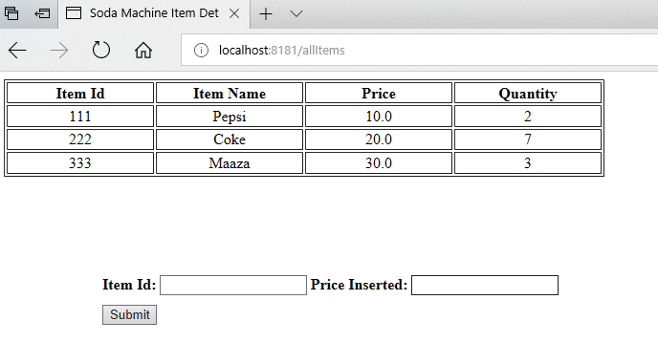

- Above screen will display all Soda items.
Steps 2: Select Item
Enter “Item Id” and “Price Inserted”. Press click On server side, price will be calculated. If Price inserted is equal to or more that Item price, item will be dispensed and following message will be displayed.
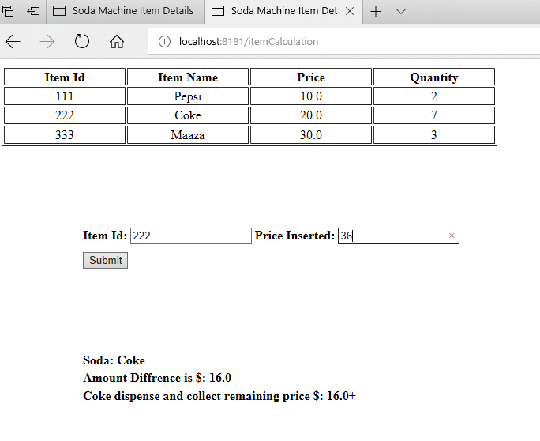
- If Price inserted is less than item cost, item will not be dispensed. Following error message will be displayed.
