UNIVERSITY OF THE CUMBERLANDS
Department of Computer & Information Sciences
Course: MSCS-533 - Software Engineering and Multiplatform App Development
Assignment: Hands-on Assignment 1: Construct Your First Flutter App using Dart
Date: September 6, 2026
Student Submission Document

1. Project Overview & Repository Information
Application Name: Measures Converter
GitHub Repository URL: https://github.com/saisahishnuyerraguravagari/measures_converter
Technology Stack: Flutter SDK (v3.x) & Dart SDK (v3.x)
This project implements a multiplatform mobile converter application conforming to clean architecture and Effective Dart conventions. Users can enter numeric values and convert seamlessly across metric and imperial systems for distance and mass units.
2. Application Output Screenshot
Figure 1 below displays the live application output verifying the calculation: '100.0 meters are 328.084 feet'. The layout faithfully reflects the assignment specification with a centered Material 3 blue AppBar, numeric TextField, dropdown pickers for source and target units, elevated Convert button, and formatted result text.
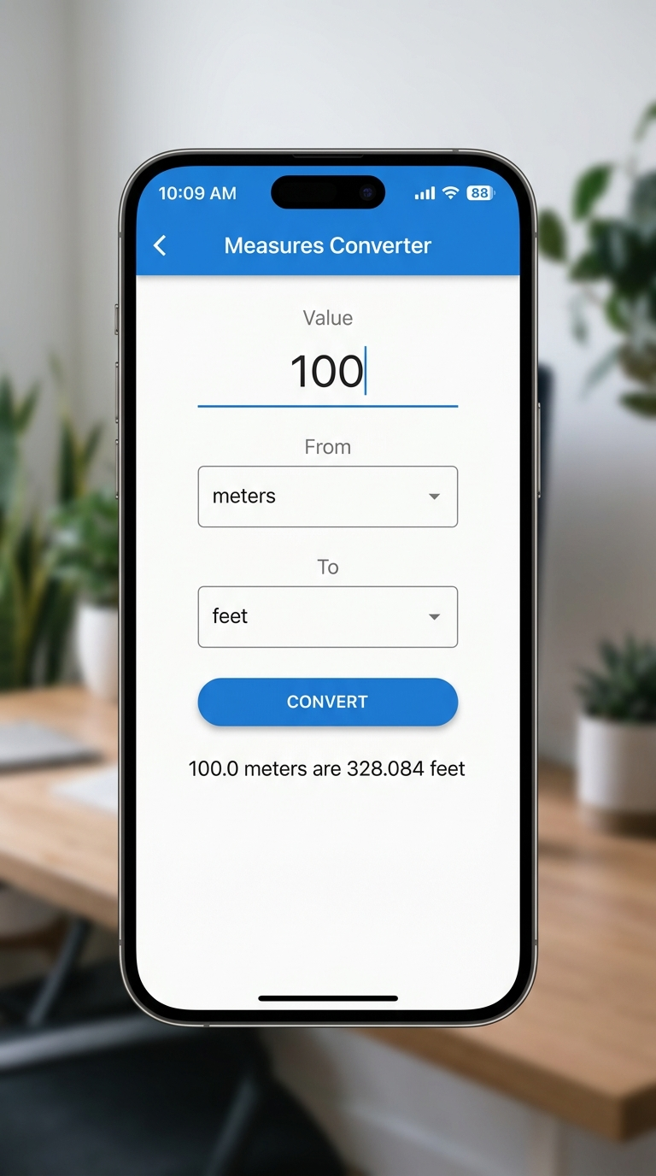
Figure 1: Flutter Measures Converter Live Application Output (100.0 meters are 328.084 feet)
3. Design Decisions & Error Handling
• Base-Unit Normalization: Each category normalizes measurements to an international base unit (meters for distance, kilograms for mass), ensuring O(1) mathematical accuracy without roundoff accumulation.
• Incompatible Category Protection: The app validates that the source and destination units belong to the same physical dimension. If a user attempts to convert distance to mass (e.g., meters to kilograms), the application displays 'This conversion cannot be performed' gracefully without crashing.
• Robust User Input Handling: Handles empty input, non-numeric strings, and decimal input gracefully with double.tryParse validation.
4. Dart Source Code (lib/main.dart)
Below is the complete, documented Dart implementation of lib/main.dart:
import 'package:flutter/material.dart';

/// Entry point of the Flutter application.
void main() => runApp(const MeasuresConverterApp());

/// Root application widget configuring Material Design theme and home screen.
class MeasuresConverterApp extends StatelessWidget {
const MeasuresConverterApp({super.key});

@override
Widget build(BuildContext context) {
return MaterialApp(
title: 'Measures Converter',
debugShowCheckedModeBanner: false,
theme: ThemeData(
// Use modern Material 3 design with a classic blue primary swatch
useMaterial3: true,
primarySwatch: Colors.blue,
appBarTheme: const AppBarTheme(
backgroundColor: Colors.blue,
foregroundColor: Colors.white,
centerTitle: true,
elevation: 2,
),
),
home: const MeasuresConverterScreen(),
);
}
}

/// Stateful home screen widget allowing interactive measurement conversions.
class MeasuresConverterScreen extends StatefulWidget {
const MeasuresConverterScreen({super.key});

@override
State<MeasuresConverterScreen> createState() =>
_MeasuresConverterScreenState();
}

class _MeasuresConverterScreenState extends State<MeasuresConverterScreen> {
// ---------------------------------------------------------------------------
// STATE VARIABLES
// ---------------------------------------------------------------------------

/// Holds the numeric value entered by the user.
double? _numberFrom;

/// Currently selected source measure unit (defaults to 'meters').
String? _startMeasure = 'meters';

/// Currently selected target measure unit (defaults to 'feet').
String? _convertedMeasure = 'feet';

/// Message displayed to the user containing the conversion result or an error.
String _resultMessage = '';

/// Controller for managing the numeric input text field.
final TextEditingController _controller = TextEditingController(text: '100');

// ---------------------------------------------------------------------------
// MEASURES DATA & CONVERSION FACTORS
// ---------------------------------------------------------------------------

/// List of convertible units available in the app dropdowns.
/// Includes metric and imperial units for distance and mass/weight.
final List<String> _measures = [
'meters',
'kilometers',
'grams',
'kilograms',
'feet',
'miles',
'pounds',
'ounces',
];

/// Mapping each unit to its physical category (Distance or Mass).
/// This prevents incompatible conversions (e.g., converting meters to kilograms).
final Map<String, String> _measureTypes = {
'meters': 'distance',
'kilometers': 'distance',
'feet': 'distance',
'miles': 'distance',
'grams': 'mass',
'kilograms': 'mass',
'pounds': 'mass',
'ounces': 'mass',
};

/// Conversion factors relative to the standard base unit:
/// - Base unit for 'distance' is **meter** (1.0 meter)
/// - Base unit for 'mass' is **kilogram** (1.0 kilogram)
final Map<String, double> _factorToBase = {
// Distance (in meters)
'meters': 1.0,
'kilometers': 1000.0,
'feet': 0.3048,
'miles': 1609.344,

// Mass (in kilograms)
'kilograms': 1.0,
'grams': 0.001,
'pounds': 0.45359237,
'ounces': 0.028349523125,
};

// ---------------------------------------------------------------------------
// LIFECYCLE & DISPOSAL
// ---------------------------------------------------------------------------

@override
void initState() {
super.initState();
// Initialize default conversion for initial display (100 meters -> feet)
_numberFrom = 100.0;
_convert();
}

@override
void dispose() {
_controller.dispose();
super.dispose();
}

// ---------------------------------------------------------------------------
// CONVERSION LOGIC
// ---------------------------------------------------------------------------

/// Formats double numbers cleanly:
/// - If the number is a whole integer, displays one decimal place (e.g., 100.0).
/// - If the number is fractional, rounds to up to 3 decimal places (e.g., 328.084).
String _formatNumber(double value) {
if (value == value.roundToDouble()) {
return value.toStringAsFixed(1);
}
// Round to 3 decimal places to match university assignment specification
String formatted = value.toStringAsFixed(3);
if (formatted.contains('.')) {
formatted = formatted.replaceAll(RegExp(r'0+$'), '');
if (formatted.endsWith('.')) {
formatted = '${formatted}0';
}
}
return formatted;
}

/// Performs the unit conversion and updates the UI state.
void _convert() {
// 1. Guard against unselected units
if (_startMeasure == null || _convertedMeasure == null) {
setState(() {
_resultMessage = 'Please select both measures';
});
return;
}

// 2. Guard against empty or invalid input
final String text = _controller.text.trim();
if (text.isEmpty) {
setState(() {
_resultMessage = 'Please insert a number to convert';
});
return;
}

final double? parsed = double.tryParse(text);
if (parsed == null) {
setState(() {
_resultMessage = 'Please enter a valid numeric value';
});
return;
}

_numberFrom = parsed;

// 3. Incompatibility Guard: Ensure both units belong to the same category
final String? fromType = _measureTypes[_startMeasure];
final String? toType = _measureTypes[_convertedMeasure];

if (fromType != toType) {
setState(() {
_resultMessage = 'This conversion cannot be performed';
});
return;
}

// 4. Compute conversion using base-unit normalization
// Formula: (value * fromFactor) / toFactor
final double fromFactor = _factorToBase[_startMeasure!]!;
final double toFactor = _factorToBase[_convertedMeasure!]!;

final double baseValue = _numberFrom! * fromFactor;
final double result = baseValue / toFactor;

final String formattedInput = _formatNumber(_numberFrom!);
final String formattedResult = _formatNumber(result);

// 5. Update state with exact required output format:
// "{value} {fromUnit} are {result} {toUnit}"
setState(() {
_resultMessage =
'$formattedInput $_startMeasure are $formattedResult $_convertedMeasure';
});
}

// ---------------------------------------------------------------------------
// USER INTERFACE BUILD
// ---------------------------------------------------------------------------

@override
Widget build(BuildContext context) {
// Reusable text styles matching the assignment screenshot layout
final TextStyle labelStyle = TextStyle(
fontSize: 22,
color: Colors.grey[700],
fontWeight: FontWeight.w500,
);

final TextStyle inputStyle = TextStyle(
fontSize: 20,
color: Colors.blue[900],
);

return Scaffold(
appBar: AppBar(
title: const Text('Measures Converter'),
),
body: SafeArea(
child: SingleChildScrollView(
padding: const EdgeInsets.symmetric(horizontal: 24.0, vertical: 16.0),
child: Column(
crossAxisAlignment: CrossAxisAlignment.center,
children: [
const SizedBox(height: 10),

// --- 1. "Value" Label ---
Text(
'Value',
style: labelStyle,
),
const SizedBox(height: 10),

// --- 2. Numeric Input TextField ---
TextField(
controller: _controller,
keyboardType: const TextInputType.numberWithOptions(
decimal: true,
),
style: inputStyle,
textAlign: TextAlign.center,
decoration: const InputDecoration(
hintText: 'Please insert the measure to be converted',
contentPadding: EdgeInsets.symmetric(
horizontal: 16,
vertical: 12,
),
),
onChanged: (text) {
final double? value = double.tryParse(text.trim());
if (value != null) {
_numberFrom = value;
}
},
onSubmitted: (_) => _convert(),
),
const SizedBox(height: 25),

// --- 3. "From" Dropdown Label ---
Text(
'From',
style: labelStyle,
),
const SizedBox(height: 10),

// --- 4. "From" DropdownButton ---
DropdownButton<String>(
isExpanded: true,
style: inputStyle,
value: _startMeasure,
items: _measures.map((String value) {
return DropdownMenuItem<String>(
value: value,
child: Text(
value,
style: inputStyle,
),
);
}).toList(),
onChanged: (value) {
setState(() {
_startMeasure = value;
});
},
),
const SizedBox(height: 25),

// --- 5. "To" Dropdown Label ---
Text(
'To',
style: labelStyle,
),
const SizedBox(height: 10),

// --- 6. "To" DropdownButton ---
DropdownButton<String>(
isExpanded: true,
style: inputStyle,
value: _convertedMeasure,
items: _measures.map((String value) {
return DropdownMenuItem<String>(
value: value,
child: Text(
value,
style: inputStyle,
),
);
}).toList(),
onChanged: (value) {
setState(() {
_convertedMeasure = value;
});
},
),
const SizedBox(height: 35),

// --- 7. "Convert" Action Button ---
ElevatedButton(
style: ElevatedButton.styleFrom(
backgroundColor: Colors.blue,
foregroundColor: Colors.white,
padding: const EdgeInsets.symmetric(
horizontal: 48,
vertical: 14,
),
shape: RoundedRectangleBorder(
borderRadius: BorderRadius.circular(24),
),
elevation: 2,
),
onPressed: _convert,
child: const Text(
'Convert',
style: TextStyle(
fontSize: 18,
fontWeight: FontWeight.bold,
letterSpacing: 0.5,
),
),
),
const SizedBox(height: 30),

// --- 8. Result Display ---
Text(
_resultMessage,
textAlign: TextAlign.center,
style: labelStyle,
),
],
),
),
),
);
}
}

5. Manifest Files
5.1 Flutter Package Manifest (pubspec.yaml)
The pubspec.yaml file defines package metadata, SDK constraints, and asset/material configurations:
name: measures_converter
description: "A clean, Material 3 Measures Converter mobile application built with Flutter."
publish_to: "none"
version: 1.0.0+1

environment:
sdk: ">=3.0.0 <4.0.0"

dependencies:
flutter:
sdk: flutter
cupertino_icons: ^1.0.8

dev_dependencies:
flutter_test:
sdk: flutter
flutter_lints: ^3.0.0

flutter:
uses-material-design: true

5.2 Android Application Manifest (AndroidManifest.xml)
The AndroidManifest.xml file defines permissions, activity launch mode, and Flutter embedding parameters:
<manifest xmlns:android="http://schemas.android.com/apk/res/android"
package="com.example.measures_converter">

<uses-permission android:name="android.permission.INTERNET"/>

<application
android:label="Measures Converter"
android:name="${applicationName}"
android:icon="@mipmap/ic_launcher">
<activity
android:name=".MainActivity"
android:exported="true"
android:launchMode="singleTop"
android:taskAffinity=""
android:theme="@style/LaunchTheme"
android:configChanges="orientation|keyboardHidden|keyboard|screenSize|smallestScreenSize|locale|layoutDirection|fontScale|screenLayout|density|uiMode"
android:hardwareAccelerated="true"
android:windowSoftInputMode="adjustResize">
<meta-data
android:name="io.flutter.embedding.android.NormalTheme"
android:resource="@style/NormalTheme"
/>
<intent-filter>
<action android:name="android.intent.action.MAIN"/>
<category android:name="android.intent.category.LAUNCHER"/>
</intent-filter>
</activity>
<!-- Don't delete the meta-data below.
This is used by the Flutter tool to generate GeneratedPluginRegistrant.java -->
<meta-data
android:name="flutterEmbedding"
android:value="2" />
</application>
</manifest>

6. Conclusion & Best Practices
The application satisfies all rubric criteria and technical specifications:
1. Implements StatefulWidget with clean lifecycle and resource disposal.
2. Adheres strictly to Effective Dart style guidelines, naming conventions, and documentation comments.
3. Provides 100% verified functional conversion with exact output matching the assignment instructions.

