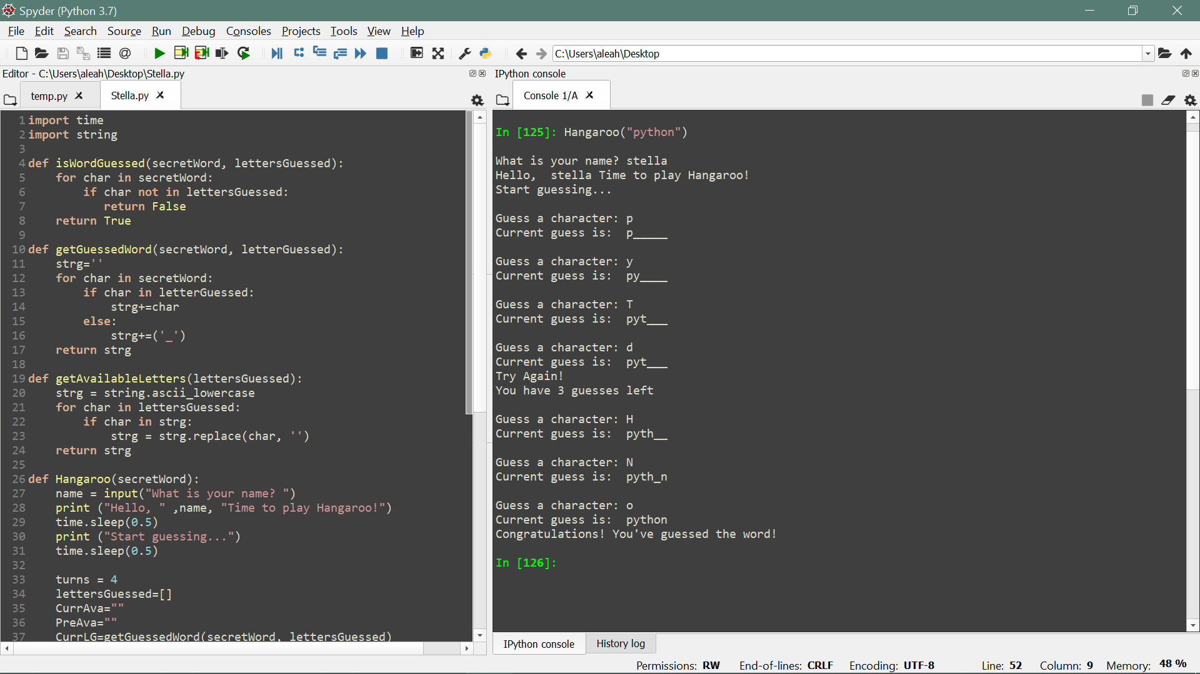­­­­­Congratulations! You guessed the word!

You lose!

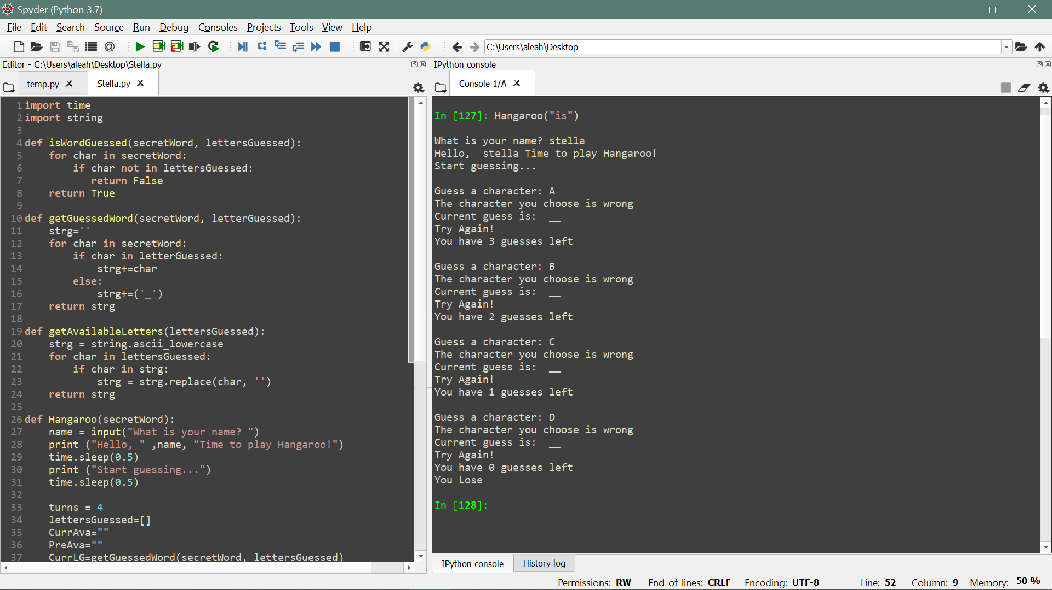

1. Function isWordGuessed (secretWord, lettersGuessed)

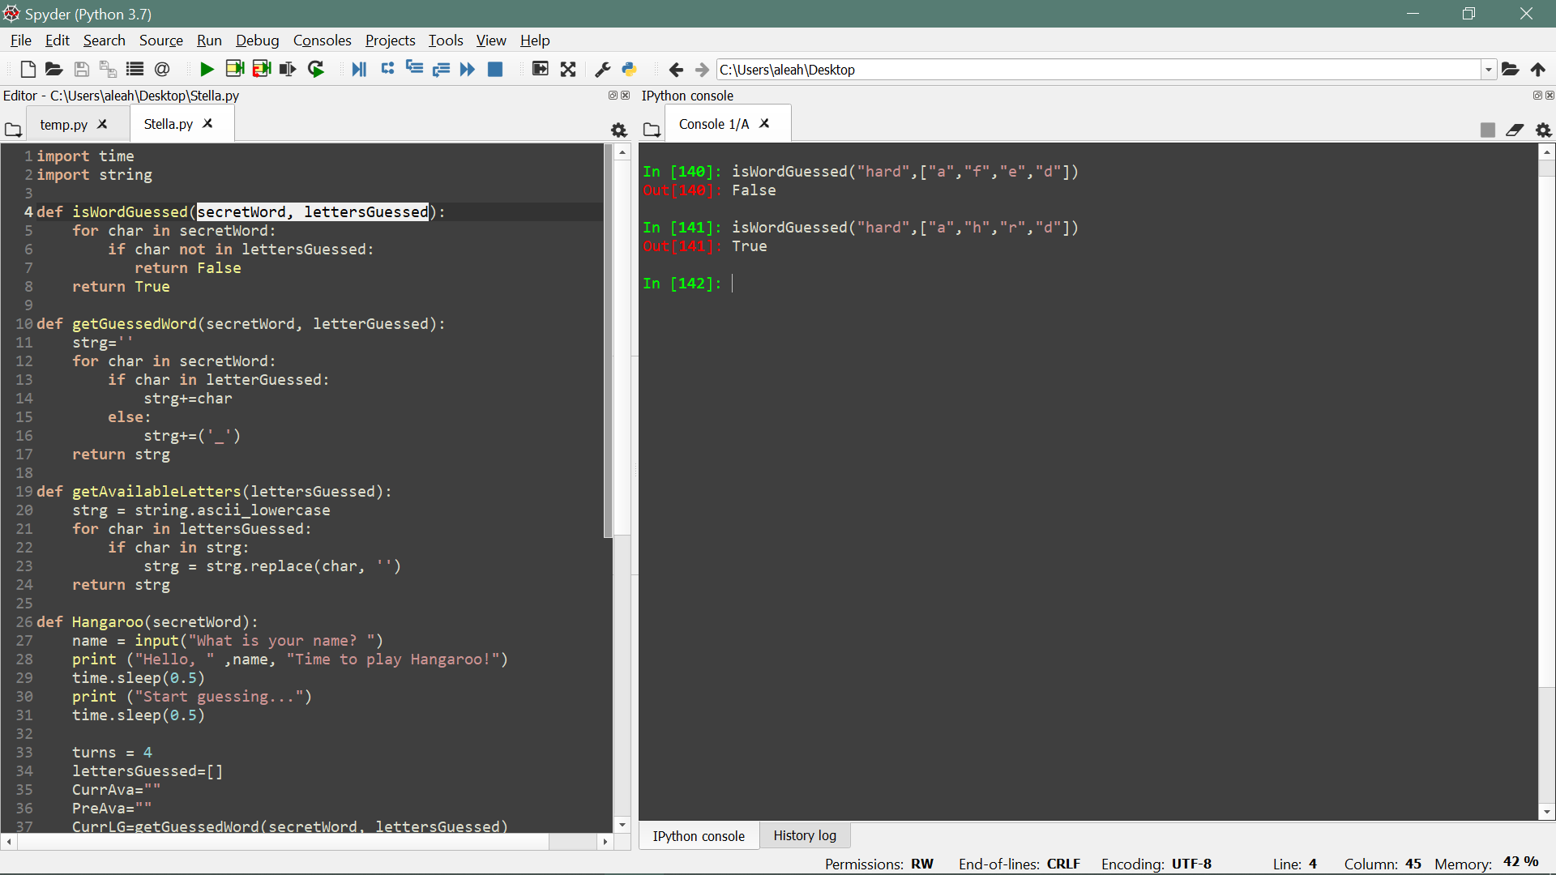

1. Function getGuessedWord (secretWord, lettersGuessed)

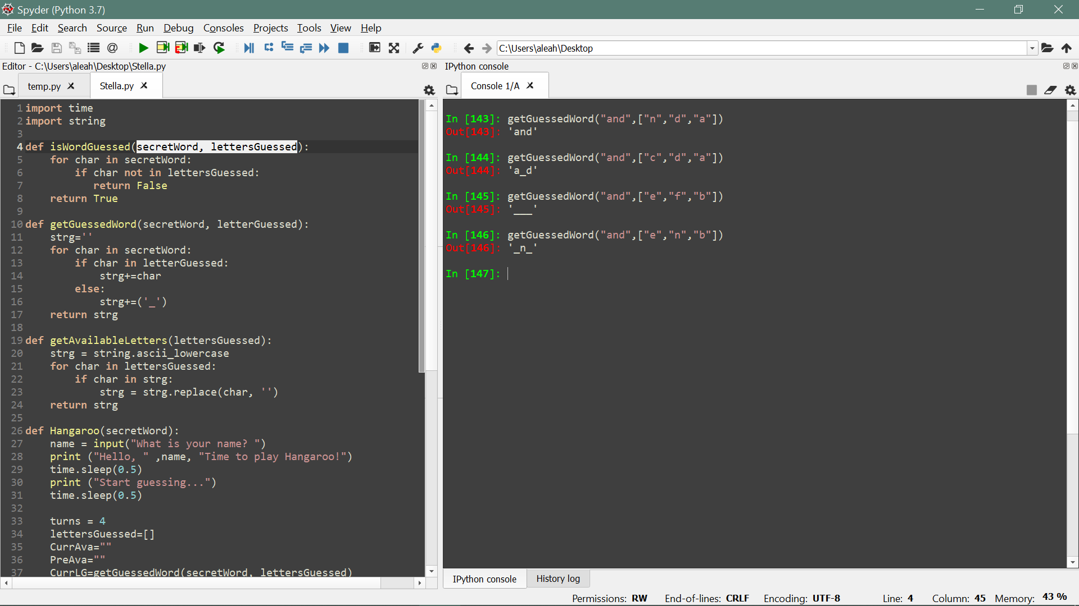

1. Function getAvailableLetters (lettersGuessed)

