SCREENSHOTS FOR MACHINE PROBLEM 4, MATLAB

**SCRIPT:**

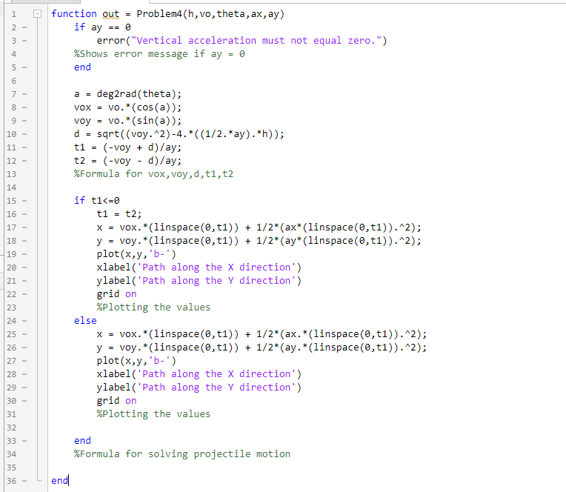

**INPUT1:**



**OUTPUT1:**

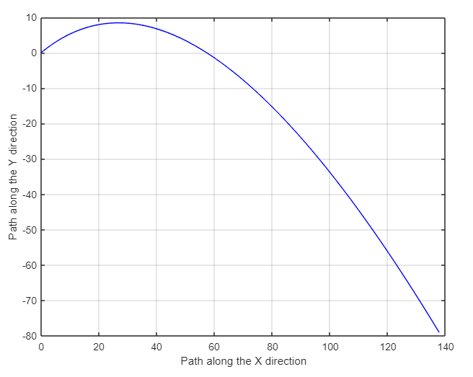

**INPUT2:**



**OUTPUT2:**

