SCREENSHOTS FOR MACHINE PROBLEM 1, PYTHON

**SCRIPT:**

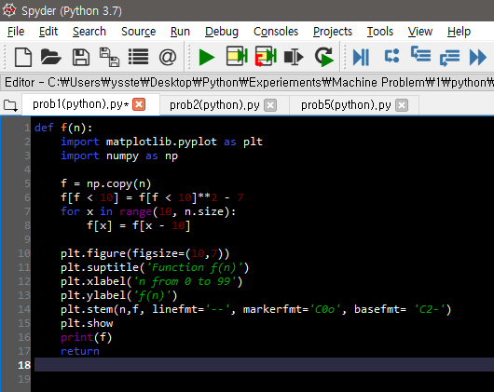

**Value of f from 0 to 99:**

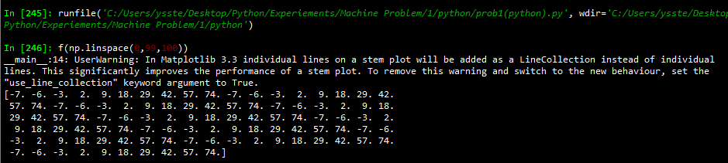

**Graph:**

