**Exercise 1: nslookup**

Use the nslookup command from the "Tools of the Trade" and answer the following questions:

1. Which is the IP address of the website www.koala.com.au? In your opinion, what is the reason for having several IP addresses as an output?
2. Find out the name of the IP address 127.0.0.1. What is special about this IP address?

Q1:

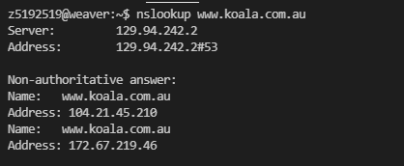

The reason for having several IP addresses is that multiple servers have been established for the same website, and these servers have different IP addresses.

Q2:

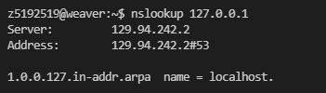

The name of IP 127.0.0.1 is localhost. The special place of it is that it is the IP address of your own machine and it’s non-routable. For this IP, it usually be used to send and receive packets locally, and that can help for testing purpose.

**Exercise 2: Use ping to test host reachability**

Are the following hosts reachable from your machine by using ping:

|  |  |
| --- | --- |
| Reachable | Unreachable |
| [www.unsw.edu.au](http://www.unsw.edu.au) | [www.getfittest.com.au](http://www.getfittest.com.au) |
| [www.mit.edu](http://www.mit.edu) | [www.hola.hp](http://www.hola.hp) |
| [www.intel.com.au](http://www.intel.com.au) | [www.kremlin.ru](http://www.kremlin.ru) |
| [www.tpg.com.au](http://www.tpg.com.au) |  |
| [www.amazon.com](http://www.amazon.com) |  |
| [www.tsinghua.edu.cn](http://www.tsinghua.edu.cn) |  |
| 8.8.8.8 |  |

For [www.getfittest.com.au](http://www.getfittest.com.au) and [www.hola.hp](http://www.hola.hp) , they do not exit.

For [www.kremlin.ru](http://www.kremlin.ru), it is unreachable because it is a governmental website and they disable their network from replying to ICMP echo request packets which used by ‘ping’. The reason behind is for security measure.

**Exercise 3: Use traceroute to understand the network topology**

Q1:

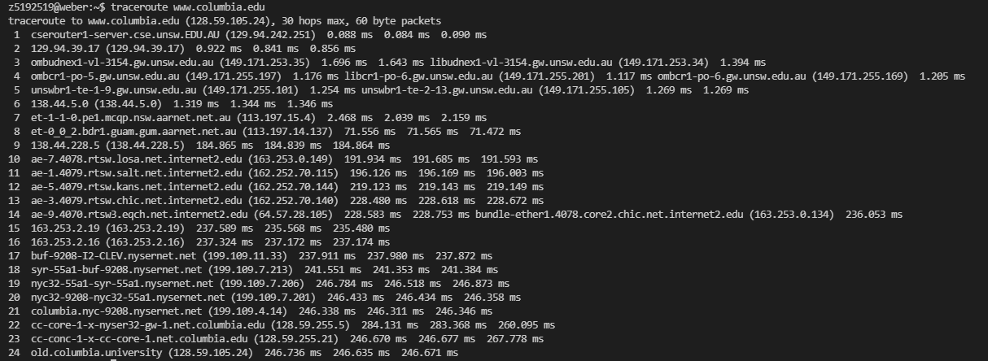

1. The output of traceroute shows that there are 24 routers between my machine and Columbia server.
2. Cause the first router is a CSE router, which is still inside the CSE workstation. So, there are 23 routers from the workstation to the Columbia server.
3. The first 5 routers have hostnames with “unsw.edu.au”, so they are part of the UNSW networking.
4. According to the data, there is a huge ping difference between 8-9 and 9-10, I guess that transoceanic transmission occurs between these three routers.

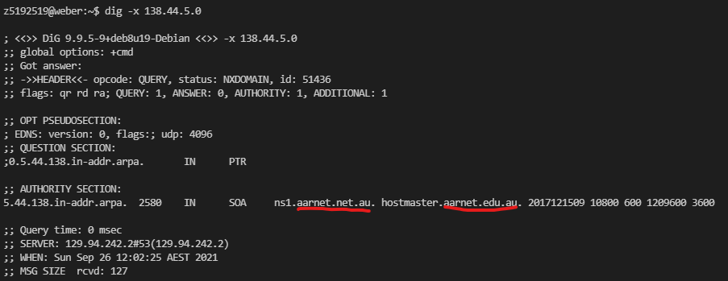

By using command “dig -x 138.44.5.0” , we can find that the information about the ninth router contains the word AARNet. So both 8th router and 9th router belong to AARNet (Australian Academic and Research Network). The 10th router contains the words rtsw.losa, so I guess that it is located in Los Angeles. After consulting the website (<https://routerproxy.net.internet2.edu/routerproxy/>), it is confirmed that it does locate in Los Angeles, CA. Therefore, the 9th and 10th router do the packets cross the Pacific Ocean.

Q2:

[www.ucla.edu](http://www.ucla.edu)

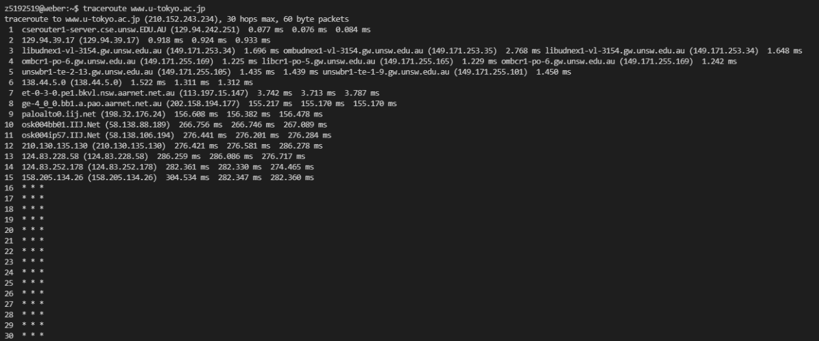

[www.u-tokyo.ac.jp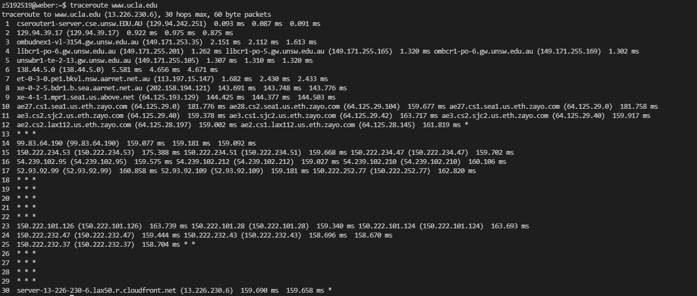](http://www.u-tokyo.ac.jp)

[www.lancaster.ac.uk](http://www.lancaster.ac.uk)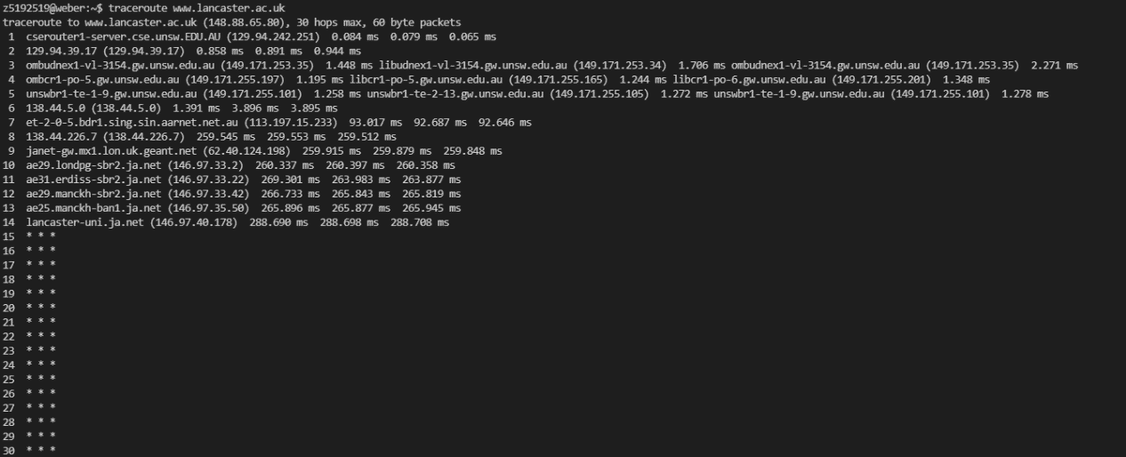

From the three diagrams, we can find that 1-6 routers are the same. So the first 7 hops are identical on all 3 paths. In that case, these three paths diverge at (138.44.5.0) router.

No, there is no proportional relationship. As we can see that Tokyo takes more hops than Los Angeles, however, Tokyo is much closer to Sydney.

Q3:

IP address of my local machine: 129.94.242.53.

IP address of www.telstra.net : 203.50.5.178

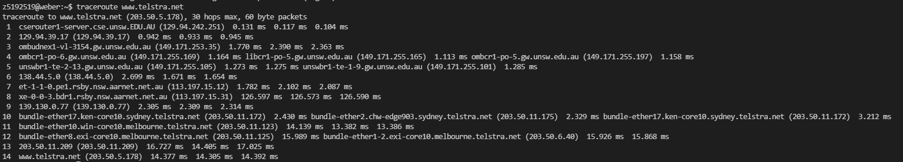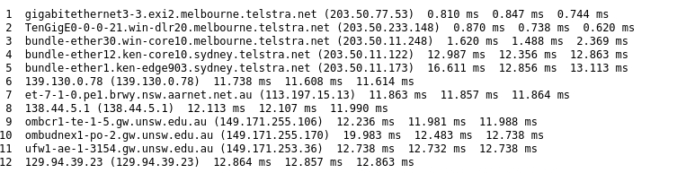

Path1 : Telstra.net ➡ 139.130.0.78 ➡ 138.44.5.1 ➡ 129.94.39.23 ➡ Local

Path2 : Local ➡ 138.44.5.0 ➡ 139.130.0.77 ➡ 203.50.11.209 ➡ Telstra.net

IP address of my local machine: 129.94.242.53.

IP address of [www.speedtest.com.sg](http://www.speedtest.com.sg) : 202.150.221.170

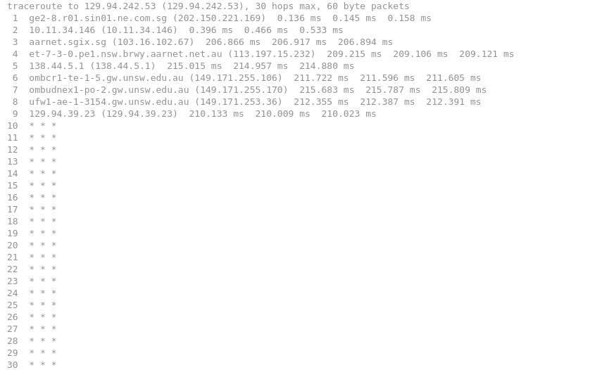

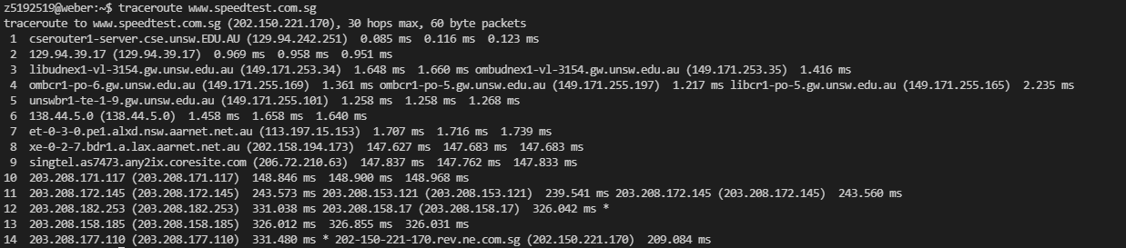

Path1 : speedtest.com ➡10.11.34.146 ➡ 138.44.5.1 ➡ 129.94.39.23 ➡ Local

Path2 : Local ➡129.94.39.17 ➡ 138.44.5.0 ➡ 203.208.171.117 ➡ 203.208.177.110 ➡ speedtest.com

After observing, we can clearly find that the paths are totally different and asymmetric.

For the shared routers:

the first case has (139.130.0.78 and 139.130.0.77).

the second case have (138.44.5.0 and 138.44.5.1) , (129.94.39.23 and 129.94.39.17), etc.

The reason behind should be : different IP addresses of one router can be allocated with different tasks and interfaces. So that the router is working bidirectional.

**Exercise 4: Use ping to gain insights into network performance**

Q1: For each of these locations ﬁnd the (approximate) physical distance from UNSW using Google Maps and compute the shortest possible time T for a packet to reach that location from UNSW. You should assume that the packet moves (i.e. propagates) at the speed of light, 3 x 10 8 m/s. Note that the shortest possible time will simply be the distance divided by the propagation speed. Plot a graph where the x-axis represents the distance to each city (i.e. Brisbane, Serdang and Berlin), and the y-axis represents the ratio between the minimum delay (i.e. RTT) as measured by the ping program (select the values for 50 byte packets) and the shortest possible time T to reach that city from UNSW. (Note that the y-values are no smaller than 2 since it takes at least 2*T time for any packet to reach the destination from UNSW and get back). Can you think of at least two reasons why the y-axis values that you plot are greater than 2?

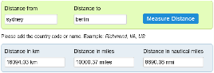Distance :

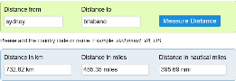Sydney – Brisbane: 733km

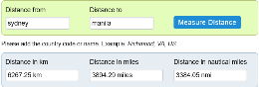Sydney – Manila: 6267km

Sydney – Berlin: 16094km

As propagation speed is 3*10^8m/s, the shortest possible time for these 3 places are:

Brisbane : 2.44ms Manila: 20.89ms Berlin:53.65ms

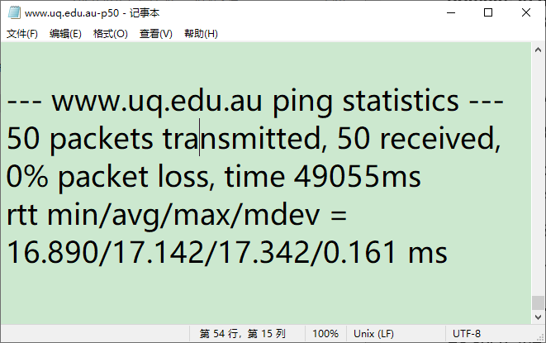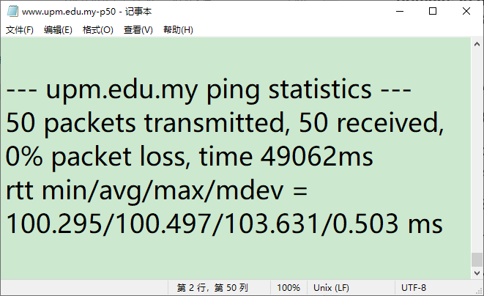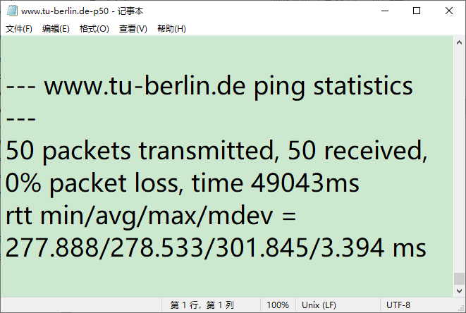Based on the *avg.txt files(as shown below), the min RTT (50 packets) of these 3 places are:

Brisbane : 16.89ms Manila: 100.295ms Berlin: 277.888ms

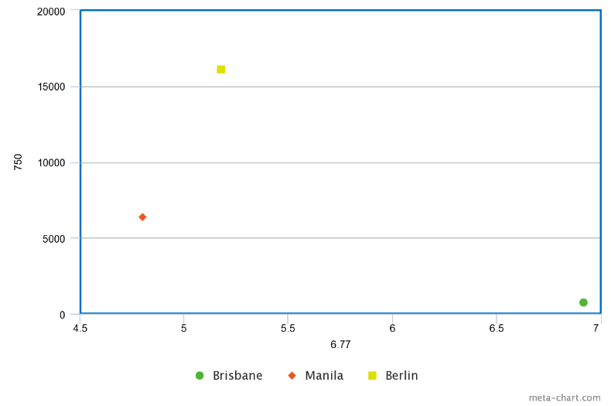Hence, the ratio of these 3 places are:

Brisbane : 6.92 , Manila: 4.80 , Berlin:5.18

For the reasons that make these ratios > 2, maybe:

1. Packets need to be transmitted along multiple cables, hops and routers, rather than directly to the destination.
2. The transmission delay and queueing delay should also be taken into account.
3. The propagation speed can’t reach the light speed in reality.
4. The paths that ISP leads may not be the shortest routing path.

Q2: Is the delay to the destinations constant or does it vary over time? Explain why.

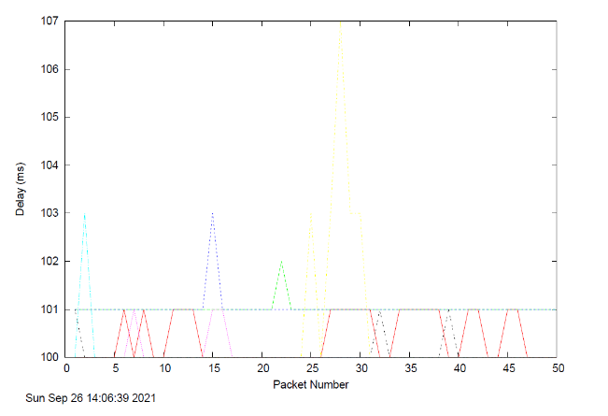www.uq.edu.au_delay.pdf

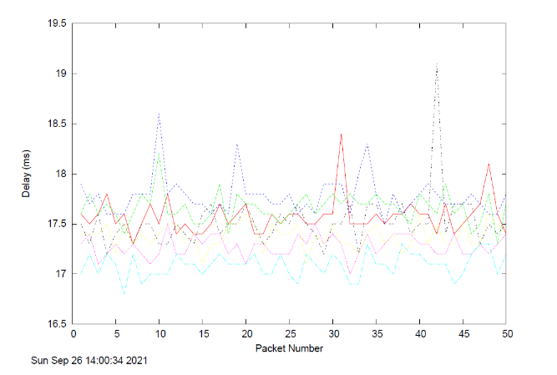www.upm.edu.my_delay.pdf

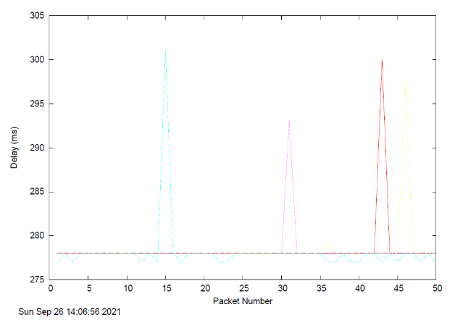www.tu-berlin.de_delay.pdf

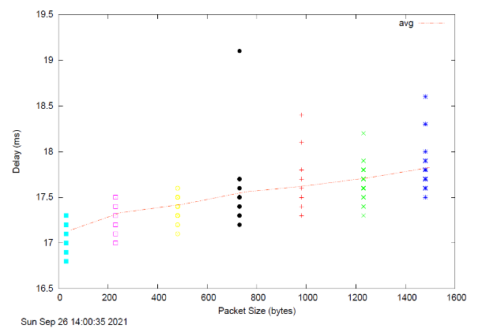www.uq.edu.au_scatter.pdf

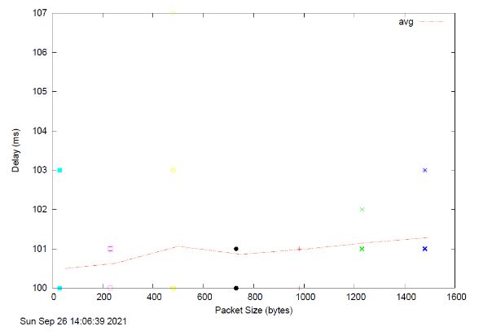www.upm.edu.my_scatter.pdf

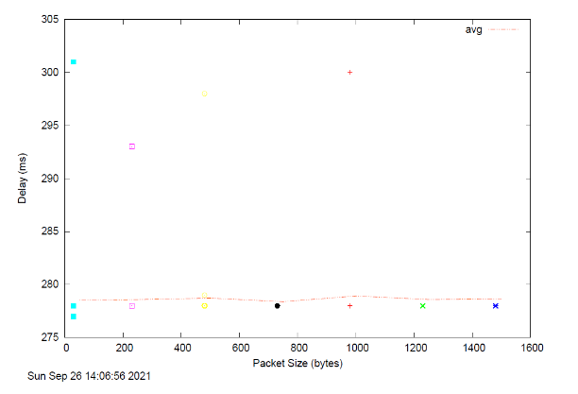www.tu-berlin.de_scatter.pdf

From the scatters, we can clearly find out that, there is no significant increase for the delay-packet line in the vertical direction. So the 3 delay-packet lines are all nearly constant, which means that the average delay does not seem to vary much for the different packet sizes.

For the reason behind:

1. As the destinations are all far away, the propagation delay may take the major part in the overall delay, and it could be significantly higher than the transmission delay(which is depended on the packet size).
2. Similarly, the queueing delay can also be significantly higher than the transmission delay. That means the network traffic conditions may have maintained a similar level of congestion during the test time.

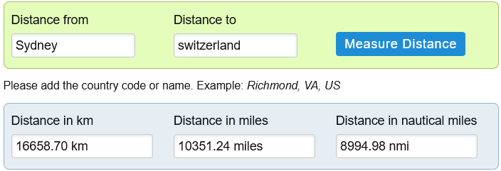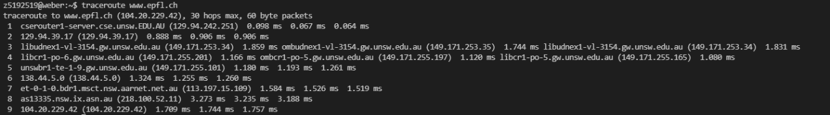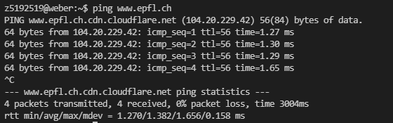Q3: Explore where the website for [www.epfl.ch](http://www.epfl.ch/) is hosted. Is it in Switzerland?

No, it isn’t. By using Ping and traceroute, we can clearly find that it has a very low RTT, which is much shorter that the possible time calculated from distance.

Q4: The measured delay (i.e., the delay you can see in the graphs) is composed of propagation delay, transmission delay, processing delay and queuing delay. Which of these delays depend on the packet size and which do not?

* The propagation delay doesn’t relay on the packet size but the length of physical link, also the propagation speed. (dprop = d/s).
* The queuing delay is the time waiting at output link for transmission, and it only depends on congestion level of router. So, it doesn’t depend on the packet size.
* The transmission delay depends on the packet size, and also the link transmission rate(bps). (dtrans = L/R).
* The nodal processing delay can depend on the packet size, as the larger packet may require longer time to be processed. But typically, this vary should be very small. So for a fixed packet size, it could still be taken as constant.