**Exercise 3: Digging into DNS**

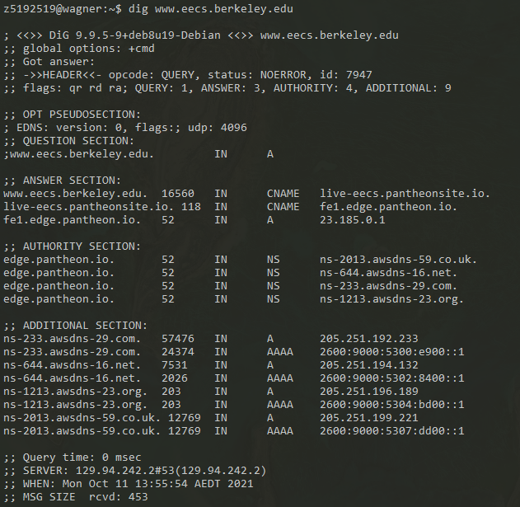

**Q1:**

**The IP addresses of** [**www.eecs.berkeley.edu**](http://www.eecs.berkeley.edu) **is 23.185.0.1 .**

**Q2:**

**The CNAME is live-eecs.pantheonsite.io . The reason to have an alias is because people need to have an easier and memorable way to visit it. And with aliases, we can classify different services which are provided from same IP address.**

**Q3:**

**There are 4 authoritative servers in the authority section :**

**ns-2013.awsdns-59.co.uk, ns-644.awsdns-16.co.uk, ns-233.awsdns-29.co.uk, ns-1213.awsdns-23.co.uk**

**In the additional section, it records some IP addresses of the previous authoritative servers. (A for IPV4, and AAAA for IPV6)**

**Q4:**

**The IP of local nameserver is 129.94.242.2#53.**

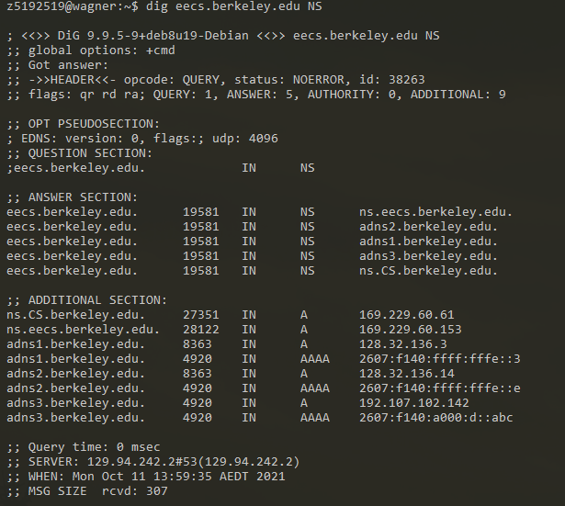

**Q5:**

**The name servers are adns1.berkeley.edu, adns2.berkeley.edu, adns3.berkeley.edu, ns.CS.berkeley.edu, ns.eecs.berkeley.edu.**

**The IP addresses are 169.229.60.61, 169.229.60.153, 128.32.136.3, 128.32.136.14, 192.107.102.142 .**

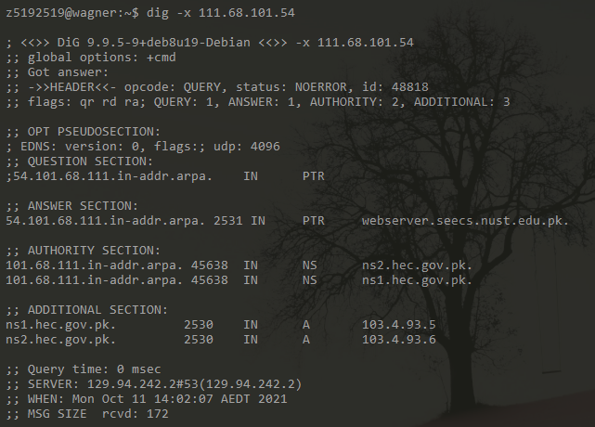

**Q6:**

**The DNS name is webserver.seecs.nust.edu.pk . The type of query is PTR.**

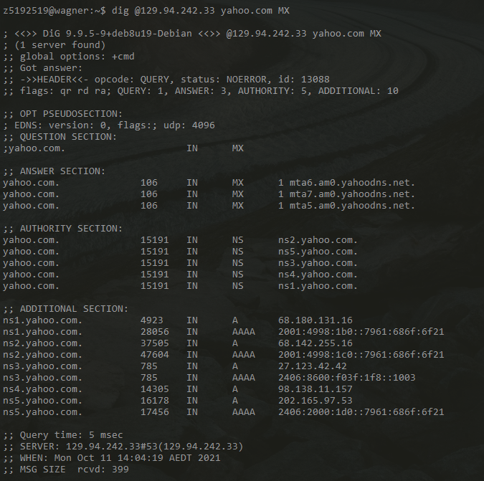

**Q7:**

**There is no “aa” in flag. This is because the CSE server has no authority for answering queries of yahoo.com domain.**

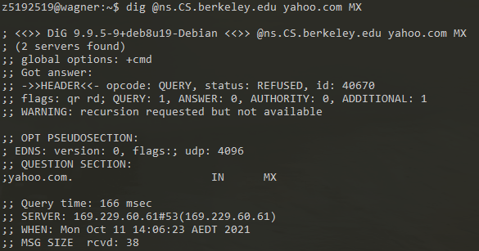

**Q8:**

**The result is that query is refused. As this nameserver is not part of the yahoo mail network, it can not give reply to the DNS query.**

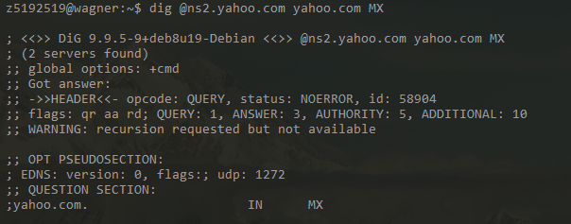

**Q9:**

**Here I obtained an authoritative answer for yahoo mail servers (ns2.yahoo.com). The DNS query type that I sent is MX.**

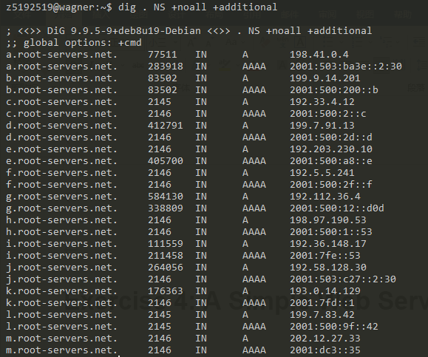

**Refer to**

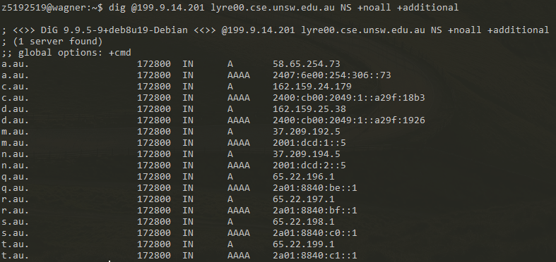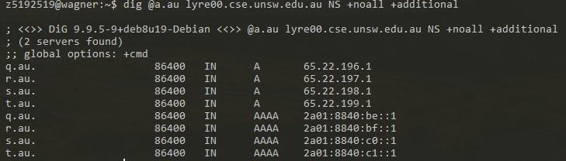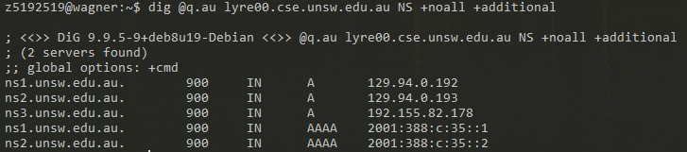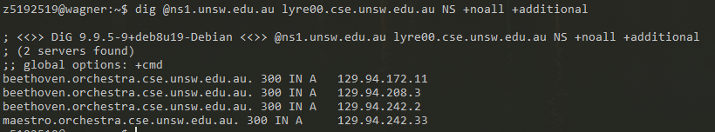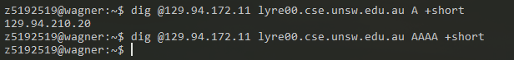

**Refer to**

**Refer to**

**Refer to**

**Now inside CSE network**

**Refer to**

**Q10:**

**Following the process as shown, the IP address of lyre00.cse.unsw.edu.au is 129.94.210.20 . And to get this, we have to query 5 DNS nameservers.**

**Q11:**

**Yes, it can. A physical machine can have several hostnames and IPs for different services or interfaces.**

**Exercise 4: A Simple Web Server**

**(Please check the submitted python file. Testing index.html and png have also been put into the submission)**