**Exercise 1 : TCP**



Q1:

As the gaia.cs.umass.edu is the server, which should be the destination (128.119.245.12) in the 1st hand shake. And the port number relevant should be 80. The IP of the host is the source, which shows as 192.168.1.102

Q2:

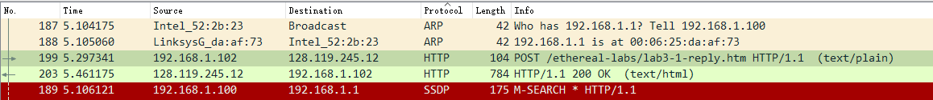The seq of POST is

Q3:

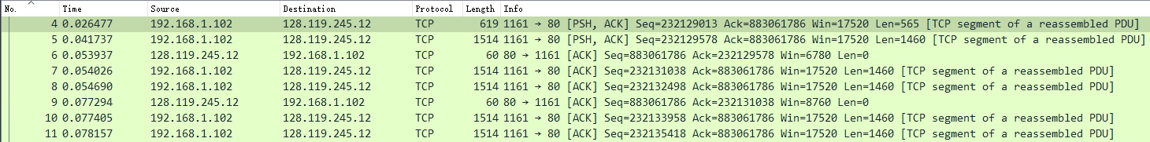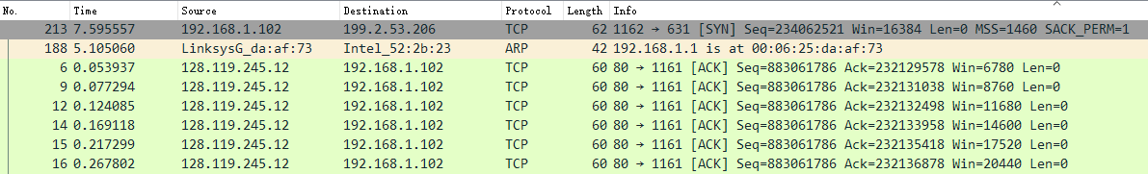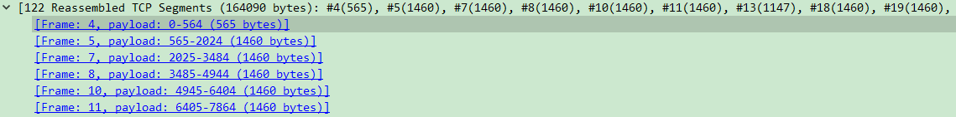

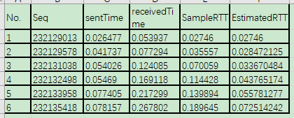

Here, the first 6 segments are frame #4, #5, #7, #8, #10, #11. The seq, sentTime, receiveTime and SampleRTT as shown in the red squares above.

In order to calculate the EstimatedRTT, we need to use formula from lecture notes :

EstimatedRTT = 0.875*EstimatedRTT(previous) + 0.125*SampleRTT

(PS. The EstimatedRTT are calculated in the excel file, which is posted inside the Lab04.tar)

Q4:

The length of these 6 segments are 565, 1460, 1460, 1460, 1460, 1460. (as the figure 1 in Q3 shows).

Q5:



The SYN-ACK message gives out the minimum size of buffer space, which is 5840 bytes.

No, lack of receiver buffer space will not throttle the sender.

Q6:

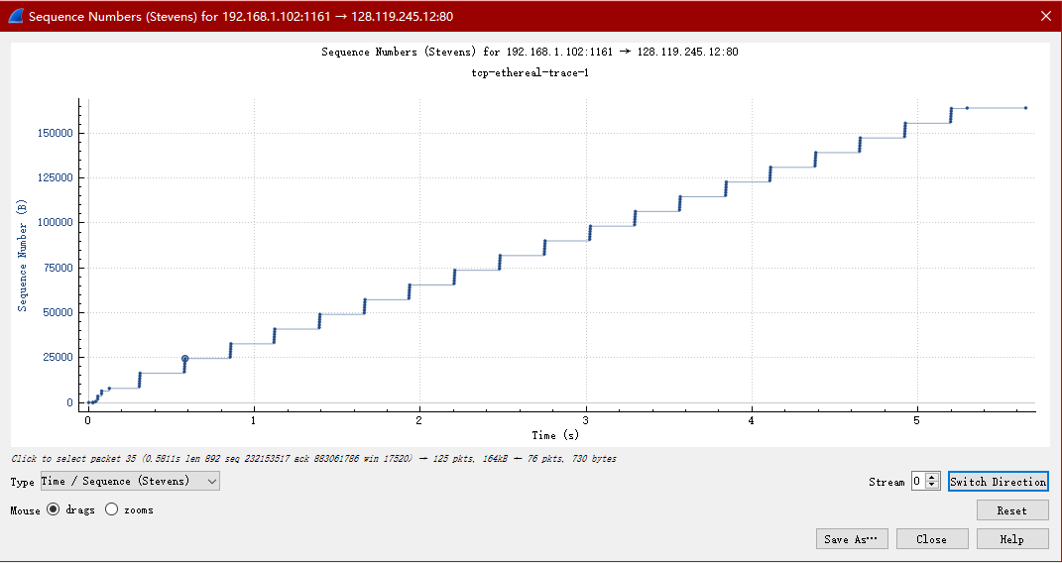

There is no retransmitted segments in the trace file. The image resembles an ascending, equal-length staircase. If there are repeatedly sent segments, there will be cases where the retransmitted segment have a smaller seq than its neighboring segments.

Q7:

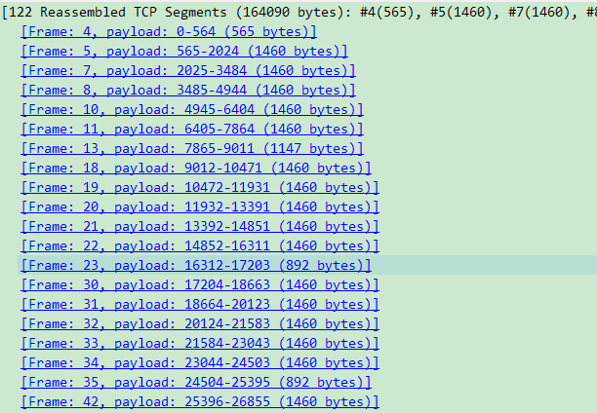

The size of ACK is usually 1460 bytes.

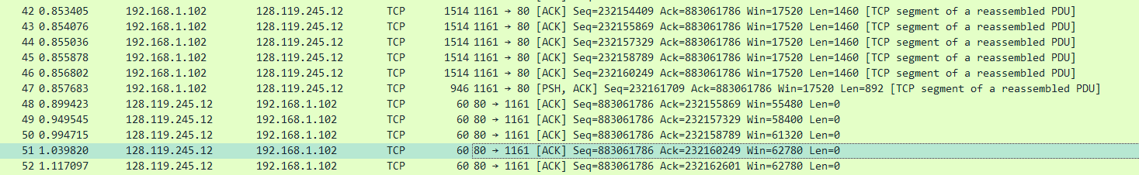

As the diagram shows, these 4 server segments acknowledged to the relevant client segment. So the ack #232155869 is acknowledging #232154409 and #232155869, where the receiver send a cumulative ACK for 2 different segments.





Q8:

The average throughput of TCP is the ratio of the total transmission data to the total transmission time.

In this lab, there are 122 segments reassembled and the total size of them is 164090 bytes.

As the time of last segment(#199) is 5.297341 sec, and the first segment(#4) is 0.026477 sec. the time cost of these 122 segments is (5.297341 - 0.026477) = 5.270864 sec.

Therefore, the TCP average throughput is 164090 bytes / 5.270864 sec = 31.131 Kbyte/sec.

**Exercise 2 : TCP**

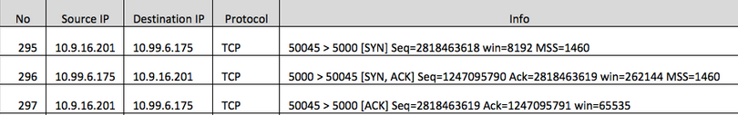

Q1:

As the table shows, the seq is 2818463618.



Q2:

Seq is 1247095790. ACK number is 2818463619.

This ACK is determined by adding 1 on the initial sequence number that received from client.



Q3:

Seq is 2818463619. ACK number is 1247095791.

There is no content data include in this message.

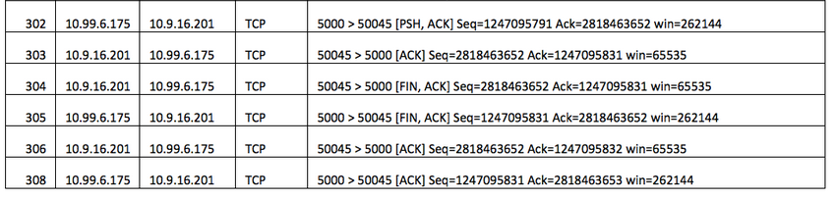

Q4:

The conversation is closed by both client and server. In the FIN stage, client and server will both generated FINs based on previous-received ACK and Seq. The ACK will not increased.

Q5:

Client: (final ACK – Initial Seq) – SYN – FIN = 2818463653 – 2818463618 – 2 = 33 Bytes.

Client: (final ACK – Initial Seq) – SYN – FIN = 1247095832 – 1247095790 – 2 = 40 Bytes.