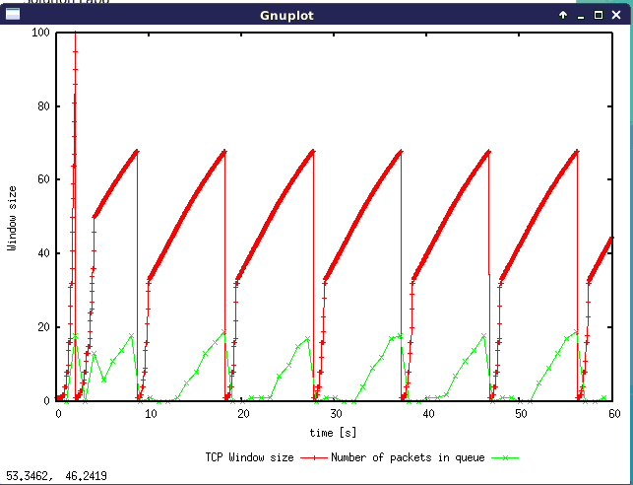**Exercise 1: Understanding TCP Congestion Control using ns-2**

**Q1:**

AS shown in the figure, the maximum of congestion window that TCP flow reaches is 100.

The congestions window size was set to 1 when it reaches this value, with the threshold to 50. The reason is that the queue is becoming full and packets got dropped, so the sender is congested, and that is why this event was triggered.

For the following part, the connection will have slow start and raise the window size rapidly to the threshold size. If the queue is full again, it will go back to slow start and repeat everything again.

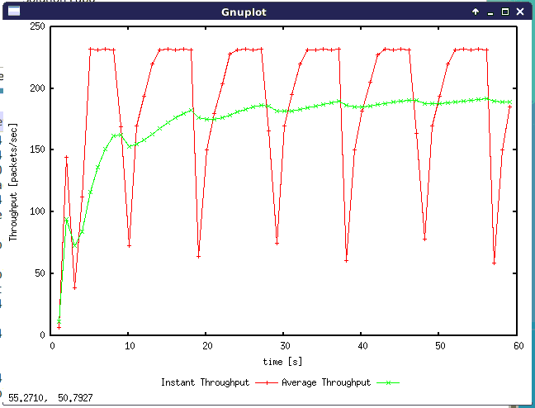

**Q2:**

From the diagram, the avg of throughput is about 190 (packets/second).

Packet size: 500 + 20 + 20 = 540 bytes

As there are 2 definitions for the TCP throughput, one in “transmit any data” and one in “transmit useful data”.

For definition 1, the throughput 190*540*8 = 820800 bps = 820.8 Kbps

For definition 2, the throughput 190*500*8 = 760000 bps = 760 Kbps

**Q3:**

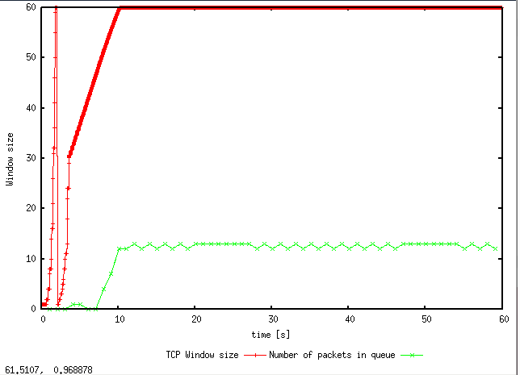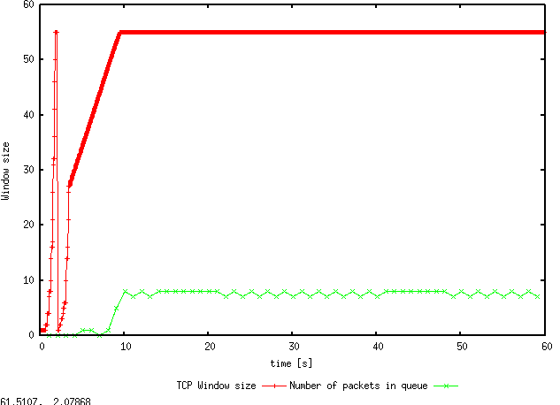

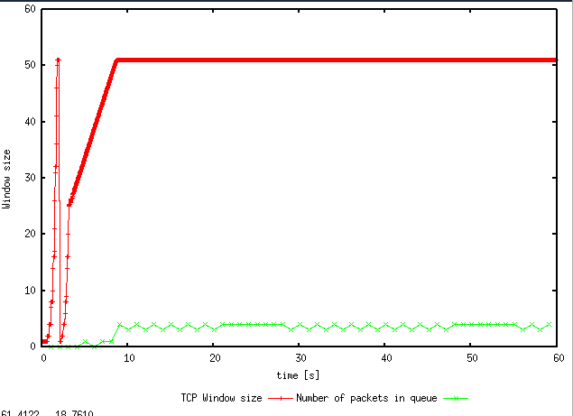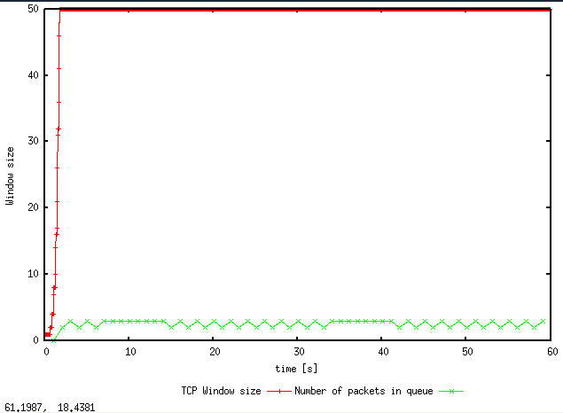

Figure (a)(b)(c)(d) from top-left to bot-right are 60packets, 55packets, 51 packets and 50 packets

AS the figures shown here, we can find that, when the maximum of congestion window size is down to 50, the oscillating stopped.

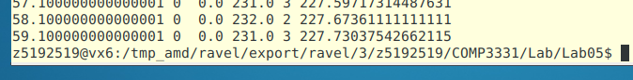

The average throughput in (packet/second), we can get this data from the last line of WindowMon.tr, which is 227.73.

Therefore, the 2 throughputs in bps are 227.73*540*8 = 983.8 Kbps and 227.73*500*8 = 910.92 Kbps.

Comparing the actual throughput to 1Mps, it was about 983.8/1000 = 98.38%, for capacity usage in percent.

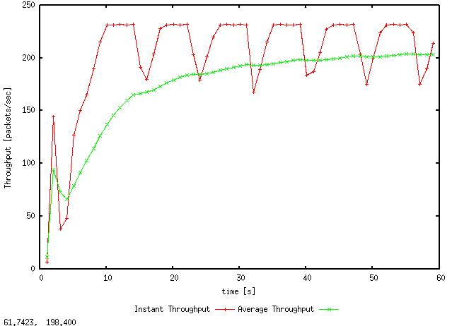**Q4:**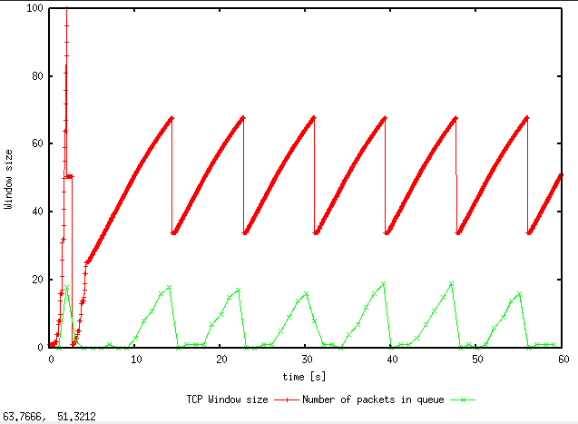

As we change “set tcp0 [new Agent/TCP]” to “set tcp0 [new Agent/TCP/Reno]”, and keep using 150 packets and 100ms which same to Q1 and Q2, we can get these two diagrams from “Window.plot” and “WindowTPut.plot”.

From Window.tr, the Reno has 203.38 (packets / second) for throughput and it goes back to 0 for only 1 time. For the Tahoe method, it has 190 (packets / second) and go back to zero for 7 times.

|  |  |  |
| --- | --- | --- |
| Type | Average throughput (packets / second) | Times of back to zero |
| Reno | 203.38 | 1 |
| Tahoe | 190 | 7 |

**Exercise 2: Flow Fairness with TCP**

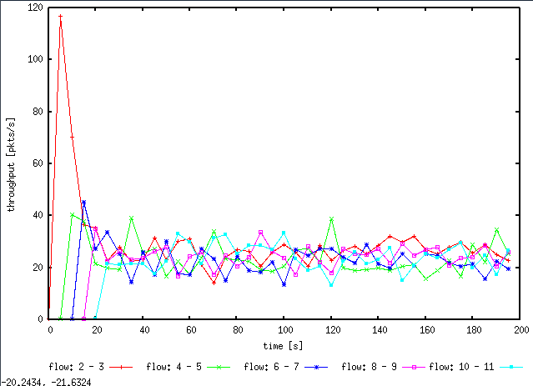

**Q1:**

Yes, as the diagram shows, after 20 seconds, all the 5 connections shared similar throughput, which is about 1/5 of the whole throughput capacity. This fair is controlled by the AIMD which can make prompt and proper adapt to each connection, in order to balance the whole network.

**Q2:**

As the diagram shows, when flow 4-5(green line) entered, the flow 2-3(red line) got a rapid decrease. Similarly, when flow 6-7(blue line) and other flows entered, all the pre-exist flows will have a rapid change.

The reason behind is the TCP congestion control. While the new flow enters, the congestion window got quickly ramped up and cause network congestion. When the timeouts and duplicate ACKs reach a certain level, the connection will re-size the congestion window and let it adapt to the new condition.

**Exercise 3: TCP competing with UDP**

**Q1:**

The UDP will not decreases its throughput or do anything on congestion control. It will remain the scheduled transmission rate and the TCP will try to use the rest throughput capacity.

**Q2:**

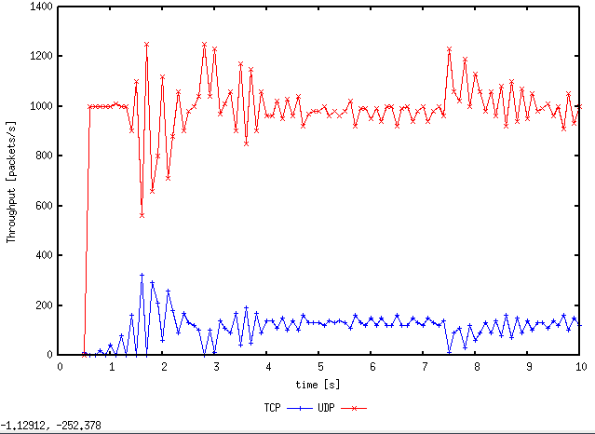

Just as what we expected, the UDP remains in a high transmit rate and the rest throughput was used to make TCP connection. This is because UDP does not have the congestion control protocol. It will keep transmission in the scheduled rate anyway. However, TCP will follow its AIMD method and make adapt when there is congestion in the network. This kind of concession will cause TCP to continue at a low rate, resulting in poor connectivity.

**Q3:**

The advantage of UDP is that it always tries it best to make the transmission processing in a high/scheduled rate, which can save people’s time. Also, as it transmits regardless on the congestion, it may also reduce the delay.

The disadvantage of UDP is that it may utilize a lot of network sources, and make other connections transmit in a poor connectivity. Also, when the network congestion happened, as it does not have congestions control, the network will remain congested forever and people will not be able to establish connections happily.