DC1 ↔ DC3 Metro DCI with EVPN Gateways
L2 extension (VLAN 40) + L3 (Type-5) over one EVPN gateway, with DC2 as an L3-only DR site
Item | Detail
Project | Add DC3 as a metro twin of DC1; stretch VLAN 40; route between all three DCs
Lab | EVE-NG on Proxmox; Arista vEOS-lab; DC1 fabric managed by Salt (NAPALM)
Date completed | 17 Oct 2026
Result | All 6 acceptance tests passed (L2 stretch, L3 both ways, DC2↔DC3 transit)
Key platform note | Border leaves upgraded EOS 4.31.2F → 4.36.3M for the full L3 EVPN gateway

1. Goal
Build a third data center (DC3) close to DC1 (metro distance, DWDM) and connect it so that:
- VLAN 40 (10.40.40.0/24) exists in both DC1 and DC3: a host can live in either DC with the same IP and gateway (VM mobility).
- DC3 can have its own subnets (VLAN 70, 10.70.70.0/24) that are routed, not stretched.
- All three DCs can reach each other, including DC2 ↔ DC3 through DC1.
- Each DC stays its own EVPN domain: no DC learns another DC’s internal VTEPs, and failures stay local.
- The design is future-proof: stretching another VLAN is a short, repeatable checklist.

2. How it works, in plain language

2.1 The real-world picture
Think of each data center as a city with its own postal system.
Network thing | City analogy
Data center (DC1, DC2, DC3) | A city with its own internal postal system
Host (VPC) | A house
VLAN 40 | "Main Street", a street that runs through both DC1 and DC3
Subnet 10.70.70.0/24 (DC3 only) | "Oak Avenue", a street that exists only in DC3
Anycast gateway 10.40.40.1 | The local post office on Main Street, one in each city
Border leaf with EVPN gateway | The customs office at the edge of each city
Metro DWDM link (Eth5) | The bridge between DC1 and DC3
VRF-lite link to DC2 (Eth4.100) | A toll highway to a far-away city (DC2)
Type-2 route | A letter addressed to a person (exact MAC/IP of a host)
Type-3 route | The flyer distribution list (who gets broadcasts on Main Street)
Type-5 route | A parcel addressed to a ZIP code (a whole subnet)

2.2 What happens to the mail
- Letters on Main Street (L2, VLAN 40). VPC1 in DC1 writes to VPC6 in DC3. DC1 only knows "VPC6 lives behind my customs office". DC1’s customs office re-stamps the letter with its own return address and sends it over the bridge; DC3’s customs office re-stamps it again and delivers it. Neither city learns the other’s street plan.
- Parcels by ZIP code (L3, Type-5). VPC7 on Oak Avenue (DC3 only) is reached by ZIP code 10.70.70.0/24. Both customs offices re-stamp these parcels too, so DC1 hosts reach DC3 subnets and vice versa.
- The far city (DC2). DC2 is connected by a toll highway that only carries parcels by ZIP code (plain IP routes), never personal letters. DC1’s customs office translates between the highway and the bridge, so DC2 and DC3 can reach each other through DC1.
- Local post offices. Main Street has a post office in both cities (anycast gateway 10.40.40.1 on DC1 leaves and on dc3-leaf1), so hosts are always routed locally: no detour (tromboning) to the other DC.

Memory hooks
Customs re-stamps the mail: each EVPN gateway re-originates routes with itself as next hop.
Letters to a name, parcels to a ZIP: Type-2 = host, Type-5 = subnet.
Metro pair stretches, DR site routes: L2 only between nearby DCs; far DCs get L3 only.
The hub translates: DC1 border-leaf converts VRF-lite IPv4 ↔ EVPN Type-5.

3. Architecture
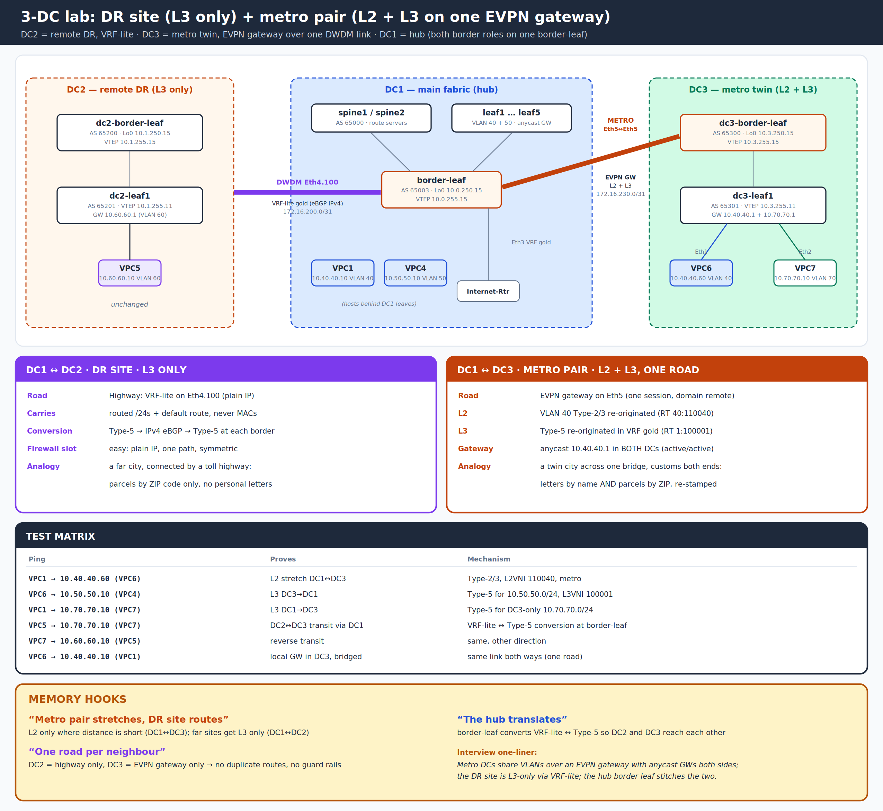
Figure 1: Three-DC design (DC2 = DR, L3 only; DC3 = metro twin, L2 + L3 over one EVPN gateway; DC1 = hub)

3.1 Inventory and addressing
Device | Role | ASN | Lo0 / Lo1 (VTEP) | Key links | EOS
dc1-border-leaf | DC1 EVPN gateway + VRF-lite to DC2 + internet | 65003 | 10.0.250.15 / 10.0.255.15 | Eth1/2 spines; Eth3 internet; Eth4.100 DC2; Eth5 DC3 | 4.36.3M
dc3-border-leaf | DC3 EVPN gateway | 65300 | 10.3.250.15 / 10.3.255.15 | Eth5 172.16.230.1/31 (DC1); Eth1 10.3.1.0/31; Lo100 10.3.100.1 (VRF gold) | 4.36.3M
dc3-leaf1 | DC3 leaf, anycast GW | 65301 | 10.3.250.11 / 10.3.255.11 | Eth11 10.3.1.1/31; Eth1 VPC6 (VLAN 40); Eth2 VPC7 (VLAN 70) | 4.31.2F
dc2-border-leaf | DC2 border (VRF-lite) | 65200 | 10.1.250.15 / 10.1.255.15 | Eth4.100 172.16.200.1/31; Eth1 to dc2-leaf1 | 4.31.2F
DC1 spines/leaves | DC1 fabric | 65000 / 6500x | 10.0.250.x / 10.0.255.x | Salt-managed | 4.31.2F

Host | Location | VLAN / VNI | IP / gateway | Purpose
VPC1 | DC1 leaf1 | 40 / 110040 | 10.40.40.10 / .1 | Stretched VLAN, DC1 side
VPC4 | DC1 leaf3 | 50 / 110050 | 10.50.50.10 / .1 | DC1-only subnet
VPC5 | DC2 dc2-leaf1 | 60 / 110060 | 10.60.60.10 / .1 | DC2-only subnet
VPC6 | DC3 dc3-leaf1 Eth1 | 40 / 110040 | 10.40.40.60 / .1 | Stretched VLAN, DC3 side
VPC7 | DC3 dc3-leaf1 Eth2 | 70 / 110070 | 10.70.70.10 / .1 | DC3-only subnet (Type-5)

3.2 Key design decisions
Decision | Choice | Why
DC1 ↔ DC3 transport | One EVPN gateway session (domain remote) carrying L2 + L3 | One road per neighbour: no duplicate routes, symmetric links
DC1 ↔ DC2 transport | VRF-lite (eBGP IPv4 in VRF gold), unchanged | DR site is L3 only; never stretch L2 over long distance
VLAN 40 gateway | Anycast 10.40.40.1 in both DC1 and DC3 | Metro active/active: hosts routed locally, no tromboning
VRF gold RT | Same 1:100001 in all DCs; L3VNI 100001 | One tenant VRF end to end
Underlay across DCI | Only the two gateway loopbacks (route-map out) | Neither DC learns the other’s internal VTEPs
EOS on border leaves | 4.36.3M | 4.31 lacks the VRF multi-domain commands (see section 7)
VRF anchor on dc3-border-leaf | Loopback100 in VRF gold | A gateway with no SVIs needs an active VRF to import Type-5

4. Route types: what crosses where
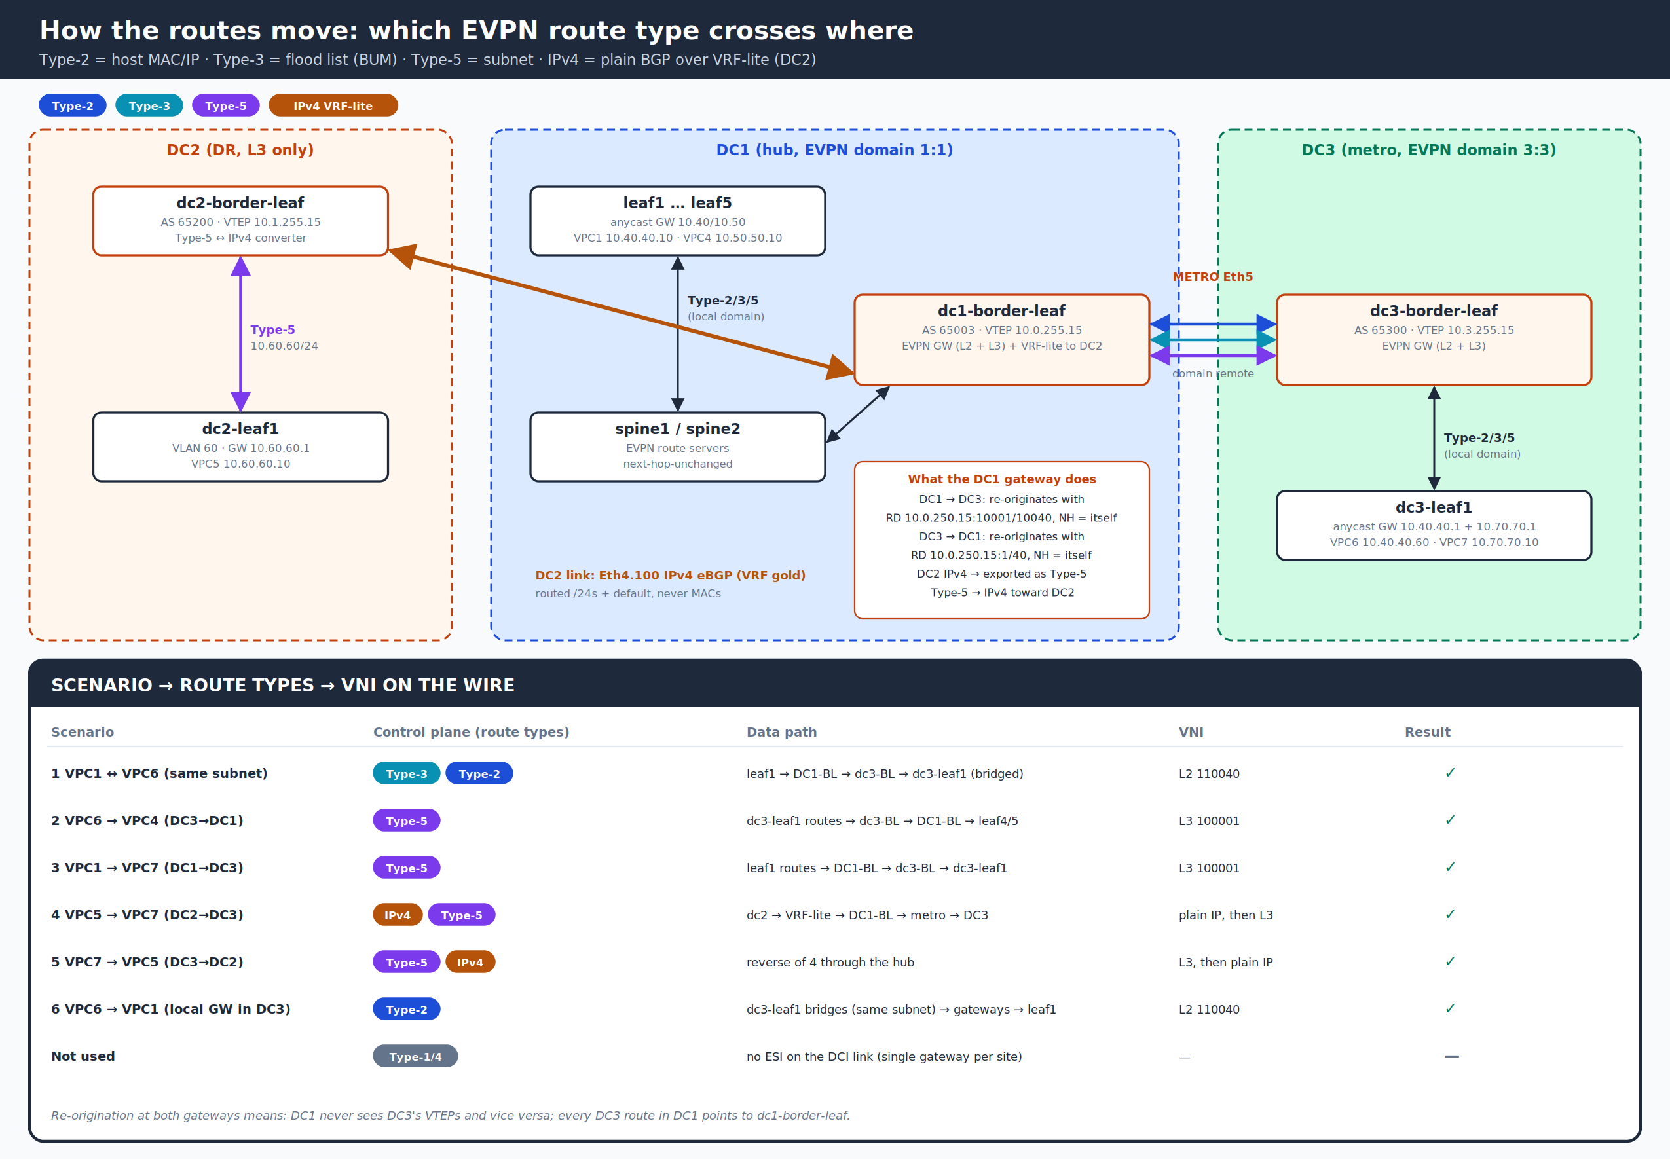
Figure 2: Route types per segment and per test scenario

4.1 EVPN route types used in this project
Type | Name | Carries | Used here for
Type-1 | Ethernet Auto-Discovery | ESI + VNI | Not on the DCI (single gateway per site). Used inside DC1 for the leaf4/5 ESI-LAG
Type-2 | MAC/IP Advertisement | Host MAC (+IP), L2VNI (+L3VNI) | VLAN 40 hosts across DC1 ↔ DC3; host /32 routes for symmetric IRB
Type-3 | Inclusive Multicast (IMET) | VTEP IP + L2VNI | VLAN 40 flood list (BUM): ends at each gateway, re-originated across
Type-4 | Ethernet Segment | ESI + VTEP IP | Not on the DCI. Inside DC1 for leaf4/5 DF election
Type-5 | IP Prefix | Subnet + L3VNI + router MAC | Subnets 10.40/10.50/10.60/10.70 and the default route between DC1 and DC3
IPv4 (not EVPN) | Plain BGP in VRF gold | Subnet | DC1 ↔ DC2 over VRF-lite; converted to/from Type-5 at each border leaf

4.2 Scenario summary
# | Test | Route types | Path | Result
1 | VPC1 → 10.40.40.60 (VPC6) | Type-3, Type-2 | Bridged: leaf1 → DC1-BL → dc3-BL → dc3-leaf1 (L2VNI 110040) | Pass
2 | VPC6 → 10.50.50.10 (VPC4) | Type-5 | Routed at dc3-leaf1 → dc3-BL → DC1-BL → leaf3/4/5 (L3VNI 100001) | Pass
3 | VPC1 → 10.70.70.10 (VPC7) | Type-5 | Routed at leaf1 → DC1-BL → dc3-BL → dc3-leaf1 (L3VNI) | Pass
4 | VPC5 → 10.70.70.10 (VPC7) | IPv4 then Type-5 | dc2 → VRF-lite → DC1-BL → metro EVPN → DC3 | Pass
5 | VPC7 → 10.60.60.10 (VPC5) | Type-5 then IPv4 | Reverse of test 4 through the hub | Pass
6 | VPC6 → 10.40.40.10 (VPC1) | Type-2 | Same subnet: bridged across both gateways | Pass

5. Configuration walkthrough
Each block below shows the configuration, what every line does, and which route types it creates or affects. DC1 leaves/spines and DC2 were not changed.

5.1 Metro underlay: reach the other gateway’s loopbacks
dc1-border-leaf (mirror on dc3-border-leaf with 172.16.230.1 / 10.3.x)
interface Ethernet5
description METRO-EVPN-DCI-to-dc3-border-leaf Ethernet5
mtu 9214
no switchport
ip address 172.16.230.0/31
!
ip prefix-list DCI-UNDERLAY-OUT seq 10 permit 10.0.250.15/32
ip prefix-list DCI-UNDERLAY-OUT seq 20 permit 10.0.255.15/32
route-map DCI-UNDERLAY-OUT permit 10
match ip address prefix-list DCI-UNDERLAY-OUT
!
router bgp 65003
neighbor 172.16.230.1 remote-as 65300
neighbor 172.16.230.1 route-map DCI-UNDERLAY-OUT out
address-family ipv4
neighbor 172.16.230.1 activate

Line | What it does | Route types
mtu 9214 | VXLAN adds 50 bytes; jumbo MTU end to end | —
neighbor 172.16.230.1 remote-as 65300 | eBGP IPv4 session over the DWDM /31 | IPv4 (underlay)
route-map DCI-UNDERLAY-OUT out | Advertise only Lo0 (EVPN peering) and Lo1 (VTEP) | IPv4: 2 prefixes each way

5.2 Metro overlay: the EVPN gateway session
dc1-border-leaf
router bgp 65003
neighbor 10.3.250.15 remote-as 65300
neighbor 10.3.250.15 update-source Loopback0
neighbor 10.3.250.15 ebgp-multihop 3
neighbor 10.3.250.15 send-community extended
neighbor 10.3.250.15 bfd
address-family evpn
domain identifier 1:1
domain identifier 3:3 remote
neighbor 10.3.250.15 activate
neighbor 10.3.250.15 domain remote

Line | What it does | Route types
update-source Loopback0 + ebgp-multihop 3 | EVPN peering between loopbacks (not the /31) | —
send-community extended | Carries route-targets, router MAC and VXLAN encap | All EVPN
domain remote | Makes this a gateway session: routes from DC3 are treated as another domain and are re-originated, not just passed through | Type-2/3/5
domain identifier 1:1 / 3:3 remote | Tags each domain (DC1 = 1:1, DC3 = 3:3) for loop prevention | All EVPN
bfd | Fast failure detection on the DCI session | —
On dc3-border-leaf the mirror is domain identifier 3:3 / domain identifier 1:1 remote and neighbor 10.0.250.15.

5.3 L2 gateway: stretching VLAN 40
dc1-border-leaf (dc3-border-leaf identical except RDs 10.3.250.15:40 / :10040)
vlan 40
name APP-40
interface Vxlan1
vxlan vlan 40 vni 110040
router bgp 65003
vlan 40
rd 10.0.250.15:40
rd evpn domain remote 10.0.250.15:10040
route-target both 40:110040
route-target import export evpn domain remote 40:110040
redistribute learned

Line | What it does | Route types
vxlan vlan 40 vni 110040 | Same L2VNI in both DCs | Type-2/3
rd 10.0.250.15:40 | RD used when re-originating into the local domain (DC1) | Type-2/3
rd evpn domain remote 10.0.250.15:10040 | RD used when re-originating toward DC3 | Type-2/3
route-target both 40:110040 | Import/export with DC1 leaves | Type-2/3
route-target import export evpn domain remote 40:110040 | Import/export with the DC3 gateway | Type-2/3
redistribute learned | Advertise locally learned MACs (none here; gateway only) | Type-2
Result
DC1 leaves see VPC6’s MAC behind 10.0.255.15 (dc1-border-leaf). DC3 sees VPC1’s MAC behind 10.3.255.15. Each flood list (Type-3) ends at the local gateway, so BUM traffic crosses the DCI only once.

5.4 L3 gateway: Type-5 between DC1 and DC3 (EOS 4.36)
dc1-border-leaf VRF gold (dc3-border-leaf identical with 10.3.250.15)
router bgp 65003
vrf gold
rd 10.0.250.15:1
rd evpn domain remote 10.0.250.15:10001
route-target import evpn 1:100001
route-target export evpn 1:100001
route-target import evpn domain all 1:100001
route-target export evpn domain all 1:100001

Line | What it does | Route types
rd 10.0.250.15:1 | RD for VRF routes re-originated into DC1 (local domain) | Type-5
rd evpn domain remote 10.0.250.15:10001 | RD for VRF routes re-originated toward DC3 | Type-5
route-target import/export evpn 1:100001 | Local-domain import/export (DC1 leaves) | Type-5, Type-2 (host /32)
route-target import/export evpn domain all 1:100001 | The fix: import/export in both domains, so the gateway installs the other DC’s prefixes in its VRF and re-originates them | Type-5
Why this was the turning point
Before this line, DC1 subnets arrived on dc3-border-leaf but were never installed in its VRF, so dc3-border-leaf advertised routes it could not forward (VPC6 got "network unreachable" from 10.3.100.1).
After it, dc3-border-leaf shows DC1 prefixes twice: RD 10.0.250.15:10001 … remote (received from DC1) and RD 10.3.250.15:1 (re-originated into DC3 with itself as next hop).

5.5 VRF anchor on dc3-border-leaf
dc3-border-leaf
interface Loopback100
description VRF gold anchor / diagnostic
vrf gold
ip address 10.3.100.1/32
router bgp 65300
vrf gold
redistribute connected
dc3-border-leaf has no SVIs or VRF-lite links in VRF gold. Without an interface the VRF stayed inactive and imported nothing. Loopback100 activates it and doubles as a per-VRF ping target (ping vrf gold 10.3.100.1). This mirrors Arista AVD’s vtep_diagnostic loopback practice. redistribute connected advertises it as a Type-5.

5.6 dc3-leaf1: a normal leaf
dc3-leaf1 (key parts)
interface Vlan40
vrf gold
ip address virtual 10.40.40.1/24
interface Vlan70
vrf gold
ip address virtual 10.70.70.1/24
interface Vxlan1
vxlan vlan 40 vni 110040
vxlan vlan 70 vni 110070
vxlan vrf gold vni 100001
ip virtual-router mac-address 00:1c:73:00:00:99
router bgp 65301
vlan 40
rd 10.3.250.11:40
route-target both 40:110040
redistribute learned
vlan 70
rd 10.3.250.11:70
route-target both 70:110070
redistribute learned
vrf gold
rd 10.3.250.11:1
route-target import evpn 1:100001
route-target export evpn 1:100001
redistribute connected

Piece | What it does | Route types it originates
ip address virtual + same vMAC as DC1 | Anycast gateway 10.40.40.1: identical IP and MAC in both DCs, so a VM keeps its gateway after moving | —
vlan 40 / vlan 70 MAC-VRFs | Advertise learned hosts and flood lists | Type-2 (VPC6, VPC7), Type-3 (VLAN 40, 70)
vrf gold redistribute connected | Advertise local subnets 10.40.40.0/24 and 10.70.70.0/24 | Type-5
dc3-leaf1 knows nothing about DC1 or DC2 VTEPs: every remote route it holds points to 10.3.255.15 (dc3-border-leaf).

5.7 DC2 path (unchanged): VRF-lite translation at the hub
dc1-border-leaf VRF gold (existing)
vrf gold
neighbor 172.16.200.1 remote-as 65200
neighbor 172.16.200.1 route-map DCI-OUT out ! 0.0.0.0/0 + 10.0.0.0/8 le 24
address-family ipv4
neighbor 172.16.200.1 activate
DC2’s 10.60.60.0/24 arrives as plain IPv4 and is exported into EVPN as Type-5 (to DC1 leaves and, via the gateway, to DC3). DC3’s 10.70.70.0/24 arrives as Type-5 and leaves toward DC2 as IPv4 (it matches 10.0.0.0/8 le 24). That is why tests 4 and 5 passed with no change in DC2.

6. Scenario walkthroughs

Test 1: VPC1 → VPC6 (same subnet, bridged)
- VPC1 ARPs for 10.40.40.60. leaf1 floods the ARP using the Type-3 list for VNI 110040, which includes dc1-border-leaf.
- dc1-border-leaf re-encapsulates toward dc3-border-leaf (its Type-3 list for the remote domain), which forwards to dc3-leaf1. VPC6 replies.
- dc3-leaf1 advertises VPC6 as Type-2; dc3-border-leaf re-originates it to DC1 (NH 10.3.255.15); dc1-border-leaf re-originates it into DC1 (NH 10.0.255.15).
- Unicast: leaf1 → VXLAN 110040 → dc1-border-leaf → VXLAN 110040 → dc3-border-leaf → VXLAN 110040 → dc3-leaf1 (three stitched tunnels).

Test 2: VPC6 → VPC4 10.50.50.10 (DC3 → DC1, routed)
- VPC6 sends to its local gateway 10.40.40.1 on dc3-leaf1.
- dc3-leaf1 looks up VRF gold: 10.50.50.0/24 is a Type-5 via VTEP 10.3.255.15 (re-originated by dc3-border-leaf), L3VNI 100001.
- dc3-border-leaf looks up its VRF: 10.50.50.0/24 via VTEP 10.0.255.15 (from DC1). dc1-border-leaf looks up its VRF: via leaf3/4/5 (local Type-5 / Type-2 host route).

Test 3: VPC1 → VPC7 10.70.70.10 (DC1 → DC3, routed)
- leaf1 routes in VRF gold: 10.70.70.0/24 Type-5 via 10.0.255.15 → dc1-border-leaf → dc3-border-leaf → dc3-leaf1 → VPC7 (all on L3VNI 100001).

Test 4/5: VPC5 ↔ VPC7 (DC2 ↔ DC3 transit)
- dc2-leaf1 → dc2-border-leaf (Type-5) → IPv4 over Eth4.100 → dc1-border-leaf VRF gold → Type-5 over the metro gateway → dc3-border-leaf → dc3-leaf1. The return reverses it.

Test 6: VPC6 → VPC1 (local gateway in DC3)
- Same subnet, so no routing: dc3-leaf1 bridges using VPC1’s Type-2 (learned via dc3-border-leaf) across the three tunnels.

7. Issues found and how they were solved
# | Symptom | Root cause | Fix
1 | rd evpn domain remote in VRF → "Ambiguous"; remote RTs → "Invalid input" | EOS 4.31.2F has no multi-domain commands under a VRF (only under MAC-VRFs) | Upgraded border leaves to 4.36.3M
2 | With next-hop-self received-evpn-routes route-type ip-prefix inter-domain, only DC1 → DC3 worked | 4.31 Type-5 gateway behaviour was one-directional | Replaced by proper VRF multi-domain config on 4.36
3 | dc3-border-leaf VRF empty although routes were received | VRF had no interface, so it was inactive | Added Loopback100 in VRF gold
4 | On 4.36, DC1 prefixes still not installed in dc3 VRF | Remote-domain RTs missing (af-ipv4 form not accepted) | route-target import/export evpn domain all 1:100001 at VRF level
5 | bgp best-path d-path rejected | Command not available in this vEOS build | Omitted (optional for two domains)

Lessons learned
The L2 EVPN gateway (MAC-VRF domain remote) worked on 4.31; the L3 gateway needed a newer release. Know your platform’s feature level before designing.
A gateway with no local SVIs still needs an active IP-VRF (a loopback) to import and re-originate Type-5 routes.
Read the EVPN table and the VRF routing table separately: a route can be "valid, best" in EVPN and still not be installed in the VRF.
show bgp evpn route-type ip-prefix ipv4 showing the remote RD (10.0.250.15:10001 … remote) plus a locally re-originated copy is the proof the gateway works.

8. Verification commands
Where | Command | Expected
Both border leaves | show ip bgp summary | Spines/leaf + 172.16.230.x Estab
Both border leaves | show bgp evpn summary | Local peers + metro peer (domain remote) Estab
dc3-border-leaf | show bgp evpn route-type ip-prefix ipv4 | DC1 prefixes with RD 10.0.250.15:10001 (remote) and 10.3.250.15:1 (re-originated)
dc3-border-leaf | show ip route vrf gold | 10.50.50/24, 10.60.60/24, default via VTEP 10.0.255.15
dc3-leaf1 | show ip route vrf gold | All remote prefixes via VTEP 10.3.255.15
dc1-border-leaf | show ip route vrf gold 10.70.70.0/24 | Via VTEP 10.3.255.15
leaf1 | show bgp evpn route-type mac-ip 10.40.40.60 | VPC6 with NH 10.0.255.15
dc3-leaf1 | show vxlan address-table vlan 40 | DC1 MACs behind 10.3.255.15
dc2-leaf1 | show ip route vrf gold 10.70.70.0/24 | Via 10.1.255.15 (transit through DC1)

9. Operations

9.1 Stretch another VLAN (example: VLAN 50 / VNI 110050)
- dc1-border-leaf: vlan 50, vxlan vlan 50 vni 110050, and router bgp → vlan 50 with rd, rd evpn domain remote, route-target both 50:110050, route-target import export evpn domain remote 50:110050.
- dc3-border-leaf: the same block with its own RDs.
- dc3-leaf1: vlan 50, vxlan vlan 50 vni 110050, BGP vlan 50, anycast SVI ip address virtual 10.50.50.1/24, an access port.
- Verify: Type-2/3 for VNI 110050 on both sides, then ping across.

9.2 Automation status
- DC1 fabric is Salt-managed with replace: True. The DCI lines on dc1-border-leaf are not yet in the templates: do not run state.apply on it until they are, or Salt will remove them. Target others with salt -L spine1,spine2,leaf1,leaf2,leaf3,leaf4,leaf5 state.apply fabric.
- Next step: add a dci: section (metro peer, stretched VLAN list, VRF multi-domain RD/RT) to the pillar and leaf.j2, and onboard DC2/DC3 switches as proxy minions.

9.3 Production hardening (beyond the lab)
Area | Production practice
Redundancy | Two gateways per site with an Interconnect ESI (RFC 9014), all-active
DCI | Two diverse circuits, BFD, MACsec on DWDM
Blast radius | Storm-control and MAC limits on stretched VLANs; approved-VLAN list
Firewalls | Stretched subnets + anycast GW cause asymmetric return paths: use a cross-DC firewall cluster with session sync, or zone firewalls at VRF edges
Governance | Stretched VLANs are documented exceptions with an exit date
Monitoring | EVPN routes per VNI, MAC moves (Type-2 sequence numbers), DCI utilisation

Interview one-liner
"DC1 and DC3 are a metro pair joined by EVPN VXLAN gateways (RFC 9014). Each DC is its own EVPN domain; the border leaves re-originate Type-2/3 for the stretched VLAN and Type-5 for subnets with themselves as next hop, so neither DC sees the other’s VTEPs. VLAN 40 has an anycast gateway in both DCs. The DR site DC2 is L3-only over VRF-lite, and the hub border leaf translates between VRF-lite and Type-5."

