Stretching VLAN 40 from DC1 to DC3
How two data centers share one Layer-2 segment through EVPN VXLAN gateways: route types, control plane and packet flow
Item | Detail
What | VLAN 40 (10.40.40.0/24, VNI 110040) exists in DC1 and DC3 as one Layer-2 segment
How | EVPN VXLAN gateway on each border leaf (RFC 9014), one EVPN domain per DC
Test hosts | VPC1 10.40.40.10 (DC1, leaf1) and VPC6 10.40.40.60 (DC3, dc3-leaf1)
Route types involved | Type-3 (find each other, flood lists) and Type-2 (exact host location)
Status | Working: VPC1 ↔ VPC6 ping successful

1. The goal in one sentence
A host in DC1 and a host in DC3 sit in the same subnet (10.40.40.0/24) and talk to each other as if they were plugged into the same switch, while each data center keeps its own independent EVPN fabric.
Why you would do this in production: VM migration (vMotion) between sites, clustered applications that need a shared subnet, or moving a workload to another DC without changing its IP address.

2. The idea in plain language

2.1 Main Street runs through two cities
Picture DC1 and DC3 as two cities, each with its own postal system. VLAN 40 is "Main Street", and it runs through both cities. VPC1 lives on Main Street in DC1; VPC6 lives on Main Street in DC3.
Each city has a customs office at its border (the border leaf with the EVPN gateway), and a bridge connects the two customs offices (the metro DWDM link, Eth5).
Network | Real world
VLAN 40 / VNI 110040 | Main Street, one street name in both cities
VPC1, VPC6 | Houses on Main Street
dc1-border-leaf, dc3-border-leaf (EVPN gateways) | Customs offices at each city border
Metro link Eth5 | The bridge between the customs offices
Type-2 route | A letter addressed to a named person: "VPC6 lives at this address"
Type-3 route | The flyer distribution list: "who wants copies of Main Street broadcasts"
VXLAN tunnel | A postman carrying a sealed envelope between two post offices
Outer IP header | The address on the envelope (changes at each customs office)
Inner Ethernet frame | The letter inside (never opened, never changed)

2.2 What the customs offices do
- When DC3 says "VPC6 lives here", DC3’s customs office re-stamps the message: "VPC6 lives behind me". DC1’s customs office re-stamps it again for DC1: "VPC6 lives behind me".
- So a DC1 leaf only ever learns "send VPC6’s mail to my own customs office". It never learns DC3’s internal addresses. That keeps each city independent: a problem in one city stays in that city.
- A letter from VPC1 to VPC6 is carried by three postmen (three VXLAN tunnels): DC1 leaf → DC1 customs → DC3 customs → DC3 leaf. The envelope address changes at each hop; the letter inside never does.

Memory hooks
Customs re-stamps the letter: each gateway rewrites the route’s next hop (and RD) to itself.
Three postmen, one envelope: three tunnels, the inner frame never changes.
Type-3 to find, Type-2 to deliver.
Same VNI everywhere: 110040 in DC1, on the metro, and in DC3.

3. The picture
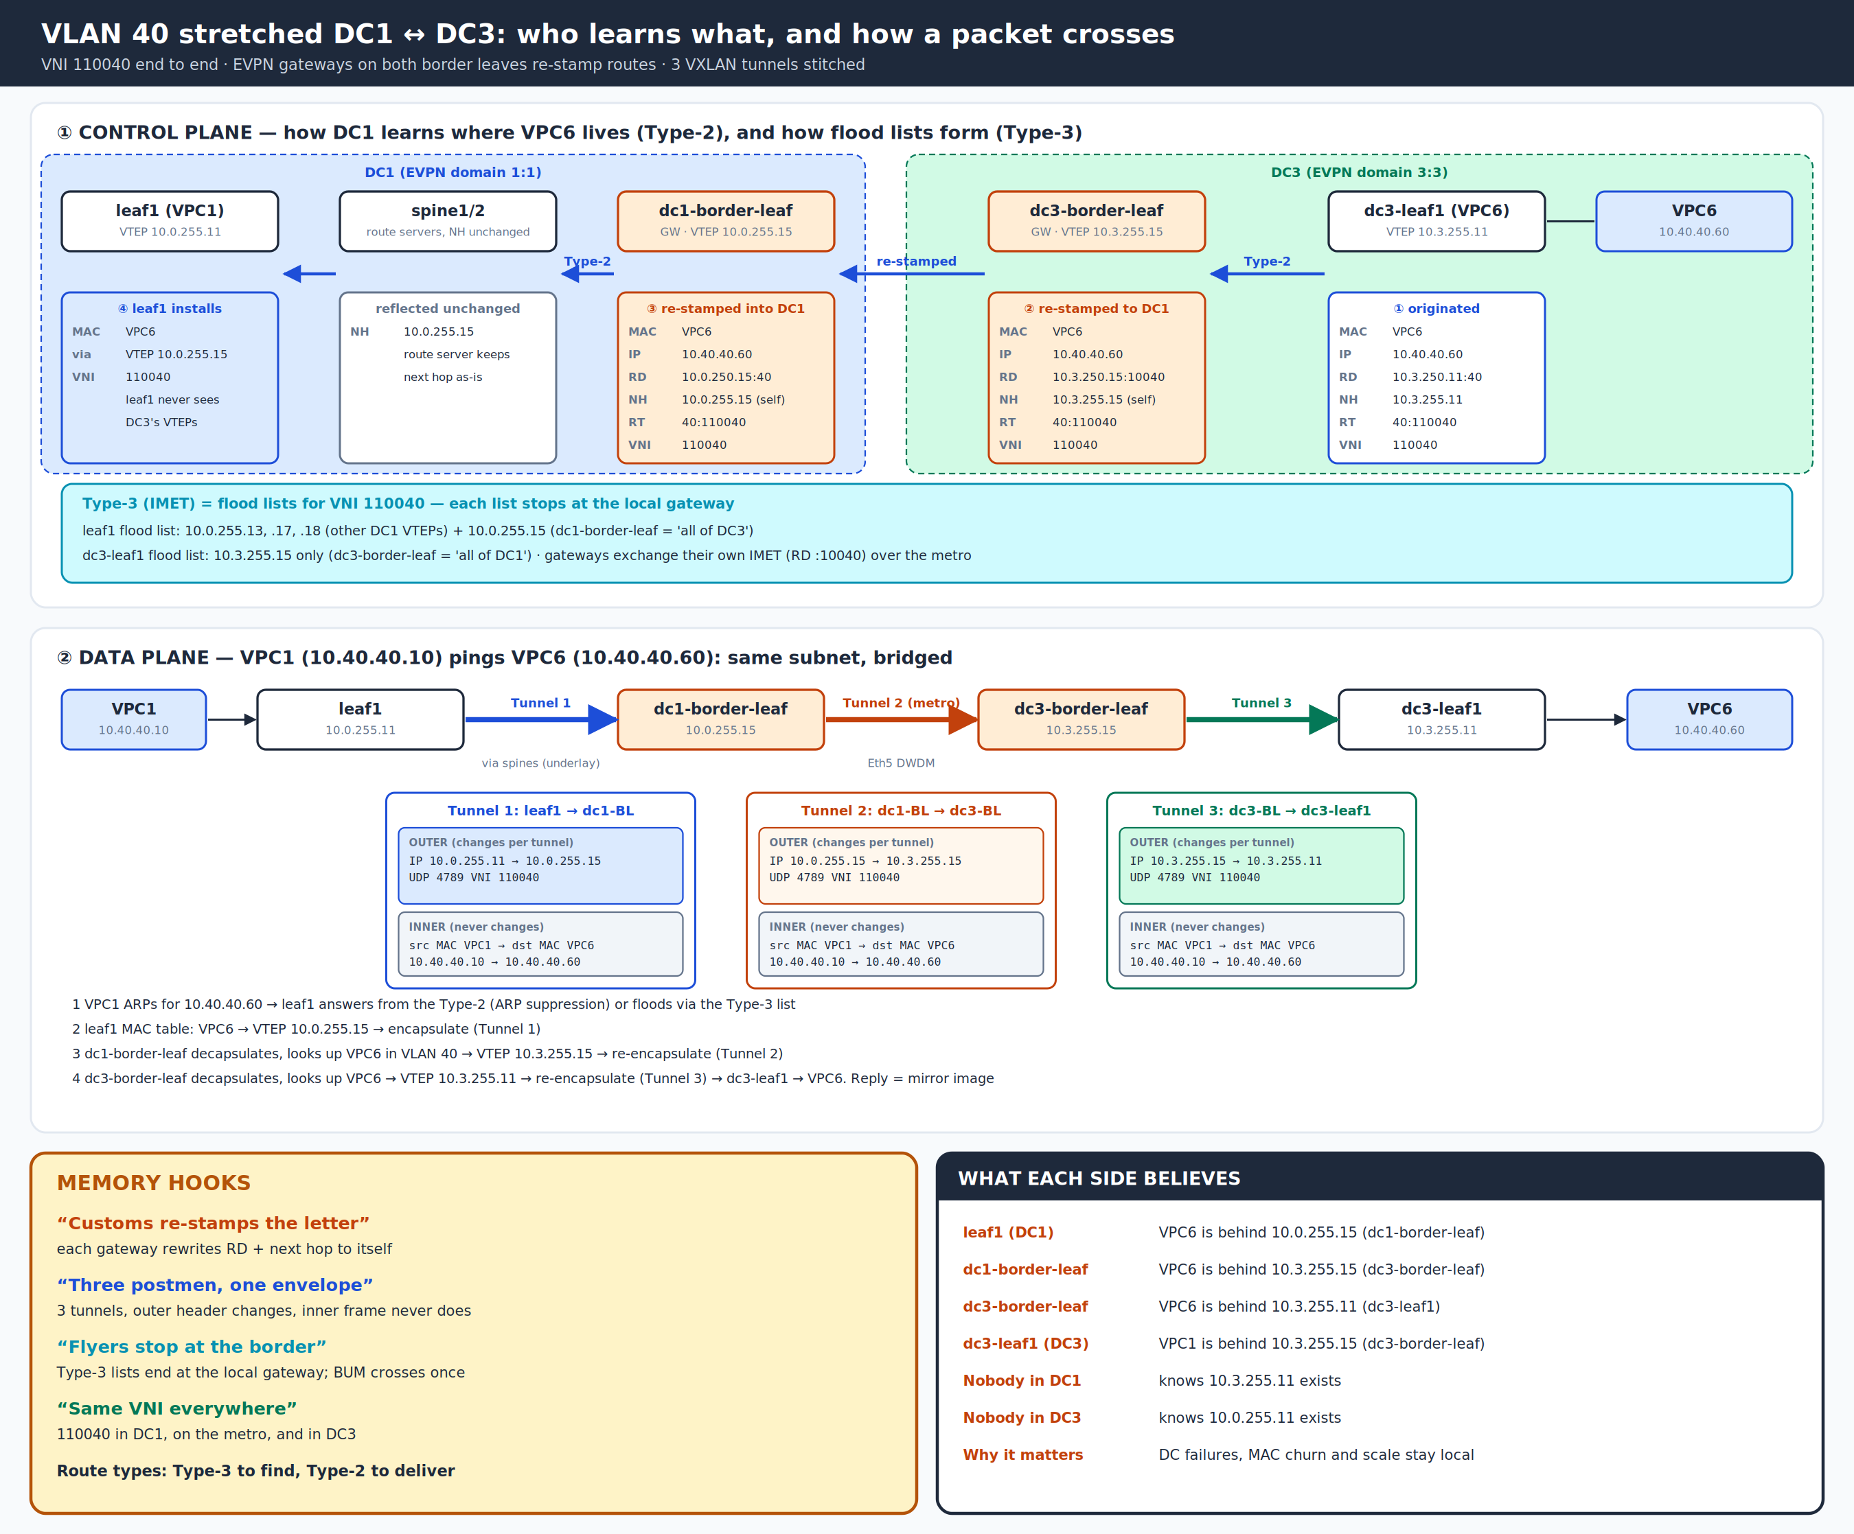
Figure 1: Control plane (how routes are learned and re-stamped) and data plane (how a frame crosses three tunnels)

3.1 The players
Device | Role for VLAN 40 | VTEP (Lo1) | EVPN peer(s)
leaf1 (+ leaf2, MLAG) | Where VPC1 lives; anycast GW 10.40.40.1 | 10.0.255.11 (shared MLAG VTEP) | spine1/2 (route servers)
spine1 / spine2 | Relay EVPN routes inside DC1, next hop unchanged | — | All DC1 leaves
dc1-border-leaf | DC1 EVPN gateway | 10.0.255.15 | spines (DC1 domain) + dc3-border-leaf (remote domain)
dc3-border-leaf | DC3 EVPN gateway | 10.3.255.15 | dc3-leaf1 (DC3 domain) + dc1-border-leaf (remote domain)
dc3-leaf1 | Where VPC6 lives; anycast GW 10.40.40.1 | 10.3.255.11 | dc3-border-leaf

4. Five ideas you need first
Idea | Plain meaning | In this lab
L2VNI | The VXLAN ID for one Layer-2 segment. Same VNI = same VLAN everywhere | 110040 for VLAN 40 in both DCs
MAC-VRF | The EVPN "table" for one VLAN: which MACs live where | router bgp → vlan 40 block
EVPN domain | One fabric that shares EVPN routes freely | DC1 = domain 1:1, DC3 = domain 3:3
Route Distinguisher (RD) | A "who sent this" tag that makes a route unique | Each device and each domain uses its own RD
Route Target (RT) | A "which table does this belong to" tag; matching RT = import | 40:110040 everywhere for VLAN 40

The key trick: gateway re-origination
A normal EVPN router passes routes along. A gateway (configured with domain remote) re-originates them: it receives a route from one domain, then advertises a fresh copy into the other domain with its own RD and its own VTEP as next hop.
That is why DC1 never needs to reach DC3’s leaf VTEPs, and the underlay between DCs only carries the two gateway loopbacks.

5. Control plane: how each side learns about the other

5.1 Step 1: Type-3 builds the flood lists
Before any host talks, every VTEP that has VLAN 40 advertises a Type-3 (IMET) route saying "send me VLAN 40 broadcasts". This builds the flood list (ingress replication list) used for ARP and other BUM traffic.
Device | Type-3 it advertises | Where it goes
dc3-leaf1 | VTEP 10.3.255.11, RD 10.3.250.11:40, VNI 110040 | To dc3-border-leaf (DC3 domain)
dc3-border-leaf | Its own VTEP 10.3.255.15, RD 10.3.250.15:40 (into DC3) and RD 10.3.250.15:10040 (to DC1) | Both domains
dc1-border-leaf | Its own VTEP 10.0.255.15, RD 10.0.250.15:40 (into DC1) and RD 10.0.250.15:10040 (to DC3) | Both domains
DC1 leaves | Their own VTEPs, RD Lo0:40 | DC1 domain only

VTEP | Its flood list for VNI 110040 | Meaning
leaf1 | 10.0.255.13, 10.0.255.17, 10.0.255.18, 10.0.255.15 | Other DC1 leaves + dc1-border-leaf (which stands for "all of DC3")
dc1-border-leaf | DC1 leaves + 10.3.255.15 | All of DC1 + dc3-border-leaf
dc3-border-leaf | 10.0.255.15 + 10.3.255.11 | dc1-border-leaf + dc3-leaf1
dc3-leaf1 | 10.3.255.15 only | dc3-border-leaf stands for "all of DC1"
Result: a broadcast crosses the metro link once, and each flood list stops at the local gateway ("flyers stop at the border").

5.2 Step 2: Type-2 tells DC1 where VPC6 lives
As soon as VPC6 sends any frame, dc3-leaf1 learns its MAC (and IP from ARP) and advertises a Type-2 (MAC/IP) route. Watch how the route changes at each customs office:
Hop | Device | RD | Next hop | What happened
① | dc3-leaf1 | 10.3.250.11:40 | 10.3.255.11 | Originated: VPC6 MAC + 10.40.40.60, RT 40:110040, VNI 110040
② | dc3-border-leaf | 10.3.250.15:10040 | 10.3.255.15 (self) | Re-stamped toward DC1 using its remote-domain RD
③ | dc1-border-leaf | 10.0.250.15:40 | 10.0.255.15 (self) | Re-stamped into DC1 using its local RD
④ | spine1/2 | unchanged | 10.0.255.15 (unchanged) | Reflected to all DC1 leaves (route servers keep next hop)
⑤ | leaf1 | — | 10.0.255.15 | Installed: "VPC6 is behind VTEP 10.0.255.15, VNI 110040"

5.3 The same in reverse: DC3 learns where VPC1 lives
Hop | Device | RD | Next hop
① | leaf1 (MLAG pair) | 10.0.250.11:40 | 10.0.255.11
② | dc1-border-leaf | 10.0.250.15:10040 | 10.0.255.15 (self)
③ | dc3-border-leaf | 10.3.250.15:40 | 10.3.255.15 (self)
④ | dc3-leaf1 installs | — | VPC1 is behind 10.3.255.15

5.4 What each device ends up believing
Device | Belief about the other DC’s host
leaf1 | VPC6 is behind 10.0.255.15 (dc1-border-leaf)
dc1-border-leaf | VPC6 is behind 10.3.255.15 (dc3-border-leaf)
dc3-border-leaf | VPC6 is behind 10.3.255.11 (dc3-leaf1, local)
dc3-leaf1 | VPC1 is behind 10.3.255.15 (dc3-border-leaf)
Nobody in DC1 | knows that 10.3.255.11 exists
Nobody in DC3 | knows that 10.0.255.11 exists

6. Data plane: VPC1 pings VPC6

6.1 ARP: "who is 10.40.40.60?"
- VPC1 broadcasts an ARP request in VLAN 40.
- If leaf1 already has VPC6’s Type-2 (MAC + IP), it answers the ARP itself (ARP suppression). The broadcast never leaves leaf1.
- If not, leaf1 floods the ARP to every VTEP on its Type-3 flood list, including dc1-border-leaf. dc1-border-leaf forwards it over the metro to dc3-border-leaf, which forwards it to dc3-leaf1. VPC6 replies, and its MAC is now learned and advertised as a Type-2.

6.2 The ping, hop by hop
Hop | Device | Lookup | Action | Outer IP (src → dst) | VNI
1 | VPC1 | ARP cache: VPC6 MAC | Sends frame VPC1-MAC → VPC6-MAC in VLAN 40 | — | —
2 | leaf1 | MAC table VLAN 40: VPC6 → VTEP 10.0.255.15 | Encapsulate (Tunnel 1), send via spines | 10.0.255.11 → 10.0.255.15 | 110040
3 | spine1/2 | Underlay route to 10.0.255.15 | Plain IP routing (does not look inside) | unchanged | —
4 | dc1-border-leaf | Decap; MAC table VLAN 40: VPC6 → VTEP 10.3.255.15 | Re-encapsulate (Tunnel 2) out Eth5 | 10.0.255.15 → 10.3.255.15 | 110040
5 | dc3-border-leaf | Decap; MAC table: VPC6 → VTEP 10.3.255.11 | Re-encapsulate (Tunnel 3) out Eth1 | 10.3.255.15 → 10.3.255.11 | 110040
6 | dc3-leaf1 | Decap; MAC table: VPC6 → Ethernet1 | Deliver plain frame to VPC6 | — | —
The reply (VPC6 → VPC1) is the mirror image: dc3-leaf1 → 10.3.255.15 → 10.0.255.15 → 10.0.255.11 → VPC1.

6.3 What changes and what never changes
Part of the packet | Changes? | Why
Inner Ethernet frame (VPC1-MAC → VPC6-MAC, 10.40.40.10 → 10.40.40.60) | Never | It is bridged: same subnet, nobody routes it
Outer IP header | At each gateway | Each tunnel has its own two endpoints
VNI | Never (110040) | Same L2VNI in DC1, metro and DC3
MTU | — | Each VXLAN header adds 50 bytes; links run MTU 9214

Why three tunnels instead of one?
Without gateways, leaf1 would build a tunnel straight to dc3-leaf1 (10.0.255.11 → 10.3.255.11). DC1 would have to learn every DC3 VTEP and every DC3 MAC change, and one big flat fabric would be one big failure domain.
With gateways, each DC only ever sees one remote VTEP (the other gateway). Scale, MAC churn and outages stay local.

7. The configuration (VLAN 40 pieces only)

7.1 dc3-leaf1: a normal leaf
dc3-leaf1
vlan 40
name APP-40
interface Ethernet1
description VPC6
switchport access vlan 40
interface Vlan40
vrf gold
ip address virtual 10.40.40.1/24
interface Vxlan1
vxlan source-interface Loopback1
vxlan vlan 40 vni 110040
ip virtual-router mac-address 00:1c:73:00:00:99
router bgp 65301
neighbor 10.3.250.15 remote-as 65300
neighbor 10.3.250.15 update-source Loopback0
neighbor 10.3.250.15 ebgp-multihop 3
neighbor 10.3.250.15 send-community extended
vlan 40
rd 10.3.250.11:40
route-target both 40:110040
redistribute learned
address-family evpn
neighbor 10.3.250.15 activate

Line | What it does | Route type
vxlan vlan 40 vni 110040 | Maps VLAN 40 to the shared L2VNI | Type-2/3
vlan 40 → rd 10.3.250.11:40 | Unique tag for routes from this leaf | Type-2/3
route-target both 40:110040 | Import/export VLAN 40 routes | Type-2/3
redistribute learned | Advertise MACs learned on access ports (VPC6) | Type-2
ip address virtual 10.40.40.1/24 + vMAC | Same gateway IP and MAC as DC1: a VM keeps its gateway after moving | —

7.2 dc3-border-leaf: the DC3 EVPN gateway
dc3-border-leaf
vlan 40
name APP-40
interface Vxlan1
vxlan source-interface Loopback1
vxlan vlan 40 vni 110040
!
interface Ethernet5
mtu 9214
no switchport
ip address 172.16.230.1/31
ip prefix-list DCI-UNDERLAY-OUT seq 10 permit 10.3.250.15/32
ip prefix-list DCI-UNDERLAY-OUT seq 20 permit 10.3.255.15/32
route-map DCI-UNDERLAY-OUT permit 10
match ip address prefix-list DCI-UNDERLAY-OUT
!
router bgp 65300
neighbor 172.16.230.0 remote-as 65003
neighbor 172.16.230.0 route-map DCI-UNDERLAY-OUT out
neighbor 10.0.250.15 remote-as 65003
neighbor 10.0.250.15 update-source Loopback0
neighbor 10.0.250.15 ebgp-multihop 3
neighbor 10.0.250.15 send-community extended
neighbor 10.0.250.15 bfd
vlan 40
rd 10.3.250.15:40
rd evpn domain remote 10.3.250.15:10040
route-target both 40:110040
route-target import export evpn domain remote 40:110040
redistribute learned
address-family evpn
domain identifier 3:3
domain identifier 1:1 remote
neighbor 10.0.250.15 activate
neighbor 10.0.250.15 domain remote
neighbor 10.3.250.11 activate
address-family ipv4
neighbor 172.16.230.0 activate
network 10.3.250.15/32
network 10.3.255.15/32

Line | What it does | Route type
neighbor 172.16.230.0 … route-map DCI-UNDERLAY-OUT out | Underlay over the metro: share only the two gateway loopbacks | IPv4 underlay
neighbor 10.0.250.15 … ebgp-multihop | EVPN session to the DC1 gateway, loopback to loopback | —
neighbor 10.0.250.15 domain remote | Makes it a gateway: routes from DC1 are another domain and get re-originated | Type-2/3
domain identifier 3:3 / 1:1 remote | Labels the two domains (loop prevention) | All
rd 10.3.250.15:40 | RD used when re-stamping DC1’s routes into DC3 | Type-2/3
rd evpn domain remote 10.3.250.15:10040 | RD used when re-stamping DC3’s routes toward DC1 | Type-2/3
route-target both 40:110040 | VLAN 40 import/export with dc3-leaf1 | Type-2/3
route-target import export evpn domain remote 40:110040 | VLAN 40 import/export with the DC1 gateway | Type-2/3

7.3 dc1-border-leaf: the DC1 EVPN gateway (mirror image)
dc1-border-leaf (VLAN 40 + metro parts)
vlan 40
name APP-40
interface Vxlan1
vxlan vlan 40 vni 110040
interface Ethernet5
mtu 9214
no switchport
ip address 172.16.230.0/31
router bgp 65003
neighbor 172.16.230.1 remote-as 65300
neighbor 172.16.230.1 route-map DCI-UNDERLAY-OUT out
neighbor 10.3.250.15 remote-as 65300
neighbor 10.3.250.15 update-source Loopback0
neighbor 10.3.250.15 ebgp-multihop 3
neighbor 10.3.250.15 send-community extended
neighbor 10.3.250.15 bfd
vlan 40
rd 10.0.250.15:40
rd evpn domain remote 10.0.250.15:10040
route-target both 40:110040
route-target import export evpn domain remote 40:110040
redistribute learned
address-family evpn
domain identifier 1:1
domain identifier 3:3 remote
neighbor evpn activate
neighbor 10.3.250.15 activate
neighbor 10.3.250.15 domain remote
DC1 leaves and spines needed no change: they already had VLAN 40 / VNI 110040 with RT 40:110040, so they simply import the re-stamped routes from dc1-border-leaf.

8. What happens when…
Event | What the network does | Route type
VPC6 (a VM) moves from DC3 to DC1 | The DC1 leaf learns the MAC and advertises a new Type-2 with a higher MAC mobility sequence number. Every device prefers the higher sequence, so DC1 and DC3 update within a second. The anycast gateway (same IP and MAC in both DCs) means the VM keeps working without re-ARPing. | Type-2 (sequence number)
The metro link fails | BFD drops the EVPN session; the gateways withdraw the re-stamped routes; VLAN 40 splits into two halves (each DC still works locally). Production fix: two links and two gateways per site. | Type-2/3 withdrawn
A broadcast storm in DC3 | Floods follow the Type-3 lists into DC1. Production fix: storm-control and MAC limits on the stretched VLAN. | Type-3
You stretch another VLAN (e.g. 50) | Add the VLAN, VNI and vlan 50 block (with domain remote RD/RT) on both gateways and the DC3 leaf. Nothing else changes. | Type-2/3 for VNI 110050

9. Verify and troubleshoot
Step | Command (device) | Healthy result
1 Underlay | show ip bgp summary (both gateways) | 172.16.230.x Estab, 2 prefixes received
2 Gateway session | show bgp evpn summary (both gateways) | Remote peer Estab
3 Flood lists | show bgp evpn route-type imet vni 110040 (dc3-leaf1) | An IMET from 10.3.255.15 (the gateway)
4 Host routes | show bgp evpn route-type mac-ip 10.40.40.60 detail (leaf1) | NH 10.0.255.15, RD 10.0.250.15:40
5 MAC table | show vxlan address-table vlan 40 (leaf1, dc3-leaf1) | Remote MAC via the local gateway VTEP
6 Data | ping 10.40.40.60 (VPC1) | Replies

If the ping fails, work down the list
Step 1 or 2 down → underlay or EVPN session problem on the metro (IP, ASN, multihop, loopback reachability).
No IMET from the gateway (step 3) → VLAN 40 / VNI missing on a gateway, or RT mismatch.
No Type-2 for the remote host (step 4) → the host never sent traffic (ping its gateway first), or domain remote RD/RT missing on a gateway.
Routes fine but no replies → MTU on the DCI, or a VXLAN data-plane issue on a gateway.

10. Interview Q&A

How do you extend a VLAN between two EVPN data centers?
EVPN VXLAN gateways on the border leaves (RFC 9014). Each DC is its own EVPN domain; the gateways re-originate Type-2 and Type-3 routes for the stretched VNI with themselves as next hop, so traffic is stitched through three tunnels.

Which route types are involved?
Type-3 builds the flood lists for BUM traffic; Type-2 advertises each host’s MAC/IP. Type-5 is only needed for routing between subnets.

Why not just one flat EVPN fabric?
A flat fabric makes every VTEP visible to every other one and turns two DCs into one failure and scale domain. Gateways hide internal VTEPs and limit the blast radius.

How does a VM keep working after moving DCs?
MAC mobility sequence numbers in Type-2 make the new location win, and an anycast gateway (same IP and MAC in both DCs) means the VM’s default gateway is already local.

What are the risks of stretching L2?
Broadcast storms and loops span both sites; asymmetric routing with stateful firewalls. Mitigate with storm-control, MAC limits, dual gateways with an interconnect ESI, and treating stretched VLANs as exceptions.

