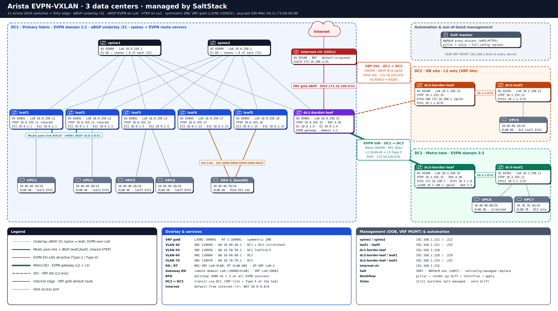
Arista EVPN-VXLAN 3-DC lab · github.com/ysudhakarbe/Arista-Spine-and-Leaf · editable source: Topology.drawio (diagrams.net)

