docs = sent_tokenize(original_text)

print("Documents:\n")

for i, document in enumerate(docs, 1):
print(f"D{i}: {document}")

print(
"\nTotal Number of Documents:",
len(docs)
)

OUTPUT:-
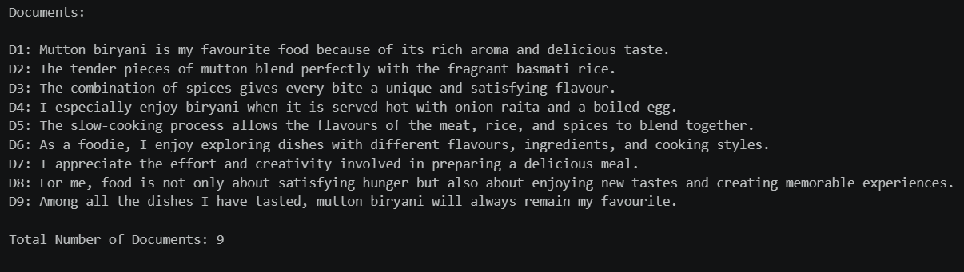

# Define the query
query = "delicious mutton biryani with rice and spices"
print("Query:\n")
print(query)
# Load English stop words
stop_words = set(
stopwords.words("english")
)

# Create the preprocessing function
def preprocess_text(text):

# Convert text to lowercase
text = text.lower()
# Remove punctuation

text = text.translate(
str.maketrans(
"",
"",
string.punctuation
)
)
# Tokenize the text

words = word_tokenize(text)

# Remove English stop words

filtered_words = [
word
for word in words
if word not in stop_words
]

# Join the processed words

processed_text = " ".join(
filtered_words
)

return processed_text

# Preprocess all documents

processed_docs = [
preprocess_text(document)
for document in docs
]

# Preprocess the query

processed_query = preprocess_text(
query
)

# Display processed documents

print("Processed Documents:\n")

for i, document in enumerate(
processed_docs,
1
):

print(
f"D{i}: {document}"
)

# Display processed query

print(
"\nProcessed Query:"
)

print(
processed_query
)

OUTPUT:-
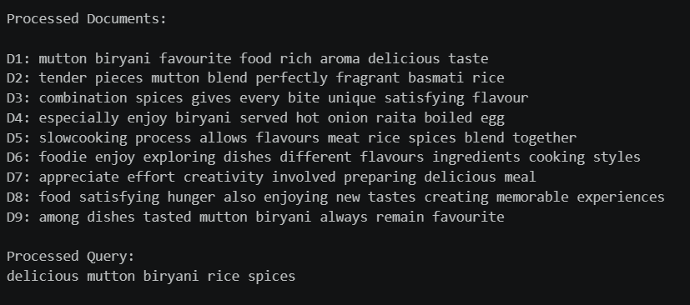

# Combine the processed documents and query

all_texts = processed_docs + [
processed_query
]

print(
"Number of Documents:",
len(processed_docs)
)

print(
"Total Texts Including Query:",
len(all_texts)
)

OUTPUT:-
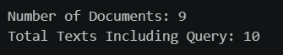

# Create the TF-IDF vectorizer

vectorizer = TfidfVectorizer()

# Calculate TF-IDF values

tfidf_matrix = vectorizer.fit_transform(all_texts)

# Convert the sparse matrix into an array

tfidf_array = tfidf_matrix.toarray()

# Get vocabulary terms

feature_names = (vectorizer.get_feature_names_out())

print( "TF-IDF Matrix Shape:",tfidf_array.shape)

print("Number of Vocabulary Terms:",len(feature_names))

OUTPUT:-
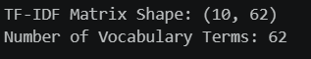

# Create a labelled TF-IDF table

tfidf_table = pd.DataFrame(
tfidf_array,
index=labels,
columns=feature_names
)

# Display the TF-IDF table

display(
tfidf_table.round(3)
)

OUTPUT:-
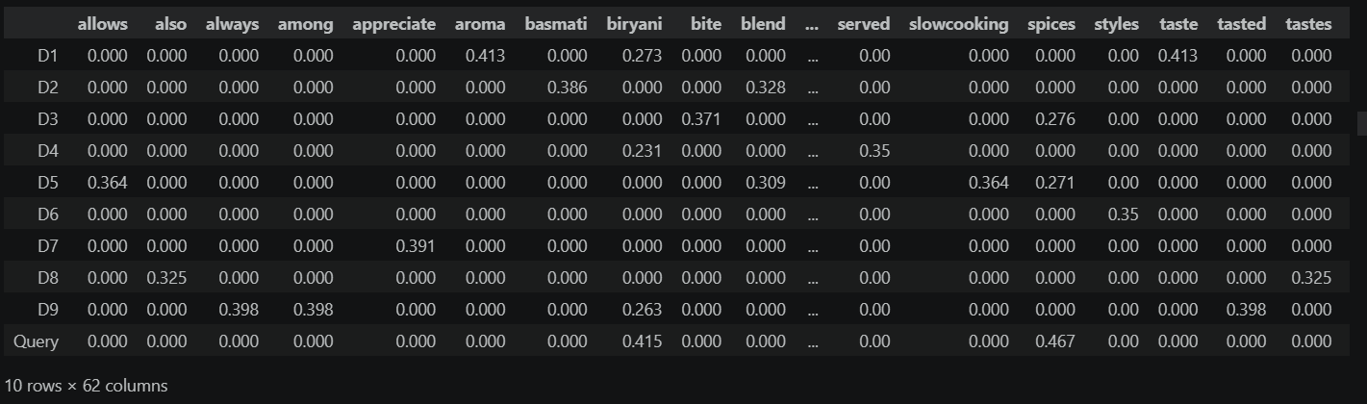
# Display only nonzero TF-IDF values

for i, label in enumerate(labels):

print(
f"\n{label} TF-IDF Scores:"
)

for term, score in zip(
feature_names,
tfidf_array[i]
):

if score > 0:

print(
f"{term}: {score:.3f}"
)

OUTPUT:-
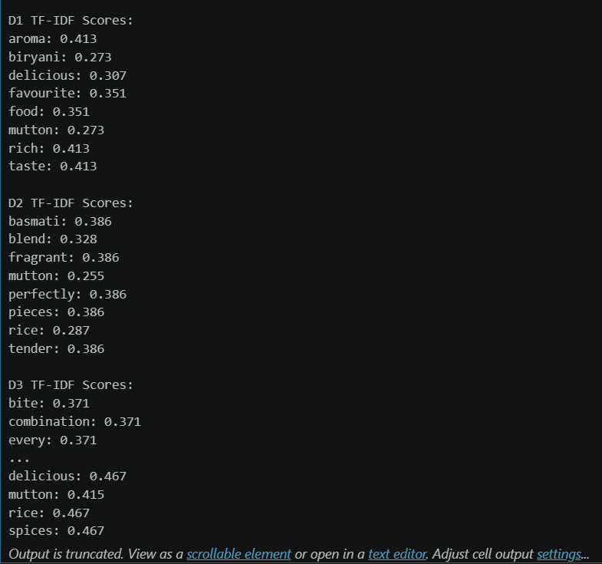

# Select all document vectors

doc_vectors = tfidf_array[:-1]

# Select the query vector

query_vector = (
tfidf_array[-1]
.reshape(
1,
-1
)
)

print(
"Document Vector Shape:",
doc_vectors.shape
)

print(
"Query Vector Shape:",
query_vector.shape
)

OUTPUT:-
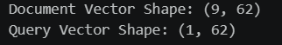

# Calculate cosine similarity

cos_sim = cosine_similarity(
doc_vectors,
query_vector
).flatten()

# Display cosine similarity values

print(
"Cosine Similarities:\n"
)

for i, similarity in enumerate(
cos_sim,
1
):

print(
f"D{i} vs Query: "
f"{similarity:.3f}"
)

OUTPUT:-
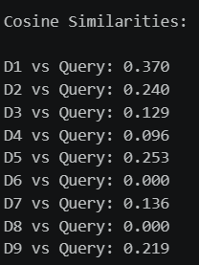
# Create the cosine-similarity table

similarity_table = pd.DataFrame({

"Document": labels[:-1],

"Original Sentence": docs,

"Cosine Similarity": cos_sim

})

# Display the table

display(
similarity_table.round(3)
)

OUTPUT:-
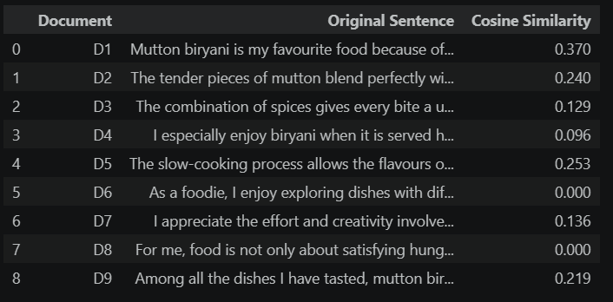

# Sort documents from highest to lowest similarity

sorted_similarity_table = (
similarity_table
.sort_values(
by="Cosine Similarity",
ascending=False
)
.reset_index(
drop=True
)
)

# Display sorted results

display(
sorted_similarity_table.round(3)
)

OUTPUT:-
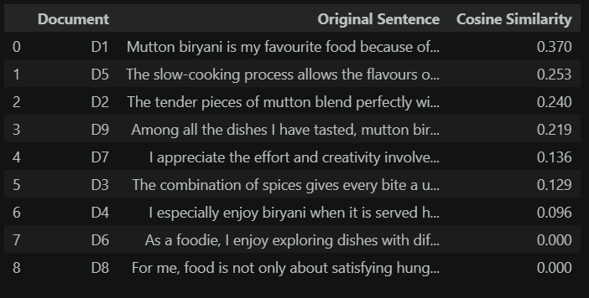

# Find the document with the highest score

most_similar_index = np.argmax(
cos_sim
)

# Get the highest cosine-similarity score

highest_similarity = cos_sim[
most_similar_index
]

print(
"Most Similar Document:\n"
)

print(
f"D{most_similar_index + 1}: "
f"{docs[most_similar_index]}"
)

print(
"\nCosine Similarity Score:",
round(
highest_similarity,
3
)
)
OUTPUT:-
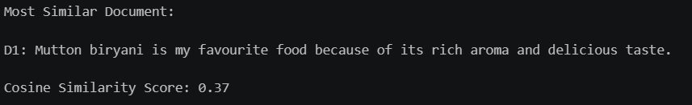

# Create the PCA model

pca = PCA(
n_components=2
)

# Convert the TF-IDF vectors into two dimensions

reduced_vectors = pca.fit_transform(
tfidf_array
)

# Display the PCA values

pca_table = pd.DataFrame(

reduced_vectors,

index=labels,

columns=[
"PCA Component 1",
"PCA Component 2"
]

)

display(
pca_table.round(3)
)

OUTPUT:-
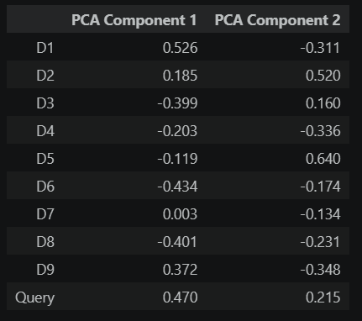
# Create the PCA graph

plt.figure(
figsize=(10, 7)
)

# Plot documents and query

for i, (x, y) in enumerate(
reduced_vectors
):

plt.scatter(
x,
y,
s=100,
label=labels[i]
)

plt.text(
x + 0.01,
y + 0.01,
labels[i],
fontsize=12
)

# Add graph details

plt.title(
"TF-IDF Vectors in 2D (PCA)"
)

plt.xlabel(
"PCA Component 1"
)

plt.ylabel(
"PCA Component 2"
)

plt.legend()

plt.grid(
True
)

# Save the graph

plt.savefig(

"Screenshots/07_tfidf_vectors_pca.png",

dpi=300,

bbox_inches="tight"

)

# Display the graph

plt.show()

OUTPUT:-
