FIT5032 Assessed Lab 4
HTML/Vue Form Validation and PrimeVue DataTable
Student | Yilian Sun
Student ID | [Student ID to be completed]
Project | FIT5032 Week 3 Library Vue application
This report records the implemented assessed lab work, source evidence, testing outcomes, and Git history for the Library Vue project.

eFolio Task 4.1
Activities 1-3 were completed in sequence: the original form was captured, HTML built-in validation was added, and the final implementation was converted to Vue custom validation.
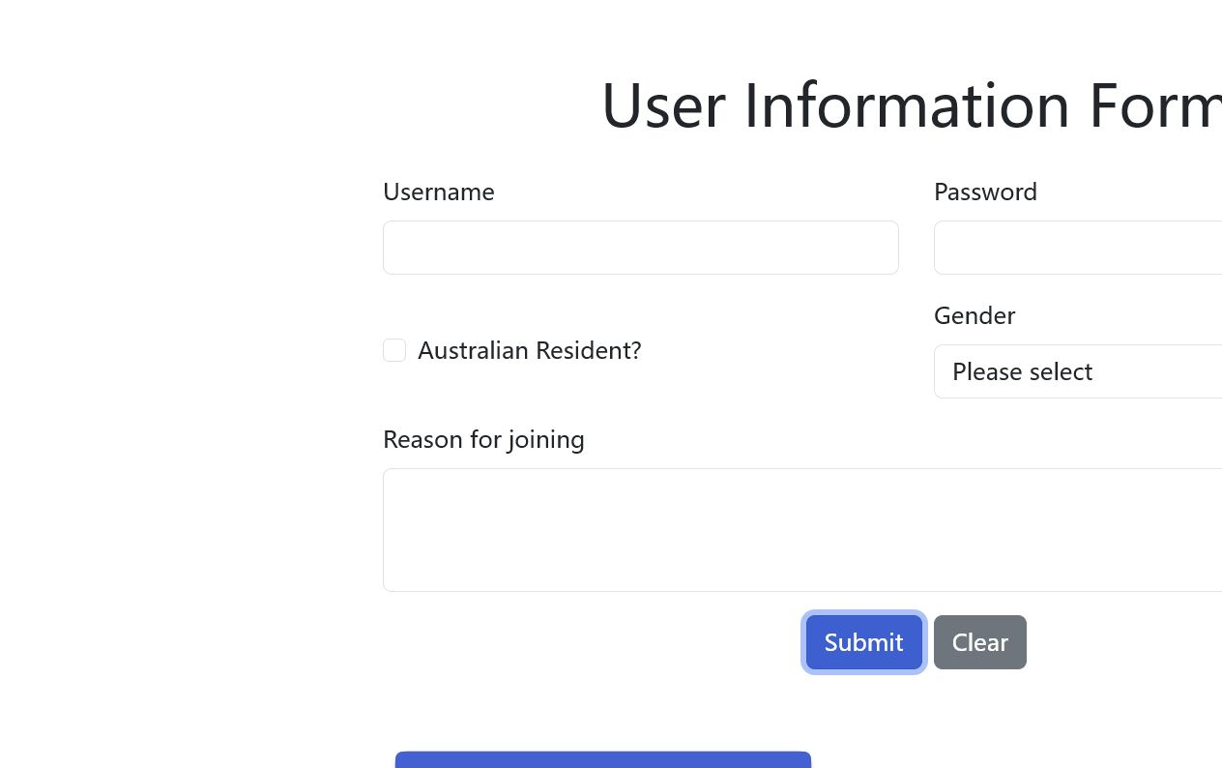
Figure 1. Original Week 3 form allows an empty submission and creates an empty card.
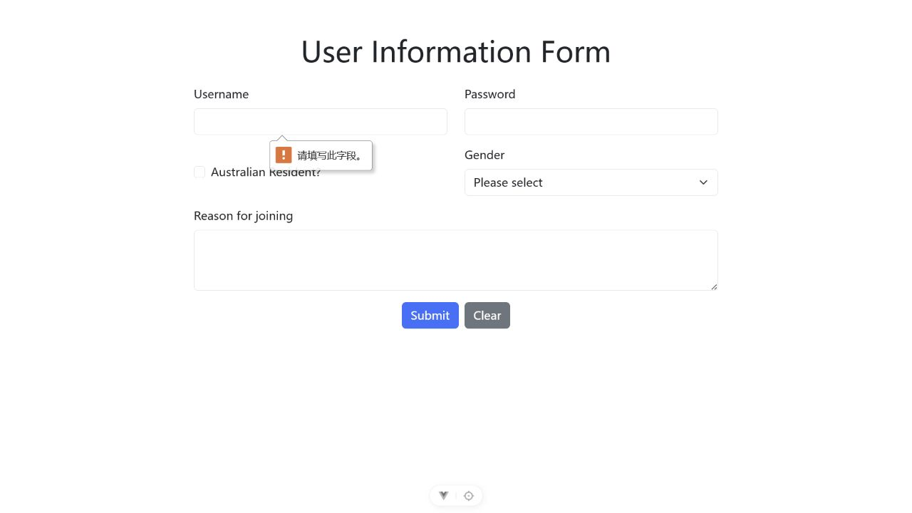
Figure 2. HTML built-in validation prevents submission when Username is empty.
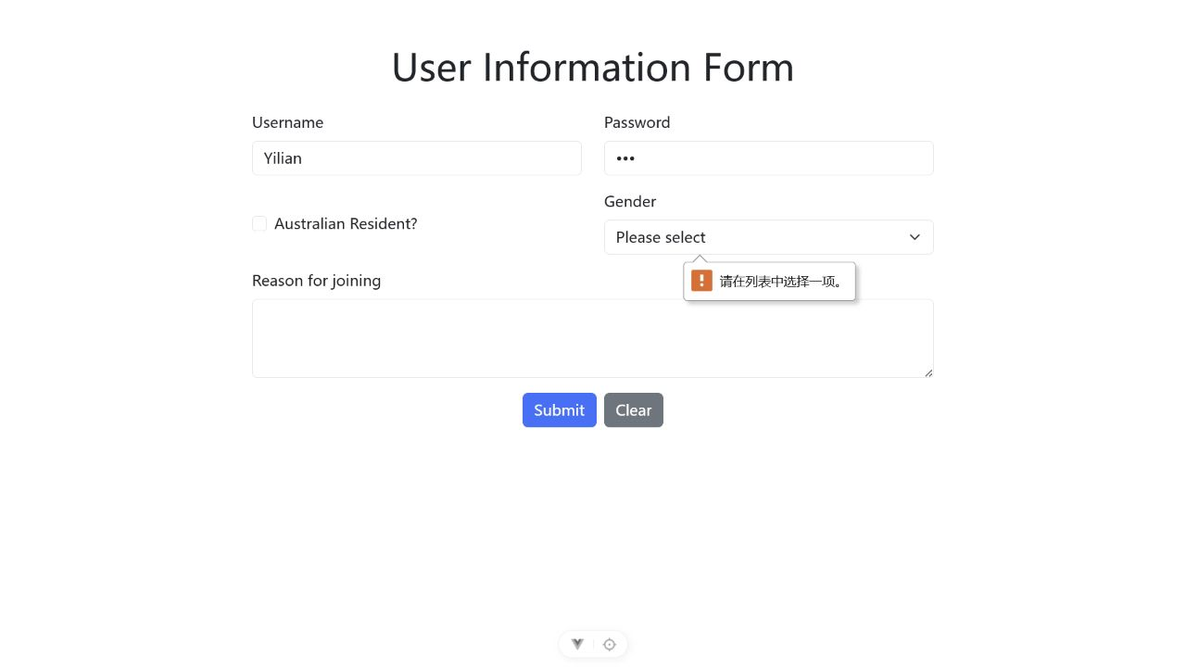
Figure 3. HTML built-in validation evidence for password length checking with password value 123.
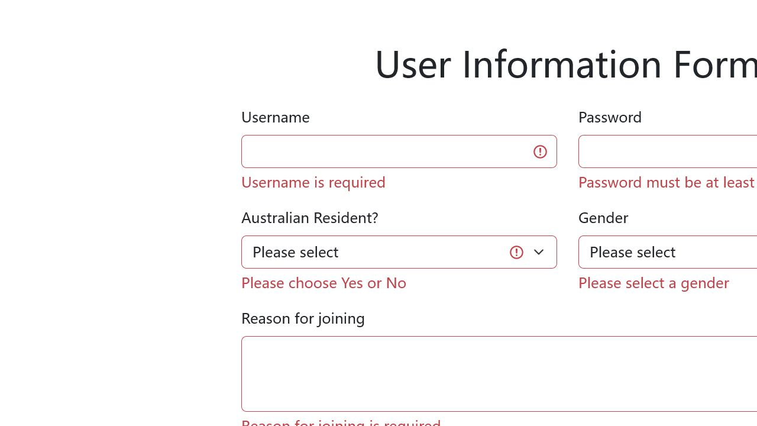
Figure 4. Vue validation prevents a missing username from being submitted.
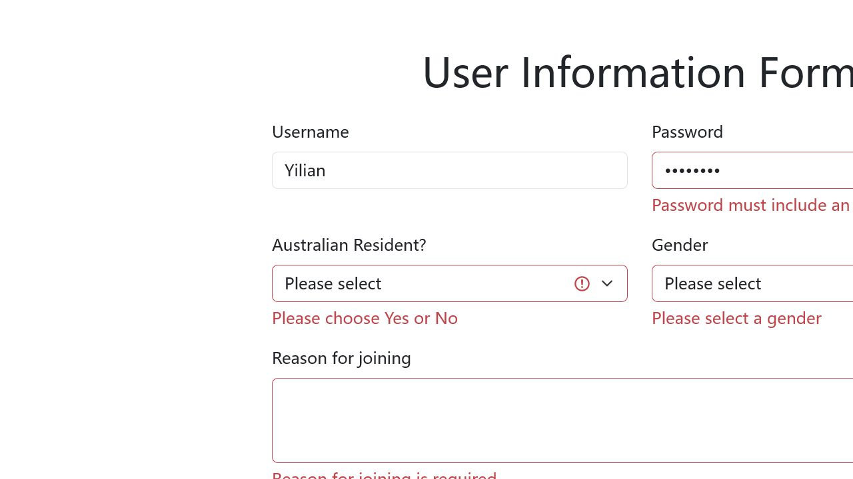
Figure 5. Vue password validation reports an invalid password and blocks submission.
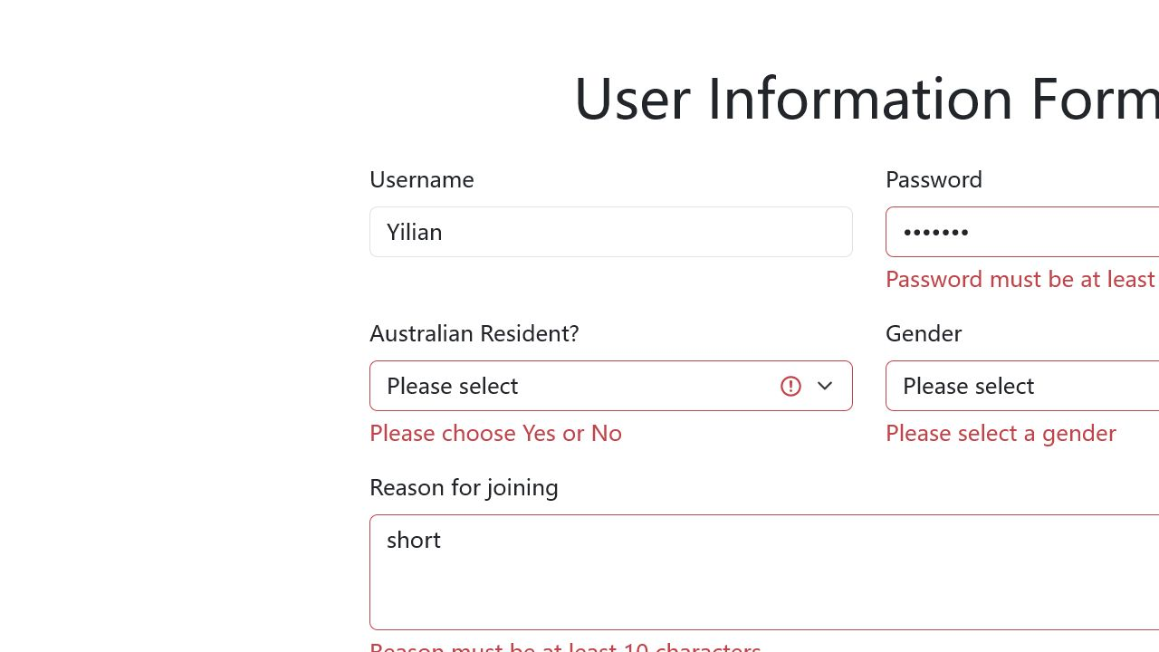
Figure 6. Vue validation displays additional Resident, Gender, and Reason errors.

eFolio Task 4.2
The final form implements five field-level validations and displays accepted records in a PrimeVue DataTable. Invalid data is blocked before it can enter the Card list or DataTable.
Field | Final validation rule
Username | Trimmed; required; at least 3 characters; spaces-only input rejected.
Password | At least 8 characters; includes uppercase, lowercase, number, and special character.
Australian Resident | User must explicitly choose Yes or No from a blank default select.
Gender | User must explicitly choose Male, Female, or Other from a blank default select.
Reason | Trimmed; required; 10 to 200 characters.
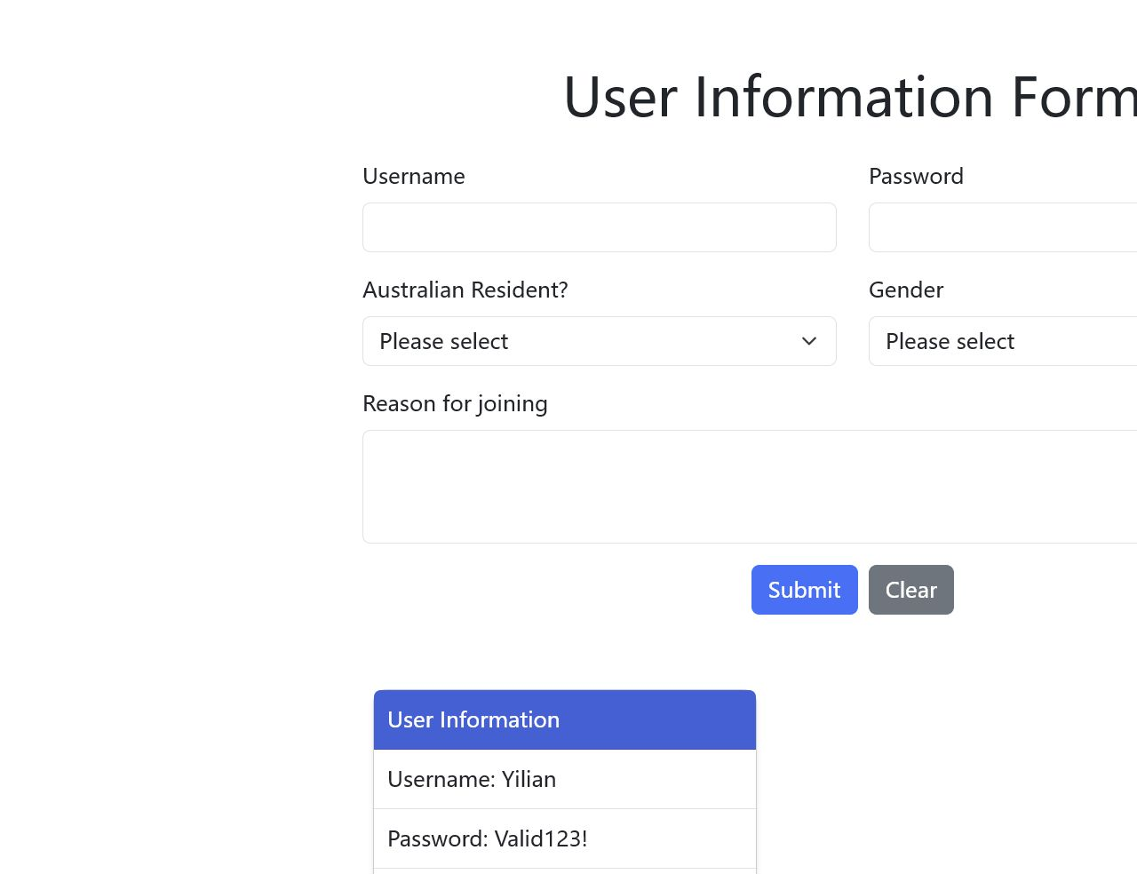
Figure 7. A valid record is accepted and displayed after passing all five validations.
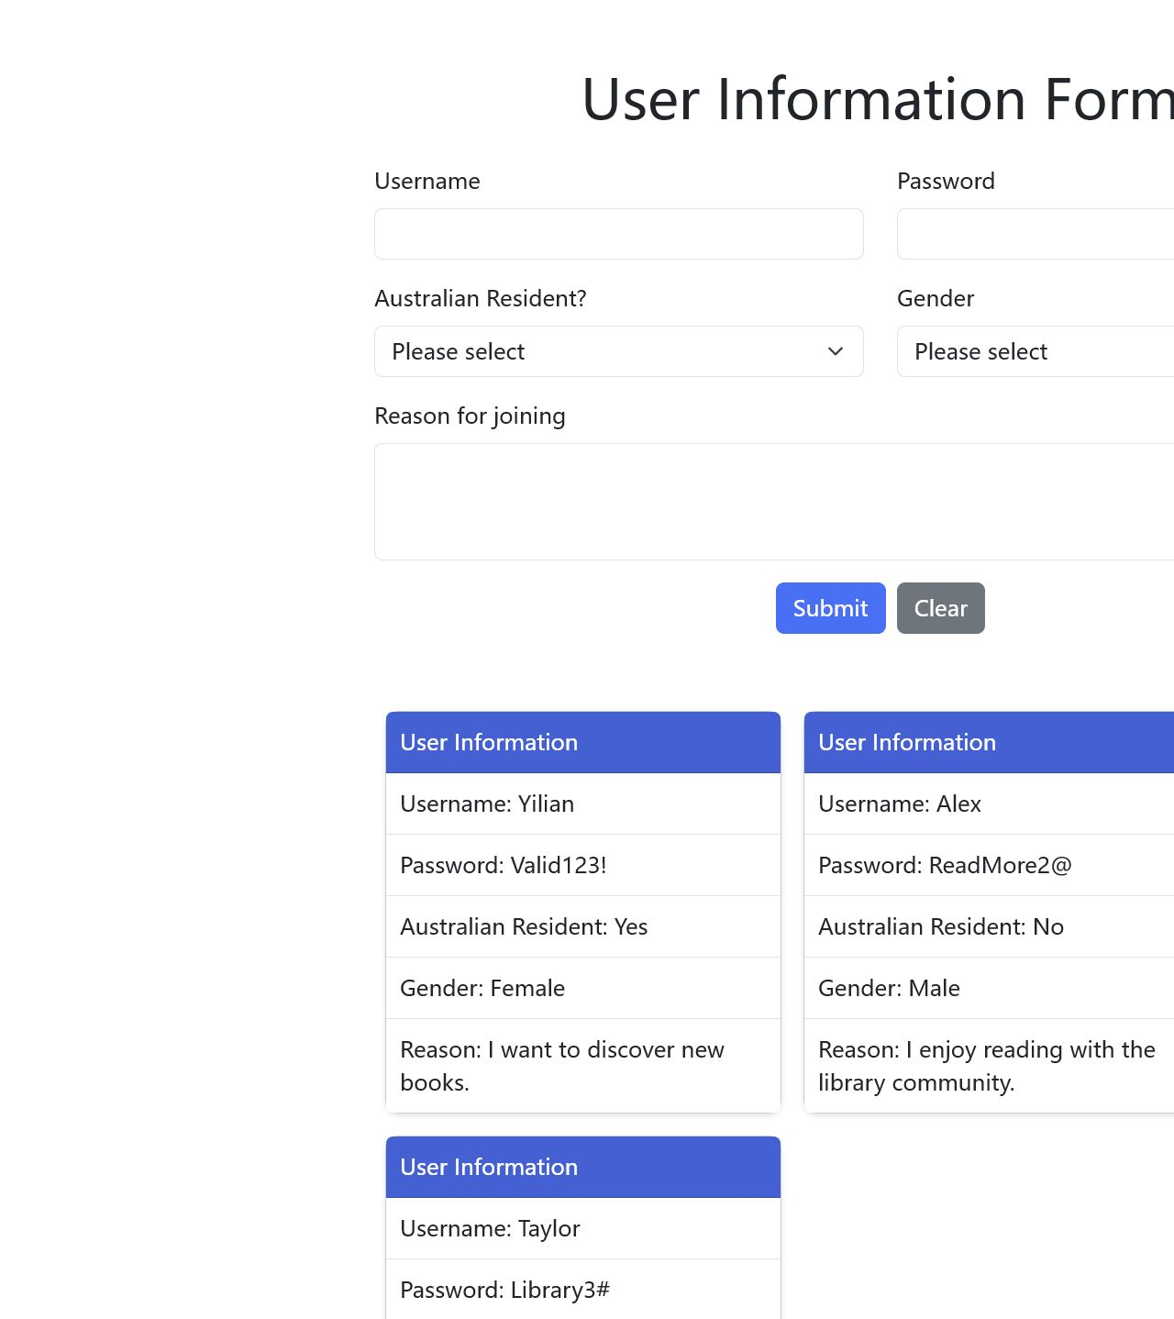
Figure 8. PrimeVue DataTable displays three valid submitted user records.
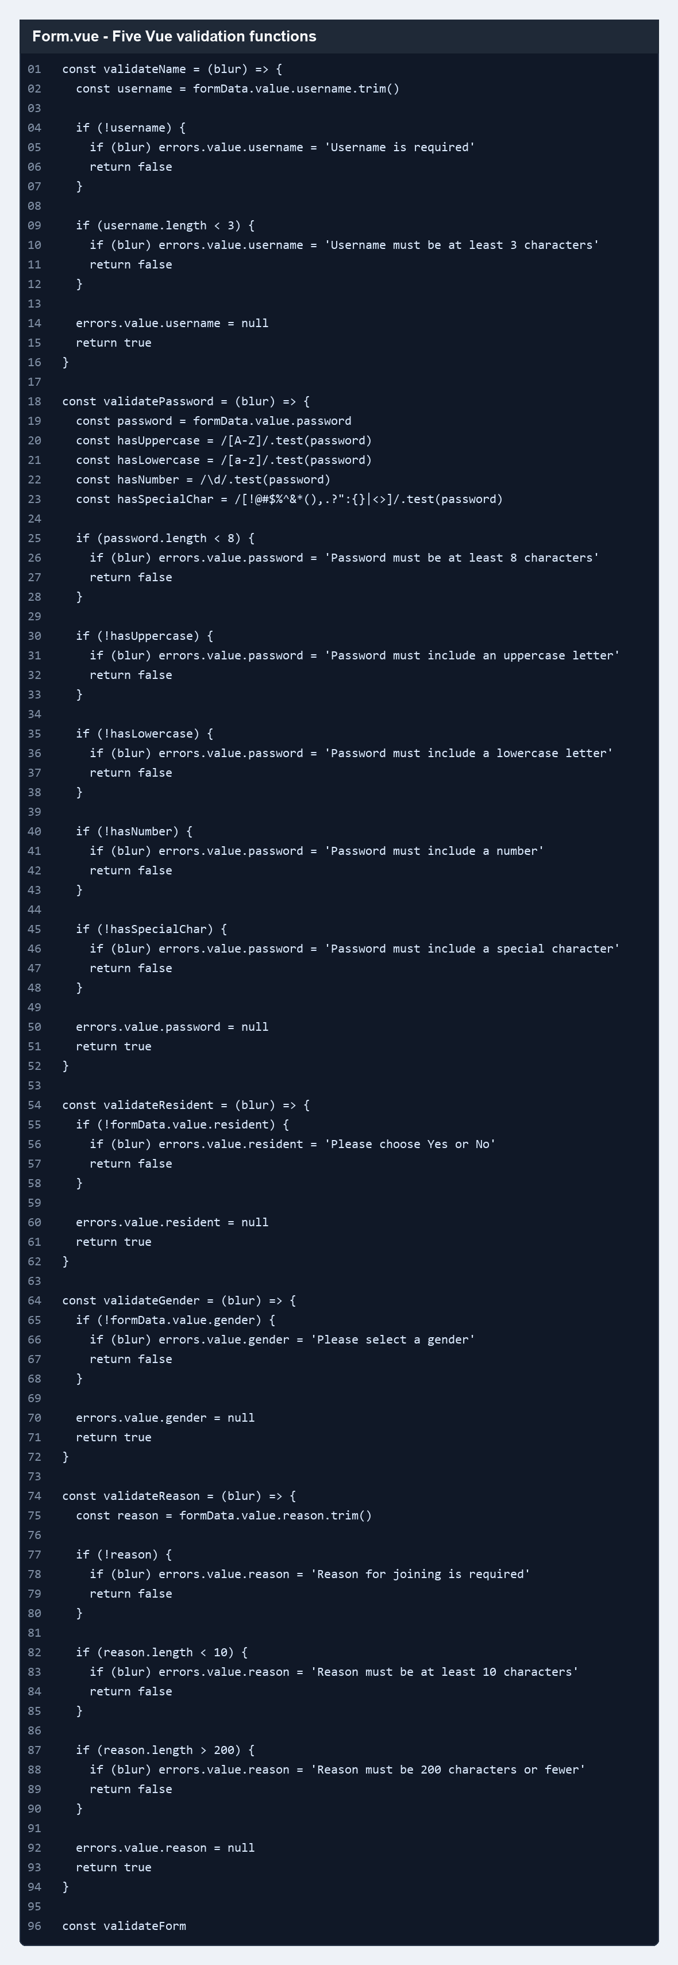
Figure 9. Source evidence for the five Vue validation functions.
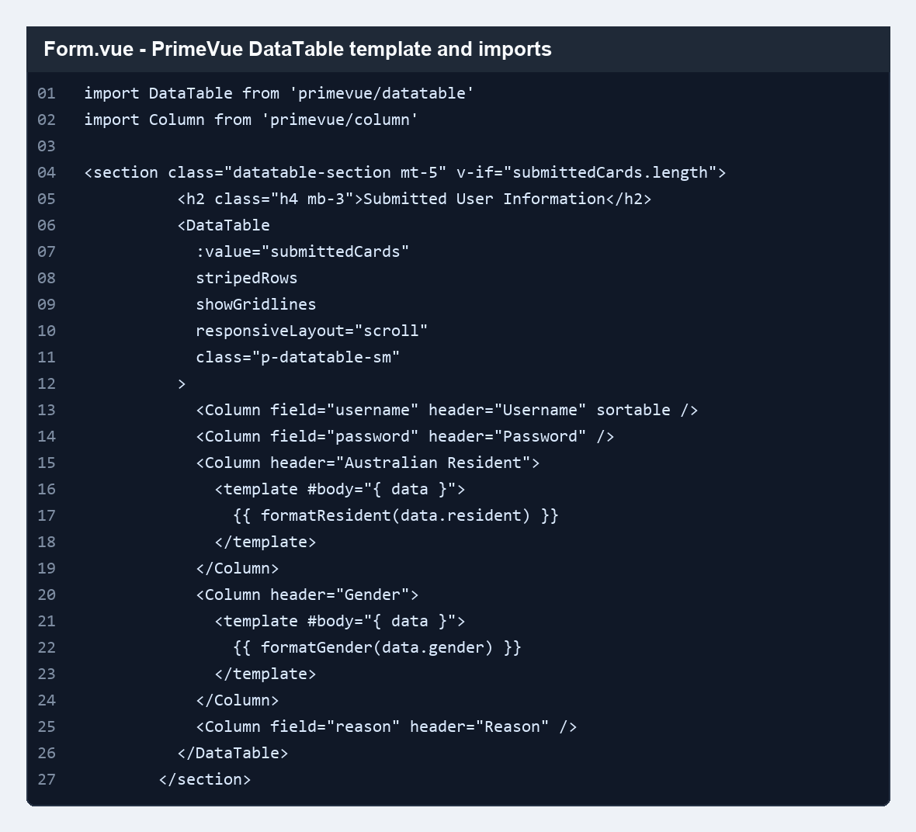
Figure 10. Source evidence for PrimeVue DataTable imports and template.
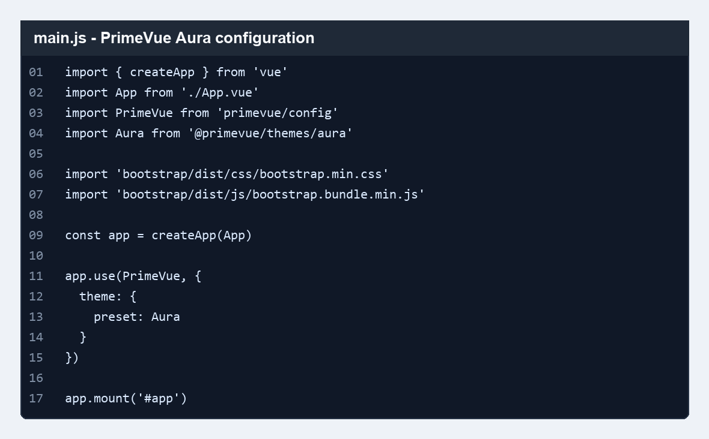
Figure 11. Source evidence for PrimeVue Aura configuration in main.js.
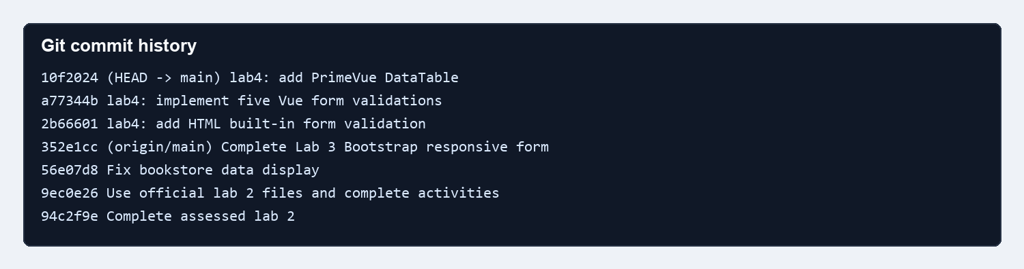
Figure 12. Git commit history showing staged assessed lab updates.

Testing Summary
Scenario | Result | Evidence
Original empty submission creates an empty card before validation | Pass | Figure 1
HTML required username blocks empty submit | Pass | Figure 2
HTML password length rule added and checked with value 123 | Pass | Figure 3
Vue empty/short username blocks submit | Pass | Figure 4
Vue password complexity blocks invalid passwords | Pass | Figure 5
Resident, Gender, and Reason extra validations block submit | Pass | Figure 6
Valid data submits successfully | Pass | Figure 7
Three valid submissions display as three DataTable rows | Pass | Figure 8
Browser console errors during DataTable capture | Pass - none observed | Browser automation log
npm run build | Pass | Vite production build completed successfully

Build and Git Summary
Build result: npm run build completed successfully after PrimeVue integration.
Git commits were created for HTML validation, Vue validation, and PrimeVue DataTable work. A final documentation commit will include this report and evidence.
Student action still required: fill in the Student ID placeholder, confirm tutor sharing on the private GitHub repository, and upload the final PDF to Moodle.

