FIT5032 Assessed Lab 5 Report
Library Vue Project
Student Name | Yilian Sun
Student Email | ysun0263@student.monash.edu
Project | ysun-library
Branch / Commit | lab5-complete / 7a2472d
Implementation Summary
This report documents the completed Lab 5 work for the Library Vue project. The implementation adds password confirmation validation, Vue DevTools evidence, Vue Router navigation, route protection, and a simple login/logout flow.
Requirement | Status | Evidence
Password confirmation | Pass | Confirm password field, mismatch validation, submit-time validation.
Vue DevTools | Pass | HomeView selected and formData expanded in Figure 2.
Vue Router | Pass | Home, About, Login, and Access Denied routes configured.
Route guard | Pass | Protected About route redirects unauthenticated users to Login.
Login/logout | Pass | Demo credentials student / fit5032; logout clears auth state.
Build | Pass | npm run build completed successfully; only bundle-size warning.
Task 5.1: Password Confirmation Validation
The form now includes a Confirm password field bound to formData.confirmPassword. Validation displays an error when the confirmation is empty or does not match the password. The check also runs during submit so invalid data cannot bypass blur validation.
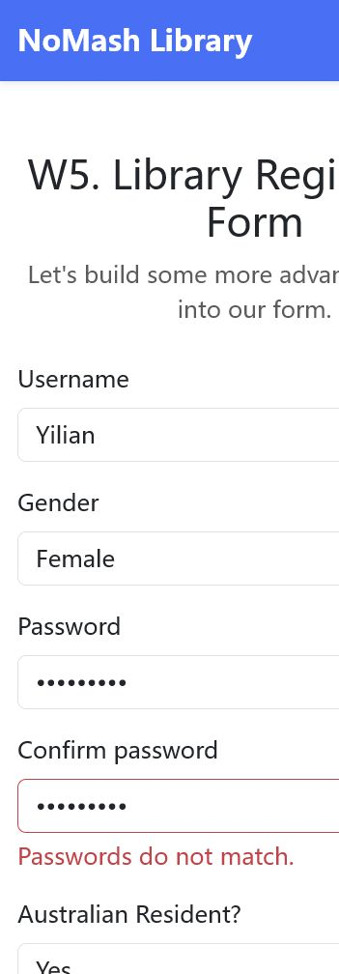
Figure 1. Password confirmation validation shows a mismatch error.
Task 5.1: Vue DevTools Evidence
Vue DevTools was opened while the application was running. The Components panel shows <HomeView> selected and formData expanded with the current form values.
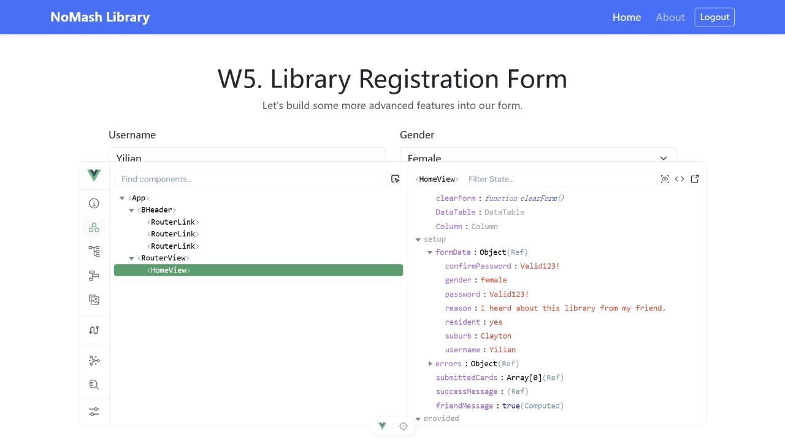
Figure 2. Vue DevTools shows HomeView selected with expanded formData.
Task 5.2: Vue Router and Protected Navigation
Vue Router was configured with Home, About, Login, and Access Denied views. The About route is protected with meta.requiresAuth and redirects unauthenticated users to Login with redirect and denied query parameters.
src/router/index.js
import { createRouter, createWebHistory } from 'vue-router'
import { isAuthenticated } from '../auth'
import HomeView from '../views/HomeView.vue'
import AboutView from '../views/AboutView.vue'
import LoginView from '../views/LoginView.vue'
import AccessDeniedView from '../views/AccessDeniedView.vue'
const routes = [
{
path: '/',
name: 'home',
component: HomeView
},
{
path: '/about',
name: 'about',
component: AboutView,
meta: {
requiresAuth: true
}
},
{
path: '/login',
name: 'login',
component: LoginView
},
{
path: '/access-denied',
name: 'access-denied',
component: AccessDeniedView
}
]
const router = createRouter({
history: createWebHistory(import.meta.env.BASE_URL),
routes
})
router.beforeEach((to) => {
if (to.meta.requiresAuth && !isAuthenticated.value) {
return {
name: 'login',
query: {
redirect: to.fullPath,
denied: '1'
}
}
}
if (to.name === 'login' && isAuthenticated.value) {
return { name: 'about' }
}
return true
})
export default router
src/App.vue
<template>
<div class="app-shell">
<BHeader />
<main class="container py-5">
<router-view />
</main>
</div>
</template>
<script setup>
import BHeader from './components/BHeader.vue'
</script>
<style>
body {
background-color: #f6f8fb;
}
.app-shell {
min-height: 100vh;
}
</style>
src/components/BHeader.vue
<template>
<header class="navbar navbar-expand-lg navbar-dark bg-primary shadow-sm">
<div class="container">
<router-link class="navbar-brand fw-semibold" to="/">
NoMash Library
</router-link>
<nav>
<ul class="navbar-nav flex-row gap-2 align-items-center">
<li class="nav-item">
<router-link class="nav-link" active-class="active" to="/">
Home
</router-link>
</li>
<li class="nav-item">
<router-link class="nav-link" active-class="active" to="/about">
About
</router-link>
</li>
<li v-if="!isAuthenticated" class="nav-item">
<router-link class="nav-link" active-class="active" to="/login">
Login
</router-link>
</li>
<li v-else class="nav-item">
<button class="btn btn-outline-light btn-sm" @click="handleLogout">
Logout
</button>
</li>
</ul>
</nav>
</div>
</header>
</template>
<script setup>
import { useRouter } from 'vue-router'
import { isAuthenticated, logout } from '../auth'
const router = useRouter()
const handleLogout = () => {
logout()
router.push('/login')
}
</script>
Key HomeView Implementation
The following excerpts show the main reactive state, computed friend message, confirmation password validation, submit handling, and PrimeVue DataTable evidence retained from Lab 4.
HomeView reactive state and computed message
import Column from 'primevue/column'
const emptyForm = () => ({
username: '',
password: '',
confirmPassword: '',
resident: '',
reason: '',
gender: '',
suburb: 'Clayton'
})
const emptyErrors = () => ({
username: null,
password: null,
confirmPassword: null,
resident: null,
gender: null,
reason: null
})
const formData = ref(emptyForm())
const errors = ref(emptyErrors())
const submittedCards = ref([])
const successMessage = ref('')
const friendMessage = computed(() =>
/\bfriend\b/i.test(formData.value.reason)
)
HomeView confirm password validation
const validateConfirmPassword = (blur = true) => {
if (!formData.value.confirmPassword) {
if (blur) errors.value.confirmPassword = 'Please confirm your password.'
return false
}
if (formData.value.confirmPassword !== formData.value.password) {
if (blur) errors.value.confirmPassword = 'Passwords do not match.'
return false
}
errors.value.confirmPassword = null
return true
}
const handlePasswordInput = () => {
validatePassword(false)
if (formData.value.confirmPassword || errors.value.confirmPassword) {
validateConfirmPassword(true)
}
}
const handleConfirmPasswordInput = () => {
if (errors.value.confirmPassword) {
validateConfirmPassword(true)
}
}
HomeView submit logic
const validateForm = () => {
const checks = [
validateName(true),
validatePassword(true),
validateConfirmPassword(true),
validateResident(true),
validateGender(true),
validateReason(true)
]
return checks.every(Boolean)
}
const submitForm = () => {
successMessage.value = ''
if (!validateForm()) return
submittedCards.value.push({
username: formData.value.username.trim(),
password: formData.value.password,
resident: formData.value.resident,
gender: formData.value.gender,
suburb: formData.value.suburb.trim() || 'Clayton',
reason: formData.value.reason.trim()
HomeView DataTable template
</div>
</div>
</div>
<section class="datatable-section mt-5" v-if="submittedCards.length">
<h2 class="h4 mb-3">Submitted User Information</h2>
<DataTable
:value="submittedCards"
stripedRows
showGridlines
responsiveLayout="scroll"
class="p-datatable-sm"
>
<Column field="username" header="Username" sortable />
<Column field="password" header="Password" />
<Column header="Australian Resident">
<template #body="{ data }">
{{ formatResident(data.resident) }}
</template>
</Column>
<Column header="Gender">
<template #body="{ data }">
{{ formatGender(data.gender) }}
</template>
</Column>
Browser Evidence
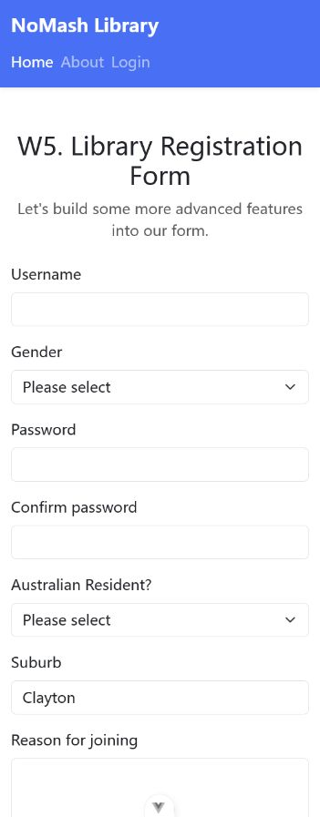
Figure 3. Home page loads successfully on localhost.

Figure 4. About page content after successful authentication.
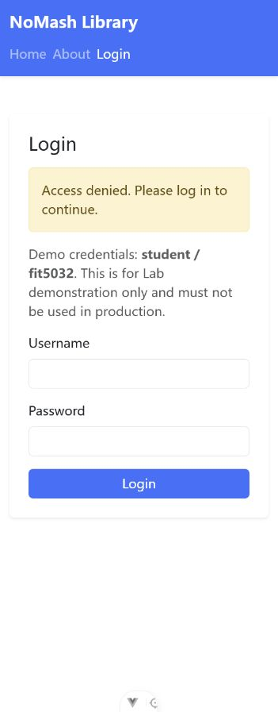
Figure 5. Unauthenticated About access redirects to Login.
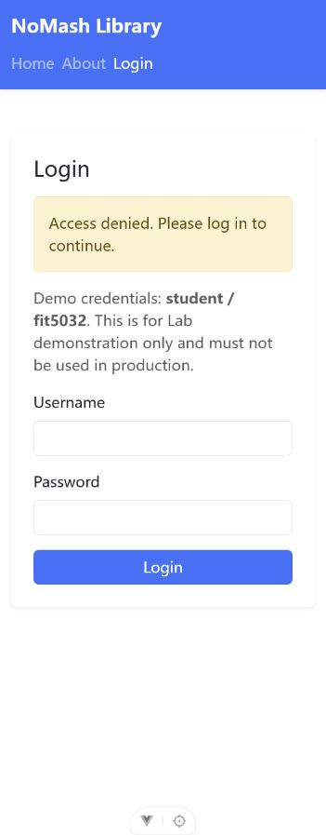
Figure 6. Login page shows access denied guidance.

Figure 7. Valid login reaches the protected About page.
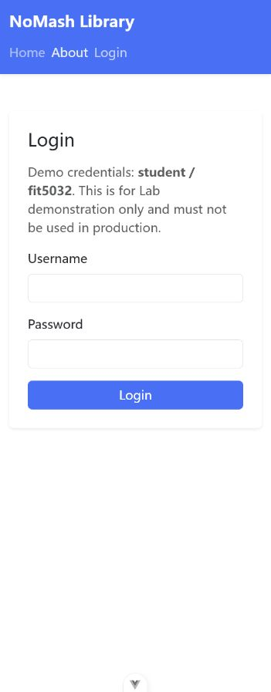
Figure 8. Logout returns the user to Login and clears authenticated navigation.
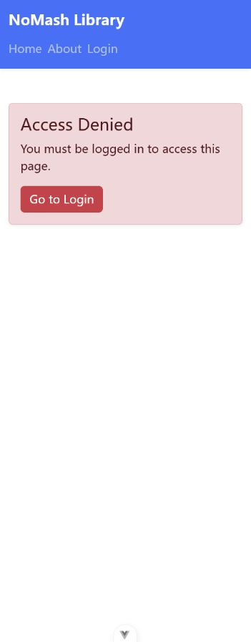
Figure 9. Access Denied route displays the protected-route warning.
Test Results
Test | Result | Notes
Password mismatch | Pass | Displayed Passwords do not match.
Empty confirm password submit | Pass | Displayed Please confirm your password.
Reason includes friend | Pass | Displayed Great to have a friend in green text.
Clear form | Pass | Reset fields, errors, success message, and suburb default.
Unauthenticated About | Pass | Redirected to /login?redirect=/about&denied=1.
Valid login | Pass | student / fit5032 navigated to /about.
Logout | Pass | Authentication state cleared and About became protected again.
Build | Pass | npm run build completed with no blocking errors.
Conclusion
All Lab 5 requested features have been implemented and verified. The report includes the required Vue DevTools evidence, route protection screenshots, and the key source code used to complete the lab.

