AI Strategy & Governance
The AI Strategy & Governance page should position governance not as compliance overhead, but as the strategic foundation that allows enterprises to scale AI confidently, responsibly, and sustainably.
Rethinking enterprise transformation
AI has increasingly become a “suitcase word” inside enterprises — a broad label used to describe everything from automation and copilots to analytics, generative AI, intelligent workflows, orchestration platforms, and strategic reinvention itself. The challenge is not merely technological complexity. The deeper challenge is conceptual fragmentation. Organizations frequently pursue disconnected modernization initiatives without a coherent transformation philosophy linking governance, operating models, workforce adaptation, observability, execution discipline, and long-term capability evolution together.
As enterprises move across the AI Continuum — from isolated experimentation toward enterprise-scale orchestration — they often discover that transformation maturity is determined less by the sophistication of individual tools and more by the organization’s ability to integrate intelligence, governance, decision-making, adaptability, and execution across the enterprise ecosystem itself. This is where the Constraint-to-Value Lens becomes strategically important. Many transformation barriers are invisible at first: fragmented ownership structures, weak observability, excessive cognitive load, implementation barriers, unclear accountability, poor integration maturity, governance ambiguity, and identity transition resistance.
The Triple Digital Revolution is accelerating this pressure simultaneously across intelligence, connectivity, and organizational adaptation. Enterprises are not simply adopting new technologies; they are entering an environment where decision velocity, workflow complexity, and human-AI interaction models continuously evolve. Traditional stack-centric modernization approaches increasingly struggle in such environments. Sustainable transformation increasingly requires flow-centric thinking where User Flow, Data Flow, Control Flow, Security Flow, and Governance & Observability Flow evolve together as interconnected enterprise systems.
This shift creates the need for layered enterprise architectures rather than isolated tool architectures. AI systems, governance models, workflow orchestration, adaptive algorithms, observability frameworks, operational controls, and human decision structures must evolve together. Shannon’s Reliability Principle becomes increasingly relevant in environments where system reliability, trust, resilience, and governance confidence directly impact enterprise adoption. Similarly, the Six Signals perspective helps organizations distinguish operational noise from transformation-relevant intelligence.
Modern transformation also requires new approaches to executive thinking. SEE-THINK-ACT leadership concepts, signal-to-noise leadership, catalytic questioning, and intellectual sovereignty become increasingly important in environments where hype cycles evolve faster than organizational adaptation. Enterprises frequently become trapped in reactive experimentation rather than disciplined AI frontier portfolio thinking. The organizations that scale successfully are often those capable of combining strategic patience with adaptive execution.
The 3i model, the Five Dimensions of Integration, and the Five Innovation Questions collectively highlight that enterprise transformation is not purely technical. It is integrative, behavioral, operational, governance-driven, and deeply organizational. The Problem-Solution Novelty Matrix and Innovation Funnel help enterprises decide where experimentation is appropriate, where standardization is required, and where scalable operating discipline becomes essential.
Transformation also changes people, not just processes. The 3W framework — Work, Workers, and Workplace — becomes increasingly important as AI reshapes role boundaries, workflows, authority structures, and organizational expectations. STAIR, OPEN, and RISE/FADE thinking provide practical lenses for redesigning workflows, decision participation, human-AI collaboration, and capability evolution. Identity transition thinking becomes essential because workforce resistance often emerges not from technology rejection, but from uncertainty around professional identity, decision authority, and long-term relevance.
Organizations increasingly recognize that human-AI fit design principles matter as much as technical capability. Johnson’s distinction between human-complementary and human-displacing AI becomes strategically important in workforce-sensitive environments. Gupta’s fairness audit thinking strengthens governance maturity around trust, transparency, and responsible scaling. Leist’s governance stack and Bartel’s alignment-versus-autonomy principle become increasingly relevant as enterprises move from assistive AI toward semi-autonomous and agentic ecosystems.
Emerging evidence around AI’s paradoxical productivity effects also introduces an important executive consideration. AI can improve speed while simultaneously weakening critical thinking, contextual reasoning, organizational learning, or governance discipline if human-AI collaboration is poorly designed. This creates the need for adaptive operating systems where augmentation, oversight, reliability, governance, and organizational learning evolve together rather than independently.
The organizations likely to create durable advantage over the next decade are not necessarily those deploying the largest number of AI tools. They are more likely to be the organizations capable of redesigning how intelligence, governance, execution, adaptability, observability, and human judgment move across the enterprise itself.
The ascAInd point of view
ascAInd approaches transformation as an enterprise capability evolution journey rather than a collection of disconnected AI initiatives. The focus is not merely deploying automation, copilots, orchestration platforms, or intelligent workflows. The objective is helping enterprises build governance-aware, adaptive, human-centered, flow-centric transformation systems capable of scaling sustainably across strategy, operations, workforce, governance, architecture, and execution.
This creates a transformation conversation operating at a fundamentally different level. Instead of discussing only tools, the focus shifts toward orchestration maturity, governance confidence, observability, adaptive operating models, enterprise integration, workforce evolution, human-AI collaboration, and long-term transformation resilience.

AI Strategy & Governance
Establish enterprise AI strategy, governance frameworks, risk controls, and operating models for scalable and responsible adoption.

PAGE POSITIONING
AI governance should not slow innovation. Done well, it creates the confidence, control, and visibility needed to scale AI across the enterprise.

The strategic challenge
Many organizations are experimenting with copilots, GenAI tools, automation agents, AI assistants, and analytics platforms, but governance often lags behind adoption. This creates a familiar pattern: promising pilots, unclear ownership, inconsistent risk controls, fragmented policies, limited observability, and executive uncertainty about what can safely scale.
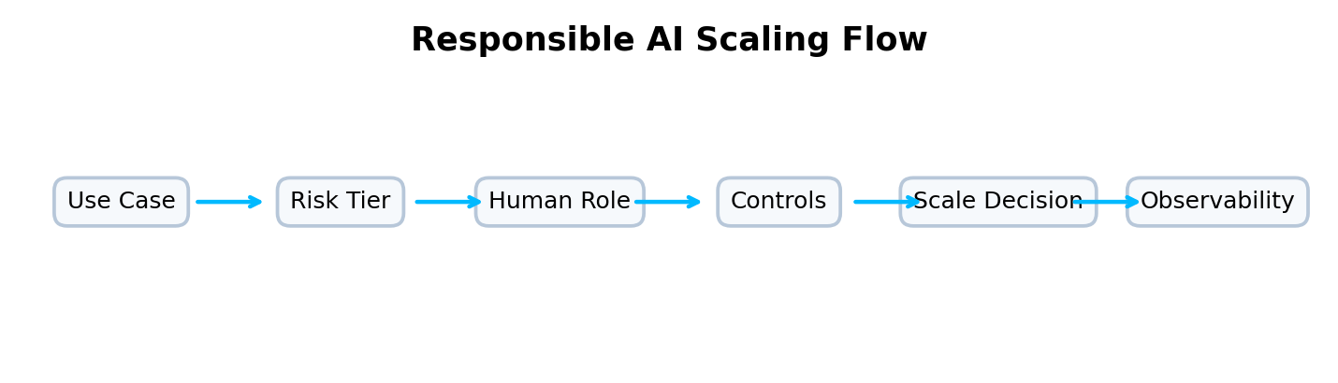
How ascAInd approaches this offering
ascAInd’s AI Strategy & Governance offering helps organizations create a responsible AI operating system. It links enterprise strategy, use-case prioritization, risk classification, human oversight, governance cadence, lifecycle controls, and value measurement. The work is informed by ideas such as human-complementary AI, fairness audit thinking, layered governance stacks, alignment-versus-autonomy principles, and signal-to-noise leadership. These concepts are not presented as theory; they shape how the enterprise decides what AI should do, what humans must retain, and how autonomy should be governed.
A webpage story, not a framework list
This page should not present frameworks as a laundry list. The intellectual depth should appear through the story: why organizations struggle, how value flows across the enterprise, where governance creates confidence, how humans and AI collaborate, and how leaders move from fragmented initiatives to scalable execution.
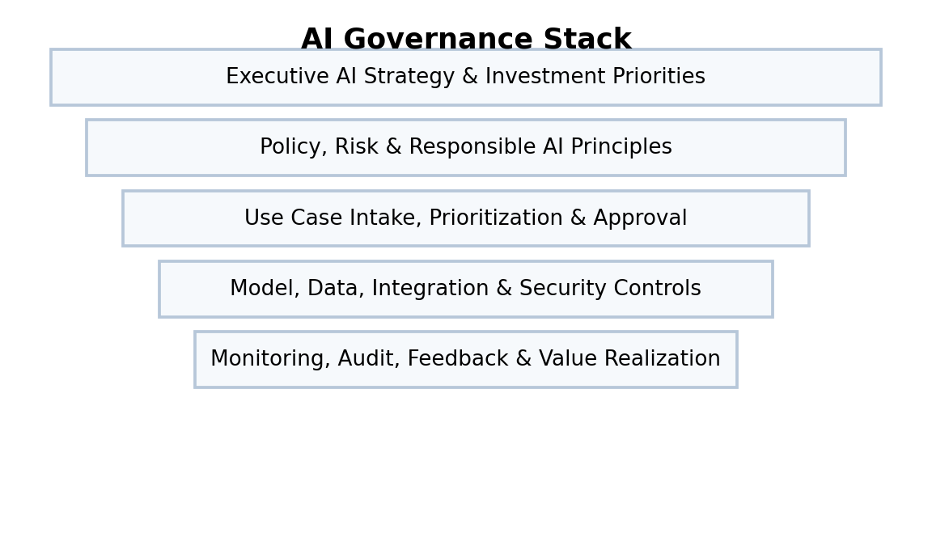
What the webpage should make clear
This offering is for leadership teams that want AI adoption to scale responsibly. The page should communicate that governance is not a compliance afterthought, but a strategic capability that enables confidence, trust, and repeatable adoption.
How the thinking comes together
The AI continuum helps place initiatives by maturity and autonomy. Johnson’s distinction between human-complementary and human-displacing AI helps shape workforce and ethical choices. Gupta’s fairness audit thinking strengthens bias and impact evaluation. Leist-style governance layering makes accountability visible. Bartel’s alignment-versus-autonomy principle helps decide how much independence AI systems should receive in different contexts.
What clients experience
Clients should see a practical path to AI governance maturity: intake, prioritization, risk tiering, control design, oversight, observability, and executive reporting. The page should generate confidence that ascAInd can help organizations scale AI without losing control.
Website section blocks / content modules
AI Strategy Blueprint  Define enterprise AI ambition, strategic priorities, investment themes, and adoption pathways. | Governance Operating Model  Clarify decision rights, forums, ownership, policies, and escalation mechanisms. | Risk & Control Framework  Classify use cases by risk and apply proportionate controls across the AI lifecycle.
Human Oversight Design  Define where humans approve, supervise, intervene, or remain accountable. | Responsible Scaling  Move validated AI use cases from pilots to repeatable enterprise adoption. | Observability & Assurance  Track performance, risk, adoption, fairness, and business value over time.

INTENDED READER IMPRESSION
The page should position ascAInd as a governance-aware AI strategy partner that helps enterprises scale AI with confidence.

Suggested webpage flow
Hero  A premium opening statement that clearly defines the offering and the strategic promise. | Challenge  A concise but compelling articulation of the client problem.
Transformation Point of View  A narrative section that shows how ascAInd thinks differently. | Visual Model  A flow, layered architecture, maturity model, or operating system diagram.
Capability Blocks  Six to eight visually balanced cards explaining the offering components. | Executive Outcome  A closing section that communicates confidence, value, and enterprise readiness.

