Enterprise Transformation Strategy
The enterprise transformation page should establish ascAInd as a transformation architect capable of helping organizations move from fragmented modernization initiatives toward governance-aware, adaptive, enterprise-scale transformation systems.
Rethinking enterprise transformation
AI has increasingly become a “suitcase word” inside enterprises — a broad label used to describe everything from automation and copilots to analytics, generative AI, intelligent workflows, orchestration platforms, and strategic reinvention itself. The challenge is not merely technological complexity. The deeper challenge is conceptual fragmentation. Organizations frequently pursue disconnected modernization initiatives without a coherent transformation philosophy linking governance, operating models, workforce adaptation, observability, execution discipline, and long-term capability evolution together.
As enterprises move across the AI Continuum — from isolated experimentation toward enterprise-scale orchestration — they often discover that transformation maturity is determined less by the sophistication of individual tools and more by the organization’s ability to integrate intelligence, governance, decision-making, adaptability, and execution across the enterprise ecosystem itself. This is where the Constraint-to-Value Lens becomes strategically important. Many transformation barriers are invisible at first: fragmented ownership structures, weak observability, excessive cognitive load, implementation barriers, unclear accountability, poor integration maturity, governance ambiguity, and identity transition resistance.
The Triple Digital Revolution is accelerating this pressure simultaneously across intelligence, connectivity, and organizational adaptation. Enterprises are not simply adopting new technologies; they are entering an environment where decision velocity, workflow complexity, and human-AI interaction models continuously evolve. Traditional stack-centric modernization approaches increasingly struggle in such environments. Sustainable transformation increasingly requires flow-centric thinking where User Flow, Data Flow, Control Flow, Security Flow, and Governance & Observability Flow evolve together as interconnected enterprise systems.
This shift creates the need for layered enterprise architectures rather than isolated tool architectures. AI systems, governance models, workflow orchestration, adaptive algorithms, observability frameworks, operational controls, and human decision structures must evolve together. Shannon’s Reliability Principle becomes increasingly relevant in environments where system reliability, trust, resilience, and governance confidence directly impact enterprise adoption. Similarly, the Six Signals perspective helps organizations distinguish operational noise from transformation-relevant intelligence.
Modern transformation also requires new approaches to executive thinking. SEE-THINK-ACT leadership concepts, signal-to-noise leadership, catalytic questioning, and intellectual sovereignty become increasingly important in environments where hype cycles evolve faster than organizational adaptation. Enterprises frequently become trapped in reactive experimentation rather than disciplined AI frontier portfolio thinking. The organizations that scale successfully are often those capable of combining strategic patience with adaptive execution.
The 3i model, the Five Dimensions of Integration, and the Five Innovation Questions collectively highlight that enterprise transformation is not purely technical. It is integrative, behavioral, operational, governance-driven, and deeply organizational. The Problem-Solution Novelty Matrix and Innovation Funnel help enterprises decide where experimentation is appropriate, where standardization is required, and where scalable operating discipline becomes essential.
Transformation also changes people, not just processes. The 3W framework — Work, Workers, and Workplace — becomes increasingly important as AI reshapes role boundaries, workflows, authority structures, and organizational expectations. STAIR, OPEN, and RISE/FADE thinking provide practical lenses for redesigning workflows, decision participation, human-AI collaboration, and capability evolution. Identity transition thinking becomes essential because workforce resistance often emerges not from technology rejection, but from uncertainty around professional identity, decision authority, and long-term relevance.
Organizations increasingly recognize that human-AI fit design principles matter as much as technical capability. Johnson’s distinction between human-complementary and human-displacing AI becomes strategically important in workforce-sensitive environments. Gupta’s fairness audit thinking strengthens governance maturity around trust, transparency, and responsible scaling. Leist’s governance stack and Bartel’s alignment-versus-autonomy principle become increasingly relevant as enterprises move from assistive AI toward semi-autonomous and agentic ecosystems.
Emerging evidence around AI’s paradoxical productivity effects also introduces an important executive consideration. AI can improve speed while simultaneously weakening critical thinking, contextual reasoning, organizational learning, or governance discipline if human-AI collaboration is poorly designed. This creates the need for adaptive operating systems where augmentation, oversight, reliability, governance, and organizational learning evolve together rather than independently.
The organizations likely to create durable advantage over the next decade are not necessarily those deploying the largest number of AI tools. They are more likely to be the organizations capable of redesigning how intelligence, governance, execution, adaptability, observability, and human judgment move across the enterprise itself.
The ascAInd point of view
ascAInd approaches transformation as an enterprise capability evolution journey rather than a collection of disconnected AI initiatives. The focus is not merely deploying automation, copilots, orchestration platforms, or intelligent workflows. The objective is helping enterprises build governance-aware, adaptive, human-centered, flow-centric transformation systems capable of scaling sustainably across strategy, operations, workforce, governance, architecture, and execution.
This creates a transformation conversation operating at a fundamentally different level. Instead of discussing only tools, the focus shifts toward orchestration maturity, governance confidence, observability, adaptive operating models, enterprise integration, workforce evolution, human-AI collaboration, and long-term transformation resilience.

Enterprise Transformation Strategy
Define the enterprise transformation direction, prioritize high-impact initiatives, and build an AI-first roadmap aligned to measurable business outcomes.

PAGE POSITIONING
Transformation is no longer a sequence of technology projects. It is an enterprise-wide redesign of how value moves through strategy, operations, people, data, governance, and execution.

The strategic challenge
Many organizations begin with AI pilots, automation ideas, or platform investments, but the work remains fragmented. Business leaders see activity, but not always momentum. Technology teams see tools, but not always enterprise alignment. Employees see change, but not always clarity. The real challenge is not whether the enterprise can start transformation. The harder question is whether it can scale transformation with discipline, confidence, and measurable outcomes.
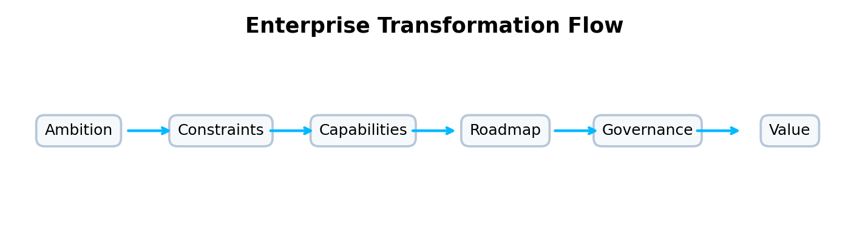
How ascAInd approaches this offering
ascAInd’s Enterprise Transformation Strategy offering helps leadership teams move from scattered initiatives to a clear transformation system. The approach looks across the AI continuum, from early experimentation to enterprise-scale adoption, and uses a constraint-to-value lens to identify where transformation is blocked: decision flows, operating models, governance, capability maturity, workforce readiness, data foundations, or execution capacity. Rather than treating strategy as a slide exercise, the work converts strategic ambition into a practical transformation architecture.
A webpage story, not a framework list
This page should not present frameworks as a laundry list. The intellectual depth should appear through the story: why organizations struggle, how value flows across the enterprise, where governance creates confidence, how humans and AI collaborate, and how leaders move from fragmented initiatives to scalable execution.
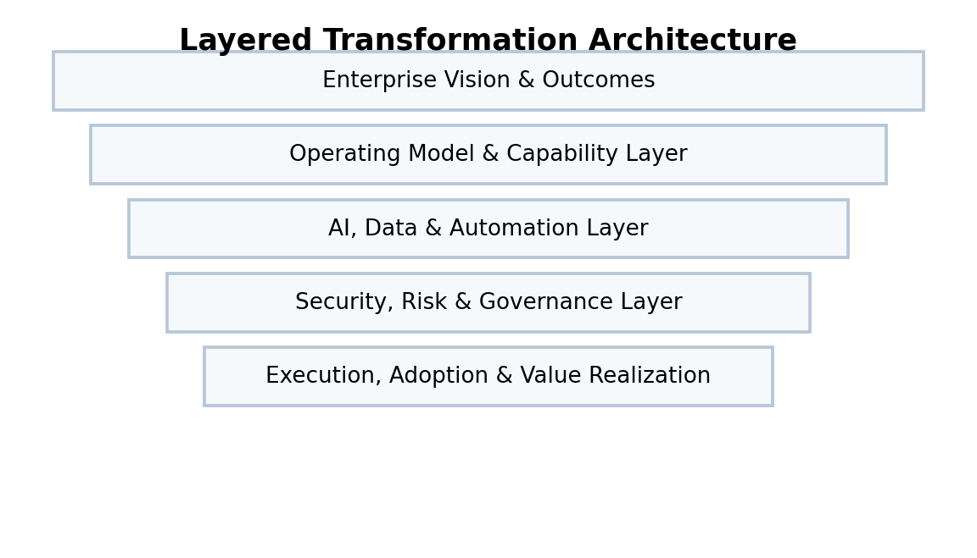
What the webpage should make clear
This offering is designed for organizations that need transformation clarity, portfolio discipline, and an executable AI-first roadmap. It connects business ambition with operating model design, enterprise architecture, governance, and measurable value realization.
How the thinking comes together
The approach naturally blends course-based and enterprise concepts without turning the page into an academic framework library. The 3W view ensures that transformation is evaluated across Work, Workers, and Workplace. SEE-THINK-ACT thinking helps leaders separate noise from strategic signals. The Constraint-to-Value lens converts barriers into execution priorities. Flow Thinking ensures the roadmap is not tool-led, but designed around user, data, control, security, and governance flows.
What clients experience
Clients should experience this as an executive transformation page: strategic, visual, structured, and confidence-building. The reader should feel that ascAInd can help them translate AI ambition into a sequenced roadmap, governance model, investment logic, and enterprise transformation rhythm.
Website section blocks / content modules
Transformation North Star  Define the ambition, business outcomes, strategic choices, and enterprise transformation priorities. | Constraint-to-Value Mapping  Identify where transformation is blocked and convert constraints into roadmap priorities. | AI-First Roadmap  Sequence initiatives across foundation, scaling, operating model, and value realization stages.
Governance Rhythm  Establish executive decision forums, prioritization logic, and value-tracking discipline. | Capability Evolution  Assess the enterprise capabilities required to move from pilots to repeatable transformation. | Value Realization  Translate strategy into measurable business, operational, workforce, and customer outcomes.

INTENDED READER IMPRESSION
The page should position ascAInd as a transformation architect that helps enterprises move from ambition to enterprise-scale execution.

Suggested webpage flow
Hero  A premium opening statement that clearly defines the offering and the strategic promise. | Challenge  A concise but compelling articulation of the client problem.
Transformation Point of View  A narrative section that shows how ascAInd thinks differently. | Visual Model  A flow, layered architecture, maturity model, or operating system diagram.
Capability Blocks  Six to eight visually balanced cards explaining the offering components. | Executive Outcome  A closing section that communicates confidence, value, and enterprise readiness.

