Executive Advisory
The executive advisory page should position ascAInd as a strategic thought partner helping leadership teams navigate the AI transformation frontier with clarity and governance confidence.
Rethinking enterprise transformation
AI has increasingly become a “suitcase word” inside enterprises — a broad label used to describe everything from automation and copilots to analytics, generative AI, intelligent workflows, orchestration platforms, and strategic reinvention itself. The challenge is not merely technological complexity. The deeper challenge is conceptual fragmentation. Organizations frequently pursue disconnected modernization initiatives without a coherent transformation philosophy linking governance, operating models, workforce adaptation, observability, execution discipline, and long-term capability evolution together.
As enterprises move across the AI Continuum — from isolated experimentation toward enterprise-scale orchestration — they often discover that transformation maturity is determined less by the sophistication of individual tools and more by the organization’s ability to integrate intelligence, governance, decision-making, adaptability, and execution across the enterprise ecosystem itself. This is where the Constraint-to-Value Lens becomes strategically important. Many transformation barriers are invisible at first: fragmented ownership structures, weak observability, excessive cognitive load, implementation barriers, unclear accountability, poor integration maturity, governance ambiguity, and identity transition resistance.
The Triple Digital Revolution is accelerating this pressure simultaneously across intelligence, connectivity, and organizational adaptation. Enterprises are not simply adopting new technologies; they are entering an environment where decision velocity, workflow complexity, and human-AI interaction models continuously evolve. Traditional stack-centric modernization approaches increasingly struggle in such environments. Sustainable transformation increasingly requires flow-centric thinking where User Flow, Data Flow, Control Flow, Security Flow, and Governance & Observability Flow evolve together as interconnected enterprise systems.
This shift creates the need for layered enterprise architectures rather than isolated tool architectures. AI systems, governance models, workflow orchestration, adaptive algorithms, observability frameworks, operational controls, and human decision structures must evolve together. Shannon’s Reliability Principle becomes increasingly relevant in environments where system reliability, trust, resilience, and governance confidence directly impact enterprise adoption. Similarly, the Six Signals perspective helps organizations distinguish operational noise from transformation-relevant intelligence.
Modern transformation also requires new approaches to executive thinking. SEE-THINK-ACT leadership concepts, signal-to-noise leadership, catalytic questioning, and intellectual sovereignty become increasingly important in environments where hype cycles evolve faster than organizational adaptation. Enterprises frequently become trapped in reactive experimentation rather than disciplined AI frontier portfolio thinking. The organizations that scale successfully are often those capable of combining strategic patience with adaptive execution.
The 3i model, the Five Dimensions of Integration, and the Five Innovation Questions collectively highlight that enterprise transformation is not purely technical. It is integrative, behavioral, operational, governance-driven, and deeply organizational. The Problem-Solution Novelty Matrix and Innovation Funnel help enterprises decide where experimentation is appropriate, where standardization is required, and where scalable operating discipline becomes essential.
Transformation also changes people, not just processes. The 3W framework — Work, Workers, and Workplace — becomes increasingly important as AI reshapes role boundaries, workflows, authority structures, and organizational expectations. STAIR, OPEN, and RISE/FADE thinking provide practical lenses for redesigning workflows, decision participation, human-AI collaboration, and capability evolution. Identity transition thinking becomes essential because workforce resistance often emerges not from technology rejection, but from uncertainty around professional identity, decision authority, and long-term relevance.
Organizations increasingly recognize that human-AI fit design principles matter as much as technical capability. Johnson’s distinction between human-complementary and human-displacing AI becomes strategically important in workforce-sensitive environments. Gupta’s fairness audit thinking strengthens governance maturity around trust, transparency, and responsible scaling. Leist’s governance stack and Bartel’s alignment-versus-autonomy principle become increasingly relevant as enterprises move from assistive AI toward semi-autonomous and agentic ecosystems.
Emerging evidence around AI’s paradoxical productivity effects also introduces an important executive consideration. AI can improve speed while simultaneously weakening critical thinking, contextual reasoning, organizational learning, or governance discipline if human-AI collaboration is poorly designed. This creates the need for adaptive operating systems where augmentation, oversight, reliability, governance, and organizational learning evolve together rather than independently.
The organizations likely to create durable advantage over the next decade are not necessarily those deploying the largest number of AI tools. They are more likely to be the organizations capable of redesigning how intelligence, governance, execution, adaptability, observability, and human judgment move across the enterprise itself.
The ascAInd point of view
ascAInd approaches transformation as an enterprise capability evolution journey rather than a collection of disconnected AI initiatives. The focus is not merely deploying automation, copilots, orchestration platforms, or intelligent workflows. The objective is helping enterprises build governance-aware, adaptive, human-centered, flow-centric transformation systems capable of scaling sustainably across strategy, operations, workforce, governance, architecture, and execution.
This creates a transformation conversation operating at a fundamentally different level. Instead of discussing only tools, the focus shifts toward orchestration maturity, governance confidence, observability, adaptive operating models, enterprise integration, workforce evolution, human-AI collaboration, and long-term transformation resilience.

Executive Advisory
Provide board-level and CXO advisory on transformation strategy, investments, governance, and enterprise-wide execution.

PAGE POSITIONING
Executives do not need more AI noise. They need clarity, judgment, governance confidence, and a practical path to enterprise value.

The strategic challenge
AI has created a new leadership challenge. Boards want innovation, business units want speed, technology teams want architecture discipline, risk leaders want control, and employees want clarity. Executives must make strategic decisions in an environment where the frontier keeps moving and yesterday’s assumptions quickly become outdated.
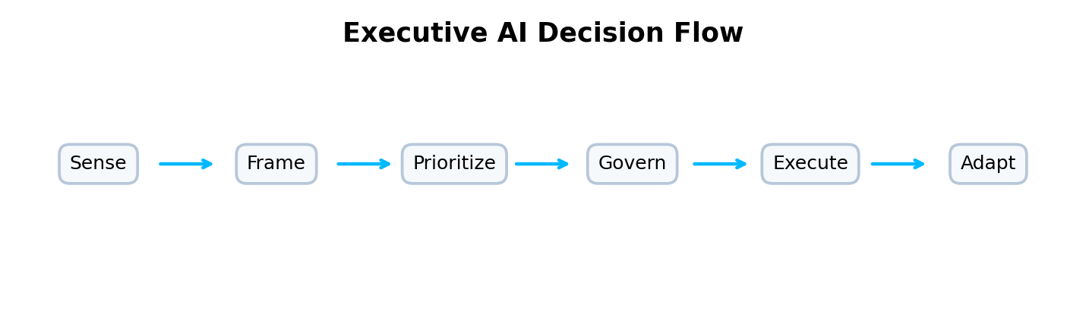
How ascAInd approaches this offering
ascAInd’s Executive Advisory offering helps leadership teams make better AI-era transformation decisions. It combines strategic framing, leadership alignment, governance maturity, AI investment prioritization, operating model choices, and execution readiness. SEE-THINK-ACT thinking supports leadership clarity. The digital forever frontier metaphor helps executives understand that AI strategy is not a one-time destination, but a continuously evolving portfolio of choices. Identity transition thinking helps leaders understand why adoption is not only technical, but also psychological and organizational.
A webpage story, not a framework list
This page should not present frameworks as a laundry list. The intellectual depth should appear through the story: why organizations struggle, how value flows across the enterprise, where governance creates confidence, how humans and AI collaborate, and how leaders move from fragmented initiatives to scalable execution.
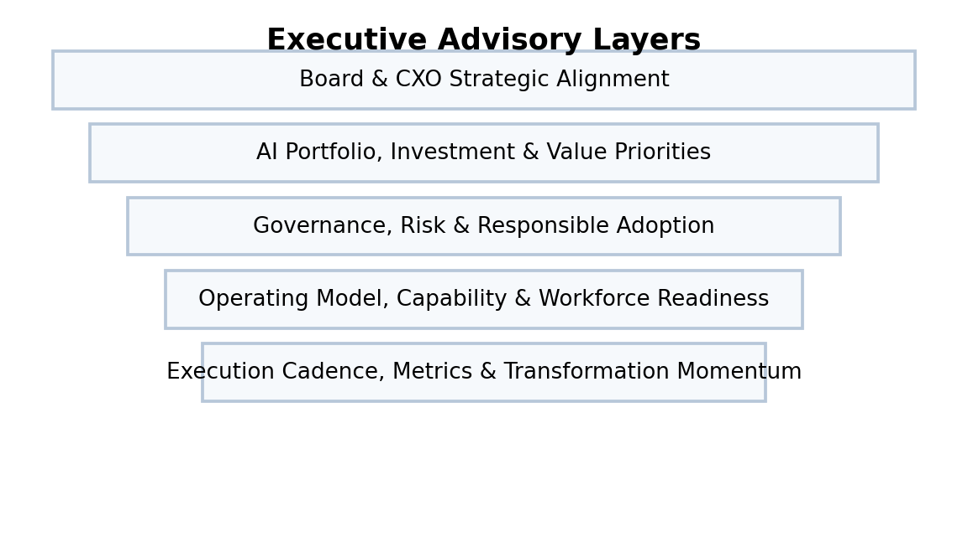
What the webpage should make clear
This offering is for executive teams that need an experienced transformation advisor, not a generic technology consultant. The page should communicate maturity, judgment, board-level confidence, and practical enterprise transformation experience.
How the thinking comes together
The page should naturally reference concepts such as signal-to-noise leadership, intellectual sovereignty, AI frontier portfolios, human-complementary AI, governance-aware autonomy, and the 3W view of organizational impact. These ideas should appear as executive decision lenses rather than academic labels.
What clients experience
Clients should see a trusted advisory model for executive workshops, AI readiness assessments, transformation prioritization, governance design, operating model alignment, and value realization. The reader should feel that ascAInd can help them move from uncertainty to structured executive action.
Website section blocks / content modules
Executive Alignment  Align board, CXO, technology, risk, operations, and business stakeholders around AI priorities. | AI Investment Choices  Prioritize where to invest, where to experiment, where to scale, and where to pause. | Governance Confidence  Define decision rights, escalation paths, risk controls, and responsible AI guardrails.
Leadership Workshops  Facilitate focused sessions on AI strategy, transformation maturity, and operating model choices. | Capability Roadmap  Identify leadership, workforce, architecture, data, governance, and execution capabilities required. | Transformation Cadence  Create rhythm, metrics, accountability, and momentum for enterprise-wide transformation.

INTENDED READER IMPRESSION
The page should position ascAInd as a senior advisory partner for leadership teams navigating the AI transformation frontier.

Suggested webpage flow
Hero  A premium opening statement that clearly defines the offering and the strategic promise. | Challenge  A concise but compelling articulation of the client problem.
Transformation Point of View  A narrative section that shows how ascAInd thinks differently. | Visual Model  A flow, layered architecture, maturity model, or operating system diagram.
Capability Blocks  Six to eight visually balanced cards explaining the offering components. | Executive Outcome  A closing section that communicates confidence, value, and enterprise readiness.

