Operating Model & Process Transformation
The operating model transformation page should communicate that AI transformation ultimately changes how work itself flows through the organization.
Rethinking enterprise transformation
AI has increasingly become a “suitcase word” inside enterprises — a broad label used to describe everything from automation and copilots to analytics, generative AI, intelligent workflows, orchestration platforms, and strategic reinvention itself. The challenge is not merely technological complexity. The deeper challenge is conceptual fragmentation. Organizations frequently pursue disconnected modernization initiatives without a coherent transformation philosophy linking governance, operating models, workforce adaptation, observability, execution discipline, and long-term capability evolution together.
As enterprises move across the AI Continuum — from isolated experimentation toward enterprise-scale orchestration — they often discover that transformation maturity is determined less by the sophistication of individual tools and more by the organization’s ability to integrate intelligence, governance, decision-making, adaptability, and execution across the enterprise ecosystem itself. This is where the Constraint-to-Value Lens becomes strategically important. Many transformation barriers are invisible at first: fragmented ownership structures, weak observability, excessive cognitive load, implementation barriers, unclear accountability, poor integration maturity, governance ambiguity, and identity transition resistance.
The Triple Digital Revolution is accelerating this pressure simultaneously across intelligence, connectivity, and organizational adaptation. Enterprises are not simply adopting new technologies; they are entering an environment where decision velocity, workflow complexity, and human-AI interaction models continuously evolve. Traditional stack-centric modernization approaches increasingly struggle in such environments. Sustainable transformation increasingly requires flow-centric thinking where User Flow, Data Flow, Control Flow, Security Flow, and Governance & Observability Flow evolve together as interconnected enterprise systems.
This shift creates the need for layered enterprise architectures rather than isolated tool architectures. AI systems, governance models, workflow orchestration, adaptive algorithms, observability frameworks, operational controls, and human decision structures must evolve together. Shannon’s Reliability Principle becomes increasingly relevant in environments where system reliability, trust, resilience, and governance confidence directly impact enterprise adoption. Similarly, the Six Signals perspective helps organizations distinguish operational noise from transformation-relevant intelligence.
Modern transformation also requires new approaches to executive thinking. SEE-THINK-ACT leadership concepts, signal-to-noise leadership, catalytic questioning, and intellectual sovereignty become increasingly important in environments where hype cycles evolve faster than organizational adaptation. Enterprises frequently become trapped in reactive experimentation rather than disciplined AI frontier portfolio thinking. The organizations that scale successfully are often those capable of combining strategic patience with adaptive execution.
The 3i model, the Five Dimensions of Integration, and the Five Innovation Questions collectively highlight that enterprise transformation is not purely technical. It is integrative, behavioral, operational, governance-driven, and deeply organizational. The Problem-Solution Novelty Matrix and Innovation Funnel help enterprises decide where experimentation is appropriate, where standardization is required, and where scalable operating discipline becomes essential.
Transformation also changes people, not just processes. The 3W framework — Work, Workers, and Workplace — becomes increasingly important as AI reshapes role boundaries, workflows, authority structures, and organizational expectations. STAIR, OPEN, and RISE/FADE thinking provide practical lenses for redesigning workflows, decision participation, human-AI collaboration, and capability evolution. Identity transition thinking becomes essential because workforce resistance often emerges not from technology rejection, but from uncertainty around professional identity, decision authority, and long-term relevance.
Organizations increasingly recognize that human-AI fit design principles matter as much as technical capability. Johnson’s distinction between human-complementary and human-displacing AI becomes strategically important in workforce-sensitive environments. Gupta’s fairness audit thinking strengthens governance maturity around trust, transparency, and responsible scaling. Leist’s governance stack and Bartel’s alignment-versus-autonomy principle become increasingly relevant as enterprises move from assistive AI toward semi-autonomous and agentic ecosystems.
Emerging evidence around AI’s paradoxical productivity effects also introduces an important executive consideration. AI can improve speed while simultaneously weakening critical thinking, contextual reasoning, organizational learning, or governance discipline if human-AI collaboration is poorly designed. This creates the need for adaptive operating systems where augmentation, oversight, reliability, governance, and organizational learning evolve together rather than independently.
The organizations likely to create durable advantage over the next decade are not necessarily those deploying the largest number of AI tools. They are more likely to be the organizations capable of redesigning how intelligence, governance, execution, adaptability, observability, and human judgment move across the enterprise itself.
The ascAInd point of view
ascAInd approaches transformation as an enterprise capability evolution journey rather than a collection of disconnected AI initiatives. The focus is not merely deploying automation, copilots, orchestration platforms, or intelligent workflows. The objective is helping enterprises build governance-aware, adaptive, human-centered, flow-centric transformation systems capable of scaling sustainably across strategy, operations, workforce, governance, architecture, and execution.
This creates a transformation conversation operating at a fundamentally different level. Instead of discussing only tools, the focus shifts toward orchestration maturity, governance confidence, observability, adaptive operating models, enterprise integration, workforce evolution, human-AI collaboration, and long-term transformation resilience.

Operating Model & Process Transformation
Redesign enterprise processes, standardize operations, and embed AI and automation into core business workflows.

PAGE POSITIONING
The AI era requires operating models that can sense, decide, act, learn, and adapt across enterprise workflows.

The strategic challenge
Organizations often automate fragments of work without redesigning the operating model around them. Processes remain complex, handoffs remain manual, roles remain unclear, and data remains disconnected. The result is a modern toolset sitting on top of legacy ways of working.
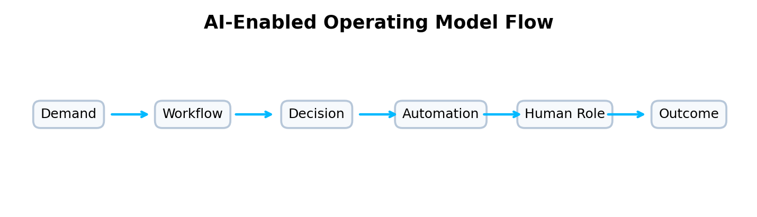
How ascAInd approaches this offering
ascAInd’s Operating Model & Process Transformation offering helps enterprises redesign how work actually happens. It uses Workflow-Empathy-Technology architecture to balance process efficiency with human adoption, customer experience, and technology enablement. The 3W lens helps evaluate the transformation across Work, Workers, and Workplace. RISE and FADE-style thinking can guide where work should be reinforced, simplified, elevated, automated, faded, or redesigned. The goal is not just process improvement; it is operating model evolution.
A webpage story, not a framework list
This page should not present frameworks as a laundry list. The intellectual depth should appear through the story: why organizations struggle, how value flows across the enterprise, where governance creates confidence, how humans and AI collaborate, and how leaders move from fragmented initiatives to scalable execution.
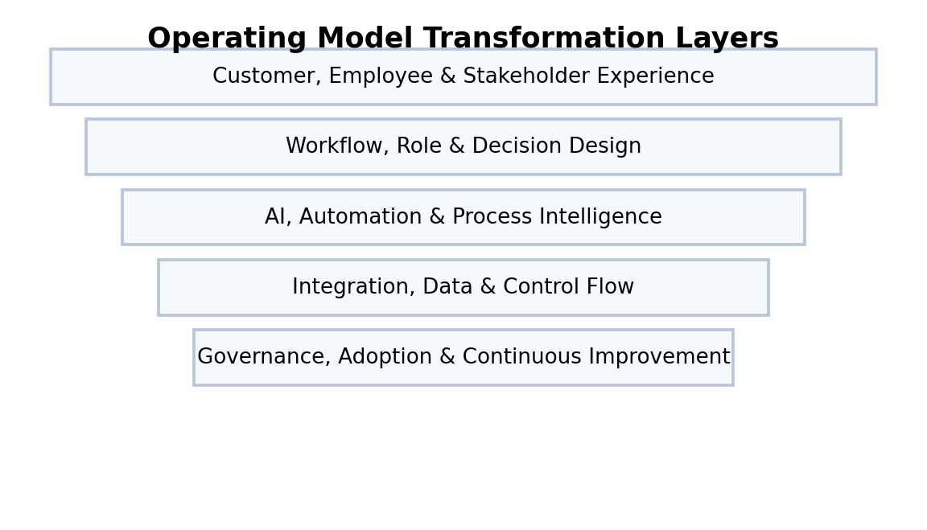
What the webpage should make clear
This offering is for organizations that need to modernize the mechanics of work. It should show that ascAInd can help redesign workflows, clarify decision ownership, embed AI and automation, and improve both operational efficiency and human adoption.
How the thinking comes together
The page should tell a story that operating models fail when they focus only on tools. Workflow-Empathy-Technology thinking keeps the human experience visible. The 3W framework ensures the design considers the work itself, the people doing or supervising the work, and the workplace context. Implementation barrier thinking helps identify where adoption may stall, while capability frameworks define what the organization must build to sustain the new model.
What clients experience
Clients should see that this is not generic process mapping. It is an enterprise operating model redesign approach that connects workflows, AI, automation, roles, governance, integration, metrics, and adoption into one coherent transformation system.
Website section blocks / content modules
Workflow Redesign  Map and redesign end-to-end workflows around outcomes, decisions, and experience. | AI & Automation Embedding  Identify where intelligence, automation, copilots, and agents can improve work execution. | Role & Decision Clarity  Define human, AI, and shared decision responsibilities across the operating model.
Process Governance  Create ownership, standards, exception handling, and continuous improvement routines. | Adoption Readiness  Address workforce confidence, behavior shifts, skills, and identity transition risks. | Operational Metrics  Measure cycle time, quality, experience, productivity, resilience, and value realization.

INTENDED READER IMPRESSION
The page should position ascAInd as a partner for redesigning work itself, not just automating existing processes.

Suggested webpage flow
Hero  A premium opening statement that clearly defines the offering and the strategic promise. | Challenge  A concise but compelling articulation of the client problem.
Transformation Point of View  A narrative section that shows how ascAInd thinks differently. | Visual Model  A flow, layered architecture, maturity model, or operating system diagram.
Capability Blocks  Six to eight visually balanced cards explaining the offering components. | Executive Outcome  A closing section that communicates confidence, value, and enterprise readiness.

