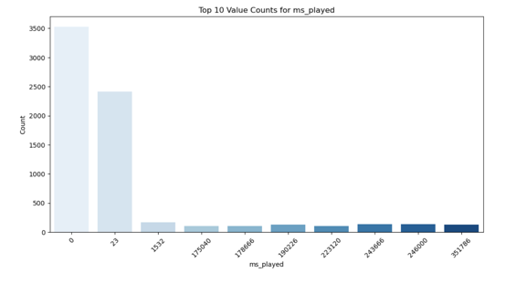
Most tracks were played for 0 or very few milliseconds, indicating frequent skips.
Only a small number of tracks were played fully, showing a clear divide between skipped and engaged songs.
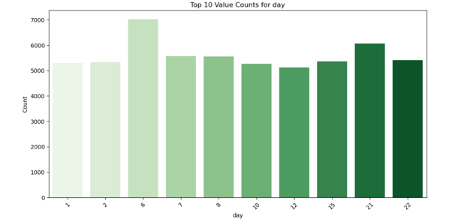
Day 6 had the highest number of plays — possibly due to a new release or user behavior pattern early in the month.
Days 15 and 21 also had high activity, indicating strong mid-to-late month engagement.
The distribution is relatively even, suggesting consistent user activity across different days of the month.

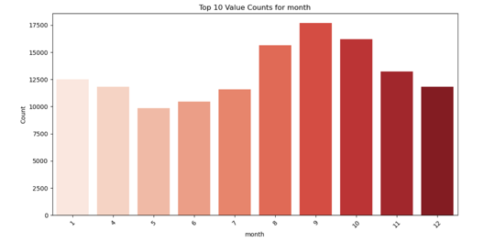
graph shows the top 10 months with the highest number of music streams based on playback activity.
September (Month 9) had the highest number of streams, followed by October and August.
Mid to late year (Aug–Oct) shows peak engagement.
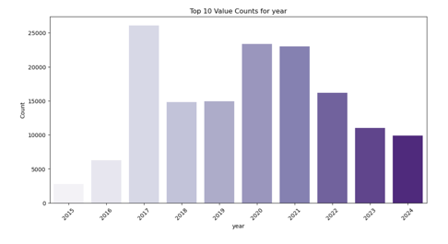
graph displays the top 10 years with the highest number of music streams in the dataset.
2017 had the highest streaming activity, followed closely by 2020 and 2021.
Recent years (2023–2024) show a decline in stream counts.
Indicates a peak period around 2017–2021, possibly due to increased user engagement or better data capture.
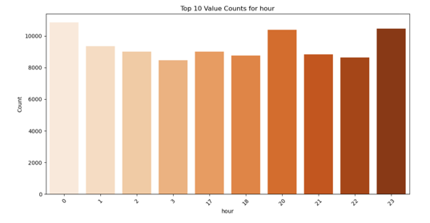
graph displays the top 10 hours of the day with the highest number of music streams.
Hour 0 (midnight) had the highest stream count, followed closely by 23 (11 PM) and 20 (8 PM).
Streaming activity is highest during late-night and evening hours.
Suggests users prefer listening to music at night, possibly for relaxation or winding down.
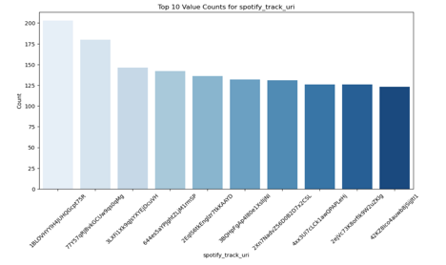
This graph displays the top 10 most frequently played Spotify tracks based on their unique spotify track uri.
The top track was streamed over 200 times, showing strong listener preference.
All top 10 tracks had 125+ plays, indicating they were highly repeated in user sessions.
This reflects favorite or go-to tracks that dominate listening behavior.

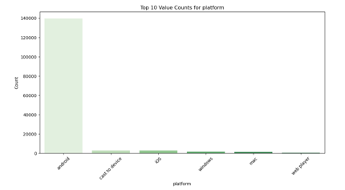
graph displays the top 10 platforms used to stream music, based on usage count.
Android dominates with over 140,000 streams, far ahead of other platforms.
Platforms like iOS, Windows, and Web Player show minimal usage in comparison.
Indicates a strong user preference for Android devices in this dataset.
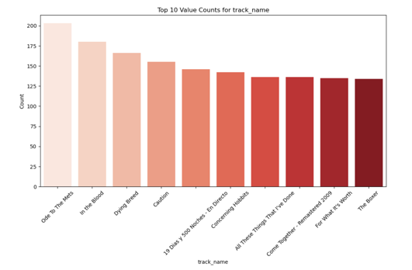
graph displays the top 10 most played song titles based on frequency of streams.
"Ode To The Mets" was the most frequently streamed song, with over 200 plays.
Other favorites include "In the Blood", "Dying Breed", and "Caution", showing strong user preference.
The top songs suggest a consistent pattern of repeated listening and possibly emotional or nostalgic value.

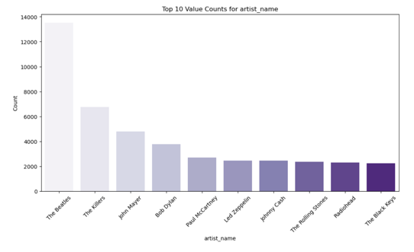
graph displays the top 10 most played artists based on stream counts.
The Beatles lead by a wide margin with over 13,000 plays, showing major fan preference.
Other popular artists include The Killers, John Mayer, and Bob Dylan, indicating a strong leaning toward classic and alternative rock.
Listening behavior shows a clear preference for iconic, guitar-driven artists.
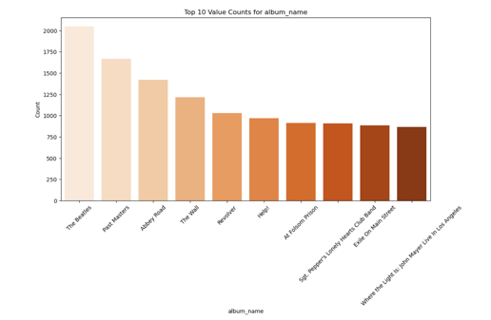
graph displays the top 10 most played albums based on total stream counts.
"The Beatles" album had the highest number of plays, followed by "Past Masters" and "Abbey Road", confirming strong Beatles fandom.
Albums from classic rock and legendary artists dominate the list (e.g., Pink Floyd, Johnny Cash, The Rolling Stones).
Suggests a strong listener preference for timeless, iconic albums across decades.
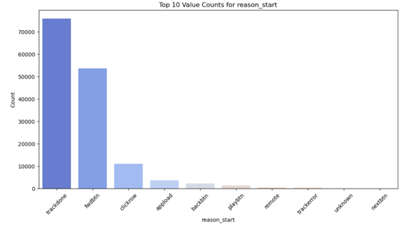
graph displays the top 10 reasons why a track started playing in the listening history.
Most plays were triggered by automatic transitions like trackdone and fwdbtn (forward button).
User-initiated plays like clickrow (manual click) were much less frequent.
Suggests users often let music play continuously rather than actively choosing each track.
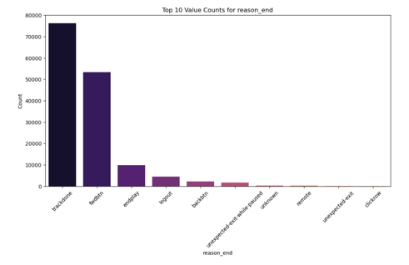
graph displays the top 10 reasons why a track ended in the listening sessions.
Most tracks ended due to trackdone (natural completion), followed by fwdbtn (user skipping).
A small portion ended due to logout or manual controls like backbtn.
Indicates a healthy mix of full listens and skips, with the majority being natural playthroughs.

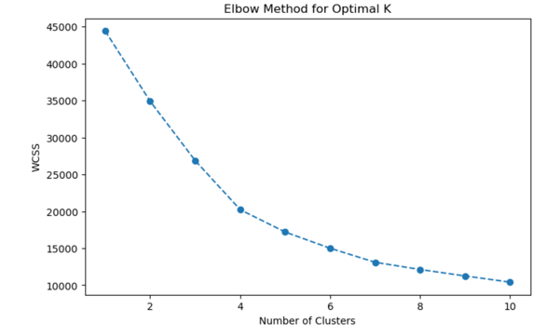
Elbow Method plot used to determine the optimal number of clusters (K) for K-Means clustering.
The "elbow point" occurs at K = 4, where the WCSS (within-cluster sum of squares) drops sharply and then levels off.
Choosing 4 clusters balances model complexity and variance explained.
This suggests that user listening behavior can be grouped into 4 distinct clusters effectively.
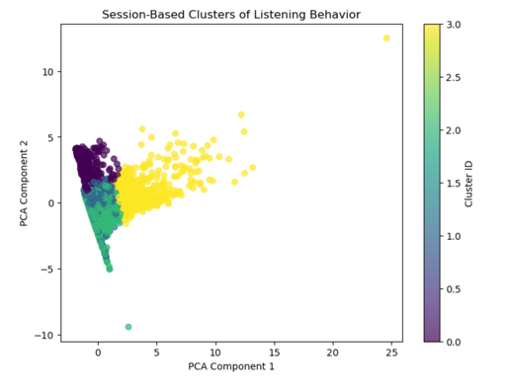
PCA scatter plot visualizes 4 session-based clusters of listening behavior, derived from K-Means clustering.
The dataset was effectively grouped into 4 distinct user behavior clusters.
Each cluster likely represents different session types (e.g., long vs. short playtime, high vs. low skip rate).
The clear separation indicates diverse listening patterns, useful for personalization or segmentation strategies.
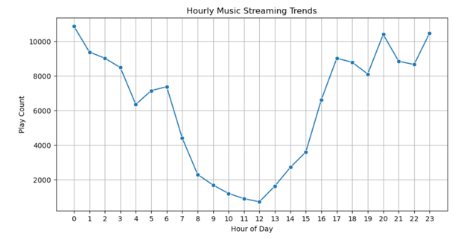
line chart displays hourly music streaming trends across a full 24-hour day.
Peak streaming hours occur at midnight (0), 20–23 hrs, showing strong late-night engagement.
Lowest activity happens between 8 AM and 12 PM, likely due to work/school routines.
Streaming gradually builds back up after noon, forming a consistent evening spike.
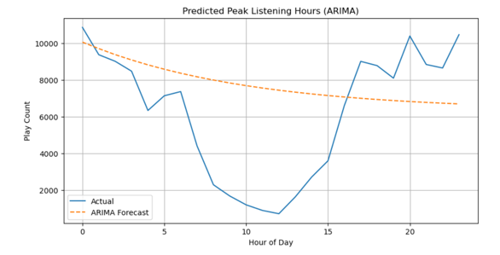
line chart compares actual hourly music play counts with an ARIMA-based forecast to identify peak listening times.
Late-night hours (0 and 23) show the highest actual listening activity.
The ARIMA model underestimates peaks, forecasting a gradual decline throughout the day.
This suggests non-linear, spike-heavy user behavior that ARIMA may not fully capture.
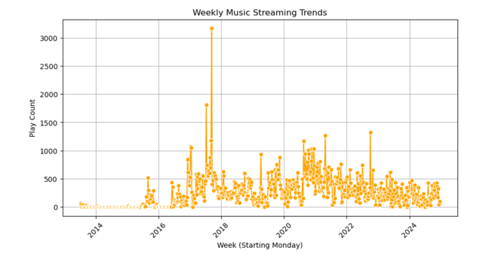
scatter plot displays weekly music streaming trends over time, grouped by each week (starting Monday).
Streaming activity increased significantly from 2016 onward, peaking around late 2017.
There's a noticeable spike in weekly play count near 2018, possibly due to a major event or favorite release.
Activity remains consistently high from 2019–2022, showing stable listening habits across years.
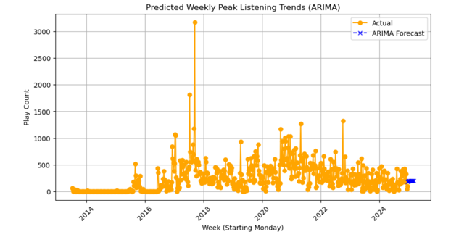
graph shows actual weekly music streaming data alongside an ARIMA forecast for upcoming weeks.
The ARIMA model predicts consistent weekly play counts for future weeks in 2025.
Past data shows high variability, with notable spikes around 2017–2018.
Forecast indicates stable but moderate engagement, without major surges.
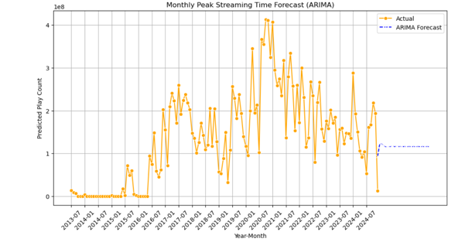
graph illustrates monthly music streaming activity over time, along with an ARIMA forecast for future months.
Play counts peaked sharply between 2020–2021, reaching over 400 million in a month.
ARIMA forecast predicts stable and moderate streaming levels through upcoming months in 2025.
The model suggests a flattening trend, with no expected sharp rises or drops.
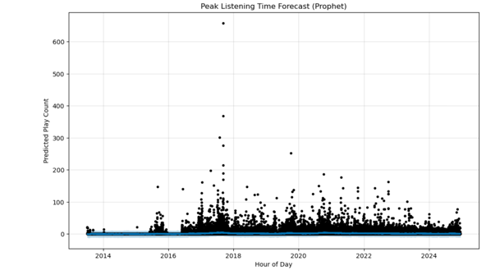
graph visualizes Prophet’s forecast of peak listening time across years, based on hourly predicted play counts.
The model captures occasional spikes in hourly listening, especially around 2017–2018.
Despite these spikes, overall listening remains low and steady, indicating consistency over time.
Prophet forecasts suggest no major hourly surges expected in the near future.
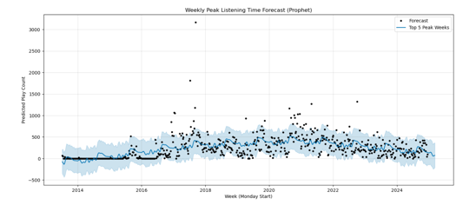
chart uses Prophet to forecast weekly peak listening trends, highlighting predicted values and confidence intervals.
Streaming activity shows a steady rise from 2015 to around 2021, followed by a slight decline.
Occasional extreme peaks, like in late 2017, stand out as anomalies.
Forecast suggests moderate weekly engagement with no major spikes expected in 2025.

