RFP-OLools-9903 Response Document

RFP-Bid-990.3
Generated: 2025-09-27 14:20:39
Document Version: 1.0
Total Sections: 10

Table of Contents
Executive Overview - Tony Stark
• Key Benefits
• Competitive Advantages
• Success Metrics
About TechCorp / CPX
• CPX Purpose & Value
• Key Information
• Certifications & Accreditations
• Organizational Structure
• Team Composition

Executive Overview
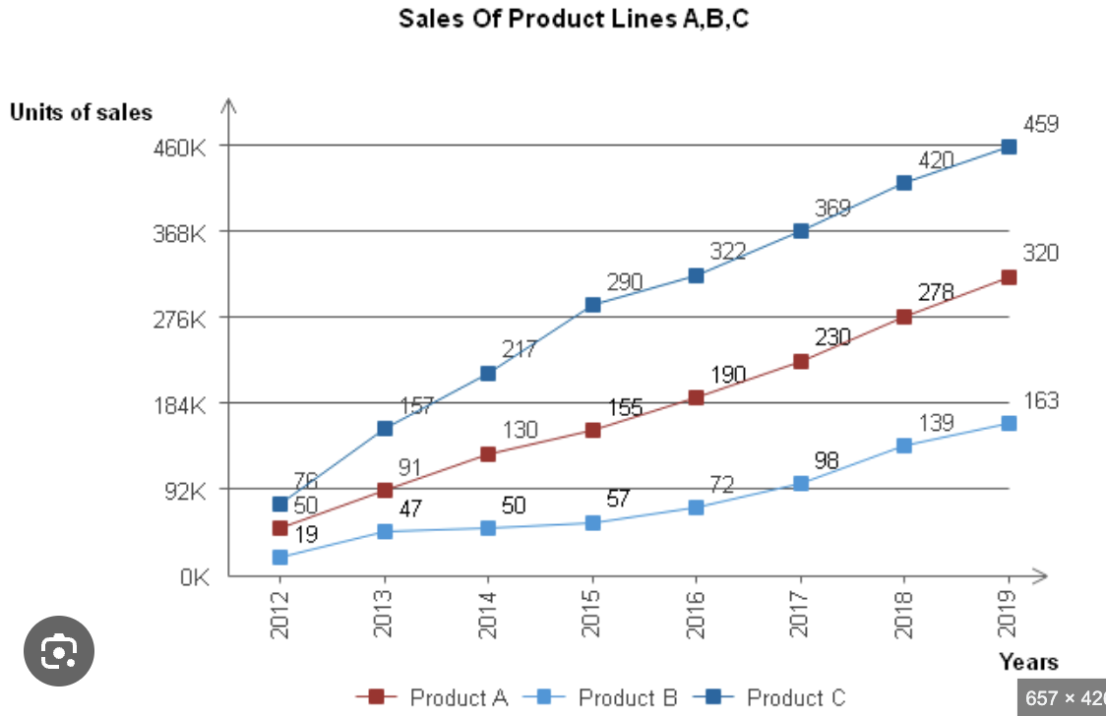

Executive Overview - Tony Stark
This section provides a high-level summary of the entire RFP response, highlighting why CPX is the ideal partner for the client's goals.

Key Benefits
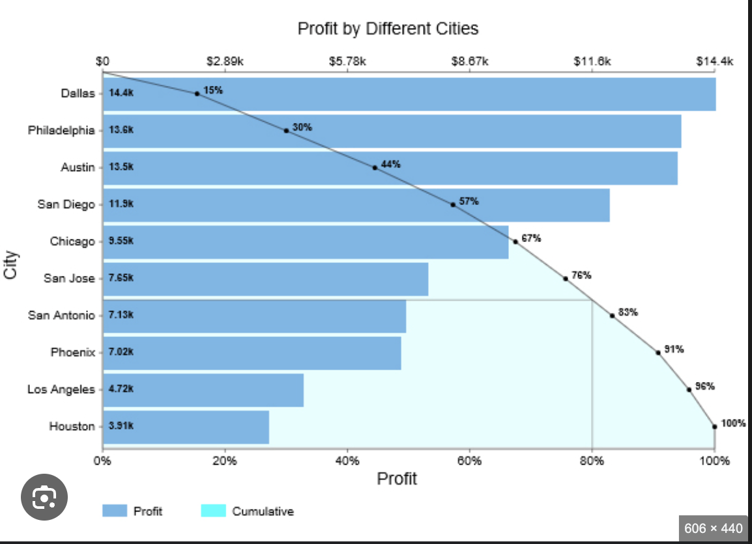
The client will benefit from significant cost reductions and improved operational efficiency through the implementation of our solutions.
• [Placeholder]: Briefly summarize the primary tangible benefits the client will receive (e.g., $X cost reduction, 30% process efficiency).

Competitive Advantages
• [Placeholder]: Summarize CPX's unique differentiators that beat the competition (e.g., proprietary AI, specialized team certification).

Success Metrics

• [Placeholder]: Define the critical, measurable goals that will determine the project's success (e.g., 99.9% uptime, completion on time and on budget).

About TechCorp / CPX

CPX Purpose & Value
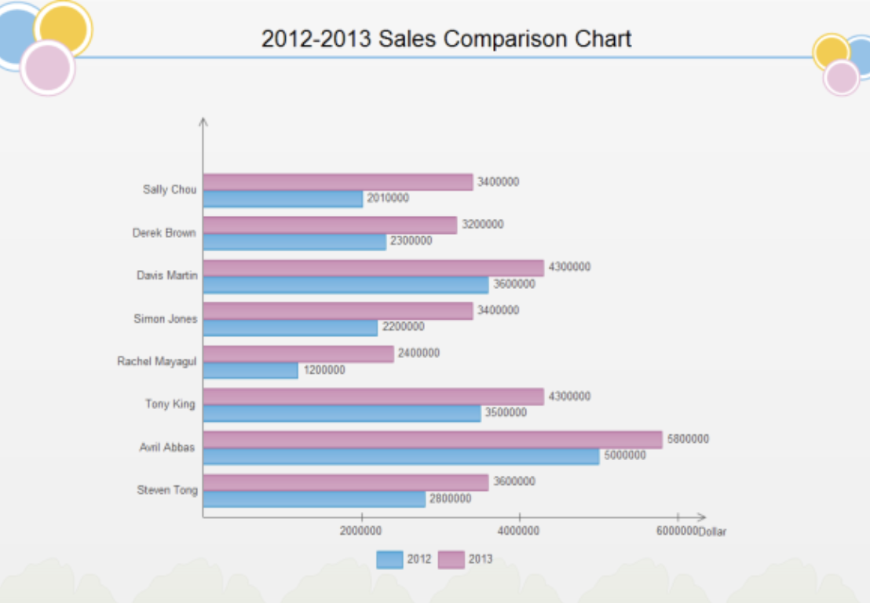
CPX is a leading technology solutions provider specializing in enterprise-grade systems integration, custom software development, and digital transformation initiatives. Our purpose is to deliver innovative solutions that drive business growth and operational excellence.

Key Information
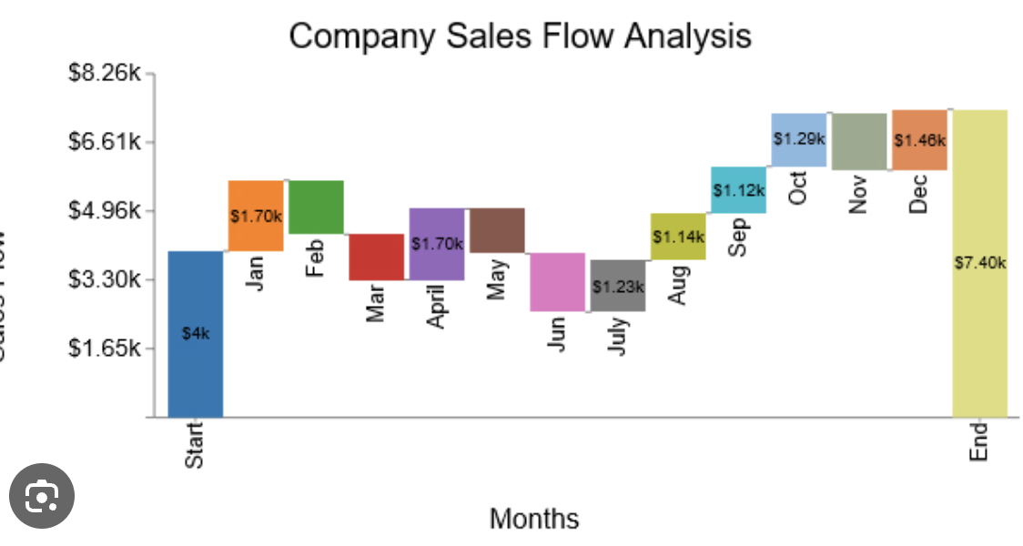
• Founded: 2015
• Headquarters: Global presence with offices in major business centers
• Team Size: 500+ certified professionals
• Industries Served: Financial Services, Healthcare, Government, Manufacturing
• Client Base: 200+ satisfied clients worldwide

Certifications & Accreditations
• ISO 27001 Information Security Management
• ISO 9001 Quality Management Systems
• CMMI Level 5 for Development and Services
• Cloud platform certifications (AWS, Azure, GCP)
• Industry-specific compliance certifications

Financial Proposal
This financial proposal outlines the budget breakdown, pricing models, payment terms, financial justifications, cost-benefit analysis, resource allocation, financial risk assessment, and payment schedules for the Managed Security Services (MSS) provider for the Security Operations Center (SOC) over a three-year period.

Budget Overview

Budget Breakdown
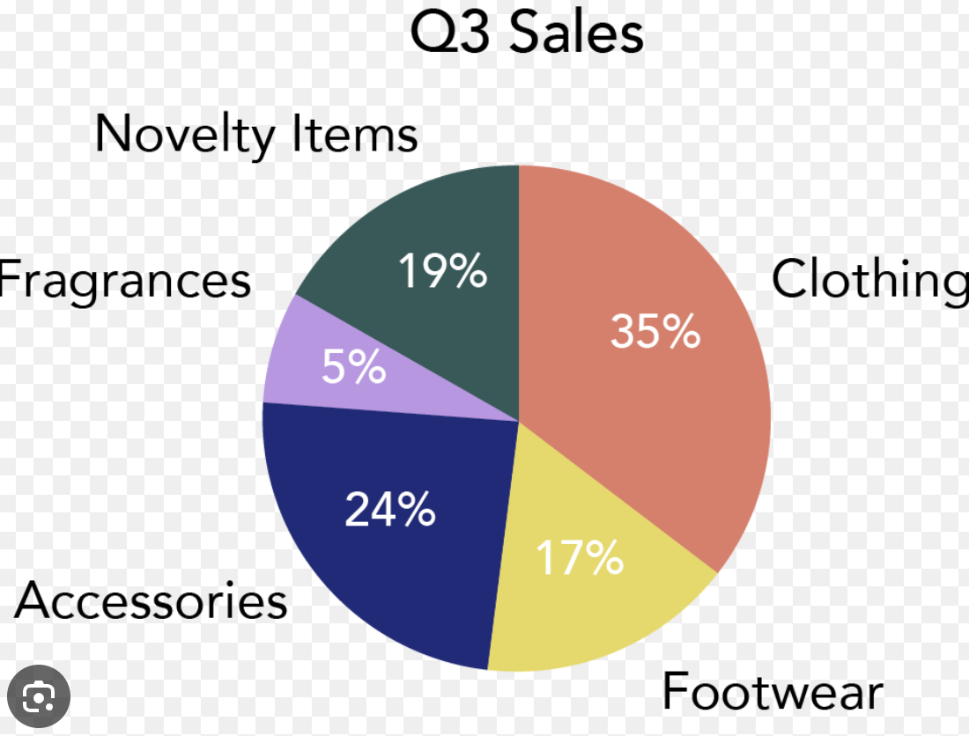
Cost Category | Year 1 | Year 2 | Year 3 | Total
Personnel Costs | $200,000 | $210,000 | $220,000 | $630,000
Technology and Tools | $150,000 | $50,000 | $50,000 | $250,000
Training and Development | $30,000 | $30,000 | $30,000 | $90,000
Operational Expenses | $20,000 | $20,000 | $20,000 | $60,000
Contingency Fund (10%) | $40,000 | $32,000 | $32,000 | $104,000
Total Estimated Cost | $440,000 | $342,000 | $352,000 | $1,134,000

