rfp-bid-990.3
Generated: 2025-09-27 14:20:39
Document Version: 1.0
Total Sections: 10

RFP-OLools-9903
1. Summary
This document is the application for CPX's RFP, which presents the Cyber Security Management Project.
- • Executive Overview - Tony Stark
- • Key Benefits
- • Competitive Advantages
- • Success Metrics

2. About TechCorp
- • 2.1. CPX Purpose & Value
- • 2.2. Key Information
- • 2.3. Certifications & Accreditations
- • 2.4. Organizational Structure
- • 2.5. Team Composition

3. Understanding of Requirements
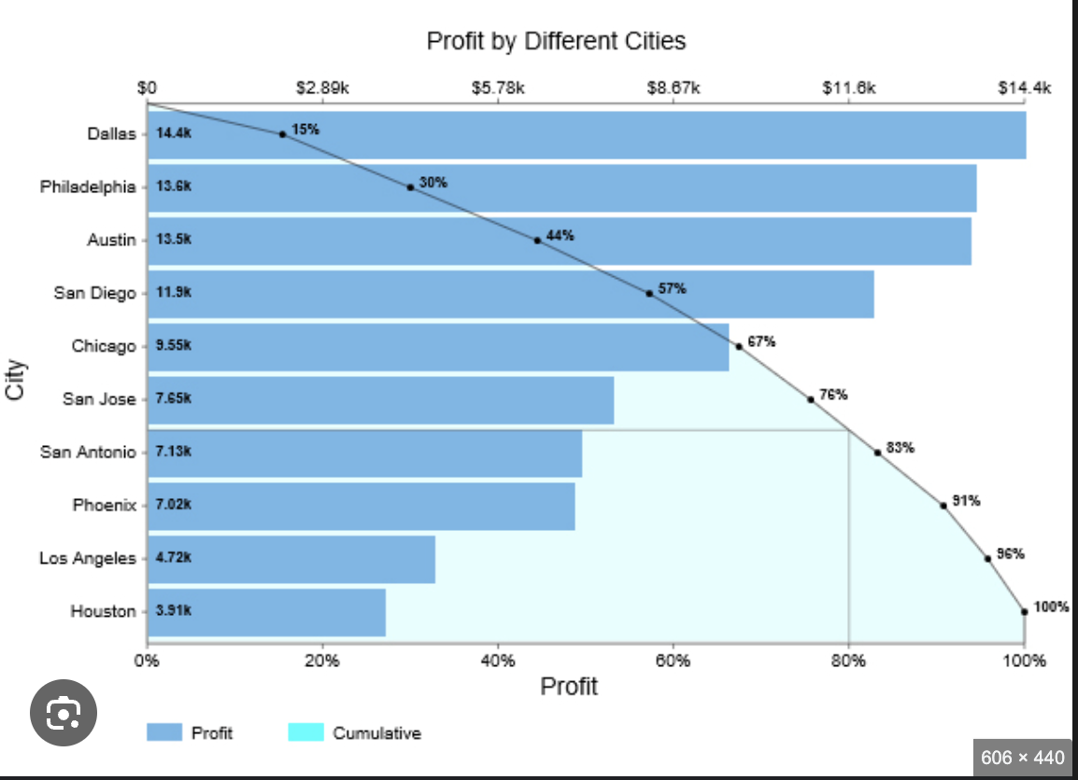

- • 3.1. Project Scope Analysis
- • 3.2. Stakeholder Requirements
- • 3.3. Success Criteria
- • 3.4. Risk Assessment

4. Proposed Solution
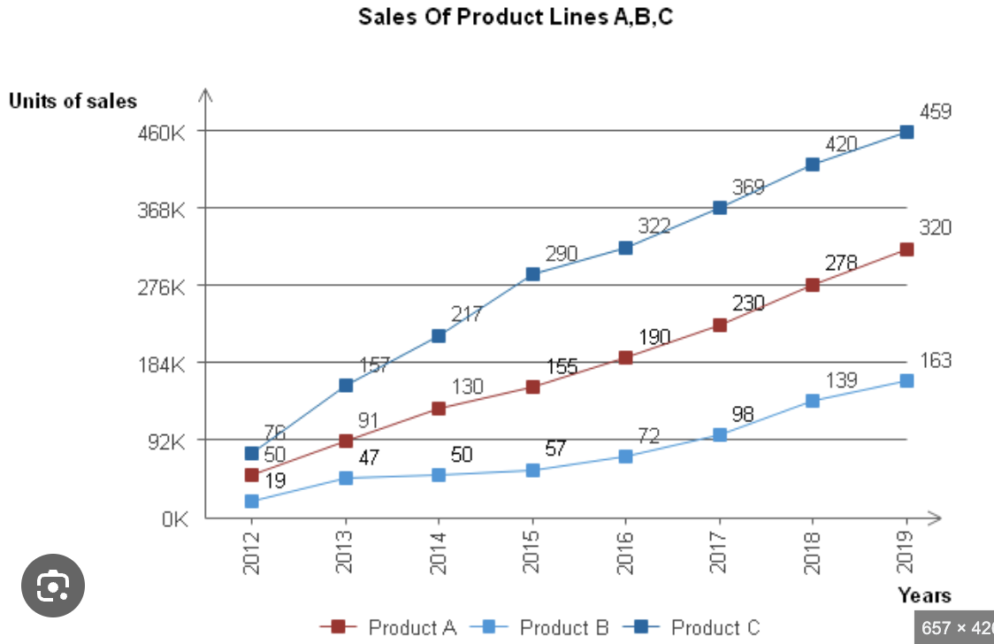
- • 4.1. Technical Architecture
- • 4.2. Implementation Approach
- • 4.3. Solution Components
- • 4.4. Integration Strategy

5. Implementation Plan
- • 5.1. Project Phases
- • 5.2. Timeline & Milestones
- • 5.3. Resource Allocation
- • 5.4. Quality Assurance

6. Team and Experience

- • 6.1. Core Team Members
- • 6.2. Relevant Experience
- • 6.3. Similar Projects
- • 6.4. Client References

Updated RFP Response
- • 7.1. Cost Breakdown
- • 7.2. Pricing Model
- • 7.3. Payment Terms
- • 7.4. Value Analysis
- • 8.1. Contractual Terms
- • 8.2. Service Level Agreements
- • 8.3. Liability & Warranty
- • 8.4. Intellectual Property

9. Additional Services

- • 9.1. Optional Modules
- • 9.2. Future Enhancements
- • 9.3. Support Services
- • 9.4. Training Programs

10. Appendices
- • 10.1. Technical Specifications
- • 10.2. Certifications
- • 10.3. Case Studies
- • 10.4. Additional Documentation

1. Summary
Section Structure:
- • Executive Overview
- • Key Benefits
- • Competitive Advantages
- • Success Metrics

2. About CPX
Section Structure:
- • 2.1. CPX Purpose & Value
- • 2.2. Key Information
- • 2.3. Certifications & Accreditations
- • 2.4. Organizational Structure
- • 2.5. Team Composition

2.1. CPX Purpose & Value
CPX is a leading technology solutions provider specializing in enterprise-grade systems integration, custom software development, and digital transformation initiatives. Our purpose is to deliver innovative solutions that drive business growth and operational excellence.

2.2. Key Information
- **Founded**: 2015
- **Headquarters**: Global presence with offices in major business centers
- **Team Size**: 500+ certified professionals
- **Industries Served**: Financial Services, Healthcare, Government, Manufacturing
- **Client Base**: 200+ satisfied clients worldwide

2.3. Certifications & Accreditations
- ISO 27001 Information Security Management
- ISO 9001 Quality Management Systems
- CMMI Level 5 for Development and Services
- Cloud platform certifications (AWS, Azure, GCP)
- Industry-specific compliance certifications

2.4. Organizational Structure

Our organization is structured around centers of excellence, ensuring deep domain expertise while maintaining agility and cross-functional collaboration.

Technical Team Response

Technical Approach
Technical Architecture
Proposed architecture will be based on a microservices design pattern to ensure modularity and scalability.
Utilize cloud-based infrastructure for flexibility and cost-effectiveness.
Implement a containerized approach using Docker and Kubernetes for easy deployment and management.
System Requirements and Specifications
Minimum hardware requirements: 8GB RAM, Quad-core processor, 100GB storage.
Operating system: Linux-based for stability and security.
Database: MySQL for relational data storage, MongoDB for NoSQL requirements.
Web server: Nginx for high performance and load balancing.
Technology Stack and Tools
Frontend: React.js for dynamic user interfaces.
Backend: Node.js for server-side logic and API development.
DevOps: Jenkins for continuous integration and deployment.
Monitoring: Prometheus for performance monitoring and Grafana for visualization.
Implementation Approach and Methodology
Agile methodology with bi-weekly sprints for iterative development.
Use of version control system like Git for code management.
Conduct regular code reviews and testing to ensure quality and reliability.
Integration Requirements
Integration with existing CRM system for data synchronization.
API integration with third-party services for additional functionality.
Implement OAuth2 for secure authentication and authorization.
Scalability and Performance Considerations
Horizontal scaling using load balancers for handling increased traffic.
Implement caching mechanisms for improved performance.
Conduct load testing to identify bottlenecks and optimize performance.
Security Architecture
Implement HTTPS protocol for secure data transmission.
Use of encryption algorithms for sensitive data storage.
Regular security audits and penetration testing to identify vulnerabilities.
Technical Standards and Compliance
Adhere to OWASP guidelines for web application security.
Ensure GDPR compliance for data protection and privacy.
Follow industry best practices for coding standards and documentation.
Technical Team Response

Technical Approach
Technical Architecture
Proposed architecture will be based on a microservices design pattern to ensure modularity and scalability.
Utilize cloud-based infrastructure for flexibility and cost-effectiveness.
Implement a containerized approach using Docker and Kubernetes for easy deployment and management.
System Requirements and Specifications
Minimum hardware requirements: 8GB RAM, Quad-core processor, 100GB storage.
Operating system: Linux-based for stability and security.
Database: MySQL for relational data storage, MongoDB for NoSQL requirements.
Web server: Nginx for high performance and load balancing.
Technology Stack and Tools
Frontend: React.js for dynamic user interfaces.
Backend: Node.js for server-side logic and API development.
DevOps: Jenkins for continuous integration and deployment.
Monitoring: Prometheus for performance monitoring and Grafana for visualization.
Implementation Approach and Methodology
Agile methodology with bi-weekly sprints for iterative development.
Use of version control system like Git for code management.
Conduct regular code reviews and testing to ensure quality and reliability.
Integration Requirements
Integration with existing CRM system for data synchronization.
API integration with third-party services for additional functionality.
Implement OAuth2 for secure authentication and authorization.
Scalability and Performance Considerations
Horizontal scaling using load balancers for handling increased traffic.
Implement caching mechanisms for improved performance.
Conduct load testing to identify bottlenecks and optimize performance.
Security Architecture
Implement HTTPS protocol for secure data transmission.
Use of encryption algorithms for sensitive data storage.
Regular security audits and penetration testing to identify vulnerabilities.
Technical Standards and Compliance
Adhere to OWASP guidelines for web application security.
Ensure GDPR compliance for data protection and privacy.
Follow industry best practices for coding standards and documentation.
Technical Team Response

Technical Approach
Technical Architecture
Proposed architecture will be based on a microservices design pattern to ensure modularity and scalability.
Utilize cloud-based infrastructure for flexibility and cost-effectiveness.
Implement a containerized approach using Docker and Kubernetes for easy deployment and management.
System Requirements and Specifications
Minimum hardware requirements: 8GB RAM, Quad-core processor, 100GB storage.
Operating system: Linux-based for stability and security.
Database: MySQL for relational data storage, MongoDB for NoSQL requirements.
Web server: Nginx for high performance and load balancing.
Technology Stack and Tools
Frontend: React.js for dynamic user interfaces.
Backend: Node.js for server-side logic and API development.
DevOps: Jenkins for continuous integration and deployment.
Monitoring: Prometheus for performance monitoring and Grafana for visualization.
Implementation Approach and Methodology
Agile methodology with bi-weekly sprints for iterative development.
Use of version control system like Git for code management.
Conduct regular code reviews and testing to ensure quality and reliability.
Integration Requirements
Integration with existing CRM system for data synchronization.
API integration with third-party services for additional functionality.
Implement OAuth2 for secure authentication and authorization.
Scalability and Performance Considerations
Horizontal scaling using load balancers for handling increased traffic.
Implement caching mechanisms for improved performance.
Conduct load testing to identify bottlenecks and optimize performance.
Security Architecture
Implement HTTPS protocol for secure data transmission.
Use of encryption algorithms for sensitive data storage.
Regular security audits and penetration testing to identify vulnerabilities.
Technical Standards and Compliance
Adhere to OWASP guidelines for web application security.
Ensure GDPR compliance for data protection and privacy.
Follow industry best practices for coding standards and documentation.
Technical Team Response

Technical Approach
Technical Architecture
Proposed architecture will be based on a microservices design pattern to ensure modularity and scalability.
Utilize cloud-based infrastructure for flexibility and cost-effectiveness.
Implement a containerized approach using Docker and Kubernetes for easy deployment and management.
System Requirements and Specifications
Minimum hardware requirements: 8GB RAM, Quad-core processor, 100GB storage.
Operating system: Linux-based for stability and security.
Database: MySQL for relational data storage, MongoDB for NoSQL requirements.
Web server: Nginx for high performance and load balancing.
Technology Stack and Tools
Frontend: React.js for dynamic user interfaces.
Backend: Node.js for server-side logic and API development.
DevOps: Jenkins for continuous integration and deployment.
Monitoring: Prometheus for performance monitoring and Grafana for visualization.
Implementation Approach and Methodology
Agile methodology with bi-weekly sprints for iterative development.
Use of version control system like Git for code management.
Conduct regular code reviews and testing to ensure quality and reliability.
Integration Requirements
Integration with existing CRM system for data synchronization.
API integration with third-party services for additional functionality.
Implement OAuth2 for secure authentication and authorization.
Scalability and Performance Considerations
Horizontal scaling using load balancers for handling increased traffic.
Implement caching mechanisms for improved performance.
Conduct load testing to identify bottlenecks and optimize performance.
Security Architecture
Implement HTTPS protocol for secure data transmission.
Use of encryption algorithms for sensitive data storage.
Regular security audits and penetration testing to identify vulnerabilities.
Technical Standards and Compliance
Adhere to OWASP guidelines for web application security.
Ensure GDPR compliance for data protection and privacy.
Follow industry best practices for coding standards and documentation.
Technical Team Response

Technical Approach
Technical Architecture
Proposed architecture will be based on a microservices design pattern to ensure modularity and scalability.
Utilize cloud-based infrastructure for flexibility and cost-effectiveness.
Implement a containerized approach using Docker and Kubernetes for easy deployment and management.
System Requirements and Specifications
Minimum hardware requirements: 8GB RAM, Quad-core processor, 100GB storage.
Operating system: Linux-based for stability and security.
Database: MySQL for relational data storage, MongoDB for NoSQL requirements.
Web server: Nginx for high performance and load balancing.
Technology Stack and Tools
Frontend: React.js for dynamic user interfaces.
Backend: Node.js for server-side logic and API development.
DevOps: Jenkins for continuous integration and deployment.
Monitoring: Prometheus for performance monitoring and Grafana for visualization.
Implementation Approach and Methodology
Agile methodology with bi-weekly sprints for iterative development.
Use of version control system like Git for code management.
Conduct regular code reviews and testing to ensure quality and reliability.
Integration Requirements
Integration with existing CRM system for data synchronization.
API integration with third-party services for additional functionality.
Implement OAuth2 for secure authentication and authorization.
Scalability and Performance Considerations
Horizontal scaling using load balancers for handling increased traffic.
Implement caching mechanisms for improved performance.
Conduct load testing to identify bottlenecks and optimize performance.
Security Architecture
Implement HTTPS protocol for secure data transmission.
Use of encryption algorithms for sensitive data storage.
Regular security audits and penetration testing to identify vulnerabilities.
Technical Standards and Compliance
Adhere to OWASP guidelines for web application security.
Ensure GDPR compliance for data protection and privacy.
Follow industry best practices for coding standards and documentation.
Technical Team Response

Technical Approach
Technical Architecture
Proposed architecture will be based on a microservices design pattern to ensure modularity and scalability.
Utilize cloud-based infrastructure for flexibility and cost-effectiveness.
Implement a containerized approach using Docker and Kubernetes for easy deployment and management.
System Requirements and Specifications
Minimum hardware requirements: 8GB RAM, Quad-core processor, 100GB storage.
Operating system: Linux-based for stability and security.
Database: MySQL for relational data storage, MongoDB for NoSQL requirements.
Web server: Nginx for high performance and load balancing.
Technology Stack and Tools
Frontend: React.js for dynamic user interfaces.
Backend: Node.js for server-side logic and API development.
DevOps: Jenkins for continuous integration and deployment.
Monitoring: Prometheus for performance monitoring and Grafana for visualization.
Implementation Approach and Methodology
Agile methodology with bi-weekly sprints for iterative development.
Use of version control system like Git for code management.
Conduct regular code reviews and testing to ensure quality and reliability.
Integration Requirements
Integration with existing CRM system for data synchronization.
API integration with third-party services for additional functionality.
Implement OAuth2 for secure authentication and authorization.
Scalability and Performance Considerations
Horizontal scaling using load balancers for handling increased traffic.
Implement caching mechanisms for improved performance.
Conduct load testing to identify bottlenecks and optimize performance.
Security Architecture
Implement HTTPS protocol for secure data transmission.
Use of encryption algorithms for sensitive data storage.
Regular security audits and penetration testing to identify vulnerabilities.
Technical Standards and Compliance
Adhere to OWASP guidelines for web application security.
Ensure GDPR compliance for data protection and privacy.
Follow industry best practices for coding standards and documentation.
Technical Team Response

Technical Approach
Technical Architecture
Proposed architecture will be based on a microservices design pattern to ensure modularity and scalability.
Utilize cloud-based infrastructure for flexibility and cost-effectiveness.
Implement a containerized approach using Docker and Kubernetes for easy deployment and management.
System Requirements and Specifications
Minimum hardware requirements: 8GB RAM, Quad-core processor, 100GB storage.
Operating system: Linux-based for stability and security.
Database: MySQL for relational data storage, MongoDB for NoSQL requirements.
Web server: Nginx for high performance and load balancing.
Technology Stack and Tools
Frontend: React.js for dynamic user interfaces.
Backend: Node.js for server-side logic and API development.
DevOps: Jenkins for continuous integration and deployment.
Monitoring: Prometheus for performance monitoring and Grafana for visualization.
Implementation Approach and Methodology
Agile methodology with bi-weekly sprints for iterative development.
Use of version control system like Git for code management.
Conduct regular code reviews and testing to ensure quality and reliability.
Integration Requirements
Integration with existing CRM system for data synchronization.
API integration with third-party services for additional functionality.
Implement OAuth2 for secure authentication and authorization.
Scalability and Performance Considerations
Horizontal scaling using load balancers for handling increased traffic.
Implement caching mechanisms for improved performance.
Conduct load testing to identify bottlenecks and optimize performance.
Security Architecture
Implement HTTPS protocol for secure data transmission.
Use of encryption algorithms for sensitive data storage.
Regular security audits and penetration testing to identify vulnerabilities.
Technical Standards and Compliance
Adhere to OWASP guidelines for web application security.
Ensure GDPR compliance for data protection and privacy.
Follow industry best practices for coding standards and documentation.
Technical Team Response

Technical Approach
Technical Architecture
Proposed architecture will be based on a microservices design pattern to ensure modularity and scalability.
Utilize cloud-based infrastructure for flexibility and cost-effectiveness.
Implement a containerized approach using Docker and Kubernetes for easy deployment and management.
System Requirements and Specifications
Minimum hardware requirements: 8GB RAM, Quad-core processor, 100GB storage.
Operating system: Linux-based for stability and security.
Database: MySQL for relational data storage, MongoDB for NoSQL requirements.
Web server: Nginx for high performance and load balancing.
Technology Stack and Tools
Frontend: React.js for dynamic user interfaces.
Backend: Node.js for server-side logic and API development.
DevOps: Jenkins for continuous integration and deployment.
Monitoring: Prometheus for performance monitoring and Grafana for visualization.
Implementation Approach and Methodology
Agile methodology with bi-weekly sprints for iterative development.
Use of version control system like Git for code management.
Conduct regular code reviews and testing to ensure quality and reliability.
Integration Requirements
Integration with existing CRM system for data synchronization.
API integration with third-party services for additional functionality.
Implement OAuth2 for secure authentication and authorization.
Scalability and Performance Considerations
Horizontal scaling using load balancers for handling increased traffic.
Implement caching mechanisms for improved performance.
Conduct load testing to identify bottlenecks and optimize performance.
Security Architecture
Implement HTTPS protocol for secure data transmission.
Use of encryption algorithms for sensitive data storage.
Regular security audits and penetration testing to identify vulnerabilities.
Technical Standards and Compliance
Adhere to OWASP guidelines for web application security.
Ensure GDPR compliance for data protection and privacy.
Follow industry best practices for coding standards and documentation.
Technical Team Response

Technical Approach
Technical Architecture
Proposed architecture will be based on a microservices design pattern to ensure modularity and scalability.
Utilize cloud-based infrastructure for flexibility and cost-effectiveness.
Implement a containerized approach using Docker and Kubernetes for easy deployment and management.
System Requirements and Specifications
Minimum hardware requirements: 8GB RAM, Quad-core processor, 100GB storage.
Operating system: Linux-based for stability and security.
Database: MySQL for relational data storage, MongoDB for NoSQL requirements.
Web server: Nginx for high performance and load balancing.
Technology Stack and Tools
Frontend: React.js for dynamic user interfaces.
Backend: Node.js for server-side logic and API development.
DevOps: Jenkins for continuous integration and deployment.
Monitoring: Prometheus for performance monitoring and Grafana for visualization.
Implementation Approach and Methodology
Agile methodology with bi-weekly sprints for iterative development.
Use of version control system like Git for code management.
Conduct regular code reviews and testing to ensure quality and reliability.
Integration Requirements
Integration with existing CRM system for data synchronization.
API integration with third-party services for additional functionality.
Implement OAuth2 for secure authentication and authorization.
Scalability and Performance Considerations
Horizontal scaling using load balancers for handling increased traffic.
Implement caching mechanisms for improved performance.
Conduct load testing to identify bottlenecks and optimize performance.
Security Architecture
Implement HTTPS protocol for secure data transmission.
Use of encryption algorithms for sensitive data storage.
Regular security audits and penetration testing to identify vulnerabilities.
Technical Standards and Compliance
Adhere to OWASP guidelines for web application security.
Ensure GDPR compliance for data protection and privacy.
Follow industry best practices for coding standards and documentation.
Technical Team Response

Technical Approach
Technical Architecture
Proposed architecture will be based on a microservices design pattern to ensure modularity and scalability.
Utilize cloud-based infrastructure for flexibility and cost-effectiveness.
Implement a containerized approach using Docker and Kubernetes for easy deployment and management.
System Requirements and Specifications
Minimum hardware requirements: 8GB RAM, Quad-core processor, 100GB storage.
Operating system: Linux-based for stability and security.
Database: MySQL for relational data storage, MongoDB for NoSQL requirements.
Web server: Nginx for high performance and load balancing.
Technology Stack and Tools
Frontend: React.js for dynamic user interfaces.
Backend: Node.js for server-side logic and API development.
DevOps: Jenkins for continuous integration and deployment.
Monitoring: Prometheus for performance monitoring and Grafana for visualization.
Implementation Approach and Methodology
Agile methodology with bi-weekly sprints for iterative development.
Use of version control system like Git for code management.
Conduct regular code reviews and testing to ensure quality and reliability.
Integration Requirements
Integration with existing CRM system for data synchronization.
API integration with third-party services for additional functionality.
Implement OAuth2 for secure authentication and authorization.
Scalability and Performance Considerations
Horizontal scaling using load balancers for handling increased traffic.
Implement caching mechanisms for improved performance.
Conduct load testing to identify bottlenecks and optimize performance.
Security Architecture
Implement HTTPS protocol for secure data transmission.
Use of encryption algorithms for sensitive data storage.
Regular security audits and penetration testing to identify vulnerabilities.
Technical Standards and Compliance
Adhere to OWASP guidelines for web application security.
Ensure GDPR compliance for data protection and privacy.
Follow industry best practices for coding standards and documentation.
Technical Team Response

Technical Approach
Technical Architecture
Proposed architecture will be based on a microservices design pattern to ensure modularity and scalability.
Utilize cloud-based infrastructure for flexibility and cost-effectiveness.
Implement a containerized approach using Docker and Kubernetes for easy deployment and management.
System Requirements and Specifications
Minimum hardware requirements: 8GB RAM, Quad-core processor, 100GB storage.
Operating system: Linux-based for stability and security.
Database: MySQL for relational data storage, MongoDB for NoSQL requirements.
Web server: Nginx for high performance and load balancing.
Technology Stack and Tools
Frontend: React.js for dynamic user interfaces.
Backend: Node.js for server-side logic and API development.
DevOps: Jenkins for continuous integration and deployment.
Monitoring: Prometheus for performance monitoring and Grafana for visualization.
Implementation Approach and Methodology
Agile methodology with bi-weekly sprints for iterative development.
Use of version control system like Git for code management.
Conduct regular code reviews and testing to ensure quality and reliability.
Integration Requirements
Integration with existing CRM system for data synchronization.
API integration with third-party services for additional functionality.
Implement OAuth2 for secure authentication and authorization.
Scalability and Performance Considerations
Horizontal scaling using load balancers for handling increased traffic.
Implement caching mechanisms for improved performance.
Conduct load testing to identify bottlenecks and optimize performance.
Security Architecture
Implement HTTPS protocol for secure data transmission.
Use of encryption algorithms for sensitive data storage.
Regular security audits and penetration testing to identify vulnerabilities.
Technical Standards and Compliance
Adhere to OWASP guidelines for web application security.
Ensure GDPR compliance for data protection and privacy.
Follow industry best practices for coding standards and documentation.
Technical Architecture

Technical Architecture
System Overview
The custom web application will be designed to streamline business processes and improve operational efficiency for [ORGANIZATION NAME].
The system will automate manual processes, reduce errors, improve data visibility, reporting, user experience, and productivity.
Scalability and maintainability will be key considerations in the system architecture.
Integration with existing systems will be seamless and efficient.
Technology Stack and Tools
Frontend: React.js for dynamic user interfaces
Backend: Node.js for server-side logic
Database: MongoDB for flexible data storage
Cloud Hosting: AWS for scalability and reliability
Version Control: Git for code management
Continuous Integration/Continuous Deployment (CI/CD) pipeline for efficient development and deployment processes
Security Architecture
Implementing industry-standard encryption protocols for data security
Role-based access control for user permissions
Regular security audits and vulnerability assessments
Incident response plan for handling security breaches
Compliance with industry regulations such as GDPR and data protection laws
System Requirements and Specifications
Functional Requirements
User authentication and authorization
Data input forms with validation
Reporting and analytics dashboard
Automated workflows and notifications
API integration with third-party systems
Non-Functional Requirements
Performance: Response time under 2 seconds
Scalability: Ability to handle 10,000 concurrent users
Reliability: 99.99% uptime
Maintainability: Codebase documentation and version control
Implementation Approach and Methodology
Agile Development Methodology
Iterative development cycles with regular feedback
Sprint planning and review meetings
User acceptance testing for feature validation
Continuous improvement based on user feedback
Project Timeline
Discovery Phase: Requirements gathering and analysis (2 weeks)
Design Phase: System architecture and UI/UX design (3 weeks)
Development Phase: Backend and frontend development (8 weeks)
Testing Phase: Quality assurance and user acceptance testing (2 weeks)
Deployment Phase: Go-live and post-launch support (1 week)
Integration Requirements
Existing System Integration
API endpoints for seamless data exchange
Data mapping and transformation for data synchronization
Error handling and logging for integration monitoring
Scalability and Performance Considerations
Scalability Plan
Horizontal scaling with load balancers for increased traffic
Database sharding for distributed data storage
Caching mechanisms for faster data retrieval
Performance Optimization
Code optimization for faster execution
Database indexing for efficient queries
Content delivery network (CDN) for static asset caching
Technical Standards and Compliance
Industry Standards
Following RESTful API design principles
Adhering to OWASP security guidelines
Compliance with GDPR and data protection regulations
Quality Assurance
Unit testing for code coverage
Integration testing for system functionality
Performance testing for scalability assessment
Technical Architecture

Technical Architecture
System Overview
The custom web application will be designed to streamline business processes and improve operational efficiency for [ORGANIZATION NAME].
The system will automate manual processes, reduce errors, improve data visibility, reporting, user experience, and productivity.
Scalability and maintainability will be key considerations in the system architecture.
Integration with existing systems will be seamless and efficient.
Technology Stack and Tools
Frontend: React.js for dynamic user interfaces
Backend: Node.js for server-side logic
Database: MongoDB for flexible data storage
Cloud Hosting: AWS for scalability and reliability
Version Control: Git for code management
Continuous Integration/Continuous Deployment (CI/CD) pipeline for efficient development and deployment processes
Security Architecture
Implementing industry-standard encryption protocols for data security
Role-based access control for user permissions
Regular security audits and vulnerability assessments
Incident response plan for handling security breaches
Compliance with industry regulations such as GDPR and data protection laws
System Requirements and Specifications
Functional Requirements
User authentication and authorization
Data input forms with validation
Reporting and analytics dashboard
Automated workflows and notifications
API integration with third-party systems
Non-Functional Requirements
Performance: Response time under 2 seconds
Scalability: Ability to handle 10,000 concurrent users
Reliability: 99.99% uptime
Maintainability: Codebase documentation and version control
Implementation Approach and Methodology
Agile Development Methodology
Iterative development cycles with regular feedback
Sprint planning and review meetings
User acceptance testing for feature validation
Continuous improvement based on user feedback
Project Timeline
Discovery Phase: Requirements gathering and analysis (2 weeks)
Design Phase: System architecture and UI/UX design (3 weeks)
Development Phase: Backend and frontend development (8 weeks)
Testing Phase: Quality assurance and user acceptance testing (2 weeks)
Deployment Phase: Go-live and post-launch support (1 week)
Integration Requirements
Existing System Integration
API endpoints for seamless data exchange
Data mapping and transformation for data synchronization
Error handling and logging for integration monitoring
Scalability and Performance Considerations
Scalability Plan
Horizontal scaling with load balancers for increased traffic
Database sharding for distributed data storage
Caching mechanisms for faster data retrieval
Performance Optimization
Code optimization for faster execution
Database indexing for efficient queries
Content delivery network (CDN) for static asset caching
Technical Standards and Compliance
Industry Standards
Following RESTful API design principles
Adhering to OWASP security guidelines
Compliance with GDPR and data protection regulations
Quality Assurance
Unit testing for code coverage
Integration testing for system functionality
Performance testing for scalability assessment
Technical Architecture

Technical Architecture
System Overview
The custom web application will be designed to streamline business processes and improve operational efficiency for [ORGANIZATION NAME].
The system will automate manual processes, reduce errors, improve data visibility, reporting, user experience, and productivity.
Scalability and maintainability will be key considerations in the system architecture.
Integration with existing systems will be seamless and efficient.
Technology Stack and Tools
Frontend: React.js for dynamic user interfaces
Backend: Node.js for server-side logic
Database: MongoDB for flexible data storage
Cloud Hosting: AWS for scalability and reliability
Version Control: Git for code management
Continuous Integration/Continuous Deployment (CI/CD) pipeline for efficient development and deployment processes
Security Architecture
Implementing industry-standard encryption protocols for data security
Role-based access control for user permissions
Regular security audits and vulnerability assessments
Incident response plan for handling security breaches
Compliance with industry regulations such as GDPR and data protection laws
System Requirements and Specifications
Functional Requirements
User authentication and authorization
Data input forms with validation
Reporting and analytics dashboard
Automated workflows and notifications
API integration with third-party systems
Non-Functional Requirements
Performance: Response time under 2 seconds
Scalability: Ability to handle 10,000 concurrent users
Reliability: 99.99% uptime
Maintainability: Codebase documentation and version control
Implementation Approach and Methodology
Agile Development Methodology
Iterative development cycles with regular feedback
Sprint planning and review meetings
User acceptance testing for feature validation
Continuous improvement based on user feedback
Project Timeline
Discovery Phase: Requirements gathering and analysis (2 weeks)
Design Phase: System architecture and UI/UX design (3 weeks)
Development Phase: Backend and frontend development (8 weeks)
Testing Phase: Quality assurance and user acceptance testing (2 weeks)
Deployment Phase: Go-live and post-launch support (1 week)
Integration Requirements
Existing System Integration
API endpoints for seamless data exchange
Data mapping and transformation for data synchronization
Error handling and logging for integration monitoring
Scalability and Performance Considerations
Scalability Plan
Horizontal scaling with load balancers for increased traffic
Database sharding for distributed data storage
Caching mechanisms for faster data retrieval
Performance Optimization
Code optimization for faster execution
Database indexing for efficient queries
Content delivery network (CDN) for static asset caching
Technical Standards and Compliance
Industry Standards
Following RESTful API design principles
Adhering to OWASP security guidelines
Compliance with GDPR and data protection regulations
Quality Assurance
Unit testing for code coverage
Integration testing for system functionality
Performance testing for scalability assessment
Technical Architecture

Technical Architecture
System Overview
The custom web application will be designed to streamline business processes and improve operational efficiency for [ORGANIZATION NAME].
The system will automate manual processes, reduce errors, improve data visibility, reporting, user experience, and productivity.
Scalability and maintainability will be key considerations in the system architecture.
Integration with existing systems will be seamless and efficient.
Technology Stack and Tools
Frontend: React.js for dynamic user interfaces
Backend: Node.js for server-side logic
Database: MongoDB for flexible data storage
Cloud Hosting: AWS for scalability and reliability
Version Control: Git for code management
Continuous Integration/Continuous Deployment (CI/CD) pipeline for efficient development and deployment processes
Security Architecture
Implementing industry-standard encryption protocols for data security
Role-based access control for user permissions
Regular security audits and vulnerability assessments
Incident response plan for handling security breaches
Compliance with industry regulations such as GDPR and data protection laws
System Requirements and Specifications
Functional Requirements
User authentication and authorization
Data input forms with validation
Reporting and analytics dashboard
Automated workflows and notifications
API integration with third-party systems
Non-Functional Requirements
Performance: Response time under 2 seconds
Scalability: Ability to handle 10,000 concurrent users
Reliability: 99.99% uptime
Maintainability: Codebase documentation and version control
Implementation Approach and Methodology
Agile Development Methodology
Iterative development cycles with regular feedback
Sprint planning and review meetings
User acceptance testing for feature validation
Continuous improvement based on user feedback
Project Timeline
Discovery Phase: Requirements gathering and analysis (2 weeks)
Design Phase: System architecture and UI/UX design (3 weeks)
Development Phase: Backend and frontend development (8 weeks)
Testing Phase: Quality assurance and user acceptance testing (2 weeks)
Deployment Phase: Go-live and post-launch support (1 week)
Integration Requirements
Existing System Integration
API endpoints for seamless data exchange
Data mapping and transformation for data synchronization
Error handling and logging for integration monitoring
Scalability and Performance Considerations
Scalability Plan
Horizontal scaling with load balancers for increased traffic
Database sharding for distributed data storage
Caching mechanisms for faster data retrieval
Performance Optimization
Code optimization for faster execution
Database indexing for efficient queries
Content delivery network (CDN) for static asset caching
Technical Standards and Compliance
Industry Standards
Following RESTful API design principles
Adhering to OWASP security guidelines
Compliance with GDPR and data protection regulations
Quality Assurance
Unit testing for code coverage
Integration testing for system functionality
Performance testing for scalability assessment
Technical Architecture

Technical Architecture
System Overview
The custom web application will be designed to streamline business processes and improve operational efficiency for [ORGANIZATION NAME].
The system will automate manual processes, reduce errors, improve data visibility, reporting, user experience, and productivity.
Scalability and maintainability will be key considerations in the system architecture.
Integration with existing systems will be seamless and efficient.
Technology Stack and Tools
Frontend: React.js for dynamic user interfaces
Backend: Node.js for server-side logic
Database: MongoDB for flexible data storage
Cloud Hosting: AWS for scalability and reliability
Version Control: Git for code management
Continuous Integration/Continuous Deployment (CI/CD) pipeline for efficient development and deployment processes
Security Architecture
Implementing industry-standard encryption protocols for data security
Role-based access control for user permissions
Regular security audits and vulnerability assessments
Incident response plan for handling security breaches
Compliance with industry regulations such as GDPR and data protection laws
System Requirements and Specifications
Functional Requirements
User authentication and authorization
Data input forms with validation
Reporting and analytics dashboard
Automated workflows and notifications
API integration with third-party systems
Non-Functional Requirements
Performance: Response time under 2 seconds
Scalability: Ability to handle 10,000 concurrent users
Reliability: 99.99% uptime
Maintainability: Codebase documentation and version control
Implementation Approach and Methodology
Agile Development Methodology
Iterative development cycles with regular feedback
Sprint planning and review meetings
User acceptance testing for feature validation
Continuous improvement based on user feedback
Project Timeline
Discovery Phase: Requirements gathering and analysis (2 weeks)
Design Phase: System architecture and UI/UX design (3 weeks)
Development Phase: Backend and frontend development (8 weeks)
Testing Phase: Quality assurance and user acceptance testing (2 weeks)
Deployment Phase: Go-live and post-launch support (1 week)
Integration Requirements
Existing System Integration
API endpoints for seamless data exchange
Data mapping and transformation for data synchronization
Error handling and logging for integration monitoring
Scalability and Performance Considerations
Scalability Plan
Horizontal scaling with load balancers for increased traffic
Database sharding for distributed data storage
Caching mechanisms for faster data retrieval
Performance Optimization
Code optimization for faster execution
Database indexing for efficient queries
Content delivery network (CDN) for static asset caching
Technical Standards and Compliance
Industry Standards
Following RESTful API design principles
Adhering to OWASP security guidelines
Compliance with GDPR and data protection regulations
Quality Assurance
Unit testing for code coverage
Integration testing for system functionality
Performance testing for scalability assessment
Technical Architecture

Technical Architecture
System Overview
The custom web application will be designed to streamline business processes and improve operational efficiency for [ORGANIZATION NAME].
The system will automate manual processes, reduce errors, improve data visibility, reporting, user experience, and productivity.
Scalability and maintainability will be key considerations in the system architecture.
Integration with existing systems will be seamless and efficient.
Technology Stack and Tools
Frontend: React.js for dynamic user interfaces
Backend: Node.js for server-side logic
Database: MongoDB for flexible data storage
Cloud Hosting: AWS for scalability and reliability
Version Control: Git for code management
Continuous Integration/Continuous Deployment (CI/CD) pipeline for efficient development and deployment processes
Security Architecture
Implementing industry-standard encryption protocols for data security
Role-based access control for user permissions
Regular security audits and vulnerability assessments
Incident response plan for handling security breaches
Compliance with industry regulations such as GDPR and data protection laws
System Requirements and Specifications
Functional Requirements
User authentication and authorization
Data input forms with validation
Reporting and analytics dashboard
Automated workflows and notifications
API integration with third-party systems
Non-Functional Requirements
Performance: Response time under 2 seconds
Scalability: Ability to handle 10,000 concurrent users
Reliability: 99.99% uptime
Maintainability: Codebase documentation and version control
Implementation Approach and Methodology
Agile Development Methodology
Iterative development cycles with regular feedback
Sprint planning and review meetings
User acceptance testing for feature validation
Continuous improvement based on user feedback
Project Timeline
Discovery Phase: Requirements gathering and analysis (2 weeks)
Design Phase: System architecture and UI/UX design (3 weeks)
Development Phase: Backend and frontend development (8 weeks)
Testing Phase: Quality assurance and user acceptance testing (2 weeks)
Deployment Phase: Go-live and post-launch support (1 week)
Integration Requirements
Existing System Integration
API endpoints for seamless data exchange
Data mapping and transformation for data synchronization
Error handling and logging for integration monitoring
Scalability and Performance Considerations
Scalability Plan
Horizontal scaling with load balancers for increased traffic
Database sharding for distributed data storage
Caching mechanisms for faster data retrieval
Performance Optimization
Code optimization for faster execution
Database indexing for efficient queries
Content delivery network (CDN) for static asset caching
Technical Standards and Compliance
Industry Standards
Following RESTful API design principles
Adhering to OWASP security guidelines
Compliance with GDPR and data protection regulations
Quality Assurance
Unit testing for code coverage
Integration testing for system functionality
Performance testing for scalability assessment
Technical Proposal for RFP-2024-003: Custom Software Development

Technical Proposal for RFP-2024-003: Custom Software Development
Technical Architecture and Design
The custom web application will be designed using a microservices architecture to ensure modularity and scalability.
Utilization of RESTful APIs for seamless communication between different components of the application.
Database design will follow normalization principles to ensure data integrity and efficiency.
System Requirements and Specifications
Minimum hardware requirements for server deployment: 4 CPU cores, 8GB RAM, 100GB storage.
Supported browsers: Google Chrome, Mozilla Firefox, Microsoft Edge.
Mobile responsiveness for optimal user experience on various devices.
Technology Stack and Tools
Frontend: React.js for dynamic user interfaces.
Backend: Node.js for server-side logic and API development.
Database: PostgreSQL for relational data storage.
Version control: Git for code management and collaboration.
Implementation Approach and Methodology
Agile methodology for iterative development and continuous feedback.
Weekly sprints with bi-weekly demos to showcase progress and gather feedback.
Continuous integration and deployment using tools like Jenkins for automated testing and deployment.
Integration Requirements
Integration with existing systems such as CRM and ERP systems through secure APIs.
Data synchronization mechanisms to ensure real-time data consistency across systems.
Compatibility testing with third-party services for seamless integration.
Scalability and Performance Considerations
Horizontal scaling using containerization with Docker and orchestration with Kubernetes for auto-scaling.
Performance monitoring tools like New Relic for real-time performance analysis and optimization.
Load testing using tools like JMeter to simulate high traffic scenarios and optimize performance.
Security Architecture
Implementation of OWASP top 10 security practices to mitigate common security vulnerabilities.
Role-based access control to ensure data confidentiality and integrity.
Regular security audits and penetration testing to identify and address security loopholes.
Technical Standards and Compliance
Compliance with GDPR regulations for data protection and privacy.
Adherence to ISO 27001 standards for information security management.
Documentation of technical specifications and compliance reports for audit purposes.
---
This technical proposal aligns with industry best practices and aims to deliver a secure, scalable, and efficient custom web application for [ORGANIZATION NAME].

