RFP-OLools-9903 Response Document

RFP-Bid-990.3
Generated: 2025-09-27 14:20:39
Document Version: 1.0
Total Sections: 10

Table of Contents
Executive Overview - Tony Stark
• Key Benefits
• Competitive Advantages
• Success Metrics
About TechCorp / CPX
• CPX Purpose & Value
• Key Information
• Certifications & Accreditations
• Organizational Structure
• Team Composition

Executive Overview

Executive Overview - Tony Stark
This section provides a high-level summary of the entire RFP response, highlighting why CPX is the ideal partner for the client's goals.

Key Benefits
• [Placeholder]: Briefly summarize the primary tangible benefits the client will receive (e.g., $X cost reduction, 30% process efficiency).

Competitive Advantages
• [Placeholder]: Summarize CPX's unique differentiators that beat the competition (e.g., proprietary AI, specialized team certification).

Success Metrics
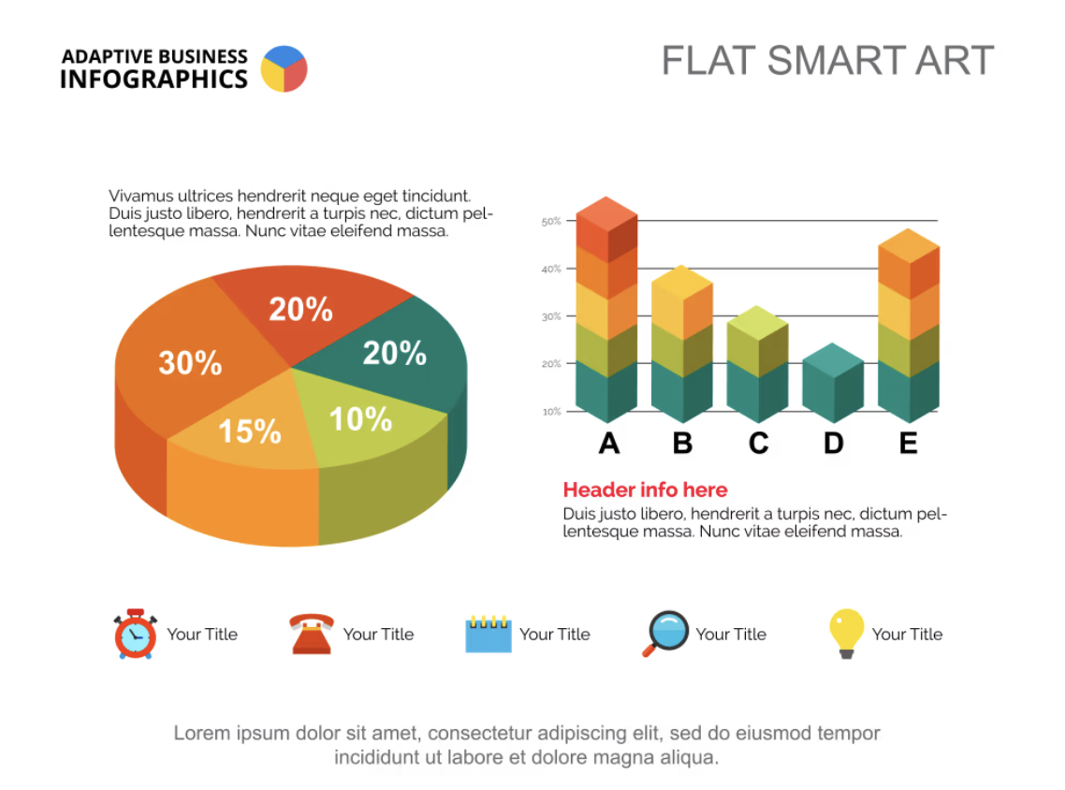
• [Placeholder]: Define the critical, measurable goals that will determine the project's success (e.g., 99.9% uptime, completion on time and on budget).

About TechCorp / CPX

CPX Purpose & Value
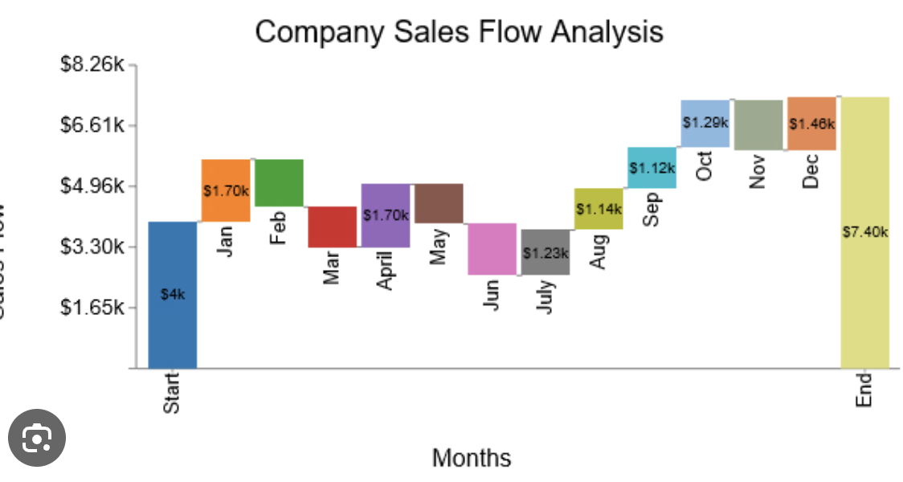
CPX is a leading technology solutions provider specializing in enterprise-grade systems integration, custom software development, and digital transformation initiatives. Our purpose is to deliver innovative solutions that drive business growth and operational excellence.

Key Information
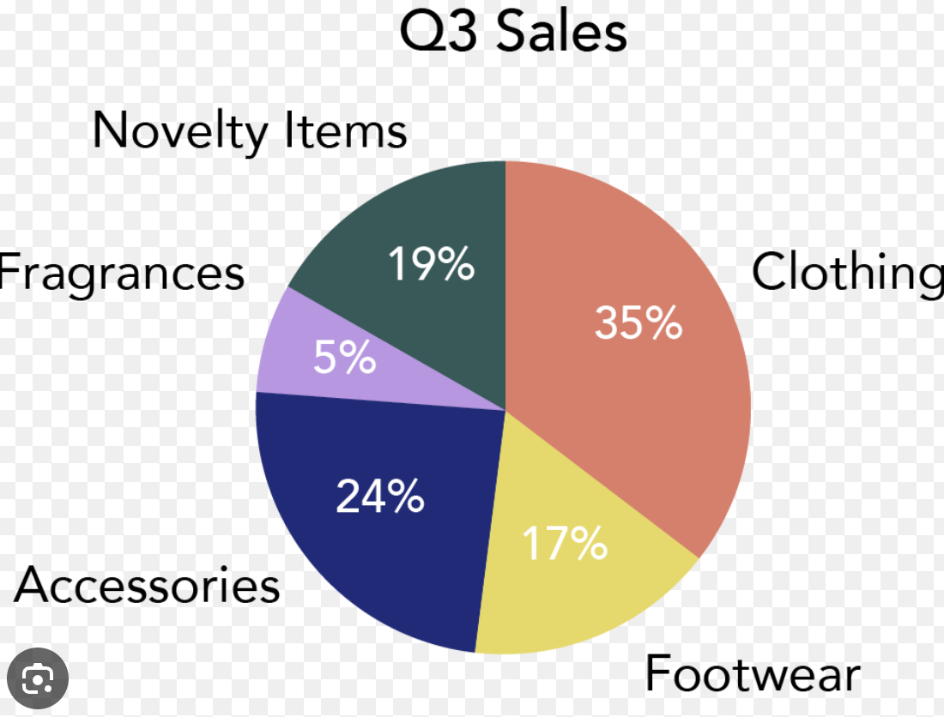
• Founded: 2015
• Headquarters: Global presence with offices in major business centers
• Team Size: 500+ certified professionals
• Industries Served: Financial Services, Healthcare, Government, Manufacturing
• Client Base: 200+ satisfied clients worldwide

Certifications & Accreditations
• ISO 27001 Information Security Management
• ISO 9001 Quality Management Systems
• CMMI Level 5 for Development and Services
• Cloud platform certifications (AWS, Azure, GCP)
• Industry-specific compliance certifications

Technical Architecture

System Overview
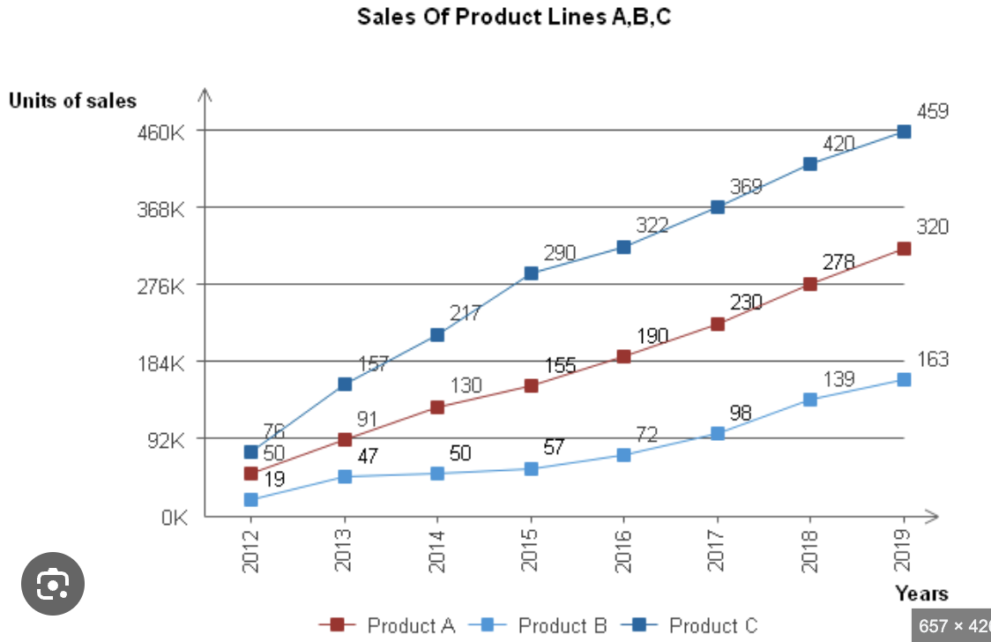
- The proposed system will consist of a multi-tier architecture, including presentation, application, and data layers.
- The system will be designed to support high availability and fault tolerance to ensure uninterrupted service.

Technology Stack
- Frontend: HTML5, CSS3, JavaScript (React.js)
- Backend: Node.js, Express.js
- Database: MongoDB
- Cloud Platform: AWS (Amazon Web Services)

Security Architecture
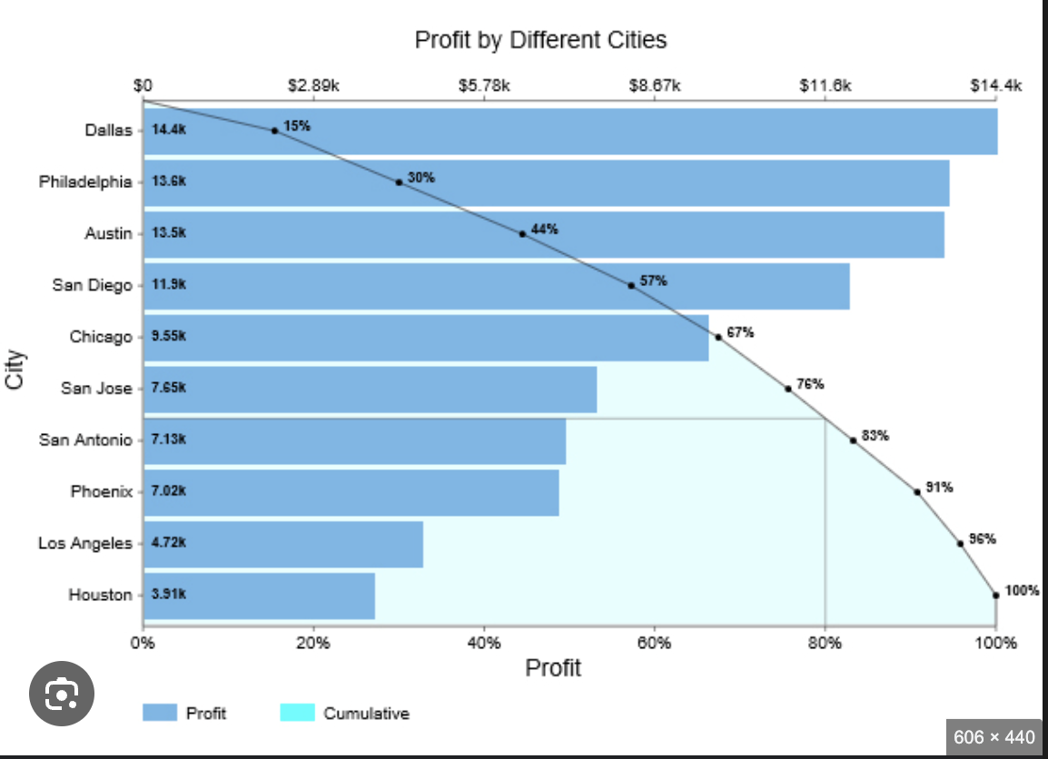
- Implementation of 24/7 Security Operations Center (SOC) monitoring for real-time threat detection and response.
- Deployment of Security Information and Event Management (SIEM) system for log analysis and correlation.
- Incident response procedures to be in place with a target response time of 1 hour.
- Compliance with ISO 27001 standards for information security management.

System Requirements and Specifications

Functional Requirements
- User authentication and authorization mechanisms.
- Data encryption at rest and in transit.
- Role-based access control for system users.
- Audit logging for all system activities.

Non-Functional Requirements
- System performance: Response time < 500ms under peak load.
- Scalability: Ability to handle a 20% increase in user traffic within 6 months.
- Availability: 99.9% uptime guarantee.
- Disaster recovery plan in place with regular backups and data replication.

Implementation Approach and Methodology
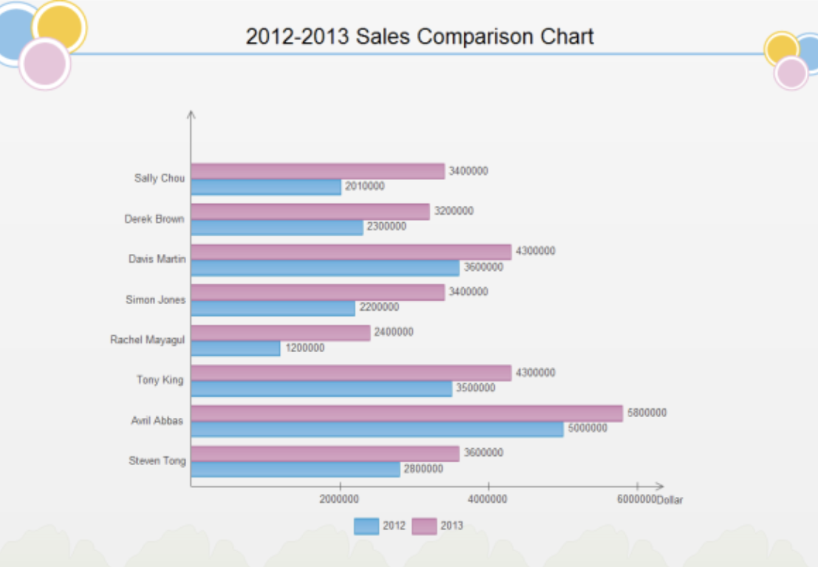

Agile Development Methodology
- Utilization of Scrum framework for iterative development and frequent releases.
- Continuous integration and deployment practices to ensure code quality and reliability.
- Regular sprint reviews with stakeholders for feedback and validation.

Integration Requirements
- Integration with existing LDAP directory service for user management.
- API integration with third-party services for data exchange.
- Webhooks for real-time notifications and event-driven architecture.

Scalability and Performance Considerations

Scalability
- Horizontal scaling of application servers to handle increased user load.
- Database sharding for distributed data storage and retrieval.
- Load balancing to distribute traffic evenly across servers.

Performance
- Caching mechanisms for frequently accessed data.
- Query optimization and indexing for efficient database operations.
- Monitoring tools for performance metrics and proactive tuning.

Technical Standards and Compliance

Industry Standards
- Adherence to OWASP (Open Web Application Security Project) guidelines for secure coding practices.
- Compliance with GDPR (General Data Protection Regulation) for data privacy and protection.
- Regular security audits and penetration testing to identify vulnerabilities.
---
This content provides a comprehensive overview of the technical aspects of the RFP proposal, addressing key requirements and specifications while ensuring alignment with industry best practices.

