RFP-OLools-9903 Response Document

RFP-Bid-990.3
Generated: 2025-09-27 14:20:39
Document Version: 1.0
Total Sections: 10

Table of Contents
Executive Overview - Tony Stark
• Key Benefits
• Competitive Advantages
• Success Metrics
About TechCorp / CPX
• CPX Purpose & Value
• Key Information
• Certifications & Accreditations
• Organizational Structure
• Team Composition

Executive Overview

Executive Overview - Tony Stark
This section provides a high-level summary of the entire RFP response, highlighting why CPX is the ideal partner for the client's goals.

Key Benefits
• [Placeholder]: Briefly summarize the primary tangible benefits the client will receive (e.g., $X cost reduction, 30% process efficiency).

Competitive Advantages
• [Placeholder]: Summarize CPX's unique differentiators that beat the competition (e.g., proprietary AI, specialized team certification).

Success Metrics
• [Placeholder]: Define the critical, measurable goals that will determine the project's success (e.g., 99.9% uptime, completion on time and on budget).

About TechCorp / CPX

CPX Purpose & Value
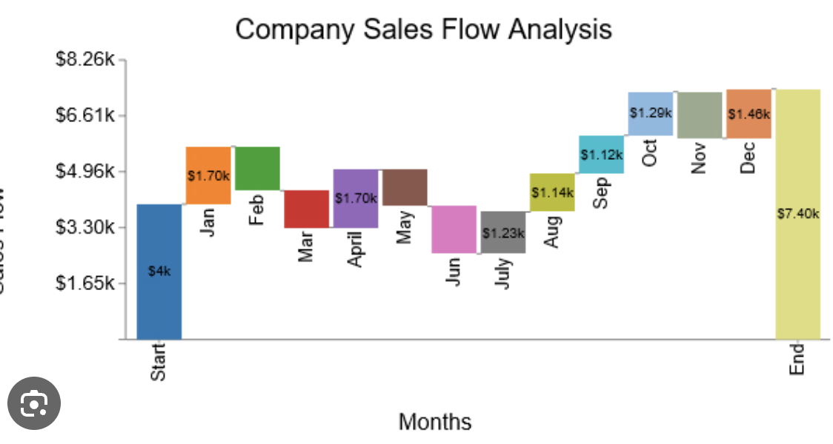
CPX is a leading technology solutions provider specializing in enterprise-grade systems integration, custom software development, and digital transformation initiatives. Our purpose is to deliver innovative solutions that drive business growth and operational excellence.

Key Information
• Founded: 2015
• Headquarters: Global presence with offices in major business centers
• Team Size: 500+ certified professionals
• Industries Served: Financial Services, Healthcare, Government, Manufacturing
• Client Base: 200+ satisfied clients worldwide

Certifications & Accreditations
• ISO 27001 Information Security Management
• ISO 9001 Quality Management Systems
• CMMI Level 5 for Development and Services
• Cloud platform certifications (AWS, Azure, GCP)
• Industry-specific compliance certifications

Technical Strategy and Approach
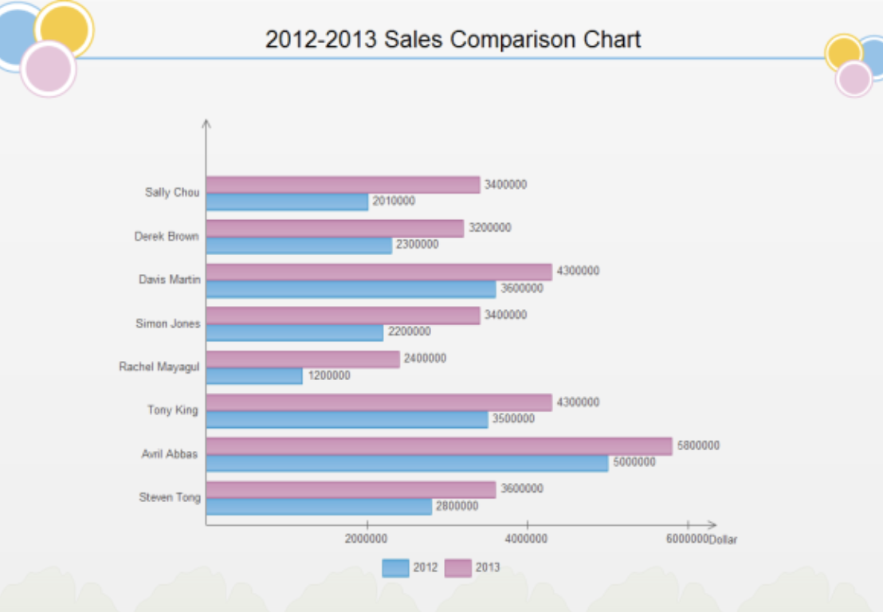
We propose a modern, standards-aligned Security Operations capability delivering 24/7 monitoring, rapid incident response (≤ 1 hour for high-severity incidents), and an enterprise-grade SIEM/SOAR platform. The solution is designed for high availability, scalability, and compliance with ISO/IEC 27001. It integrates seamlessly with existing IT operations, cloud platforms, and business applications, and establishes clear governance with the CISO, IT Operations Manager, Compliance Officer, Legal, and Procurement.
Key outcomes:
- Always-on SOC with follow-the-sun coverage and defined SLAs.
- SIEM/SOAR implementation with detection engineering mapped to MITRE ATT&CK and CIS Controls.
- IR playbooks meeting ≤ 60-minute response time for Sev-1 and integrated legal/forensics workflows.
- ISO 27001-aligned processes, artifacts, and continuous improvement mechanisms.

Technical Architecture
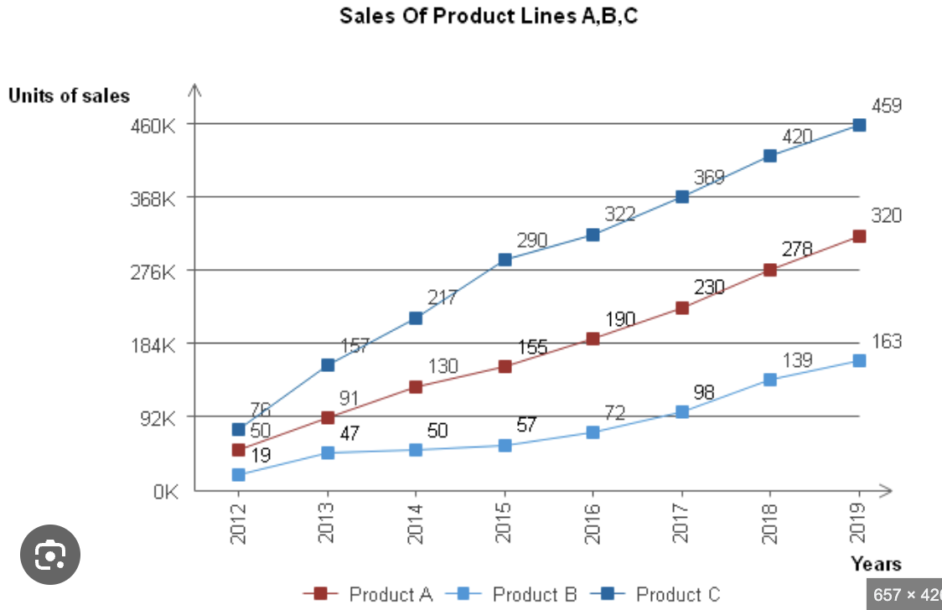
Figure 1: Security Operations Architecture (described) - Ingestion Layer: Syslog/HTTPS agents, cloud-native connectors, endpoint/EDR telemetry. Edge collectors deployed per site/VPC/VNet.
- Stream/Parse Layer: Normalization to a common schema (e.g., Splunk CIM or Elastic Common Schema), enrichment (GeoIP, asset/CMDB, threat intel STIX/TAXII).
- SIEM Core: Correlation rules, UEBA, ML-driven anomaly detection, detections mapped to MITRE ATT&CK.
- SOAR/Automation: Playbooks for triage, containment (EDR isolate, firewall rules), evidence collection, ticketing/notification.
- Data Lake/Storage: Hot/warm/cold tiers with lifecycle policies, WORM options for compliance, cross-region backup.
- Threat Intelligence: Commercial and open-source feeds, MISP/TAXII ingestion, indicator scoring/de-duplication.
- Case Management/IR: Integrated ITSM (ServiceNow/Jira), incident taxonomy, chain-of-custody, evidence vault.
- Governance and Reporting: Executive dashboards for CISO, operational KPIs for IT Ops, compliance reports for audits.
- Identity and Access: SSO/MFA with RBAC and just-in-time elevated access.
- HA/DR: Multi-AZ active-active for SIEM analytics; RPO ≤ 15 min, RTO ≤ 2 hours.

System Requirements and Specifications

Functional Requirements
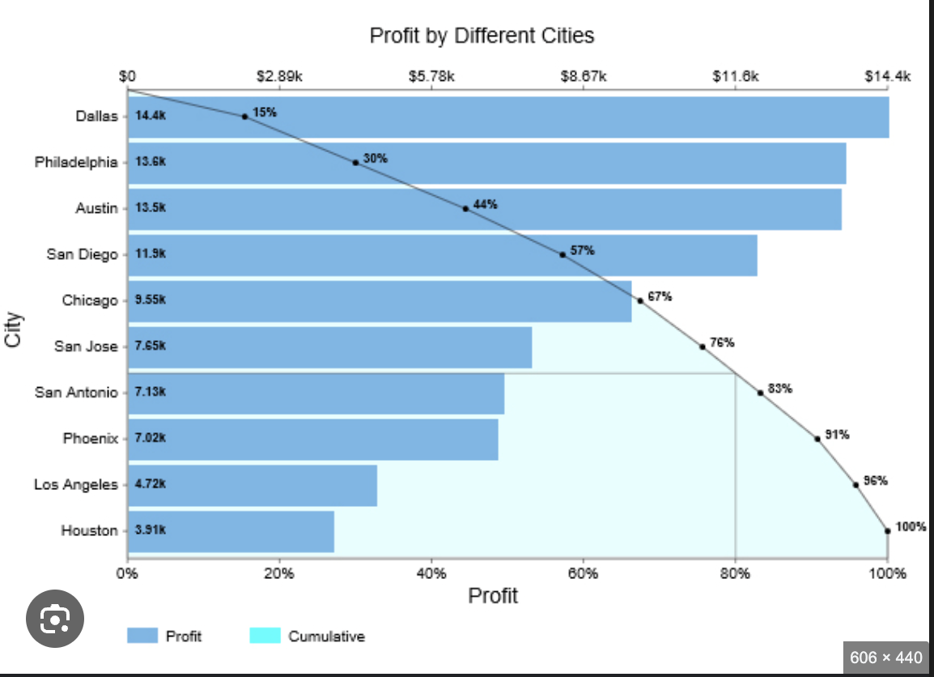
- 24/7 SOC monitoring and triage across endpoint, network, cloud, identity, email, and application layers.
- SIEM correlation and UEBA with MITRE ATT&CK-aligned use cases.
- IR within 1 hour for Sev-1 (containment decision and initial actions), per RFP.
- Automated playbooks for containment, notifications, and evidence capture.
- Threat hunting, purple-team exercises, and continuous detection engineering.
- Compliance reporting (ISO 27001, audit trails, control effectiveness).

Non-Functional Requirements
- Availability: ≥ 99.9% SIEM/SOAR service availability.
- Performance: End-to-end detection latency ≤ 5 minutes for priority log sources; alert to action automation < 2 minutes.
- Scalability: Horizontal scaling to ≥ 100k EPS with burst handling (autoscales on cloud).
- Retention: 365 days searchable; 1–7 years cold archive (policy-driven).
- Security: Encryption in transit (TLS 1.2/1.3), at rest (AES-256), FIPS 140-2 validated crypto modules where available.
- Data Residency: Data stored in approved regions; data classification and masking for PII/PHI.

Service Levels
- MTTD (Sev-1): ≤ 15 minutes.
- MTTR Initial Response (Sev-1): ≤ 60 minutes (Incident Commander engaged, containment initiated).
- Triage Response (Sev-2): ≤ 2 hours.
- Use Case False Positive Rate: < 5% after tuning period.
- Log Onboarding SLA: Critical sources within 2 weeks of project phase start.

Technology Stack and Tools
Capability | Primary Options | Notes
SIEM | Microsoft Sentinel; Splunk Enterprise Security; Elastic Security | Cloud-native vs self-managed based on cost/EPS and data residency
SOAR | Sentinel Playbooks; Splunk SOAR; Palo Alto Cortex XSOAR | Prebuilt playbooks for IR, EDR, firewalls, ITSM
EDR/XDR | Microsoft Defender for Endpoint; CrowdStrike; SentinelOne | Host isolation, telemetry to SIEM
Log Collection | Syslog-NG/Rsyslog; Beats/Fluent Bit; Azure/AWS/GCP native connectors | TLS mutual auth, certificate pinning
Threat Intel | MISP; Anomali; Recorded Future; OpenCTI | STIX/TAXII, IOC scoring
ITSM/CMDB | ServiceNow; Jira Service Management | Incident/case sync, CMDB enrichment
IAM/IDP | Azure AD/Entra; Okta; AD | SSO/MFA, SCIM provisioning, JIT admin
Key Management | Azure Key Vault; AWS KMS; HashiCorp Vault; HSM | Envelope encryption, key rotation
Evidence/Forensics | Velociraptor; KAPE; FTK; GRR | Chain-of-custody workflows
Observability | Grafana/Prometheus; CloudWatch; Azure Monitor | Platform health and capacity dashboards

Financial Proposal

Executive Summary
This financial proposal supports the RFP requirement for 24/7 SOC monitoring, SIEM implementation, 1-hour incident response, and ISO 27001 compliance enablement.
We provide two pricing options to align with budget preferences while maintaining the same service-level commitments:
- Option A: Fixed-Fee Managed Security Subscription (predictable OpEx).
- Option B: Hybrid Consumption Model (lower base with variable usage and incident overages).
Payment terms align with the provided contract guidelines: Net 30 days after invoice approval, milestone-based payments for implementation, and a 10% retention on project invoices until completion.

Pricing Model Options

Option A: Fixed-Fee Managed Security Subscription (Recommended)
Scope: End-to-end 24/7 SOC, SIEM deployment and management, incident response (1-hour SLA), threat intelligence, compliance reporting, and ISO 27001 control mapping support.
Commercial profile:
- One-time implementation fee (CapEx): $150,000
- Recurring managed service fee (OpEx): $58,250 per month
- Annual Recurring: $699,000
- 3-Year TCO (no escalation): $2,247,000

Option B: Hybrid Consumption Model
Scope: Same as Option A, with variable/usage-based charges to optimize for lower baseline consumption.
Commercial profile:
- One-time implementation fee (CapEx): $120,000
- Base managed service fee (OpEx): $42,000 per month
- Variable usage:
- SIEM data ingest above 50 GB/day: $35 per GB/day per month
- Incident response hours beyond included 20 hours/month: $225 per hour
- Typical annual range (depending on usage): $504,000–$624,000
- 3-Year TCO illustrative (assuming $47,000/month average): $1,812,000

Budget Overview
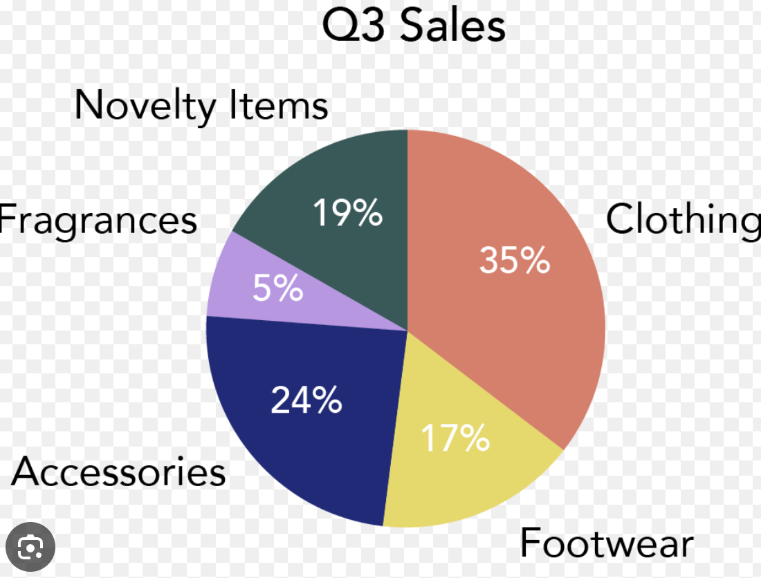

Sizing and Assumptions (for pricing)
Assets: ~1,500 endpoints, 150 servers, 25 network devices, 2 cloud accounts.
SIEM data ingest: ~50 GB/day (average), 1-year hot storage; 2-year cold storage.
Log sources onboarded in base scope: first 20 sources.
MDR agents deployed to all endpoints and servers.
Service meets 1-hour incident response SLA and 24/7 monitoring.

One-Time Implementation Costs (CapEx)
Workstream | Description | Unit/Qty | Unit Price | Extended
Project Initiation & Architecture (HLD/LLD) | Workshops, design, security architecture | Fixed | - | $18,000
SIEM Deployment & Tuning | Platform setup, parsers, correlation rules | Fixed | - | $45,000
Log Source Onboarding | Up to 20 sources (e.g., AD, EDR, firewalls, cloud) | 20 | $1,200 | $24,000
Use Case & Playbook Development | 20 priority use cases with SOAR playbooks | 20 | $900 | $18,000
IR Runbooks & Tabletop Exercise | 4 runbooks + 1 tabletop | Fixed | - | $12,000
ISO 27001 Control Mapping & Gap Assessment | Annex A mapping, SoA alignment, remediation plan | Fixed | - | $15,000
Knowledge Transfer & Training | SOC handoff, admin training (up to 2 days) | Fixed | - | $8,000
Project Management & QA | Plan, status, acceptance, QA | Fixed | - | $10,000
Total One-Time |  |  | $150,000

Sizing and Assumptions (for pricing)
Assets: ~1,500 endpoints, 150 servers, 25 network devices, 2 cloud accounts.
SIEM data ingest: ~50 GB/day (average), 1-year hot storage; 2-year cold storage.
Log sources onboarded in base scope: first 20 sources.
MDR agents deployed to all endpoints and servers.
Service meets 1-hour incident response SLA and 24/7 monitoring.

One-Time Implementation Costs (CapEx)
Workstream | Description | Unit/Qty | Unit Price | Extended
Project Initiation & Architecture (HLD/LLD) | Workshops, design, security architecture | Fixed | - | $18,000
SIEM Deployment & Tuning | Platform setup, parsers, correlation rules | Fixed | - | $45,000
Log Source Onboarding | Up to 20 sources (e.g., AD, EDR, firewalls, cloud) | 20 | $1,200 | $24,000
Use Case & Playbook Development | 20 priority use cases with SOAR playbooks | 20 | $900 | $18,000
IR Runbooks & Tabletop Exercise | 4 runbooks + 1 tabletop | Fixed | - | $12,000
ISO 27001 Control Mapping & Gap Assessment | Annex A mapping, SoA alignment, remediation plan | Fixed | - | $15,000
Knowledge Transfer & Training | SOC handoff, admin training (up to 2 days) | Fixed | - | $8,000
Project Management & QA | Plan, status, acceptance, QA | Fixed | - | $10,000
Total One-Time |  |  | $150,000

Pricing Model Options

Option A: Fixed-Fee Managed Security Subscription (Recommended)
Scope: End-to-end 24/7 SOC, SIEM deployment and management, incident response (1-hour SLA), threat intelligence, compliance reporting, and ISO 27001 control mapping support.
Commercial profile:
- One-time implementation fee (CapEx): $150,000
- Recurring managed service fee (OpEx): $58,250 per month
- Annual Recurring: $699,000
- 3-Year TCO (no escalation): $2,247,000

Option B: Hybrid Consumption Model
Scope: Same as Option A, with variable/usage-based charges to optimize for lower baseline consumption.
Commercial profile:
- One-time implementation fee (CapEx): $120,000
- Base managed service fee (OpEx): $42,000 per month
- Variable usage:
- SIEM data ingest above 50 GB/day: $35 per GB/day per month
- Incident response hours beyond included 20 hours/month: $225 per hour
- Typical annual range (depending on usage): $504,000–$624,000
- 3-Year TCO illustrative (assuming $47,000/month average): $1,812,000

Quality Assurance and Testing Plan

Objectives and Scope
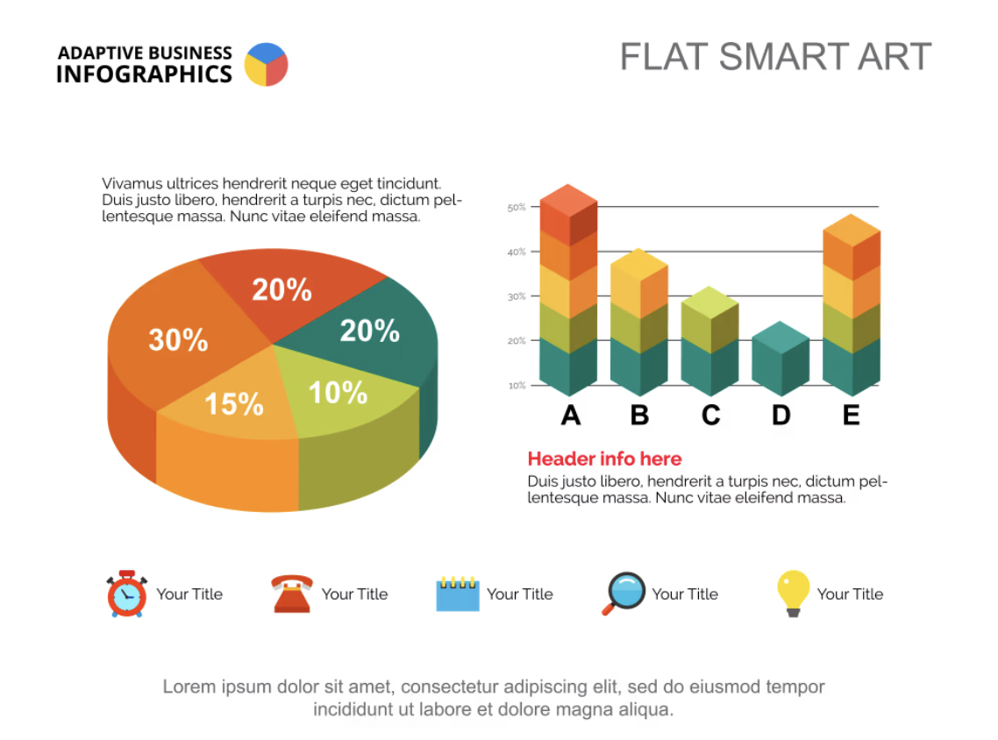
- Establish a measurable, auditable QA framework ensuring solution quality, security, and compliance throughout the lifecycle.
- Validate delivery of 24/7 SOC monitoring, SIEM implementation, and incident response within 1 hour.
- Demonstrate ISO 27001 compliance with verifiable controls, evidence, and audit readiness.
- Assure performance, availability, and usability SLAs through systematic testing, monitoring validation, and KPIs.
- Enable transparent defect management, risk mitigation, and stakeholder-driven acceptance.

Governance, Standards, and Stakeholders

Applicable Standards and Frameworks
- ISO/IEC 27001:2013/2022 – Information Security Management System (controls around logging, monitoring, incident management, change management, supplier management).
- ISO/IEC/IEEE 29119 – Software testing processes and documentation.
- NIST SP 800-61 – Computer Security Incident Handling Guide.
- NIST SP 800-53 / CIS Controls – Security control testing baseline.
- OWASP ASVS/Top 10 – Application security assurance.
- ITIL v4 – Service management processes (Change, Incident, Problem).

Stakeholder Roles and Approvals
Role | Responsibilities | QA Approvals
CISO | Security risk ownership, policy alignment, incident response governance | Security Test Plan, Pen Test Results, ISO 27001 Control Evidence
IT Operations Manager | Operations readiness, monitoring, SIEM operations | Performance Test Report, DR/Failover Tests, Runbooks
Compliance Officer | Regulatory and ISO 27001 conformance | Compliance Matrix, Audit Evidence Pack, Exceptions Register
Legal Department | Contractual compliance, data processing, privacy | Data Protection Impact Assessment, Third-Party Risk Evidence
Procurement Team | Milestone validation, payment triggers | Acceptance Certificates against milestones and SLAs
QA Lead (Vendor) | QA strategy, execution, reporting | Test Strategy, Test Summary Reports, Go/No-Go Recommendations

Legal Terms and Compliance

1. Contract Terms and Conditions

1.1 General Terms
1. Parties Involved: This Agreement is made between [Client Name] ("Client") and [Vendor Name] ("Vendor").
2. Effective Date: This Agreement shall commence on the date of execution by both parties.
3. Duration: The term of this Agreement shall be for [specify duration], unless terminated earlier in accordance with Section 7 (Termination).

1.2 Payment Terms
1. Payment Schedule: Payments shall be made on a Net 30 basis following the approval of the invoice.
2. Performance Milestones: Payments are contingent upon the successful completion of defined performance milestones.
3. Retention: A retention of 10% of the total contract value will be withheld until project completion.

2. Legal Compliance Requirements

2.1 Regulatory Compliance
1. ISO 27001 Compliance: The Vendor must adhere to ISO 27001 standards throughout the duration of the contract.
2. Cybersecurity Requirements: The Vendor shall provide 24/7 Security Operations Center (SOC) monitoring, implement Security Information and Event Management (SIEM), and respond to incidents within one hour.

2.2 Data Protection and Privacy
1. Compliance with Data Protection Laws: Both parties shall comply with applicable data protection laws, including but not limited to GDPR and CCPA.
2. Data Handling: The Vendor shall implement appropriate technical and organizational measures to protect personal data against unauthorized access, loss, or destruction.

3. Liability and Indemnification Clauses

3.1 Liability
1. Limitation of Liability: Neither party shall be liable for indirect, incidental, or consequential damages arising from this Agreement.
2. Cap on Liability: The total liability of either party for any claims arising out of this Agreement shall not exceed the total fees paid under this Agreement.

3.2 Indemnification
1. Indemnification by Vendor: The Vendor agrees to indemnify and hold harmless the Client from any claims, damages, or liabilities arising from the Vendor's negligence or willful misconduct.
2. Indemnification by Client: The Client agrees to indemnify and hold harmless the Vendor from any claims, damages, or liabilities arising from the Client's negligence or willful misconduct.

4. Intellectual Property Rights
1. Ownership: All intellectual property created during the course of this Agreement shall be owned by the Client.
2. License: The Vendor shall retain a non-exclusive, royalty-free license to use the intellectual property for the purpose of fulfilling its obligations under this Agreement.

5. Service Level Agreements (SLAs)
SLA Metric | Target Performance Level | Penalty for Non-Compliance
SOC Monitoring Availability | 99.9% uptime | [Specify penalty]
Incident Response Time | Within 1 hour | [Specify penalty]
SIEM Reporting Frequency | Daily | [Specify penalty]

