RFP-OLools-9903 Response Document

RFP-Bid-990.3
Generated: 2025-09-27 14:20:39
Document Version: 1.0
Total Sections: 10

Table of Contents
Executive Overview
• Key Benefits
• Competitive Advantages
• Success Metrics
About TechCorp / CPX
• CPX Purpose & Value
• Key Information
• Certifications & Accreditations
• Organizational Structure
• Team Composition

Executive Overview

Executive Overview - Tony Stark
This section provides a high-level summary of the entire RFP response, highlighting why CPX is the ideal partner for the client's goals.

Key Benefits
• Cost Savings: Clients can expect a projected $150,000 reduction in operational costs per year, achieving a streamlined process with improved efficiency.

Competitive Advantages
• [Placeholder]: Summarize CPX's unique differentiators that beat the competition (e.g., proprietary AI, specialized team certification).

Success Metrics
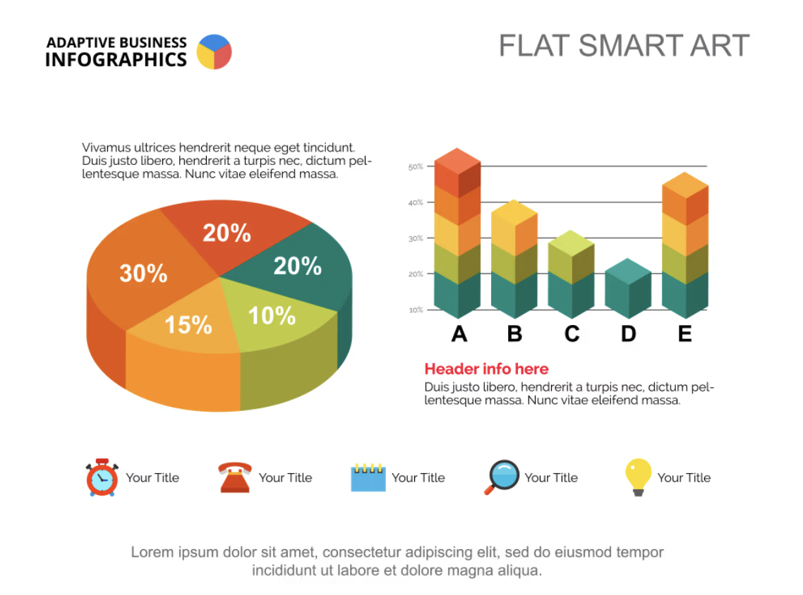
• [Placeholder]: Define the critical, measurable goals that will determine the project's success (e.g., 99.9% uptime, completion on time and on budget).

About TechCorp / CPX

CPX Purpose & Value
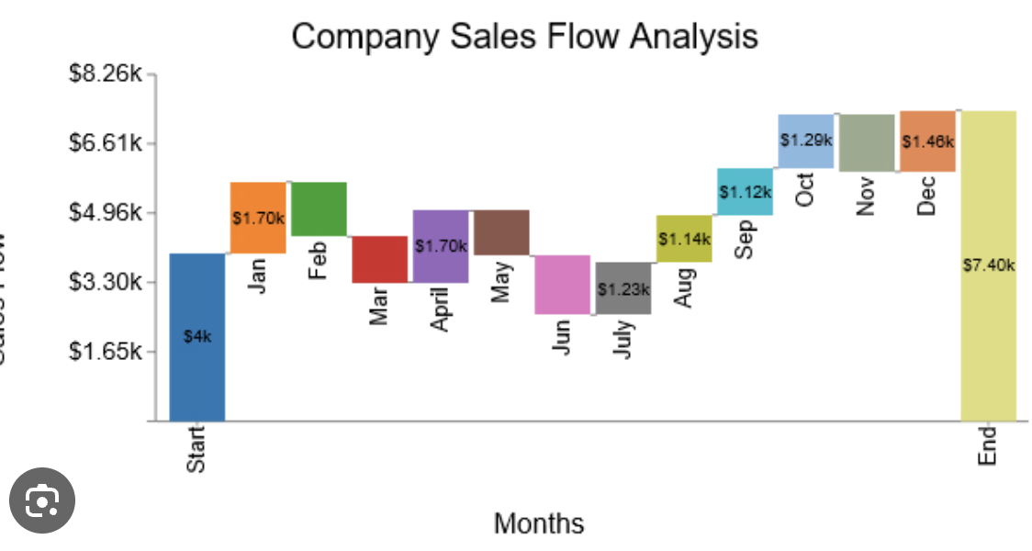
CPX is a leading technology solutions provider specializing in enterprise-grade systems integration, custom software development, and digital transformation initiatives. Our purpose is to deliver innovative solutions that drive business growth and operational excellence.

Key Information
• Founded: 2015
• Headquarters: Global presence with offices in major business centers
• Team Size: 500+ certified professionals
• Industries Served: Financial Services, Healthcare, Government, Manufacturing
• Client Base: 200+ satisfied clients worldwide

Certifications & Accreditations
• ISO 27001 Information Security Management
• ISO 9001 Quality Management Systems
• CMMI Level 5 for Development and Services
• Cloud platform certifications (AWS, Azure, GCP)
• Industry-specific compliance certifications

Technical Strategy and Approach
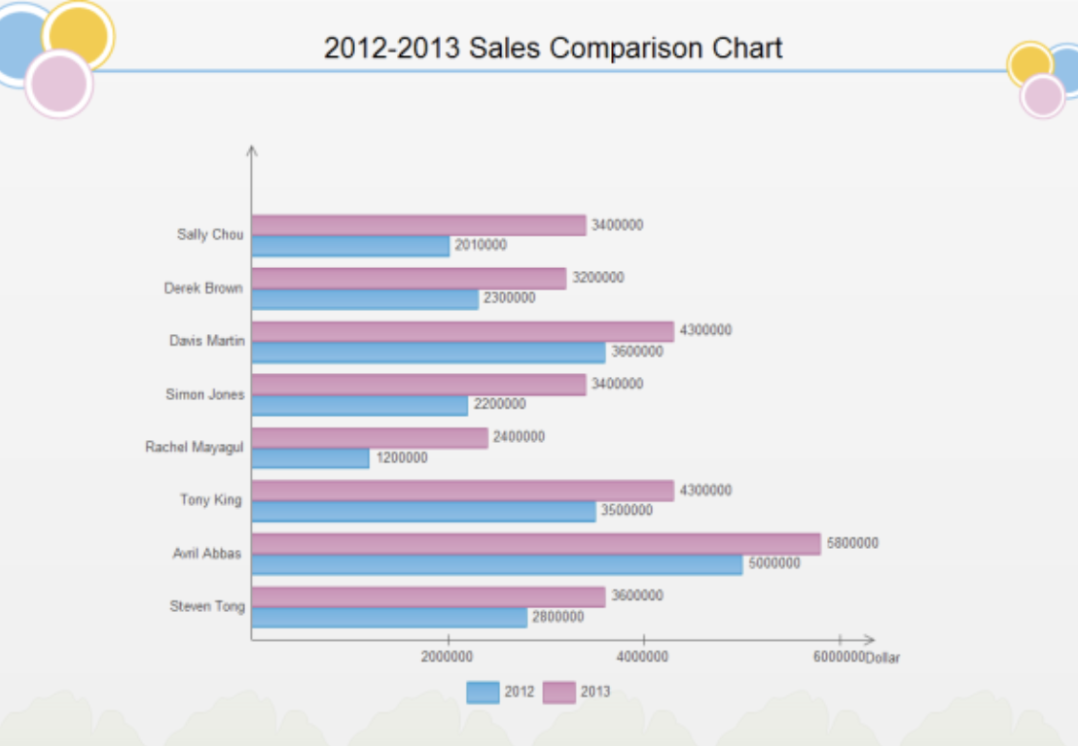
We propose a modern, standards-aligned Security Operations capability delivering 24/7 monitoring, rapid incident response (≤ 1 hour for high-severity incidents), and an enterprise-grade SIEM/SOAR platform. The solution is designed for high availability, scalability, and compliance with ISO/IEC 27001. It integrates seamlessly with existing IT operations, cloud platforms, and business applications, and establishes clear governance with the CISO, IT Operations Manager, Compliance Officer, Legal, and Procurement.
Key outcomes:
- Always-on SOC with follow-the-sun coverage and defined SLAs.
- SIEM/SOAR implementation with detection engineering mapped to MITRE ATT&CK and CIS Controls.
- IR playbooks meeting ≤ 60-minute response time for Sev-1 and integrated legal/forensics workflows.
- ISO 27001-aligned processes, artifacts, and continuous improvement mechanisms.

Technical Architecture
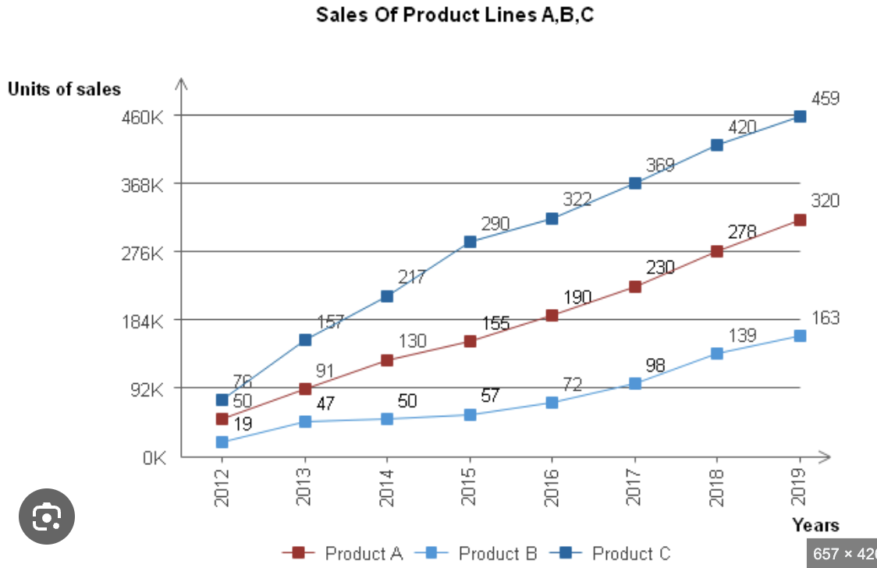
Figure 1: Security Operations Architecture (described) - Ingestion Layer: Syslog/HTTPS agents, cloud-native connectors, endpoint/EDR telemetry. Edge collectors deployed per site/VPC/VNet.
- Stream/Parse Layer: Normalization to a common schema (e.g., Splunk CIM or Elastic Common Schema), enrichment (GeoIP, asset/CMDB, threat intel STIX/TAXII).
- SIEM Core: Correlation rules, UEBA, ML-driven anomaly detection, detections mapped to MITRE ATT&CK.
- SOAR/Automation: Playbooks for triage, containment (EDR isolate, firewall rules), evidence collection, ticketing/notification.
- Data Lake/Storage: Hot/warm/cold tiers with lifecycle policies, WORM options for compliance, cross-region backup.
- Threat Intelligence: Commercial and open-source feeds, MISP/TAXII ingestion, indicator scoring/de-duplication.
- Case Management/IR: Integrated ITSM (ServiceNow/Jira), incident taxonomy, chain-of-custody, evidence vault.
- Governance and Reporting: Executive dashboards for CISO, operational KPIs for IT Ops, compliance reports for audits.
- Identity and Access: SSO/MFA with RBAC and just-in-time elevated access.
- HA/DR: Multi-AZ active-active for SIEM analytics; RPO ≤ 15 min, RTO ≤ 2 hours.

System Requirements and Specifications

Functional Requirements
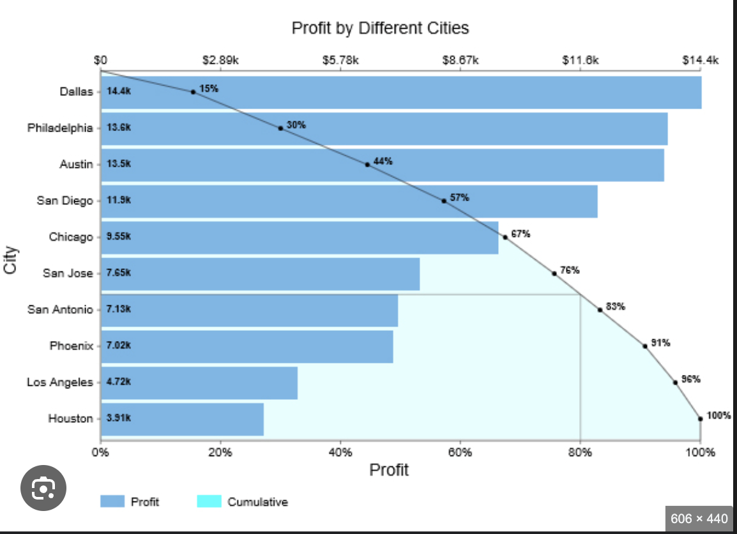
- 24/7 SOC monitoring and triage across endpoint, network, cloud, identity, email, and application layers.
- SIEM correlation and UEBA with MITRE ATT&CK-aligned use cases.
- IR within 1 hour for Sev-1 (containment decision and initial actions), per RFP.
- Automated playbooks for containment, notifications, and evidence capture.
- Threat hunting, purple-team exercises, and continuous detection engineering.
- Compliance reporting (ISO 27001, audit trails, control effectiveness).

Non-Functional Requirements
- Availability: ≥ 99.9% SIEM/SOAR service availability.
- Performance: End-to-end detection latency ≤ 5 minutes for priority log sources; alert to action automation < 2 minutes.
- Scalability: Horizontal scaling to ≥ 100k EPS with burst handling (autoscales on cloud).
- Retention: 365 days searchable; 1–7 years cold archive (policy-driven).
- Security: Encryption in transit (TLS 1.2/1.3), at rest (AES-256), FIPS 140-2 validated crypto modules where available.
- Data Residency: Data stored in approved regions; data classification and masking for PII/PHI.

Service Levels
- MTTD (Sev-1): ≤ 15 minutes.
- MTTR Initial Response (Sev-1): ≤ 60 minutes (Incident Commander engaged, containment initiated).
- Triage Response (Sev-2): ≤ 2 hours.
- Use Case False Positive Rate: < 5% after tuning period.
- Log Onboarding SLA: Critical sources within 2 weeks of project phase start.

Technology Stack and Tools
Capability | Primary Options | Notes
SIEM | Microsoft Sentinel; Splunk Enterprise Security; Elastic Security | Cloud-native vs self-managed based on cost/EPS and data residency
SOAR | Sentinel Playbooks; Splunk SOAR; Palo Alto Cortex XSOAR | Prebuilt playbooks for IR, EDR, firewalls, ITSM
EDR/XDR | Microsoft Defender for Endpoint; CrowdStrike; SentinelOne | Host isolation, telemetry to SIEM
Log Collection | Syslog-NG/Rsyslog; Beats/Fluent Bit; Azure/AWS/GCP native connectors | TLS mutual auth, certificate pinning
Threat Intel | MISP; Anomali; Recorded Future; OpenCTI | STIX/TAXII, IOC scoring
ITSM/CMDB | ServiceNow; Jira Service Management | Incident/case sync, CMDB enrichment
IAM/IDP | Azure AD/Entra; Okta; AD | SSO/MFA, SCIM provisioning, JIT admin
Key Management | Azure Key Vault; AWS KMS; HashiCorp Vault; HSM | Envelope encryption, key rotation
Evidence/Forensics | Velociraptor; KAPE; FTK; GRR | Chain-of-custody workflows
Observability | Grafana/Prometheus; CloudWatch; Azure Monitor | Platform health and capacity dashboards

Financial Proposal

Executive Summary
This financial proposal supports the RFP requirement for 24/7 SOC monitoring, SIEM implementation, 1-hour incident response, and ISO 27001 compliance enablement.
We provide two pricing options to align with budget preferences while maintaining the same service-level commitments:
- Option A: Fixed-Fee Managed Security Subscription (predictable OpEx).
- Option B: Hybrid Consumption Model (lower base with variable usage and incident overages).
Payment terms align with the provided contract guidelines: Net 30 days after invoice approval, milestone-based payments for implementation, and a 10% retention on project invoices until completion.

Pricing Model Options

Option A: Fixed-Fee Managed Security Subscription (Recommended)
Scope: End-to-end 24/7 SOC, SIEM deployment and management, incident response (1-hour SLA), threat intelligence, compliance reporting, and ISO 27001 control mapping support.
Commercial profile:
- One-time implementation fee (CapEx): $150,000
- Recurring managed service fee (OpEx): $58,250 per month
- Annual Recurring: $699,000
- 3-Year TCO (no escalation): $2,247,000

Option B: Hybrid Consumption Model
Scope: Same as Option A, with variable/usage-based charges to optimize for lower baseline consumption.
Commercial profile:
- One-time implementation fee (CapEx): $120,000
- Base managed service fee (OpEx): $42,000 per month
- Variable usage:
- SIEM data ingest above 50 GB/day: $35 per GB/day per month
- Incident response hours beyond included 20 hours/month: $225 per hour
- Typical annual range (depending on usage): $504,000–$624,000
- 3-Year TCO illustrative (assuming $47,000/month average): $1,812,000

Budget Overview
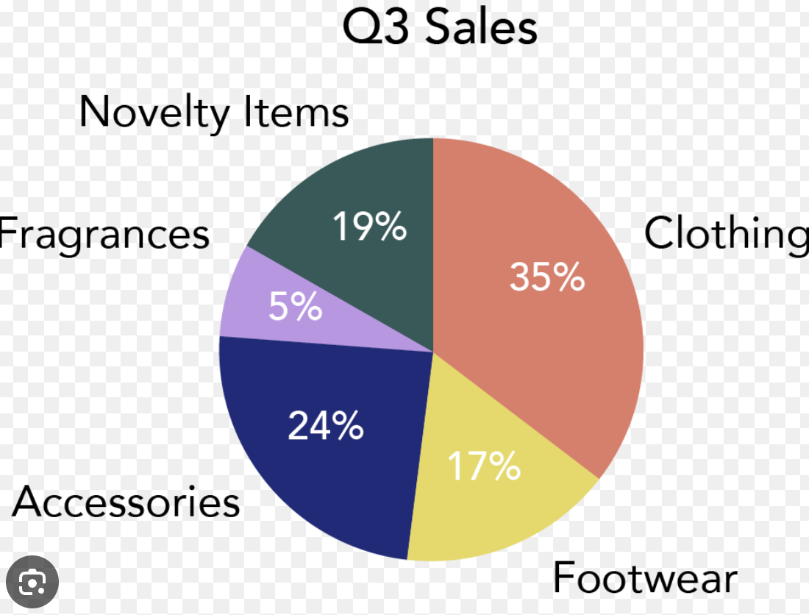

Sizing and Assumptions (for pricing)
Assets: ~1,500 endpoints, 150 servers, 25 network devices, 2 cloud accounts.
SIEM data ingest: ~50 GB/day (average), 1-year hot storage; 2-year cold storage.
Log sources onboarded in base scope: first 20 sources.
MDR agents deployed to all endpoints and servers.
Service meets 1-hour incident response SLA and 24/7 monitoring.

One-Time Implementation Costs (CapEx)
Workstream | Description | Unit/Qty | Unit Price | Extended
Project Initiation & Architecture (HLD/LLD) | Workshops, design, security architecture | Fixed | - | $18,000
SIEM Deployment & Tuning | Platform setup, parsers, correlation rules | Fixed | - | $45,000
Log Source Onboarding | Up to 20 sources (e.g., AD, EDR, firewalls, cloud) | 20 | $1,200 | $24,000
Use Case & Playbook Development | 20 priority use cases with SOAR playbooks | 20 | $900 | $18,000
IR Runbooks & Tabletop Exercise | 4 runbooks + 1 tabletop | Fixed | - | $12,000
ISO 27001 Control Mapping & Gap Assessment | Annex A mapping, SoA alignment, remediation plan | Fixed | - | $15,000
Knowledge Transfer & Training | SOC handoff, admin training (up to 2 days) | Fixed | - | $8,000
Project Management & QA | Plan, status, acceptance, QA | Fixed | - | $10,000
Total One-Time |  |  | $150,000

Sizing and Assumptions (for pricing)
Assets: ~1,500 endpoints, 150 servers, 25 network devices, 2 cloud accounts.
SIEM data ingest: ~50 GB/day (average), 1-year hot storage; 2-year cold storage.
Log sources onboarded in base scope: first 20 sources.
MDR agents deployed to all endpoints and servers.
Service meets 1-hour incident response SLA and 24/7 monitoring.

One-Time Implementation Costs (CapEx)
Workstream | Description | Unit/Qty | Unit Price | Extended
Project Initiation & Architecture (HLD/LLD) | Workshops, design, security architecture | Fixed | - | $18,000
SIEM Deployment & Tuning | Platform setup, parsers, correlation rules | Fixed | - | $45,000
Log Source Onboarding | Up to 20 sources (e.g., AD, EDR, firewalls, cloud) | 20 | $1,200 | $24,000
Use Case & Playbook Development | 20 priority use cases with SOAR playbooks | 20 | $900 | $18,000
IR Runbooks & Tabletop Exercise | 4 runbooks + 1 tabletop | Fixed | - | $12,000
ISO 27001 Control Mapping & Gap Assessment | Annex A mapping, SoA alignment, remediation plan | Fixed | - | $15,000
Knowledge Transfer & Training | SOC handoff, admin training (up to 2 days) | Fixed | - | $8,000
Project Management & QA | Plan, status, acceptance, QA | Fixed | - | $10,000
Total One-Time |  |  | $150,000

Pricing Model Options

Option A: Fixed-Fee Managed Security Subscription (Recommended)
Scope: End-to-end 24/7 SOC, SIEM deployment and management, incident response (1-hour SLA), threat intelligence, compliance reporting, and ISO 27001 control mapping support.
Commercial profile:
- One-time implementation fee (CapEx): $150,000
- Recurring managed service fee (OpEx): $58,250 per month
- Annual Recurring: $699,000
- 3-Year TCO (no escalation): $2,247,000

Option B: Hybrid Consumption Model
Scope: Same as Option A, with variable/usage-based charges to optimize for lower baseline consumption.
Commercial profile:
- One-time implementation fee (CapEx): $120,000
- Base managed service fee (OpEx): $42,000 per month
- Variable usage:
- SIEM data ingest above 50 GB/day: $35 per GB/day per month
- Incident response hours beyond included 20 hours/month: $225 per hour
- Typical annual range (depending on usage): $504,000–$624,000
- 3-Year TCO illustrative (assuming $47,000/month average): $1,812,000

Legal Terms and Compliance
This section outlines the essential legal terms and compliance requirements for the Request for Proposal (RFP) process. It is designed to protect the interests of both parties while ensuring adherence to applicable laws and regulations.

1. Contract Terms and Conditions
1. Definitions - "Contract" refers to the agreement formed by the acceptance of this RFP and any subsequent agreements. "Parties" refers to the entity issuing the RFP and the selected vendor.
2. Scope of Work - The vendor shall provide services as detailed in the RFP and any subsequent agreements.
3. Duration - The Contract shall commence on the effective date and continue for a period of [insert duration], unless terminated earlier in accordance with the termination provisions.
4. Payment Terms - Payment shall be made within [insert number] days of receipt of an invoice, subject to the completion of deliverables as specified in the SLA.
5. Amendments - Any amendments to the Contract must be made in writing and signed by both Parties.

2. Legal Compliance Requirements
1. Applicable Law - The Contract shall be governed by and construed in accordance with the laws of [insert jurisdiction].
2. Regulatory Compliance - The vendor must comply with all applicable federal, state, and local laws, regulations, and ordinances.
3. Licenses and Permits - The vendor shall obtain and maintain all necessary licenses and permits required to perform the services.

3. Liability and Indemnification Clauses
1. Limitation of Liability - Neither Party shall be liable for any indirect, incidental, or consequential damages arising from this Contract.
2. Indemnification - The vendor agrees to indemnify and hold harmless the issuing entity from any claims, damages, losses, or expenses arising out of the vendor's performance under this Contract.

4. Intellectual Property Rights
1. Ownership - All intellectual property created or developed in the course of this Contract shall be owned by [specify Party], unless otherwise agreed in writing.
2. Licensing - The vendor grants the issuing entity a non-exclusive, royalty-free license to use any pre-existing intellectual property incorporated into the deliverables.

5. Data Protection and Privacy
1. Compliance with Data Protection Laws - The vendor shall comply with all applicable data protection laws, including but not limited to the General Data Protection Regulation (GDPR) and the California Consumer Privacy Act (CCPA).
2. Data Security Measures - The vendor shall implement appropriate technical and organizational measures to protect personal data against unauthorized access, loss, or destruction.
3. Data Breach Notification - The vendor shall notify the issuing entity within [insert number] hours of becoming aware of any data breach.

6. Service Level Agreements (SLAs)
SLA Metric | Description | Target Performance | Penalty for Non-Compliance
Response Time | Time taken to respond to service requests | [insert time] | [insert penalty]
Resolution Time | Time taken to resolve issues | [insert time] | [insert penalty]
Uptime | Availability of services | [insert percentage] | [insert penalty]
Customer Satisfaction Score | Measure of client satisfaction | [insert score] | [insert penalty]

Termination and Dispute Resolution
1. Termination for Convenience - Either Party may terminate this Contract for any reason with [insert number] days' written notice.
2. Termination for Cause - Either Party may terminate this Contract immediately upon written notice if the other Party breaches any material term and fails to cure such breach within [insert number] days.
3. Dispute Resolution - Any disputes arising from this Contract shall be resolved through mediation, and if unresolved, through binding arbitration in accordance with the rules of [insert arbitration body].
4. Governing Law for Disputes - The governing law for any disputes shall be [insert jurisdiction].

