RFP-OLools-9903 Response Document

RFP-Bid-990.3
Generated: 2025-09-27 14:20:39
Document Version: 1.0
Total Sections: 10

Table of Contents
Executive Overview - Tony Stark
• Key Benefits
• Competitive Advantages
• Success Metrics
About TechCorp / CPX
• CPX Purpose & Value
• Key Information
• Certifications & Accreditations
• Organizational Structure
• Team Composition

Executive Overview
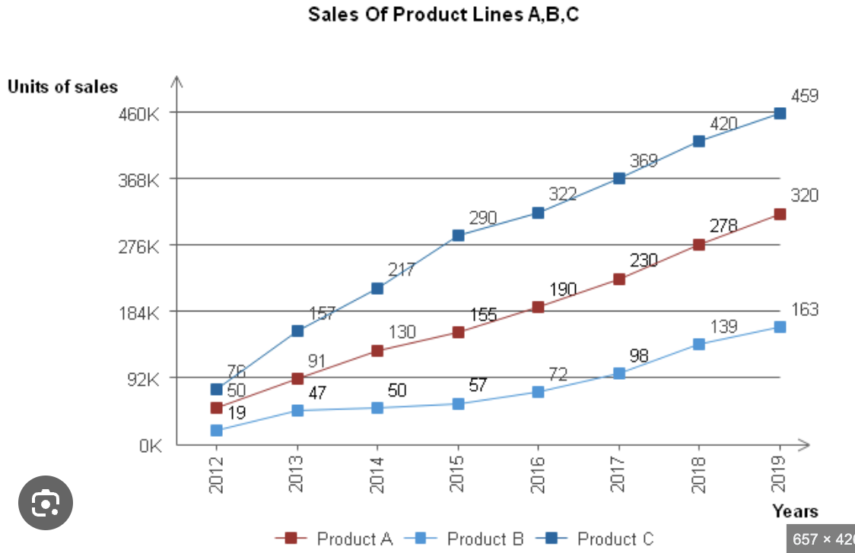

Executive Overview - Tony Stark
This section provides a high-level summary of the entire RFP response, highlighting why CPX is the ideal partner for the client's goals.

Key Benefits
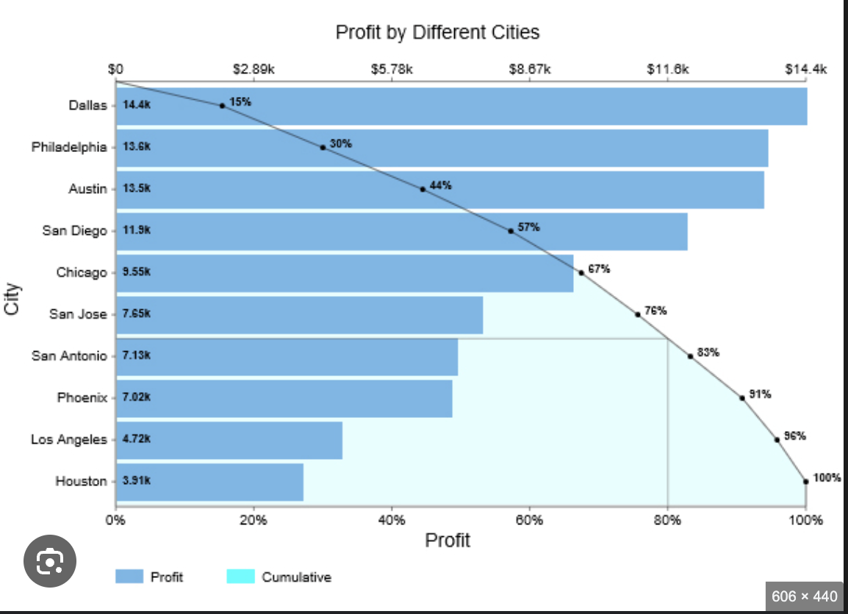
• [Placeholder]: Briefly summarize the primary tangible benefits the client will receive (e.g., $X cost reduction, 30% process efficiency).

Competitive Advantages
• [Placeholder]: Summarize CPX's unique differentiators that beat the competition (e.g., proprietary AI, specialized team certification).

Success Metrics
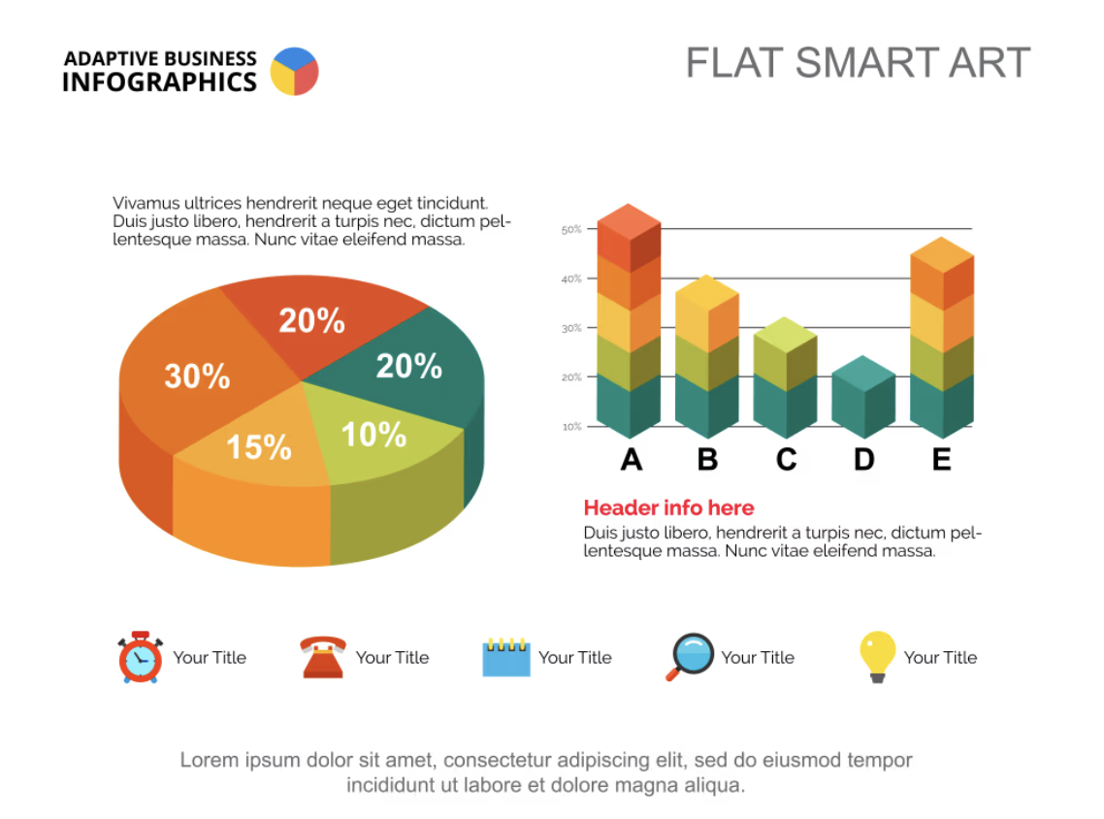
• [Placeholder]: Define the critical, measurable goals that will determine the project's success (e.g., 99.9% uptime, completion on time and on budget).

About TechCorp / CPX

CPX Purpose & Value
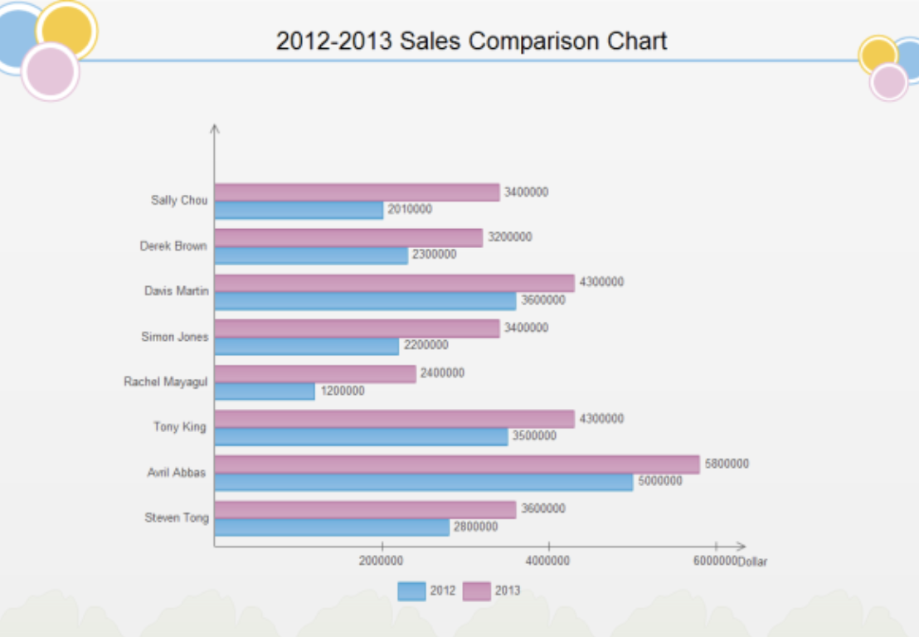
CPX is a leading technology solutions provider specializing in enterprise-grade systems integration, custom software development, and digital transformation initiatives. Our purpose is to deliver innovative solutions that drive business growth and operational excellence.

Key Information
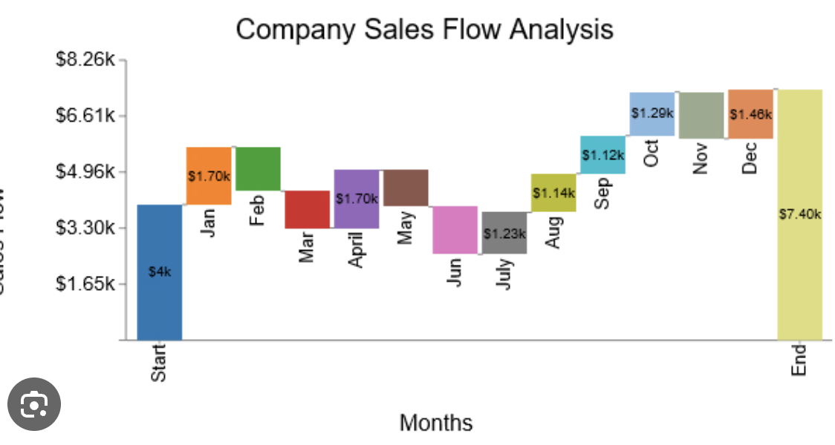
• Founded: 2015
• Headquarters: Global presence with offices in major business centers
• Team Size: 500+ certified professionals
• Industries Served: Financial Services, Healthcare, Government, Manufacturing
• Client Base: 200+ satisfied clients worldwide

Certifications & Accreditations
• ISO 27001 Information Security Management
• ISO 9001 Quality Management Systems
• CMMI Level 5 for Development and Services
• Cloud platform certifications (AWS, Azure, GCP)
• Industry-specific compliance certifications

Financial Proposal
This financial proposal outlines the budget breakdown, pricing models, payment terms, financial justifications, and risk assessments necessary for the successful execution of the project. Each section is designed to provide clarity and transparency, ensuring alignment with the client's requirements.

Budget Overview

Budget Breakdown
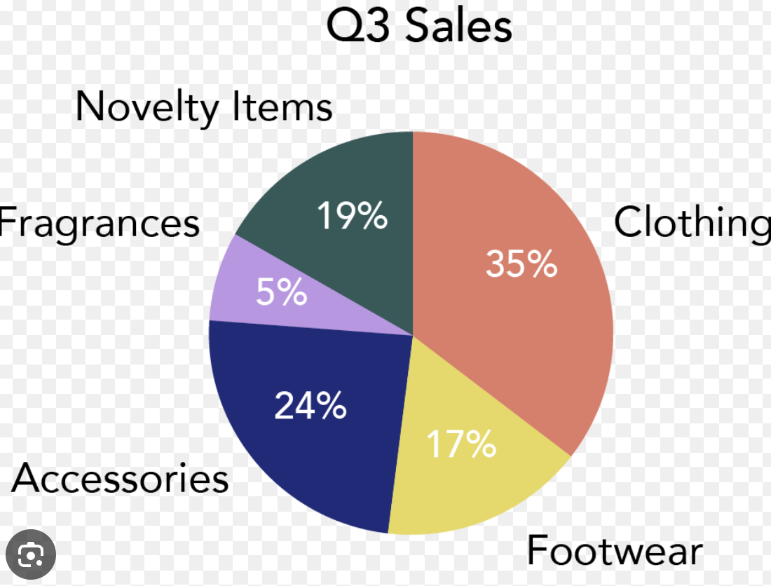
Budget Item | Description | Estimated Cost
Personnel Costs | Salaries and benefits for project staff | $150,000
Equipment and Supplies | Necessary tools and materials | $50,000
Software Licenses | Licensing fees for required software | $20,000
Travel Expenses | Travel costs for project-related activities | $15,000
Contingency Fund | Reserve for unexpected expenses | $10,000
Total Estimated Cost |  | $245,000

Pricing Models and Payment Terms
- **Fixed Price Model**: A total fixed price of $245,000 for the entire project.
- **Payment Schedule**:
- **Initial Payment**: 30% upon contract signing ($73,500)
- **Milestone Payment**: 40% upon completion of the first phase ($98,000)
- **Final Payment**: 30% upon project completion and acceptance ($73,500)

Financial Justifications and ROI Analysis
### Financial Justifications
Investing in this project is justified by the following factors:
- **Increased Efficiency**: Streamlining operations will reduce costs by an estimated 20% annually.
- **Enhanced Capabilities**: New tools and processes will allow for better service delivery and customer satisfaction.

ROI Analysis
- **Projected Annual Savings**: $50,000
- **Total Investment**: $245,000
- **Payback Period**: 5 years (calculated as Total Investment / Annual Savings)

