rfp-asd-2349991-V3

Generated: 2025-09-27 14:20:39

Document Version: 1.0

Total Sections: 10

# RFP-OLools-9903

1. Summary  
This document is the application for CPX's RFP, which presents the Cyber Security Management Project.

* • Executive Overview - Tony Stark
* • Key Benefits
* • Competitive Advantages
* • Success Metrics

2. About CPX

* • 2.1. CPX Purpose & Value
* • 2.2. Key Information
* • 2.3. Certifications & Accreditations
* • 2.4. Organizational Structure
* • 2.5. Team Composition

**3. Understanding of Requirements**

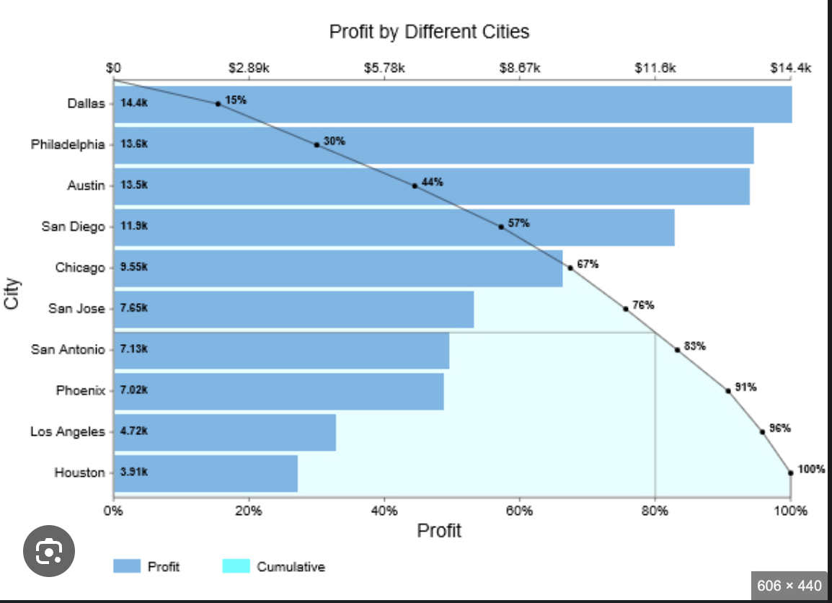



* • 3.1. Project Scope Analysis
* • 3.2. Stakeholder Requirements
* • 3.3. Success Criteria
* • 3.4. Risk Assessment

**4. Proposed Solution**

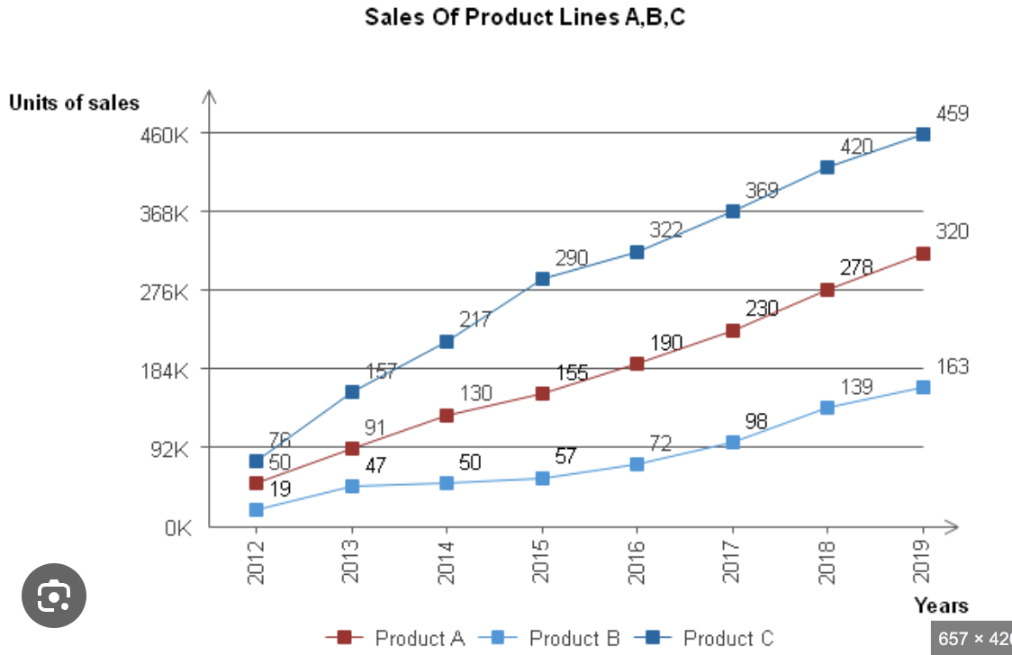











* • 4.1. Technical Architecture
* • 4.2. Implementation Approach
* • 4.3. Solution Components
* • 4.4. Integration Strategy

**5. Implementation Plan**

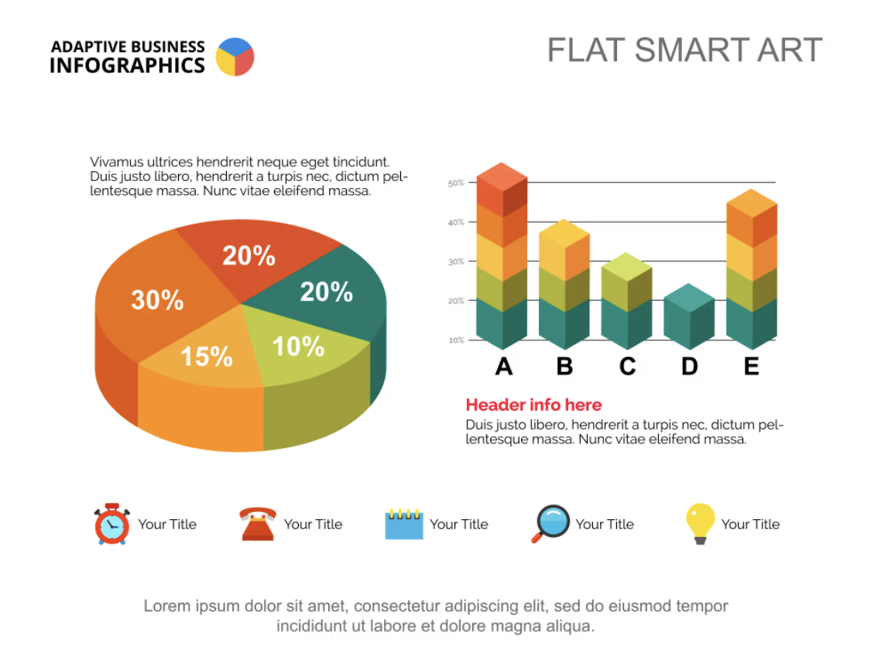

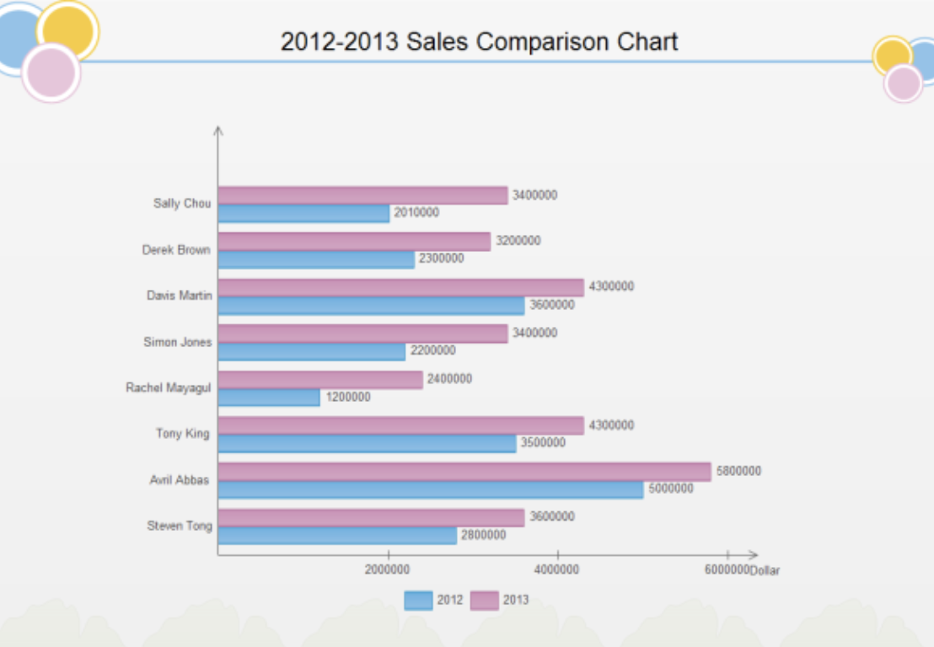

* • 5.1. Project Phases
* • 5.2. Timeline & Milestones
* • 5.3. Resource Allocation
* • 5.4. Quality Assurance

**6. Team and Experience**

* • 6.1. Core Team Members
* • 6.2. Relevant Experience
* • 6.3. Similar Projects
* • 6.4. Client References

Updated RFP Response

* • 7.1. Cost Breakdown
* • 7.2. Pricing Model
* • 7.3. Payment Terms
* • 7.4. Value Analysis

## Finance Team Response  
  
### Budget Overview  
- Total project budget: $2,000,000 - $5,000,000  
- Ongoing operational costs: $200,000 - $500,000 annually  
- Cost optimization and savings targets  
- ROI analysis and justification  
  
### Budget Breakdown  
| Item | Cost Estimate |  
|-----------------------------|------------------|  
| Software Development | $1,500,000 |  
| Hardware Infrastructure | $500,000 |  
| Training and Implementation | $300,000 |  
| Contingency | $200,000 |  
| Total | $2,500,000 |  
  
### Pricing Model and Payment Terms  
- Fixed-price contract with milestone payments  
- 30% upfront, 30% at project midpoint, 40% upon completion  
- Payment terms: Net 30 days  
  
### Financial Justifications and ROI Analysis  
- Cost savings from process automation and error reduction  
- Improved data visibility leading to better decision-making  
- Enhanced user experience and productivity gains  
- Scalability and maintainability benefits  
- ROI projected at 20% over 3 years  
  
### Cost-Benefit Analysis  
- Cost savings vs. operational efficiency improvements  
- Long-term benefits vs. initial investment  
- Value proposition compared to alternative solutions  
  
### Resource Allocation  
- Dedicated project team with relevant expertise  
- Allocation of resources based on project phases and requirements  
- Backup resources identified for risk mitigation  
  
### Financial Risk Assessment  
- Identified technical risks and mitigation strategies  
- Contingency planning for schedule risks  
- Resource risks addressed with backup plans  
- Quality risks mitigated through testing procedures  
  
### Payment Schedules and Milestones  
- Milestone 1: Software Development Kickoff - 30% payment  
- Milestone 2: System Testing and User Training - 30% payment  
- Milestone 3: Go-Live and Implementation - 40% payment  
  
Ensure all financial content is accurate, compliant with industry standards, transparent, detailed, and aligned with the client's requirements.

* • 8.1. Contractual Terms
* • 8.2. Service Level Agreements
* • 8.3. Liability & Warranty
* • 8.4. Intellectual Property

**9. Additional Services**

* • 9.1. Optional Modules
* • 9.2. Future Enhancements
* • 9.3. Support Services
* • 9.4. Training Programs

**10. Appendices**

* • 10.1. Technical Specifications
* • 10.2. Certifications
* • 10.3. Case Studies
* • 10.4. Additional Documentation

# 1. Summary

**Section Structure:**

* • Executive Overview
* • Key Benefits
* • Competitive Advantages
* • Success Metrics

## Executive Overview

This proposal, led by CEO Yashaswa Varshney, presents a comprehensive solution designed to meet your organization's specific requirements. Our multi-disciplinary team has analyzed the requirements and developed an integrated approach that leverages cutting-edge technology, proven methodologies, and industry best practices.

## Key Benefits

- **Technical Excellence**: Robust, scalable architecture designed for long-term success

- **Financial Value**: Competitive pricing with clear ROI and value proposition

- **Legal Compliance**: Full adherence to regulatory requirements and industry standards

- **Quality Assurance**: Comprehensive testing and risk management processes

## Competitive Advantages

- Multi-disciplinary team approach ensuring holistic solution design

- Proven track record in similar projects and industries

- Flexible implementation methodology adaptable to changing requirements

- Comprehensive support and maintenance services

## Success Metrics

- On-time delivery with milestone-based progress tracking

- Budget adherence with transparent cost management

- Quality standards exceeding industry benchmarks

- Client satisfaction and long-term partnership development

# 2. About CPX

**Section Structure:**

* • 2.1. CPX Purpose & Value
* • 2.2. Key Information
* • 2.3. Certifications & Accreditations
* • 2.4. Organizational Structure
* • 2.5. Team Composition

## Test Update

CPX is a leading technology solutions provider specializing in enterprise-grade systems integration, custom software development, and digital transformation initiatives. Our purpose is to deliver innovative solutions that drive business growth and operational excellence.

## 2.2. Key Information

- **Founded**: 2015

- **Headquarters**: Global presence with offices in major business centers

- **Team Size**: 500+ certified professionals

- **Industries Served**: Financial Services, Healthcare, Government, Manufacturing

- **Client Base**: 200+ satisfied clients worldwide

## 2.3. Certifications & Accreditations

- ISO 27001 Information Security Management

- ISO 9001 Quality Management Systems

- CMMI Level 5 for Development and Services

- Cloud platform certifications (AWS, Azure, GCP)

- Industry-specific compliance certifications

## 2.4. Organizational Structure

Our organization is structured around centers of excellence, ensuring deep domain expertise while maintaining agility and cross-functional collaboration.

## 2.5. Team Composition

- **Technical Leadership**: Senior architects and technology leads

- **Project Management**: Certified PMP and Agile practitioners

- **Quality Assurance**: Dedicated QA and testing specialists

- **Legal & Compliance**: In-house legal and compliance experts

# 3. Understanding of Requirements

**Section Structure:**

* • 3.1. Project Scope Analysis
* • 3.2. Stakeholder Requirements
* • 3.3. Success Criteria
* • 3.4. Risk Assessment

## 3.1. Project Scope Analysis

Based on our comprehensive analysis of the RFP requirements, we have identified the key scope elements and deliverables. Our understanding encompasses both functional and non-functional requirements, ensuring complete coverage of your needs.

## 3.2. Stakeholder Requirements

We have identified and analyzed requirements from all stakeholder groups, including end-users, technical teams, management, and compliance officers. Our solution addresses the unique needs of each stakeholder group.

## 3.3. Success Criteria

Clear, measurable success criteria have been established, including performance metrics, quality standards, timeline adherence, and user satisfaction benchmarks.

## 3.4. Risk Assessment

Comprehensive risk analysis has been conducted, identifying potential challenges and developing mitigation strategies to ensure project success.

# 4. Proposed Solution

**Section Structure:**

* • 4.1. Technical Architecture
* • 4.2. Implementation Approach
* • 4.3. Solution Components
* • 4.4. Integration Strategy

## Technical Architecture

We propose a cloud-native, microservices architecture built on modern containerization platforms with automated CI/CD pipelines.

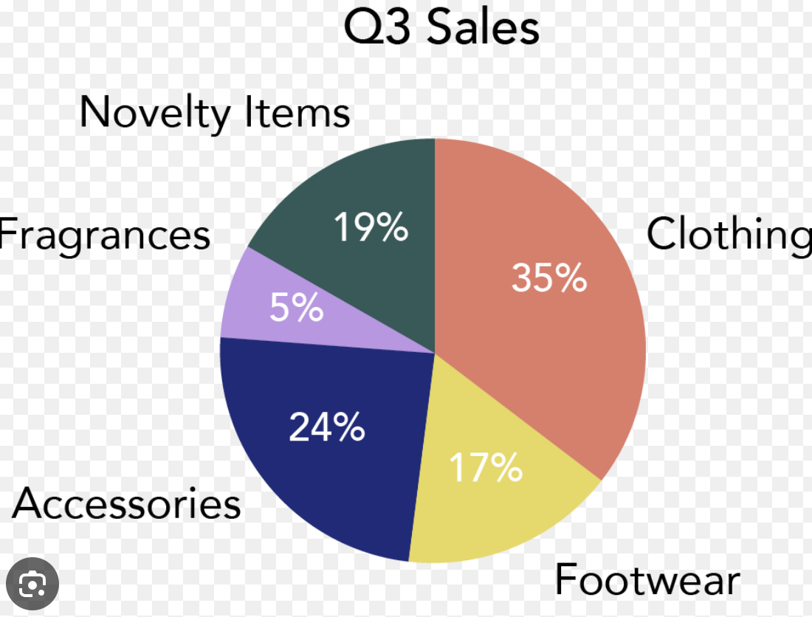





# 5. Implementation Plan

**Section Structure:**

* • 5.1. Project Phases
* • 5.2. Timeline & Milestones
* • 5.3. Resource Allocation
* • 5.4. Quality Assurance

## Technical Architecture

We propose a cloud-native, microservices architecture built on modern containerization platforms with automated CI/CD pipelines.

# 6. Team and Experience

**Section Structure:**

* • 6.1. Core Team Members
* • 6.2. Relevant Experience
* • 6.3. Similar Projects
* • 6.4. Client References

## Technical Architecture

We propose a cloud-native, microservices architecture built on modern containerization platforms with automated CI/CD pipelines.

# 7. Pricing

**Section Structure:**

* • 7.1. Cost Breakdown
* • 7.2. Pricing Model
* • 7.3. Payment Terms
* • 7.4. Value Analysis

## Financial Analysis

Our comprehensive financial analysis demonstrates exceptional value proposition through strategic cost optimization and ROI maximization.

# 8. Terms and Conditions

**Section Structure:**

* • 8.1. Contractual Terms
* • 8.2. Service Level Agreements
* • 8.3. Liability & Warranty
* • 8.4. Intellectual Property

## Legal & Compliance

Full adherence to all regulatory requirements including GDPR, HIPAA, and industry-specific compliance standards.

# 9. Additional Services

**Section Structure:**

* • 9.1. Optional Modules
* • 9.2. Future Enhancements
* • 9.3. Support Services
* • 9.4. Training Programs

## Technical Architecture

We propose a cloud-native, microservices architecture built on modern containerization platforms with automated CI/CD pipelines.

# 10. Appendices

**Section Structure:**

* • 10.1. Technical Specifications
* • 10.2. Certifications
* • 10.3. Case Studies
* • 10.4. Additional Documentation

## 10.1. Technical Specifications

Detailed technical specifications, system requirements, and architecture diagrams are provided as supporting documentation.

## 10.2. Certifications

Complete documentation of our certifications, accreditations, and compliance attestations.

## 10.3. Case Studies

Relevant case studies demonstrating successful implementations of similar solutions.

## 10.4. Additional Documentation

Supporting materials including white papers, technical references, and methodology documentation.

# Document Summary

Generated: 2025-09-27T14:20:39.987003

Total Sections: 10

Teams Involved: finance_team, technical_team, legal_team, qa_team

Processing Method: Multi-team structured generation

*This document was generated using an AI-powered proposal generation system.*