Tile representation: 3 bits

|  |  |  |  |
| --- | --- | --- | --- |
|  | 001 |  | 110 |
|  | 011 |  | 100 |
|  | 010 |  | 101 |
|  | 000 |  |  |

Output: 1 bit

1 for circle win, 0 for no circle win

=====================================================================================

Training sample 1

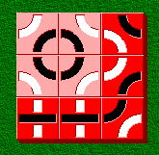 Golden output: 1

|  |  |  |
| --- | --- | --- |
| 010 | 100 | 101 |
| 101 | 011 | 010 |
| 110 | 110 | 011 |

Training sample 2

 Golden output: 0

|  |  |  |
| --- | --- | --- |
| 010 | 011 | 010 |
| 101 | 110 | 011 |
| 100 | 010 | 110 |

Training sample 3

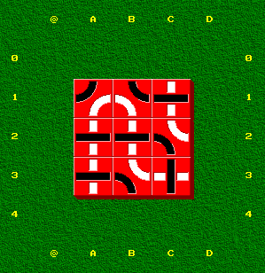 Golden output: 0

|  |  |  |
| --- | --- | --- |
| 011 | 101 | 110 |
| 110 | 110 | 100 |
| 110 | 100 | 111 |

Training sample 4

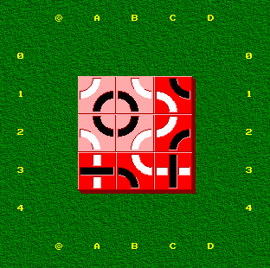 Golden output: 1

|  |  |  |
| --- | --- | --- |
| 010 | 100 | 101 |
| 101 | 011 | 010 |
| 110 | 100 | 111 |

Training sample 5

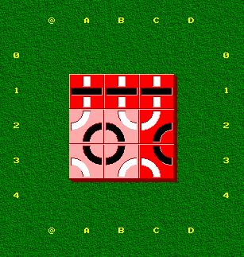 Golden output: 1

|  |  |  |
| --- | --- | --- |
| 110 | 110 | 110 |
| 010 | 100 | 010 |
| 101 | 011 | 101 |

Training sample 6

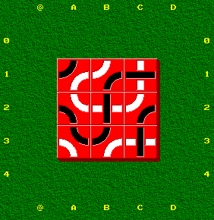 Golden output: 0

|  |  |  |
| --- | --- | --- |
| 011 | 010 | 110 |
| 100 | 111 | 010 |
| 101 | 011 | 111 |

Training sample 7

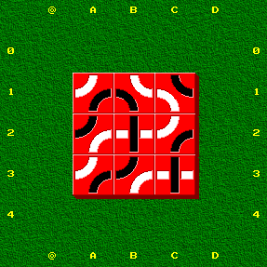 Golden output: 0

|  |  |  |
| --- | --- | --- |
| 010 | 100 | 101 |
| 011 | 111 | 010 |
| 010 | 011 | 111 |

Training sample 8

 Golden output: 0

|  |  |  |
| --- | --- | --- |
| 010 | 011 | 010 |
| 101 | 110 | 011 |
| 100 | 010 | 110 |

Training sample 9

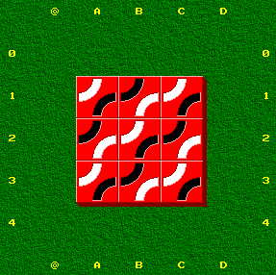 Golden output: 0

|  |  |  |
| --- | --- | --- |
| 010 | 011 | 010 |
| 011 | 010 | 011 |
| 010 | 011 | 010 |

Training sample 10

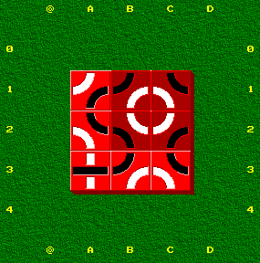 Golden output: 1

|  |  |  |
| --- | --- | --- |
| 010 | 011 | 101 |
| 101 | 100 | 010 |
| 110 | 011 | 101 |

Training sample 11

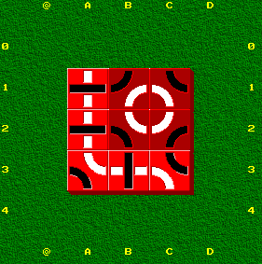 Golden output: 1

|  |  |  |
| --- | --- | --- |
| 110 | 011 | 101 |
| 110 | 100 | 010 |
| 100 | 111 | 101 |

Training sample 12

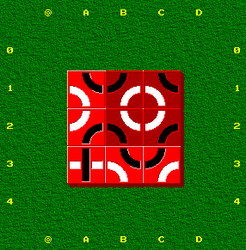 Golden output: 1

|  |  |  |
| --- | --- | --- |
| 101 | 011 | 101 |
| 010 | 100 | 010 |
| 111 | 101 | 011 |

Training sample 13

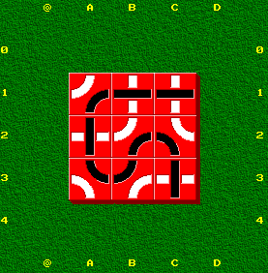 Golden output: 0

|  |  |  |
| --- | --- | --- |
| 010 | 110 | 110 |
| 111 | 010 | 100 |
| 101 | 011 | 111 |

Training sample 14

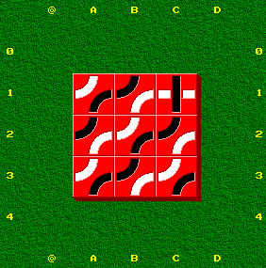 Golden output: 0

|  |  |  |
| --- | --- | --- |
| 010 | 011 | 111 |
| 011 | 010 | 011 |
| 010 | 011 | 010 |

Training sample 15

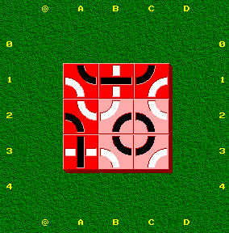 Golden output: 1

|  |  |  |
| --- | --- | --- |
| 101 | 110 | 011 |
| 100 | 010 | 100 |
| 111 | 101 | 011 |

Training sample 16

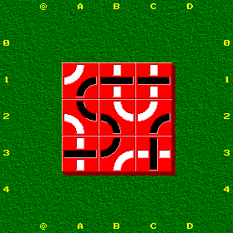 Golden output: 0

|  |  |  |
| --- | --- | --- |
| 010 | 110 | 110 |
| 101 | 100 | 010 |
| 110 | 011 | 111 |

Training sample 17

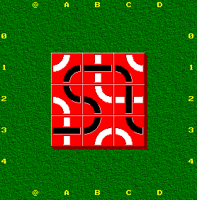 Golden output: 0

|  |  |  |
| --- | --- | --- |
| 010 | 110 | 100 |
| 101 | 100 | 111 |
| 110 | 011 | 101 |

Training sample 18

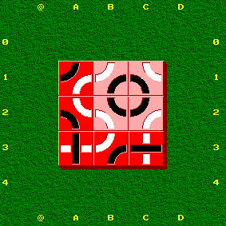 Golden output: 1

|  |  |  |
| --- | --- | --- |
| 011 | 010 | 100 |
| 100 | 101 | 011 |
| 111 | 010 | 110 |

Training sample 19

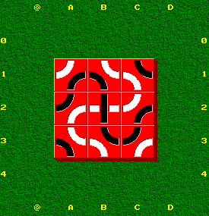 Golden output: 0

|  |  |  |
| --- | --- | --- |
| 010 | 100 | 101 |
| 011 | 111 | 010 |
| 100 | 101 | 011 |

Training sample 20

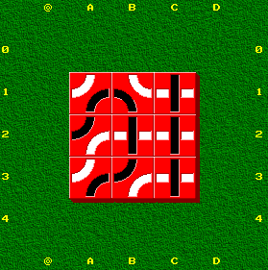 Golden output: 0

|  |  |  |
| --- | --- | --- |
| 010 | 100 | 111 |
| 011 | 111 | 111 |
| 010 | 011 | 111 |