

SCSJ2203: Software Engineering

**Software Design Document**

Let’s Get Hot! (LeGeT)

Version 2.0

15/05/2016

Department of Software Engineering

Faculty of Computing

Prepared by: LeGeT

**Revision Page**

1. **Overview**

This is the second draft version 2.0 documenting intrinsic subsystems of Let’s Get Hot! (LeGeT) apps. Subsystems included are User Profile, BMI Calculator, Daily Water Intake, Workout Tips, Pharmacy Locator and Healthy Food Suggestion.

1. **Target Audience**

i. Client  
ii. System Developer  
iii. Programmer

1. **Project Team Members**

i. Mohd Hakimi Iqmall Bin Mohd Zolkifly - Workout Tips  
ii. Amy Natasha Binti Abdul Rashid - Daily Water Intake  
iii. Afif Wahdi Bin Mustafa - Pharmacy Locator  
iv. Amirah Binti Adnan - BMI Calculator & User Profile  
v. Yap Yoong Seng - Healthy food Suggestion

1. **Version Control History**

|  |  |  |  |
| --- | --- | --- | --- |
| **Version** | **Primary Author(s)** | **Description of Version** | **Date Completed** |
| 1.0  2.0 | LeGeT group members  LeGeT group members | Initial draft  Second draft | 29/4/2016  14/5/2016 |

**Note:**

This template is an annotated outline for a software design document adapted from the IEEE Recommended Practice for Software Design Descriptions. The IEEE Recommended Practice for Software Design Descriptions have been reduced in order to simplify this assignment while still retaining the main components and providing a general idea of a project definition report. Please refer to IEEE Std 1016­1998 1 for the full IEEE Recommended Practice for Software Design Descriptions. Examples of models are from Satzinger (2011). Compiled by Shahliza Abdul Halim, PhD and checked by Shahida Sulaiman, PhD on 2 May 2016.

**Table of Contents**

|  |  |  |  |  |  |
| --- | --- | --- | --- | --- | --- |
| **1** | **Introduction** | | | | 1 |
|  | 1.1 | Purpose | | | 1 |
|  | 1.2 | Scope | | | 1 |
|  | 1.3 | Definitions, Acronyms and Abbreviations | | | 2 |
|  | 1.4 | Reference Materials | | | 2 |
|  | 1.5 | System Overview | | | 2 |
| **2** | **System Architectural Design** | | | |  |
|  | 2.1 | Architectural Style and Rationale | | |  |
|  | 2.2 | Component Model | | |  |
|  | 2.3 | Use Case Diagram | | |  |
| 3 | **Detailed Description of Modules** | | | |  |
|  | 3.1 | Complete Package Diagram | | |  |
|  | 3.2 | Modules Detailed Descriptions | | |  |
|  |  | 3.2.1 | Module User Profile | |  |
|  |  |  | 3.2.1.1 | Package Diagram |  |
|  |  |  | 3.2.1.2 | Class Diagram |  |
|  |  |  | 3.2.1.3 | Sequence Diagrams |  |
|  |  | 3.2.2 | Module BMI Calculator | |  |
|  |  |  | 3.2.2.1 | Package Diagram |  |
|  |  |  | 3.2.2.2 | Class Diagram |  |
|  |  |  | 3.2.2.3 | Sequence Diagrams  3.2.3 Module Pharmacy Locator  3.2.3.1 Package Diagram  3.2.3.2 Class Diagram  3.2.3.3 Sequence Diagram  3.2.4 Module Daily Water Intake  3.2.4.1 Package Diagram  3.2.4.2 Class Diagram  3.2.4.3 Sequence Diagram |  |
|  |  | 3.2.5 | Module Healthy Food Suggestion | |  |
|  |  |  | 3.2.5.1 | Package Diagram |  |
|  |  |  | 3.2.5.2 | Class Diagram |  |
|  |  | 3.2.6 | 3.2.5.3  3.2.6.1  3.2.6.2  3.2.6.3 | Sequence Diagram  Module Workout Tips  Package Diagram  Class Diagram  Sequence Diagram |  |
| 4 | **Data Design** | | | |  |
|  | 4.1 | Data Description | | |  |
|  | 4.2 | Data Dictionary | | |  |
| 5 | **User Interface Design** | | | |  |
|  | 5.1 | Overview of User Interface | | |  |
|  | 5.2 | Screen Images | | |  |
| 6 | **Requirements Matrix** | | | |  |
|  |  | | | |  |

1. **Introduction**
   1. **Purpose**

The purpose of the Software Design Document is to provide a description of the design of a system fully enough to allow for software development to proceed with an understanding of what is to be built and how it is expected to built. The Software Design Document provides information necessary to provide description of the details for the software and system to be built.

* 1. **Scope**

This Software Design Document is for a base level system which will work as a proof of concept for the use of building a system that provides a base level of functionality to show feasibility for large scale production use. This Software Design is focused on the base level system and critical parts of the system. For this particular Software Design Document, the focus is placed on generation of the documents and modification of the documents. The system will be used in conjunction with other .pre-existing system (e.g Youtube) and will consist largely of a interfaces interactions.

The aim for this document is to provide designs of an Android apps Let’s Get Hot (LeGeT). The apps can tell user about their Body Mass Index (BMI) by calculate the height and weight, and will show the estimated water needed in one day that should be drink base on the BMI. User can set alarm to remind them to drink the water. LeGeT apps also provide the guide of workout routine to help users keep their health and body fit. Futuremore, this apps will show the suggestion of healthy foods to eat and provide the pharmacy locator. User can also add and update user pofiling in the apps.

* 1. **Definitions, Acronyms and Abbreviation**
* **Username** - An identification used by a person with access to a computer,network, or online service.
* **BMI** - Body Mass Index
* **LeGeT** - Let’s Get Hot!
* **Database** - Computer software apps that interact with user, other apps, and it capture and analyse the data.
* **HTTPS** - A protocol for secure communication over a computer network which is widely used on the internet.
* **GPS** - Global Positioning System
* **apps** - applications

Definitions of all terms, acronyms and abbreviation used are to be defined here.

* 1. **References**

1. Workflow materials: The Umlet was used in the creation of creating workflow of diagrams of this document. The umlet open sourse software may be accessed at creately.com
2. BMI Formula: The formula of calculating BMI is taken from the website <http://www.epic4health.com/bmiformula.html>
3. Body Categorization: The body categorization is taken for the website http://www.cdc.gov/healthyweight/assessing/bmi/adult_bmi/

Specify complete list of references using a standardized reference format.

* 1. **Overview**

The Software Design Document is divided into 6 sections with various subsections. The sections of the Software Design Document are:

1. Introduction
2. System Architectural Design
3. Detailed Descriptions of Modules
4. Data Design
5. User Interface Design
6. Requirements Matrix
7. **System Architectural Design** 
   1. **Architecture Style and Rationale**

Web-based system architecture:

User Profile System is a web-based system. The user can enter own name, height and weight for own profiling and further analysis by the system. Server and database are needed to store the user data.

Pharmacy Locator System is a web-based system. This system provides the location of pharmacies to user within the searching radius. The data of pharmacies is retrieved from server and database.

Application-based system architecture:

Healthy Food Suggestion System is an application-based system. This system suggests the recommended healthy food to user according to categories. The food information and recipe are stored in the application.

BMI Calculator System is an application-based system. The user can enter own height and weight or other peoples’ to obtain BMI value, body category, recommended water intake volume and supposed weight. The BMI calculation algorithm with its classification is stored in the application.

Water Intake System is an application-based system. The user sums up the volume of water taken in a day into the application. The system will shows the total volume of water taken and also calculates the remaining water volume is needed taken by user. The water volume summation is stored in the application.

Daily Workout System is an application-based system. This system suggests the workout methods to user along with timer. The timer helps the user to count the remaining time for user to finish the workout. The workout steps are stored in the application.

* 1. **Architecture Model**

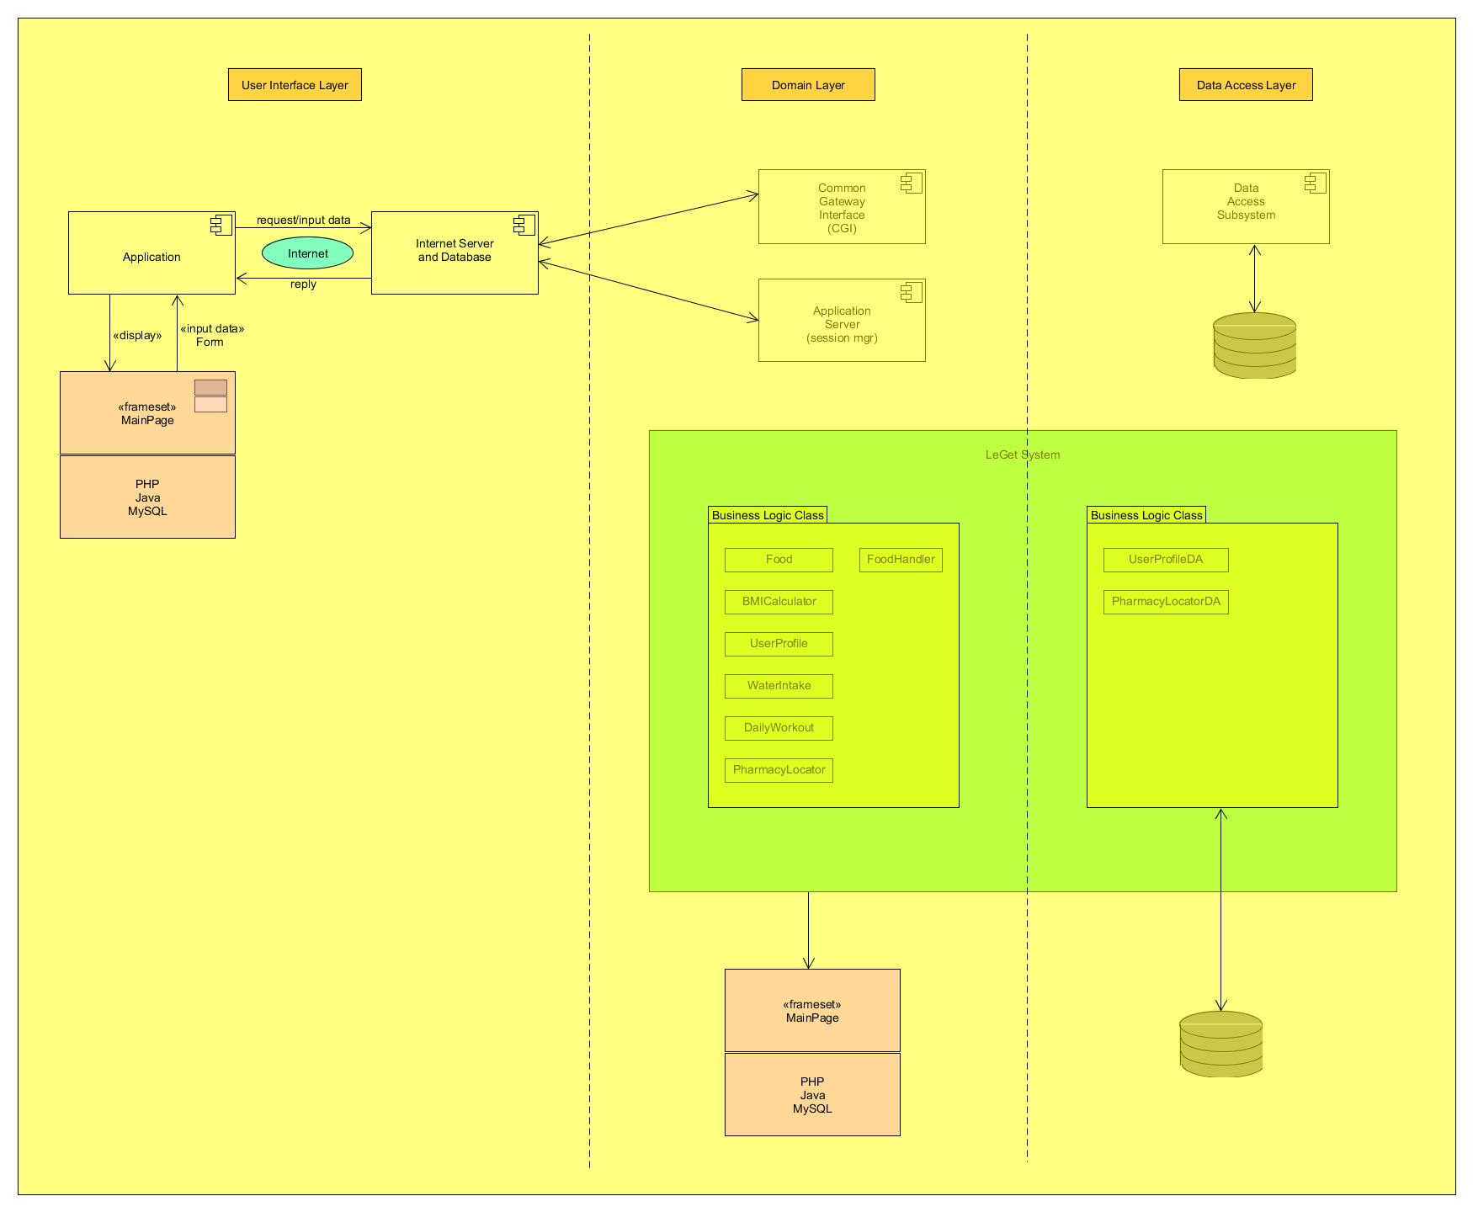

**Figure 2.1: Component Model of Leget System**

* 1. **Use Case Diagram**

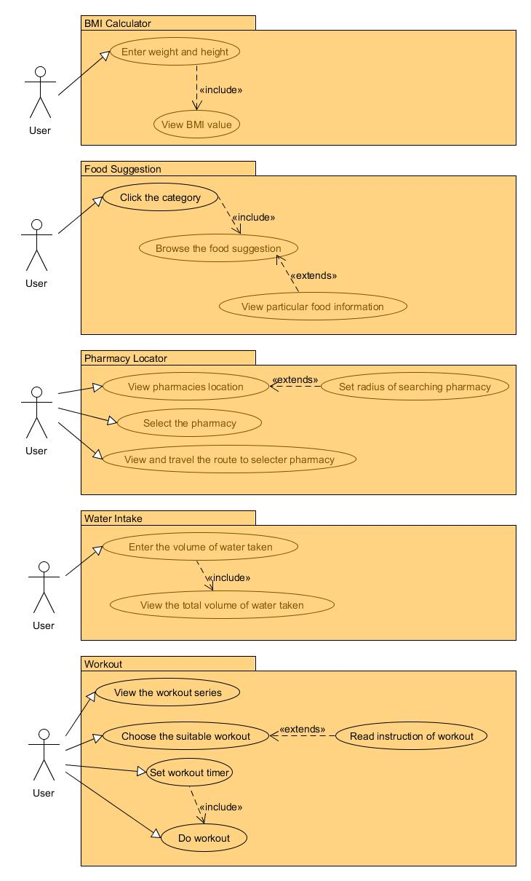

**Figure 2.2: Use Case Diagram of Leget System**

1. **Detailed Description of Components**
   1. **Complete Package Diagram**

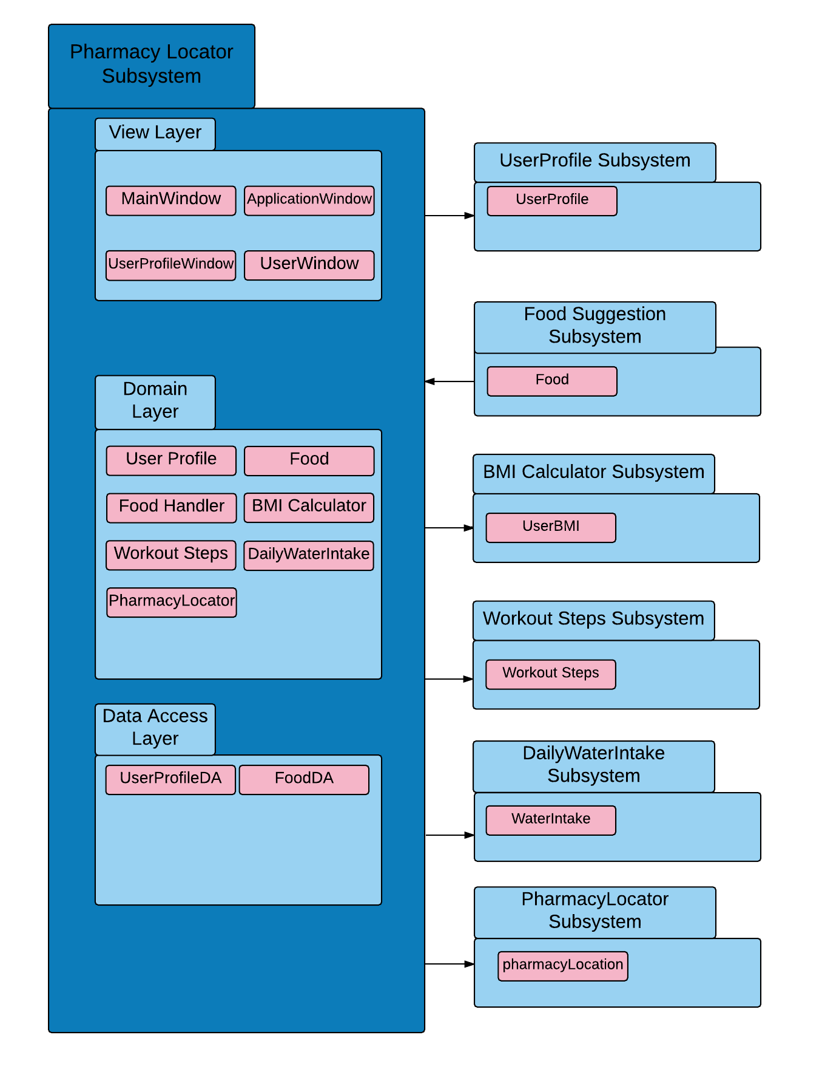

**Figure 3.1: Subsystem of LeGeT System**

* 1. **Detailed Description**
     1. **Module of User Profile Subsystem**
        1. **P001: Package User Profile**

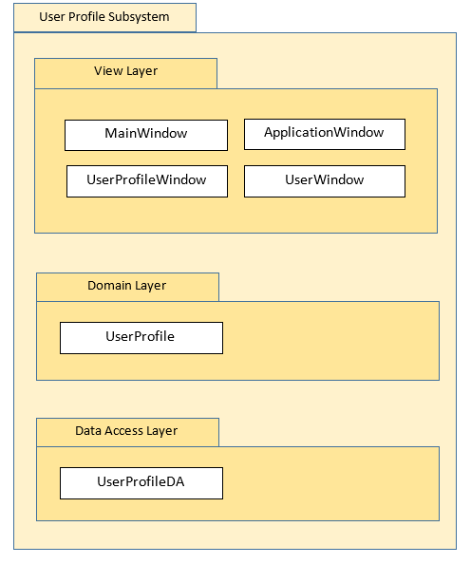

**Figure 3.2.1.1: Package Diagram of User Profile Subsystem**

* + - 1. **Class Diagram**

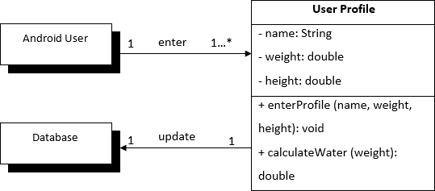

**Figure 3.2.1.2: Class Diagram of User Profile Subsystem**

* + - 1. **Sequence Diagram**

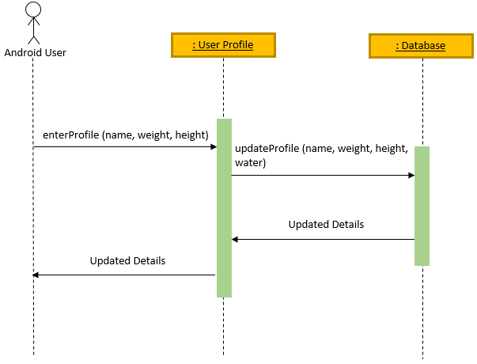

**Figure 3.2.1.3: Sequence Diagram of User Profile Subsystem**

* + 1. **Module Healthy Food Suggestion Subsystem**

3.2.2.1 **P002: Package Healthy Food Suggestion**

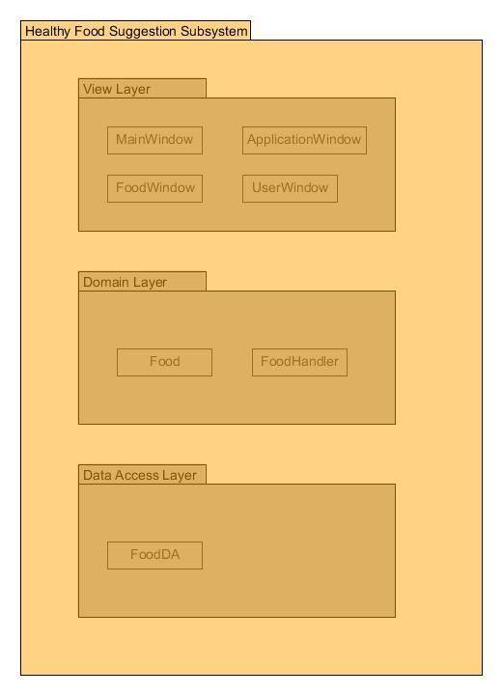

**Figure 3.2.2.1: Package Diagram of Healthy Food Suggestion Subsystem**

This package describes the healthy food suggestions can be obtained by users including the type of food, its nutrition information and calorie value as well as recipe and preparing time.

3.2.2.2 **Class Diagram**

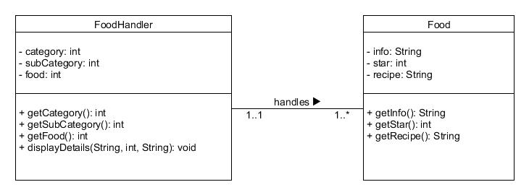

**Figure 3.2.2.2: Class Diagram of Healthy Food Suggestion Subsystem**

3.2.2.3 **Sequence Diagrams**

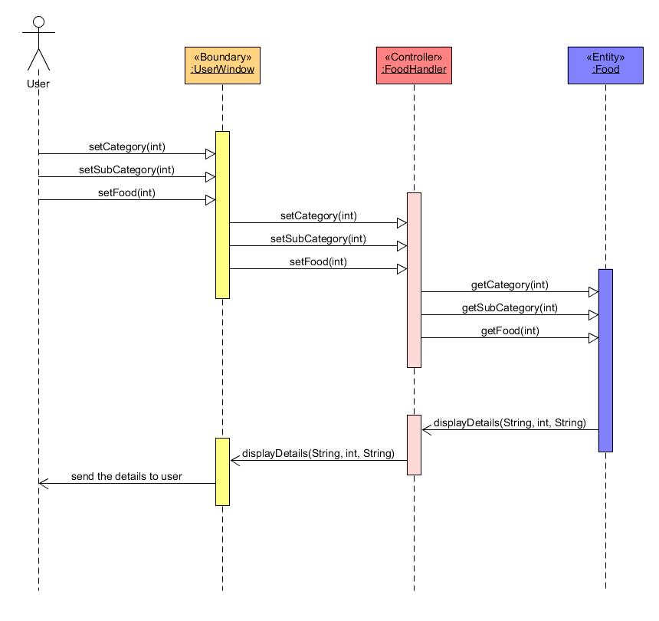

**Figure 3.2.2.3: Sequence Diagram of Healthy Food Suggestion Subsystem**

**3.2.3 Module BMI Calculator**

**3.2.3.1 P003: Package BMI Calculator Subsystem**

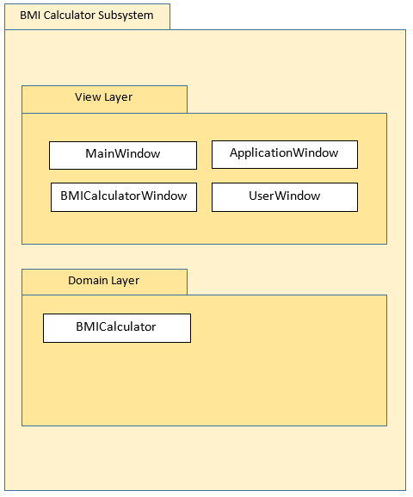

**Figure 3.2.3.1: Package Diagram of BMI Calculator Subsystem**

This package describes BMI Calculator Subsystem in different layers with the purpose of displaying BMI results (BMI Value, BMI Level, Suggested Water Intake and Ideal Weight) after getting inputs from user.

**3.2.3.2 Class Diagram**

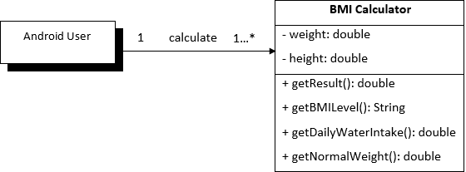

**Figure 3.2.3.2: Class Diagram of BMI Calculator Subsystem**

**3.2.3.3 Sequence Diagrams**

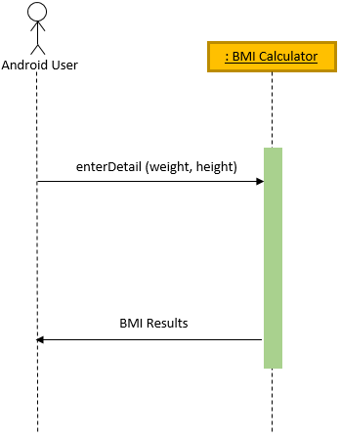

**Figure 3.2.3.3: Sequence Diagram of BMI Calculator Subsystem**

3.2.4  **Module Workout Steps**

3.2.4.1  **P004: Package Workout Steps Subsystem**

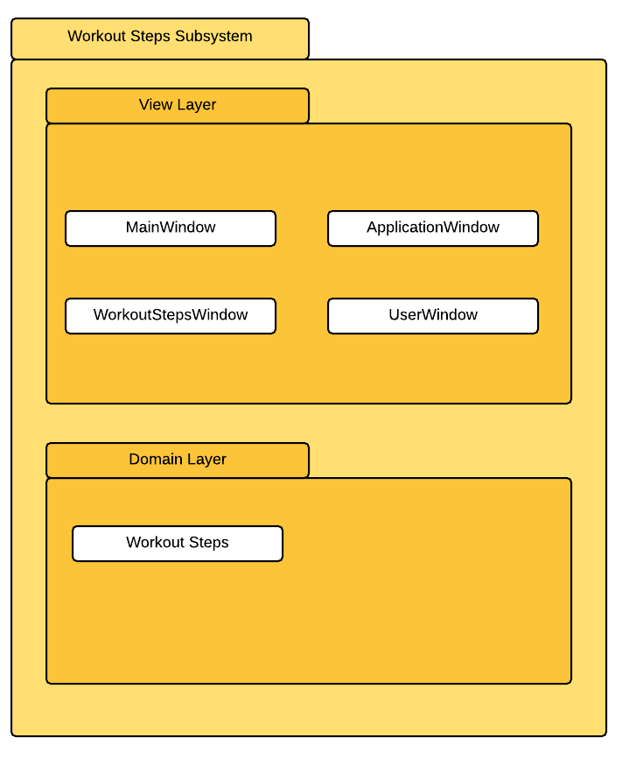

**Figure 3.2.4.1: Package Diagram of Workout Steps Subsystem**

This package describes Workout Steps Subsystem in different layers with the purpose of displaying type and description of workout exercises (Paper push up, Chair squat) after getting inputs from user.

3.2.4.2 **Class Diagram**

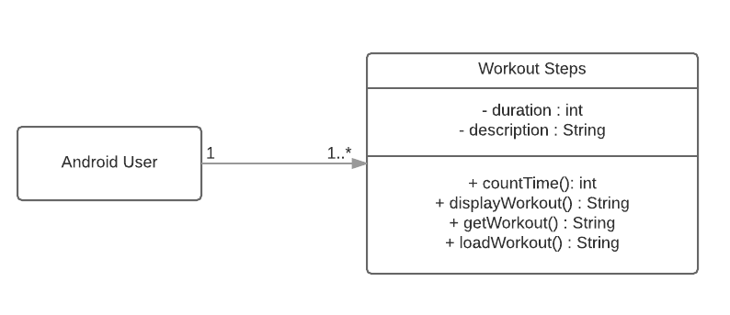

**Figure 3.2.4.2: Class Diagram of Workout Steps Subsystem**

3.2.4.3 **Sequence Diagrams**

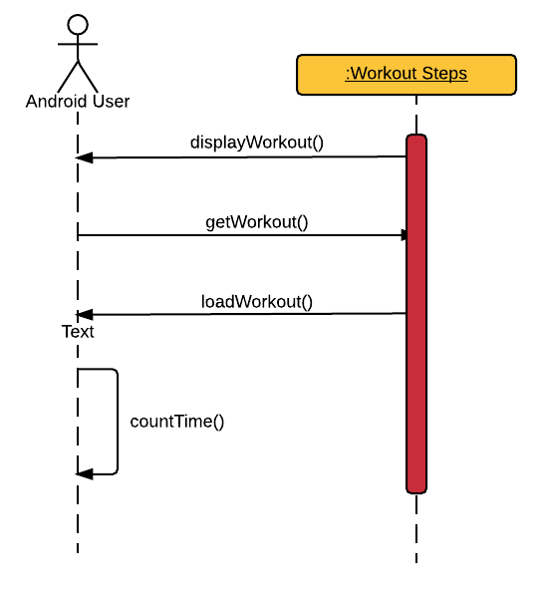

**Figure 3.2.4.3: Sequence Diagram of Workout Steps Subsystem**

**3.2.4 Daily Water Intake**

**3.2.4.1 Package Diagram**

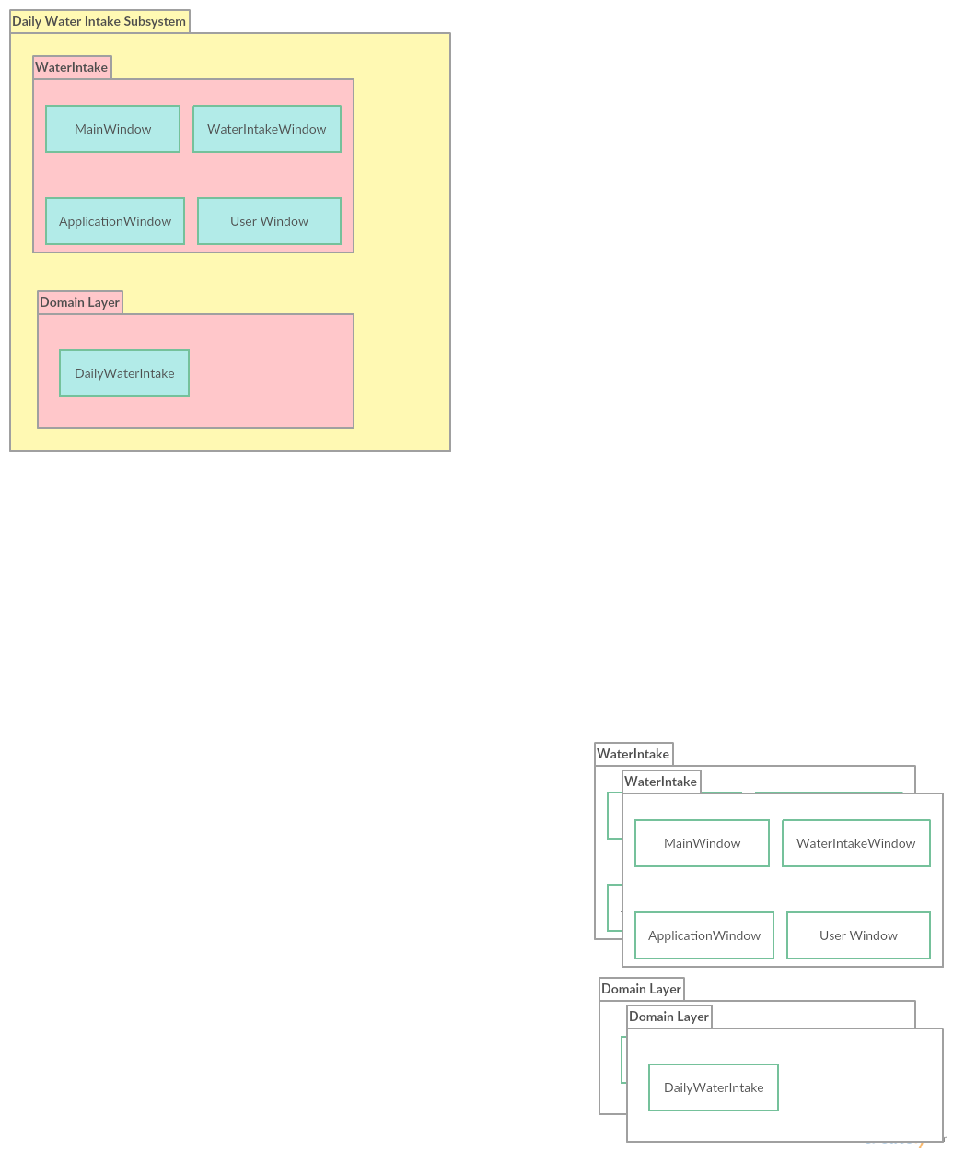

**Figure 3.2.4.1: Package Diagram of Daily Water Intake Subsystem**

**3.2.4.2 Class Diagram**

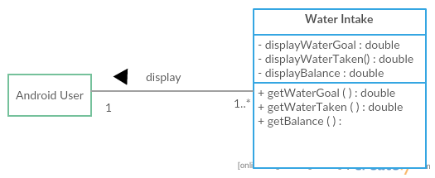

**Figure 3.2.4.2: Class Diagram of Daily Water Intake Subsystem**

**3.2.4.3 Sequence Diagram**

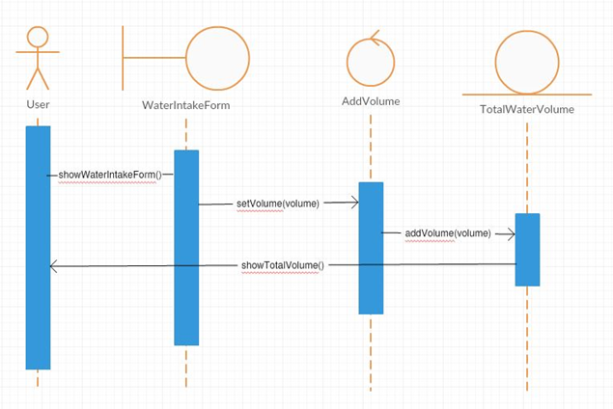

**Figure 3.2.4.3: Sequence Diagram of Daily Water Intake Subsystem**

**3.2.5 Module Pharmacy Locator**

**3.2.5.1 P005: Package Pharmacy Locator Subsystem**

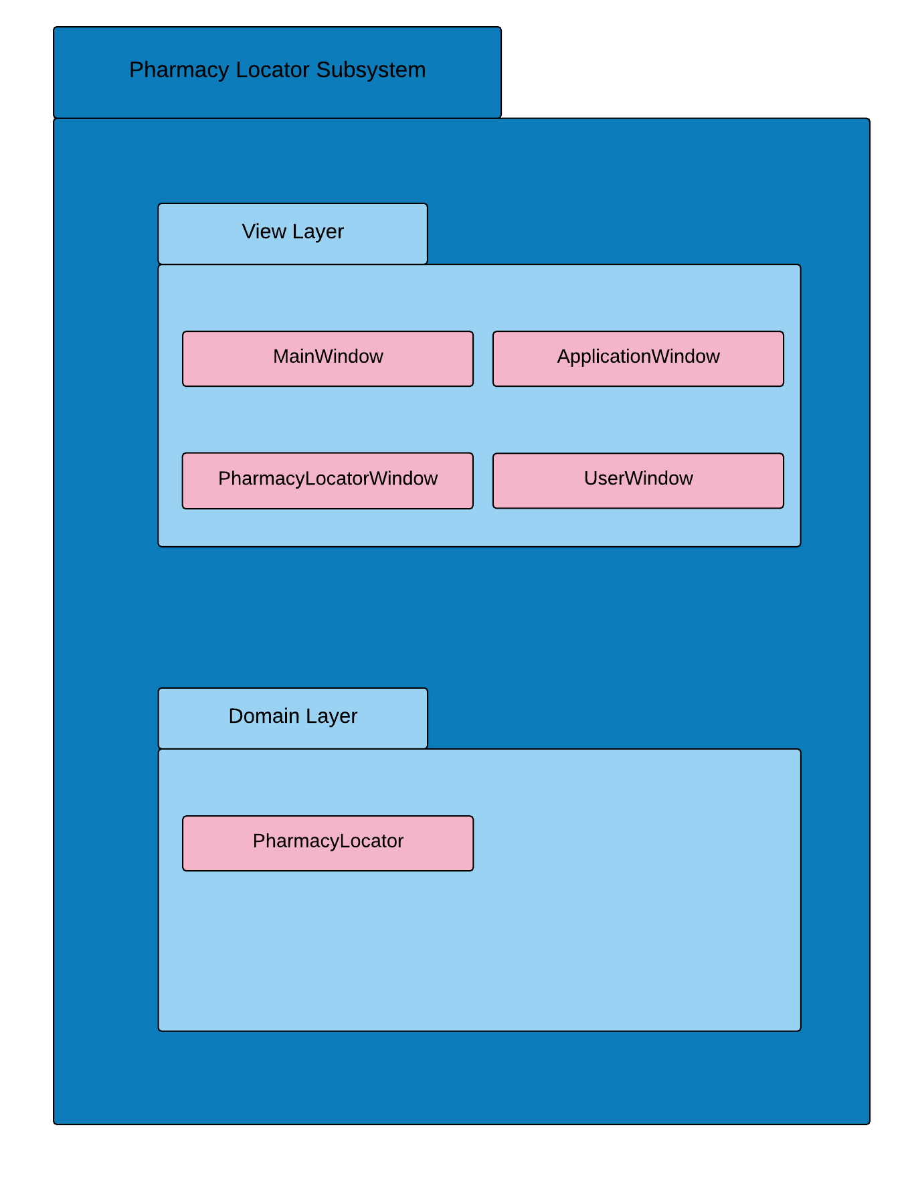

**Figure 3.2.5.1: Package Diagram of Pharmacy Locator Subsystem**

This package locate the current location of the user. It also will locate the location of the nearest pharmacy around 5 KM radius of based on the user location. The pharmacy name and others description of the pharmacy are provided.

**3.2.5.2 Class Diagram**

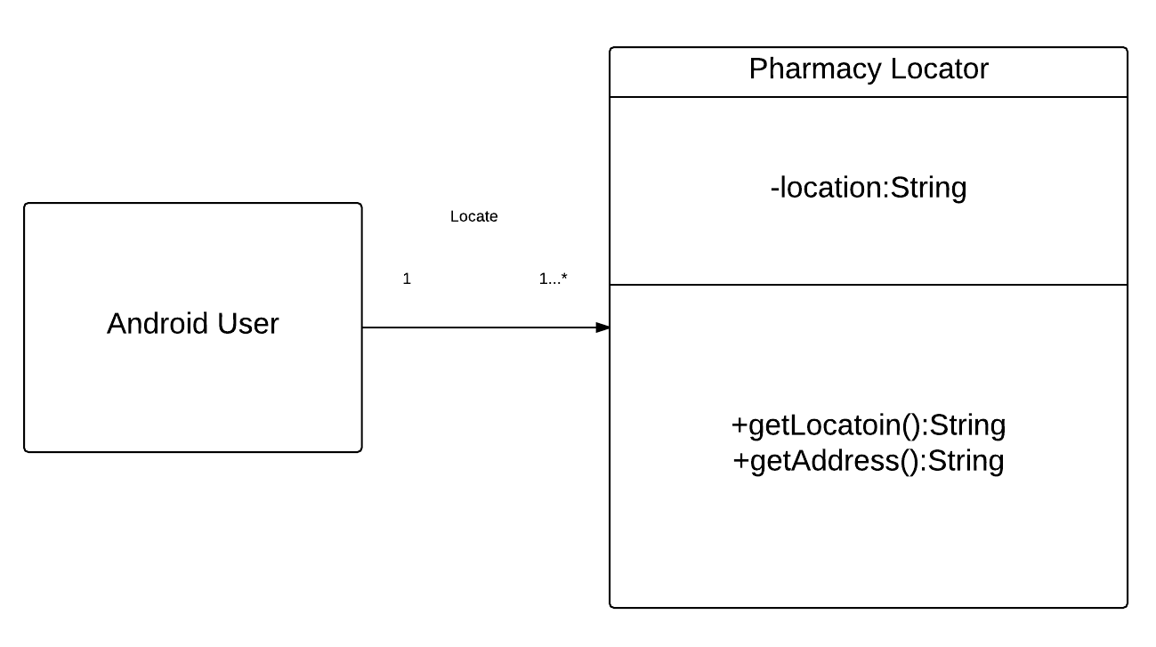

**Figure 3.2.5.2: Class Diagram of Pharmacy Locator Subsystem**

**3.2.5.3 Sequence Diagrams**

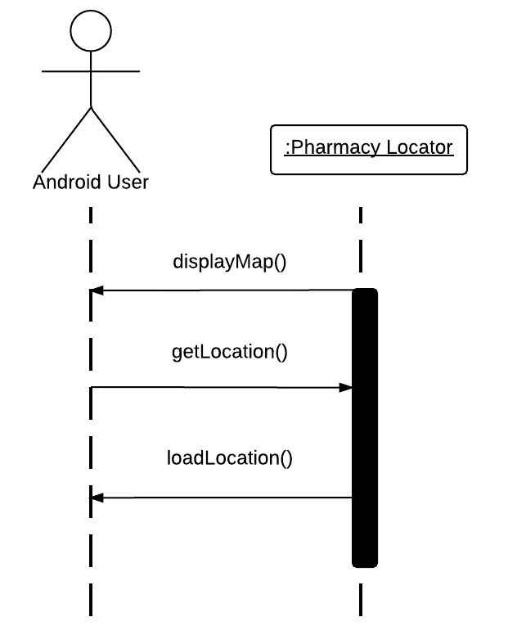

**Figure 3.2.5.1: Sequence Diagram of Pharmacy Locator Subsystem**

1. **Data Design**
   1. **Data Description**

|  |  |
| --- | --- |
| **Entity Name** | **Description** |
| Food | General term describing all food suggestion with its recipe and information in the application. |
| BMICalculator | Describing BMI calculation with variables used such as height and weight and results such as BMI value, BMI level, suggested daily water intake and ideal weight. |
| UserProfile | Describing variables used for the subsystem such as user name, weight and height. Setting for measurement of weight, height and volume are also included in here. |
| WorkoutSteps | Giving explaination and guide for user to practise workout such as Paper Push Up and Chair Squat with timer. |
| Pharmacy | Show the name Pharmacy name and the description about that pharmacy like address, telephone number and other details. |
| Daily Water Intake | User can set how much water they will take for one day. User can update the water intake that they have taken. |

* 1. **Data Dictionary**

**User Profile**

|  |  |  |  |  |  |
| --- | --- | --- | --- | --- | --- |
| **Entity Name** | **Attributes & Methods** | **Description** | **Data Type** | **Null** | **Multi-**  **valued** |
| User Profile | name | User’s name | String | No | No |
| weight | User’s weight | double | No | No |
| height | User’s height | double | No | No |
| enterProfile() | To save user profile in database | method | - | - |
| calculateWater() | To autom-calculate water intake for a specific user to be kept in database | method | - | - |

**Healthy Food Suggestion**

|  |  |  |  |  |  |
| --- | --- | --- | --- | --- | --- |
| **Entity Name** | **Attributes & Methods** | **Description** | **Data Type** | **Null** | **Multi-**  **valued** |
| Food | category | Selection of category in main interface | int | No | No |
|  | subCategory | Selection of sub-category in particular category | int | No | No |
|  | food | Selection of food in particular sub-category | int | No | No |
|  | info | The information of food | String | No | No |
|  | star | The rating of food | int | No | No |
|  | recipe | The recipe of food | String | No | No |
|  | getCategory() | Get the category requested by user | Method | - | - |
|  | getSubCategory() | Get the sub-category requested by user | Method | - | - |
|  | getFood() | Get the particular food information and recipe requested by user | Method | - | - |
|  | getInfo() | Get the infomation of food | Method | - | - |
|  | getStar() | Get the rating of food | Method | - | - |
|  | getRecipe() | Get the recipe of food | Method | - | - |
|  | displayDetails (info, star, recipe) | Returns the information, rating and recipe of food to user | Method | - | - |

**BMI Calculator**

|  |  |  |  |  |  |
| --- | --- | --- | --- | --- | --- |
| **Entity Name** | **Attributes & Methods** | **Description** | **Data Type** | **Null** | **Multi-**  **valued** |
| BMI Calculator | weight | User’s weight | double | No | No |
|  | height | User’s height | double | No | No |
|  | getResult() | To get BMI value | method | - | - |
|  | getBMILevel() | To get BMI level | method | - | - |
|  | getDailyWaterIntake() | To calculate daily water intake based on user’s height and weight | method | - | - |
|  | getNormalWeight() | Displays ideal weight based from user’s height | method | - | - |

**Workout Steps**

|  |  |  |  |  |  |
| --- | --- | --- | --- | --- | --- |
| **Entity Name** | **Attributes & Methods** | **Description** | **Data Type** | **Null** | **Multi-**  **valued** |
| Workout Steps | duration | time taken for doing exercise | int | No | No |
|  | description | explaination about type of workouts | String | No | No |
|  | countTime() | count the time taken | method | - | - |
|  | displayWorkout() | display the list of workout that have in the system | method | - | - |
|  | getWorkout() | To retrieve the workout steps | method | - | - |
|  | loadWorkout() | to load the workout steps selected to main screen | method | - | - |

**Daily Water Intake**

|  |  |  |  |  |  |
| --- | --- | --- | --- | --- | --- |
| **Entity Name** | **Attributes & Methods** | **Description** | **Data Type** | **Null** | **Multi-**  **valued** |
| Water Intake | displayWaterGoal() | Water intake goal for a day | double | No | No |
|  | displayWaterTaken() | Water been taken | double | No | No |
|  | displayBalance() | Balance of the water from the goal | double | - | - |

**Pharmacy Locator**

|  |  |  |  |  |  |
| --- | --- | --- | --- | --- | --- |
| **Entity Name** | **Attributes & Methods** | **Description** | **Data Type** | **Null** | **Multi-**  **valued** |
| Pharmacy Locator | displayMap() | General map view of the pharmacy locator system | method | - | - |
|  | getLocation() | Locate the user location | method | - | - |
|  | loadLocation() | Load the pharmacy around the user location | method | - | - |

1. **User Interface Design**
   1. **Overview of User Interface**
2. **Module of User Profile**

User Profile

1. User will need to enter name, height and weight for tap on ‘Save’ button for data keeping.
2. Based from the data, the system will calculate automatically for user daily water intake and save in database.
3. User can return to main menu by tapping on menu icon

**2. Module Healthy Food Suggestion**

View food suggestion

* 1. In the main interface, the user can select one from 3 categories which are including Course, Dietary Needs and Classifications.
  2. After clicking the category, there are sub-categories related to the selected category. For example, in the Course category, there are breakfast, lunch, dinner, side dish, soup and drink sub-categories. The user can select one of the sub-categories based on own desires.
  3. The images of food are displayed after clicking the sub-category. The user clicks on the food based on own desires.
  4. After clicking on particular food image, there are 2 tabs: Info and Recipe, however Info tab is highlighted and the information of food will first displayed. The rating of food also is shown.
  5. The user clicks on Recipe tab, the recipe of food is shown.
  6. The user requests to recall the food information, the user clicks on Info tab to view information.

**3. Module of BMI Calculator**

BMI Calculator

1. User will need to fill in weight and height in the required fields and and taps on ‘Calculate BMI’ button.
2. The results (BMI Value, BMI Level, Suggested Daily Water Intake and Ideal Weight) will be displayed.
3. User can return to main menu by tapping on menu icon.

**4. Module of Workout Steps**

Workout Steps

1. User can view the instruction on how to practise the workout by clicking Instruction Menu and also provided with video from Youtube to get more information.
2. User need to push the Start button to begin.
3. User will face variety of workouts after pushing the Start button and the timer will be autamatically work.
4. A dialog message will appeared at the screen after all session of workout is done and user can choose either want to continue doing workout or not.

**5. Module of Daily Water Intake**

Water Intake

1. User will be displayed with water goal for each day based on the bmi calculator suggestion.
2. Water taken also will be display for the convenience of the user to know how much water has been taken.
3. User will know how much a water left.
4. User can click on ‘+’ button to add the amount of the water.

**6. Module of Pharmacy Locator**

Pharmacy Locator

1. User will display with the general view of the map.
2. When user press the locate button, it will show the current location of the user.
3. The system also will show the mark that locate the pharmacy around user (5 KM) radius.
4. When clicking the pharmacy locator mark, it will show the name and others details about the pharmacy.
   1. **Screen Images**
5. Healthy Food Suggestion

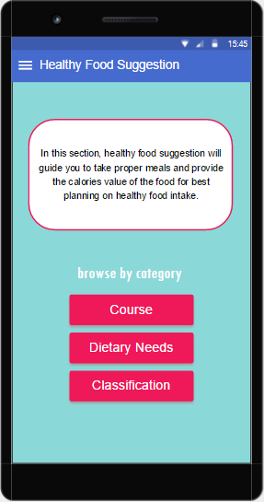 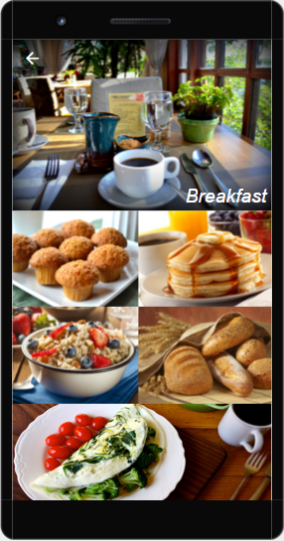

1. BMI Calculator interfaces screenshot

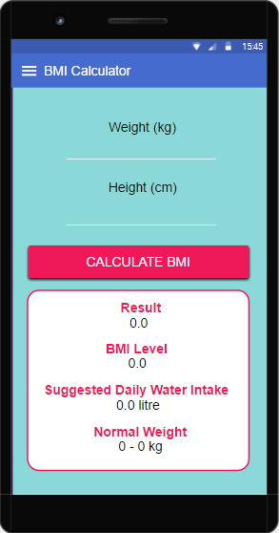 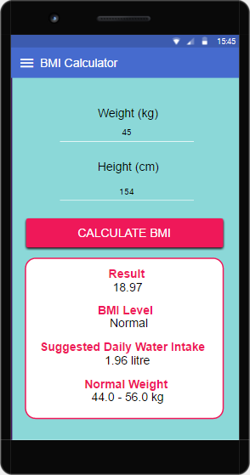

1. User Profile interfaces screenshot

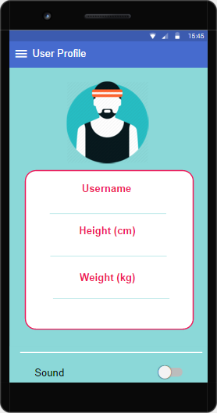 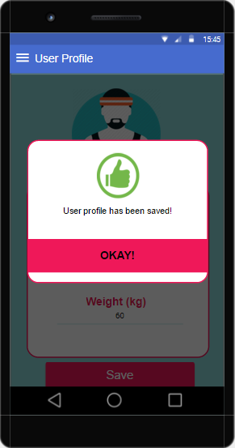

d) Daily Water Intake

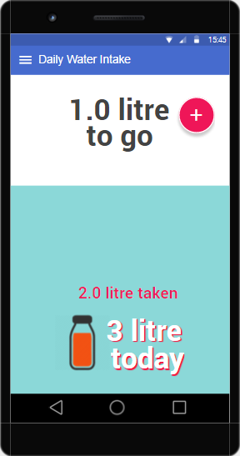 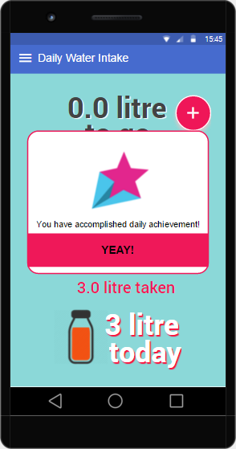

e) Workout Steps

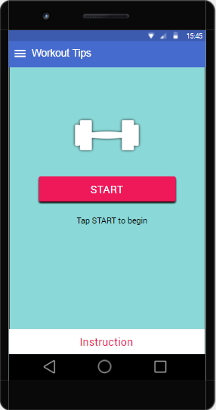 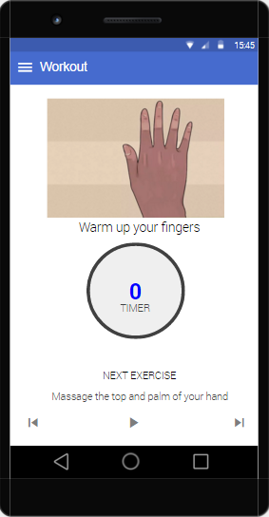

f) Pharmacy Locator

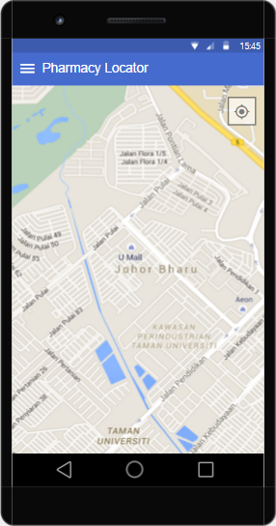 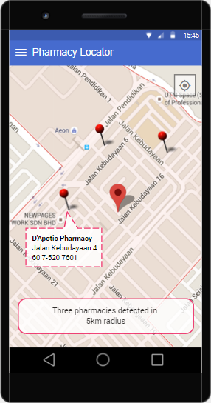

1. **Requirements Matrix**

|  |  |  |  |  |  |  |
| --- | --- | --- | --- | --- | --- | --- |
|  | P001 | P002 | P003 | P004 | P005 | P006 |
| Module1, UC001 | X |  |  |  |  |  |
| Module2, UC002 |  | X |  |  |  |  |
| Module3, UC003 |  |  | X |  |  |  |
| Module4, UC004 |  |  |  | X |  |  |
| Module5, UC005 |  |  |  |  | X |  |
| Module6, UC006 |  |  |  |  |  | X |

The packages and respective sequence diagrams for the scenarios are as below.

|  |  |  |  |  |  |
| --- | --- | --- | --- | --- | --- |
|  | SD001 | SD002 | SD003 | SD004 | SD005 |
| P001 | X |  |  |  |  |
| P002 |  | X |  |  |  |
| P003 |  |  | X |  |  |
| P004 |  |  |  | X |  |
| P005 |  |  |  |  | X |