

SCSJ2013 | **DATA STRUCTURES AND ALGORITHM |** SEMESTER 1 | 2015/2016 | **SECTION 08**

**|RUHAIDAH BINTI SAMSUDIN|**

GROUP PROJECT FINAL REPORT

**PADDLE BOAT QUEUING SYSTEM**

Group Members:

1. Yap Yoong Seng A14CS0150
2. Benedict Baxter Baru A14CS0160
3. Lee Kuan Xin A14CS0165
4. **INTRODUCTION**

1.1 PROJECT SYNOPSIS

As the title of the project suggest, this project is to ease the Atlas River paddle boat business to manage their paddle boat reservation. This system will provide 6 types of functions, namely:

1. Viewing paddle boat list
2. Sorting the paddle boat
3. Search for a paddle boat
4. Viewing the dock status
5. Viewing the renting queue
6. Making reservation

We are using several types of data structure in our project, which are sorting, searching, queue and stack. The view paddle boat list function gives users a list of paddle boats available, as well as all the information such as the ID of the boat, the name and type of it. For this project purpose, we have identified 3 types of paddle boat, which are couple, family and family deluxe. The sorting paddle boat function eases user to read the list as they are able to sort the list by their ID, name and type. As UX experience is a big issue in system development, this function prove to be helpful for easy reading of the paddle boat list. The search function, like its name suggested, searches for a paddle boat when prompted. Next, the view dock status function gives a visual representation of the paddle boat in the dock. If one is being used/rented, it will be removed from the dock.

Next would be the main functions of our system, firstly the making reservation function, where users/customer would be able to make reservation for their desired paddle boat. Users will be asked to enter some information, such as their details, number of passengers and time of their reservation. The number of passengers will be automatically assigned a paddle boat depending on the number. For example, if “2” is being entered, than the paddle boat that would be assigned would be the couple paddle boat. The reservation would then be sent to the reservation queue where customers would be placed in a queue for them to wait for their turn for the available boat. Basically, the main function of our system is the reservation system , where it would be a “First Come First Serve” basis. The rest of the function is to further ease anyone using the system.

1.2 OBJECTIVE OF PROJECT

1. Implementing data algorithm in a system (Sort, Search, Stack and Queue).
2. Preparing an interface that would ease users
3. Providing a fully computerized system of reservation
4. **SYSTEM ANALYSIS AND DESIGN**

2.1 CONTEXT DIAGRAM

Gives paddle boat information

Make reservation

ATLAS RIVER

SPORTS CLUB

Paddle Boat Reservation System

Admin

View paddle boat list

Customer

Search paddle boat

Based on the context diagram above, Customer would be able to make reservation of the paddle boat, view the list of paddle boat and search for their desired paddle boat. Admin basically provides information to the system such as the paddle boat information.

2.2 UML DIAGRAM

For this project, we will be using 2 class, namely:

1. Boat
2. Passenger

For the **Boat** class, it will apply the stack concept. This class will store the paddle boat information, which is the boat number. The boats that are available are couple-boat (2 persons), family-boat (4 persons) and deluxe-family-boat (6 persons).

As for the **Passenger** class, it will apply the queue concept where it will generate the waiting number for each customer who wants to ride the boat.

UML DIAGRAM

|  |
| --- |
| Passenger |
| passengerName  passengerPhone  duration  boatType |
| Passenger ()  Passenger (string, int,int)  void setpassengerName()  void setpassengerPhone()  void setDuration()  void getBoatType()  getPassengerName  getPassengerPhone  getDuration  getBoatType  printPassengerName  viewPassenger |

|  |
| --- |
| Boat |
| boatName  boatID  boatType |
| Boat ()  Boat (string, int, int)  void setBoatName()  void setBoatID()  void setBoatType()  getBoatName()  getBoatID ()  getBoatType()  printBoatName()  viewBoat()  determineBoatType() |

UML DIAGRAM (STACK AND QUEUE)

As mentioned above, the boat class uses the stack concept and the passenger class uses the queue concept.

|  |
| --- |
| Boat |
| Boat boatStack  NodeStack *next |
| NodeStack *head  void createStack()  void push(Boat)  void pop()  stackTop()  stackTop2()  isEmpty() |

|  |
| --- |
| Passenger |
| Passenger person  nodeQueue *next |
| nodeQueue *backPtr  void createQueue()  void destroyQueue()  isEmpty()  void enQueue(Passenger)  void deQueue()  getFront()  getRear()  countNode() |

1. **SYSTEM PROTOTYPE**

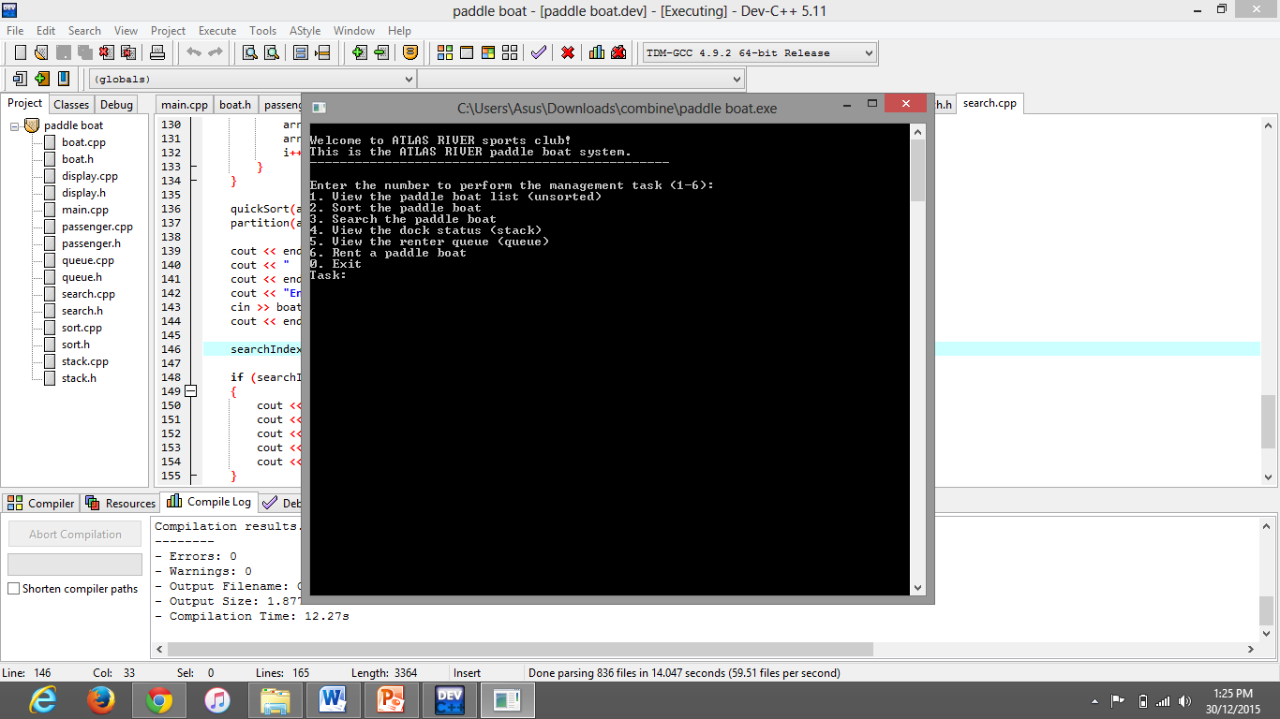The following figures show the interface for our system.

Figure 1 : Main Menu

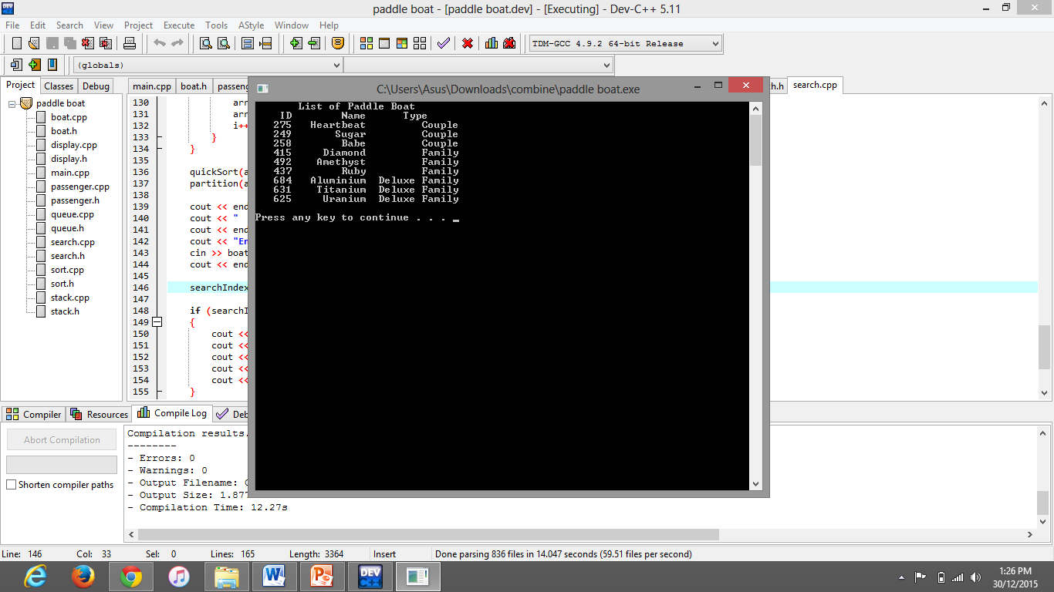

Figure 2 : View Paddle Boat List

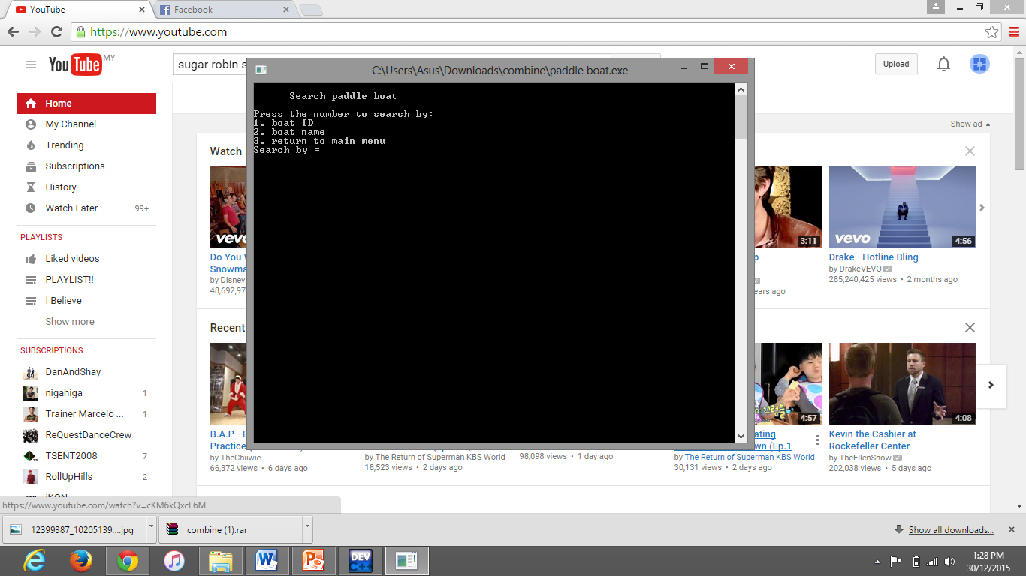

Figure 3 : Searching system. Can search by ID or name of paddle boat

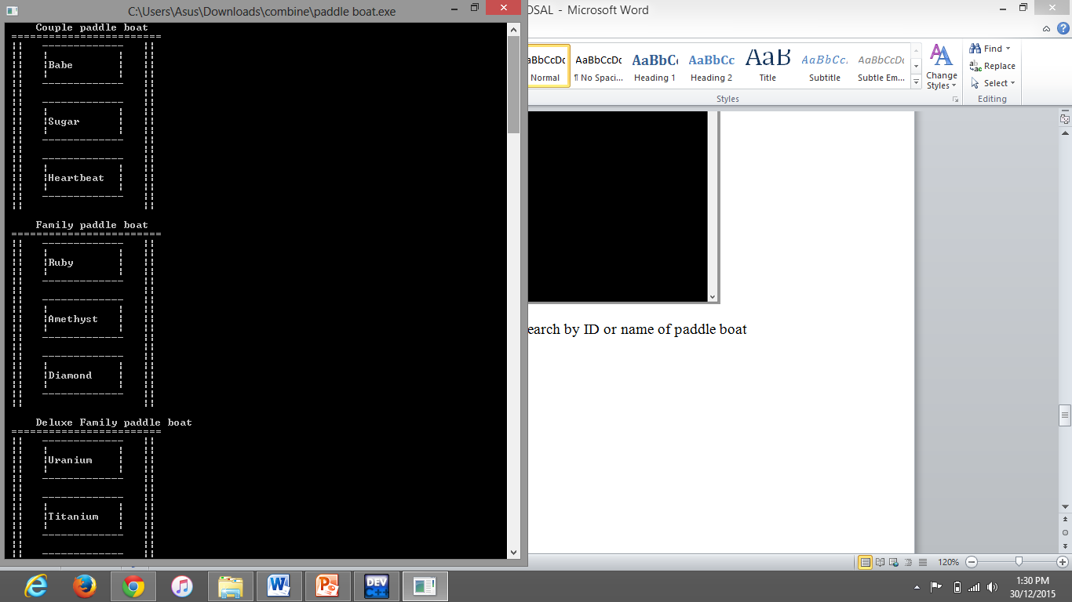

Figure 4: Viewing the dock status

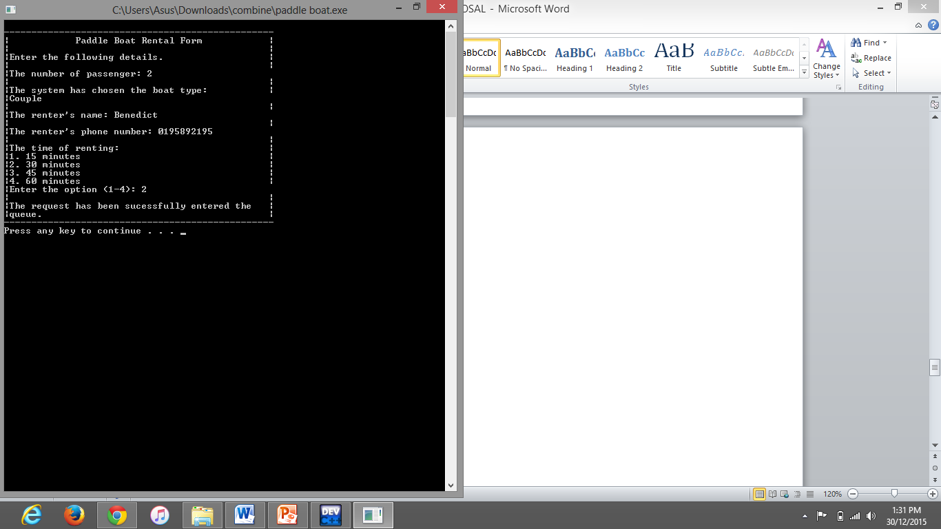

Figure 5: Renting system

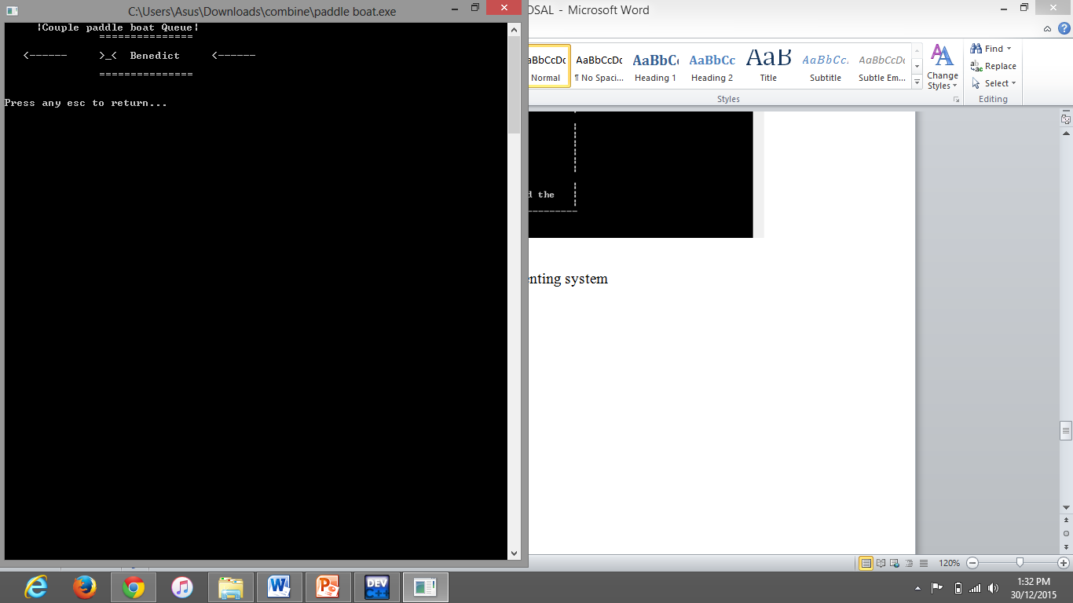

Figure 6: Renting queue. Data was successfully inserted and now Benedict is in queue