中山大学研究生期末考试
考试科目：《复变函数》
=========================================================================
学年学期：20 学年 季学期 姓 名：
学 院/系：计算机学院 学 号：
考试方式： 卷 年级专业：
考试时长： 120分钟
任课老师:

====================================================================================
- Calculate the following value(s) of (10)
- 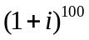
- 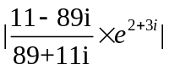
- Given the a function u(x,y) = y³-3x²y (10)
- Show that u(x,y) is a harmonic function
- Find an analytic f(z) whose real part is u(x,y), and maps 0 to i
- Suppose that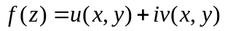 and that f’(z) exists at a point z₀=x₀+iy₀. Then the first-order partial derivatives of u and v must exist at (x₀,y₀), and they must satisfy the Cauchy-Riemann equations. (10)

- Calculate (10)

a. 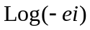

b. The principal value of 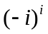
- As shown in the following Figure, Let C₁ denote the polygonal line OAB, C₂ denote the segment OB of the line y=x, f(z) = y-x-i3x², (z=x+iy) then evaluate the integrals (10)
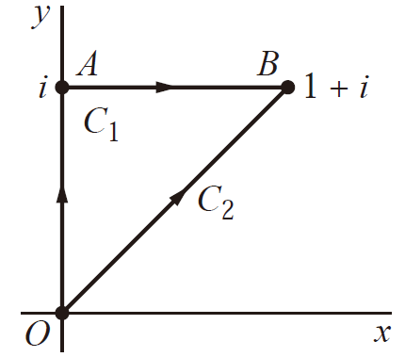
- 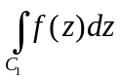 (b) 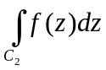
- Let C be the arc of the circle |z|=2 from z=2 to z=2i that lies in the first quadrant. Show that (10)
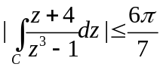
- Suppose that z_{n} = x_{n} + iy_{n} (n = 1, 2, . . .) and z = x + iy. Show that (10)

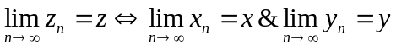
- Give the Laurent series expansions in powers of z for the function (10)
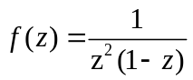
- In the region 0<|z|<1
- In the region 1<|z|<∞
- Evaluate the following integrals (10)
- 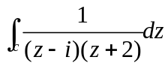, where C is the positively circle |z|=1/2
- 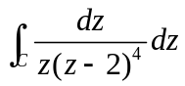 , where C is the positively circle |z-2|=1

10. Calculate the following integral (10)

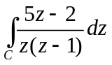

Where C is the circle |Z|=2, described counterclockwise.

