中山大学本科生期末考试
考试科目：《工程数学》（A卷）
学年学期：2017学年第2学期 姓 名：
学 院/系：数据科学与计算机学院 学 号：
考试方式：闭卷 年级专业：
考试时长：120分钟 班 别：

警示 《中山大学授予学士学位工作细则》第八条：“考试作弊者，不授予学士学位。”

-------以下为试题区域，共10道大题，每题10分，总分100分,考生请在答题纸上作答-------
- Show that if z lies on the circle |z|=2, then
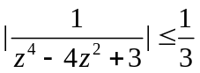
Answer: 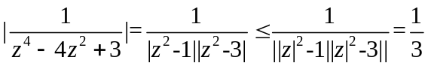
- Suppose that v is a harmonic conjugate of u in a domain D and also that u is a harmonic conjugate of v in D. Show how it follows that both u(x, y) and v(x, y) must be constant throughout D.
Answer: Textbook p. 82 Ex. 3
- (a) If e^{z} is pure imaginary, what restriction is placed on z?
(b) Find all roots of the equation log z= iπ/2
Answer: a) z=x+iy, y=π/2+kπ, k in Z; b) z= i
- Let C₀ and C denote the circles z = z₀+Re^{iθ} (-π≤θ≤+π) and z = Re^{iθ} (-π≤θ≤+π), respectively, show that
- 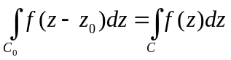 , where f is piecewise continuous on C
- 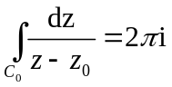
Answer: Textbook P136. Ex.10
- Let C₁ denote the positively oriented boundary of the square whose sides lie along the lines x = ±1, y = ±1 and let C₂ be the positively oriented circle |z| = 4, show that 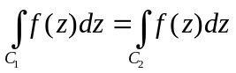, when
- 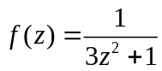 (b) 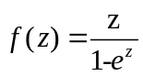 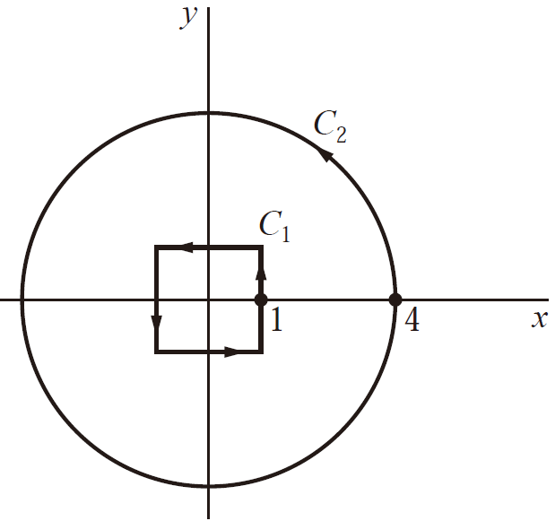

Answer: Textbook P.161 Ex. 2
- Give the Laurent series expansions in powers of z for the function
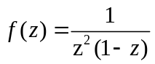
- In the region 0<|z|<1
- In the region 1<|z|<∞
Answer: Textbook P206, Ex. 4
- Let two functions p and q be analytic at a point z₀. If p(z₀)≠0, q(z₀)=0, q’ (z₀)≠0, show that
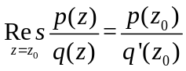
Answer: Textbook P. 253, Theorem 2
- Determine the number of zeros, counting multiplicities, of the polynomial Z⁶-5z⁴+z³-2z, inside the circle |z|=1
Answer: 4, Textbook P297, Ex.6
- Find the bilinear transformation 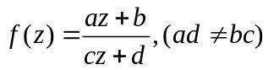, which maps the points
- 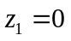, 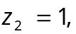 and 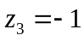 onto 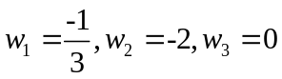
- 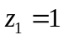, 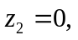 and 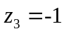 onto 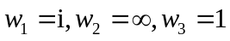
Answer: a) 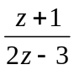; b) 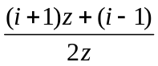
- Given the a function u(x,y) = 2x-2xy
- Show that u(x,y) is a harmonic function
- Find an analytic f(z) whose real part is u(x,y)

Answer: v(x,y) = x²-y²+2y

