**EBS 289K**

**Homework 1**

ID: 916686000

Name: Boyan Cai

**Problem 1, 2, 3:**

Codes are in my MATLAB files. hw1_circle.m works for running in a circle. Hw1_rectangle.m works for running in a square.

**Problem 4:**

Figures can be seen in problem 5.1.

**Problem 5:**

1. No slips and no skidding:

Without slips and skidding, the tractor follows our order ideally. A perfect rectangle and a perfect circle are made here.

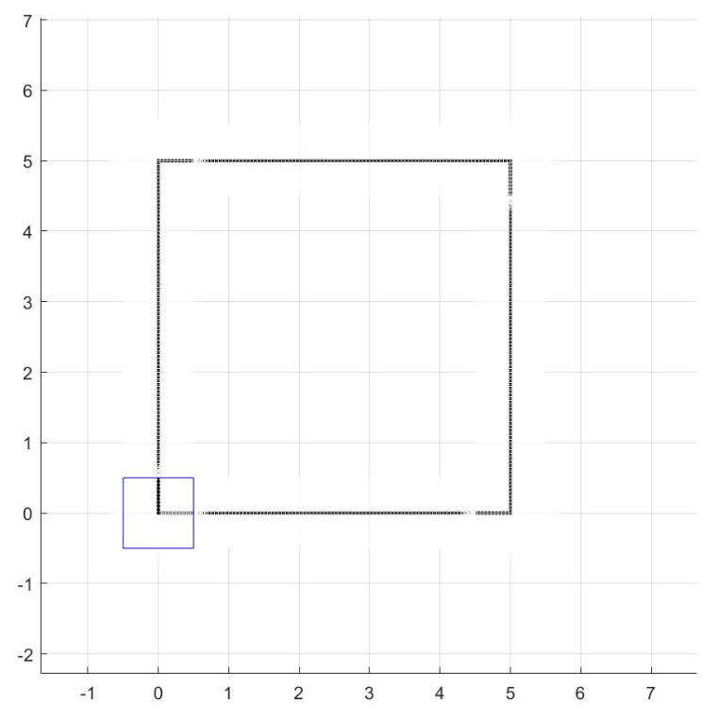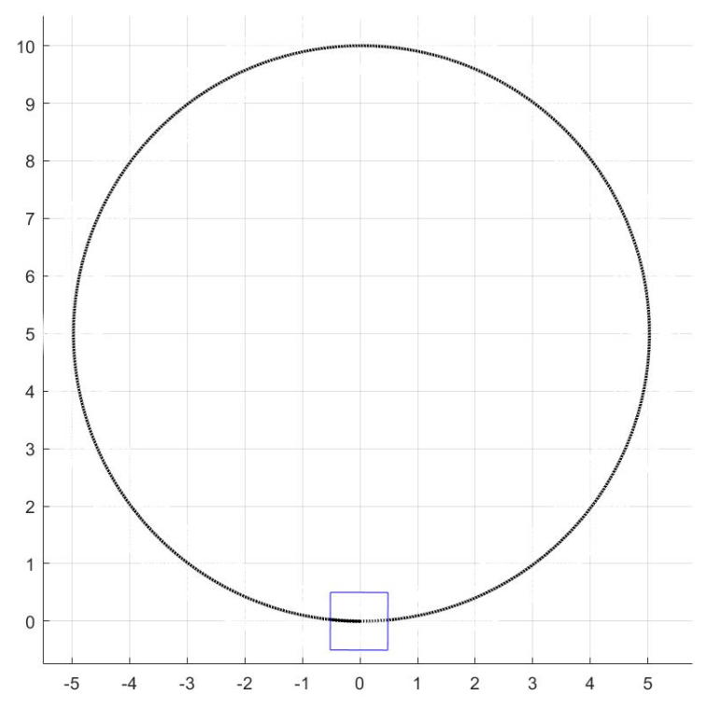

Figure 1 Trajectories without slips and skidding

1. Sl=0.1, Sr=0.2, =0:

With more slips on the right wheel, the car supposes to turn right a little bit when we told the tractor to go straight. The tractor cannot turn an accurate 90 degrees as well. Thus, the tractor cannot make a perfect square or a circle this time.

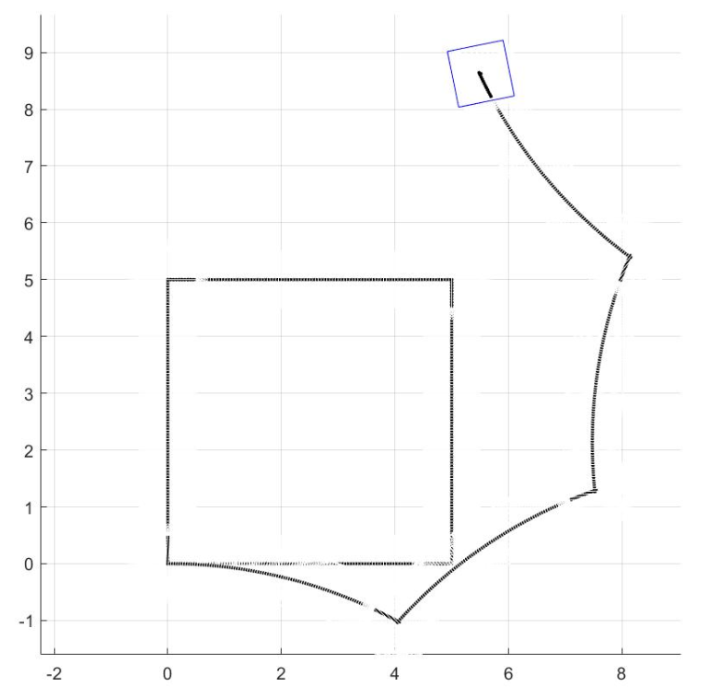 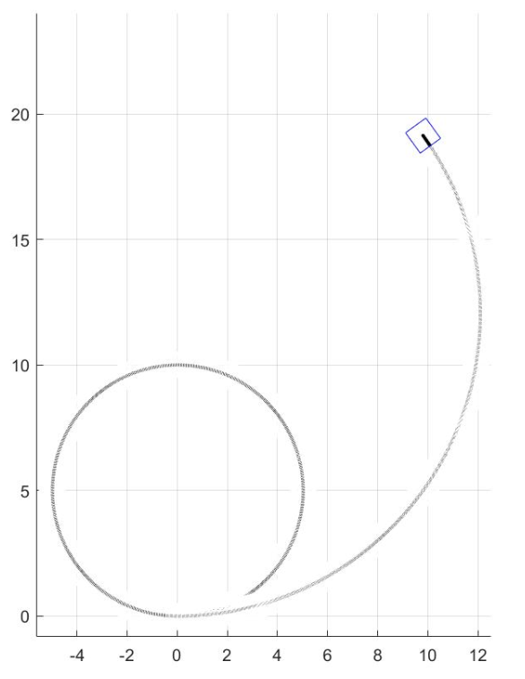

Figure 2 Trajectories with slips but no skidding

1. Sl=0, Sr=0, =5:

With skidding equals to 5, the tractor supposes to move a little bit left. However, the theta is still be the same. Thus, the tractor can still draw a perfect square and a perfect circle but with a small left movement compared with the original position.

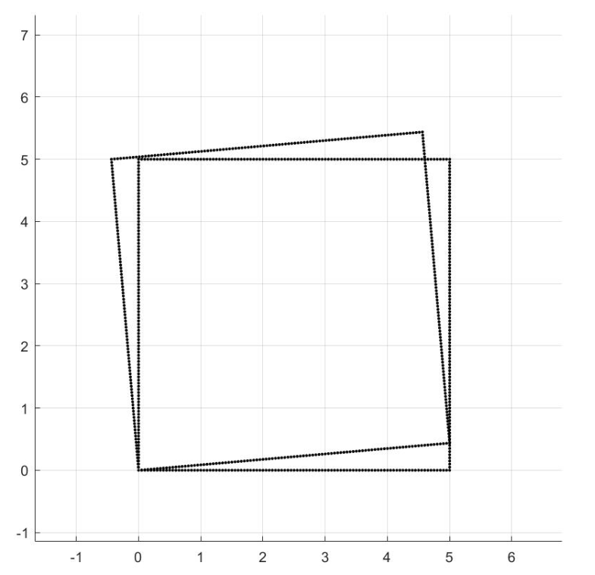 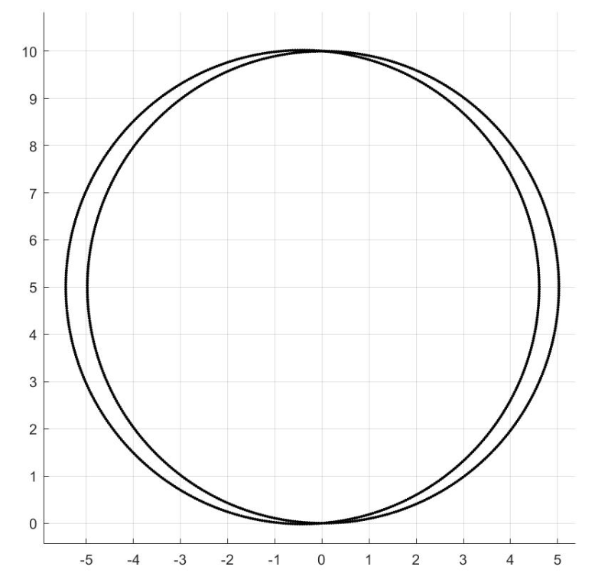

Figure 3 Trajectories without slips but with skidding

1. Sl=0.1, Sr=0.2, =5:

The effects of the combination of slips and skidding can be seen below. The tractor supposes to have a right turn bias and a left movement bias. Thus, the path we created is different with Figure 2. In square paths, due to the effects of , two paths have a crossing part which is not appeared in Figure 2.

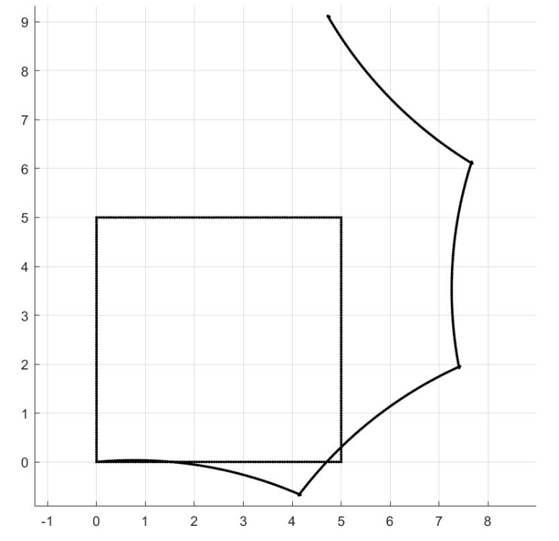 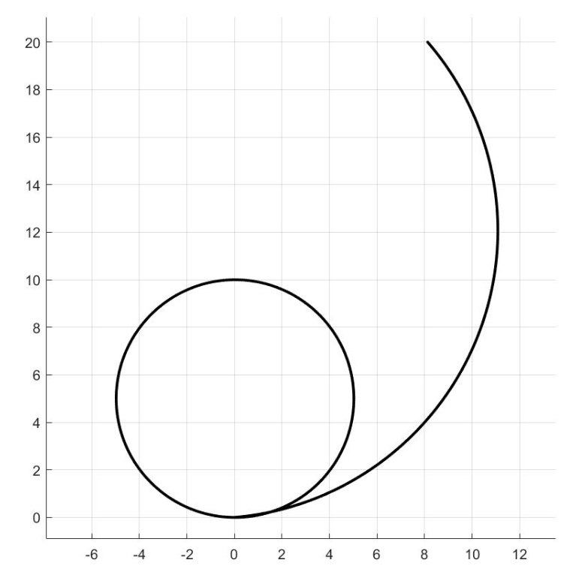

Figure 4 Trajectories with slips and skidding

**Problem 6:**

Comments are included in each part.

**Problem 7:**

Let us regenerate all those figures with =0.5. With a larger , we need less steps to regenerate figures.

1. Sl=0.1, Sr=0.2, =0:

There is no much difference on the square figure. But for circle, it is clear that the center of the circle is not (0,5) any more. That is because the bigger the , the less accurate we can get per step.

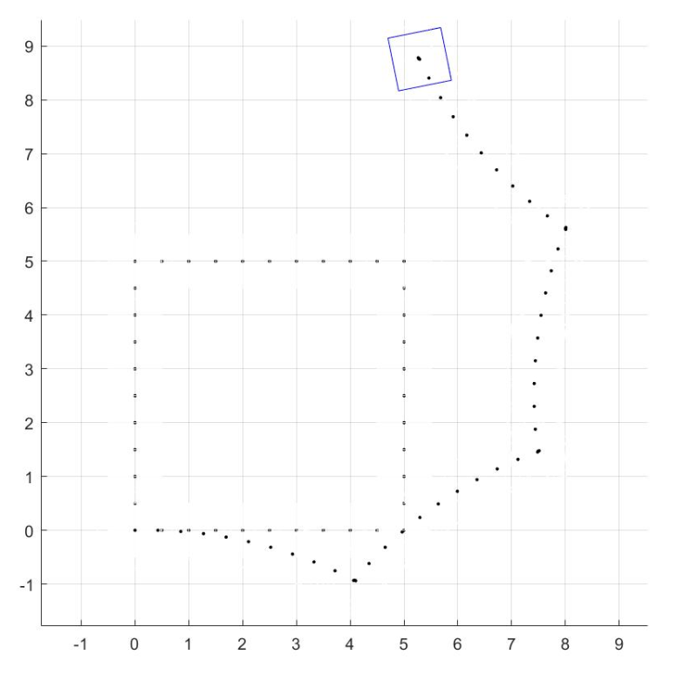 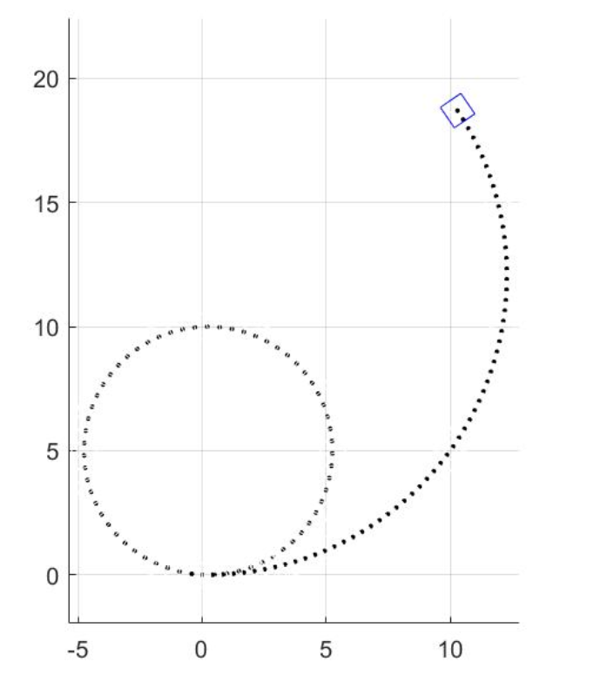

Figure 5 Trajectories with slips but no skidding

1. Sl=0, Sr=0, =5:

Again, there is no much difference when we applied a larger to square plotting. But the center of the circle has a movement compared with a smaller. 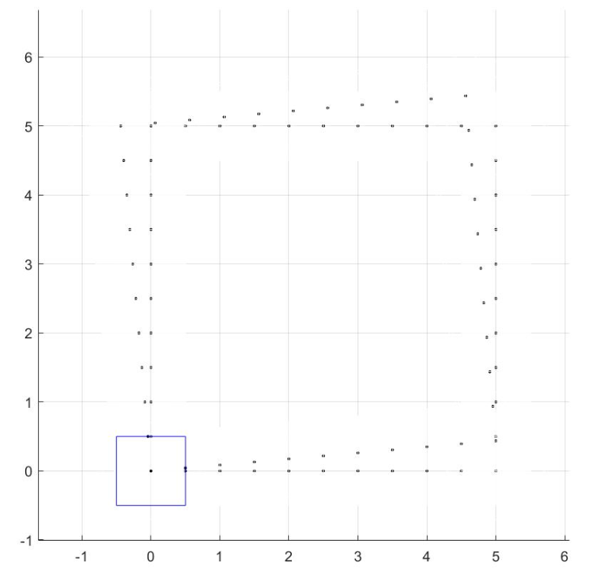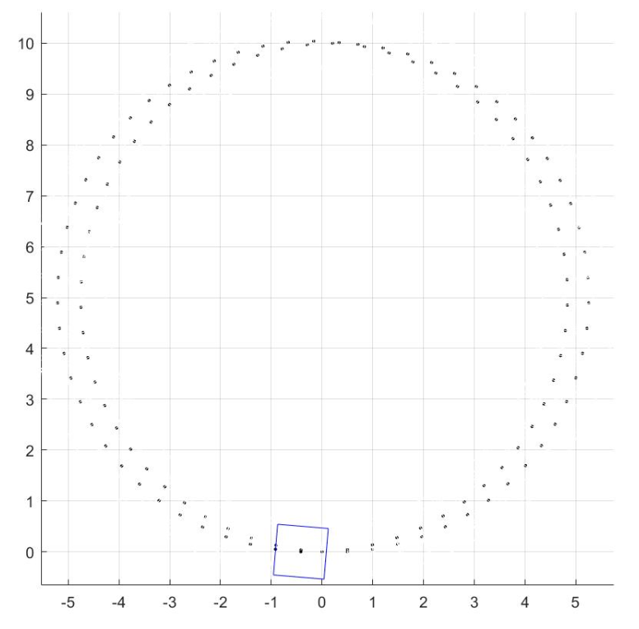

Figure 6 Trajectories without slips but with skidding

1. Sl=0.1, Sr=0.2, =5:

Same effects on this part.

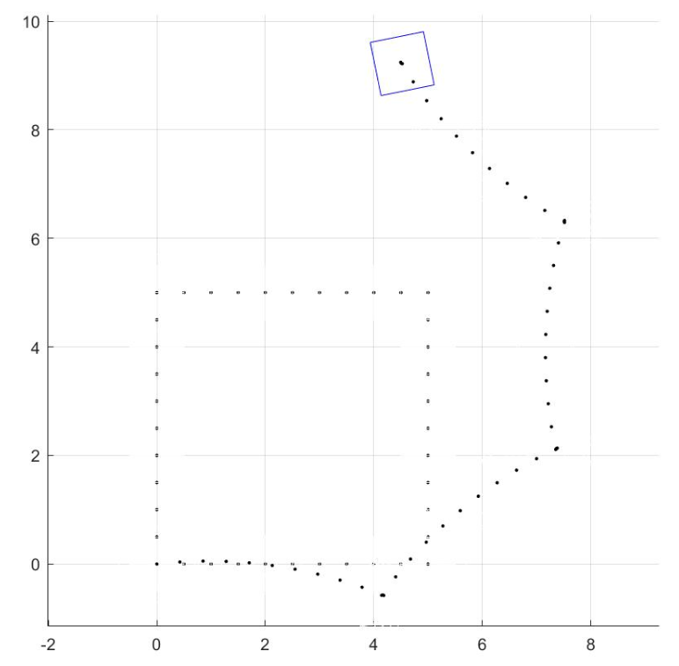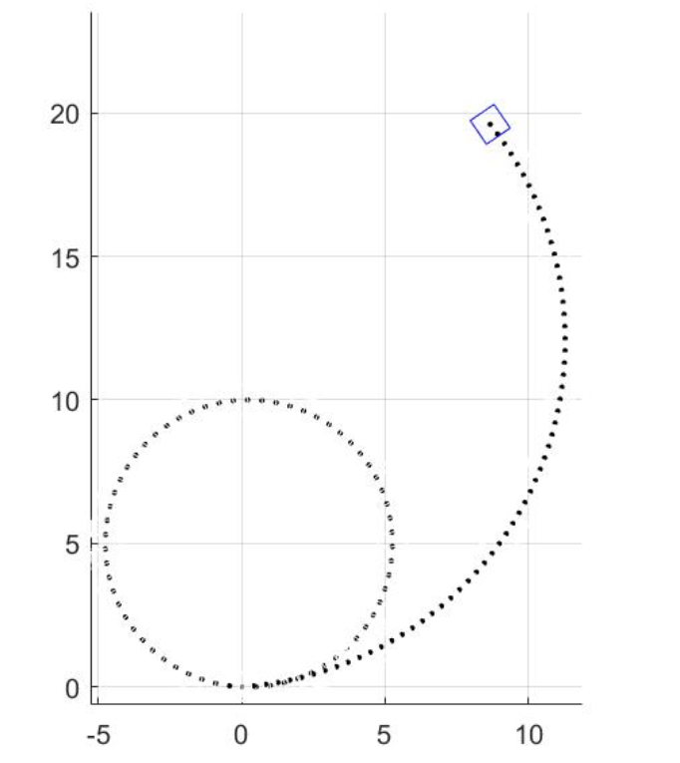

Figure 7 Trajectories with slips and skidding

Analysis:

With bigger , the tractor supposes to have bigger error. “supposes” means not every time, the bigger the , the larger error we have. In most cases, we have larger errors. But if we go straight and the goal distance can be exactly divided by the distance that we move forward per step, we can go to the destination without error luckily. This is the reason why the square figure seems good with a larger . But in most cases, with a larger , we collect more error per step. This is the reason why our circle figure changed.