Course: Programming Fundamental – ENSF337

Lab #: Lab 3

Instructor: M. Moussavi

Student Name: Shanzi Ye

Lab Section: B01

Date submitted: May 24, 2022

# Exercise A

Point 1：

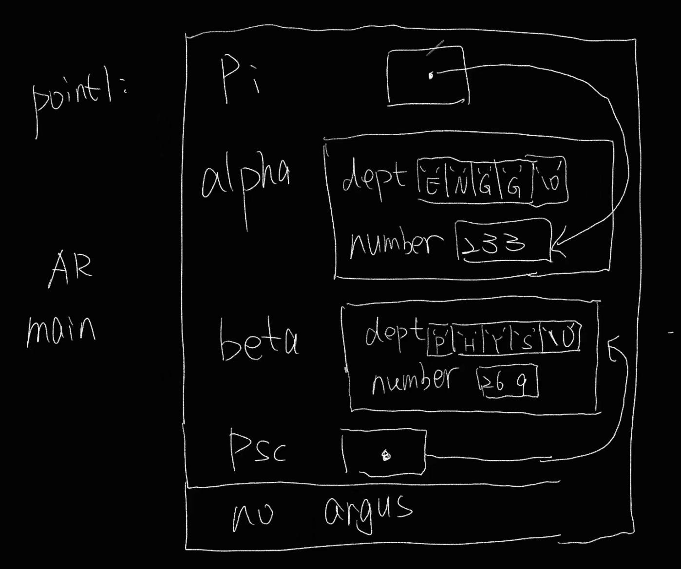

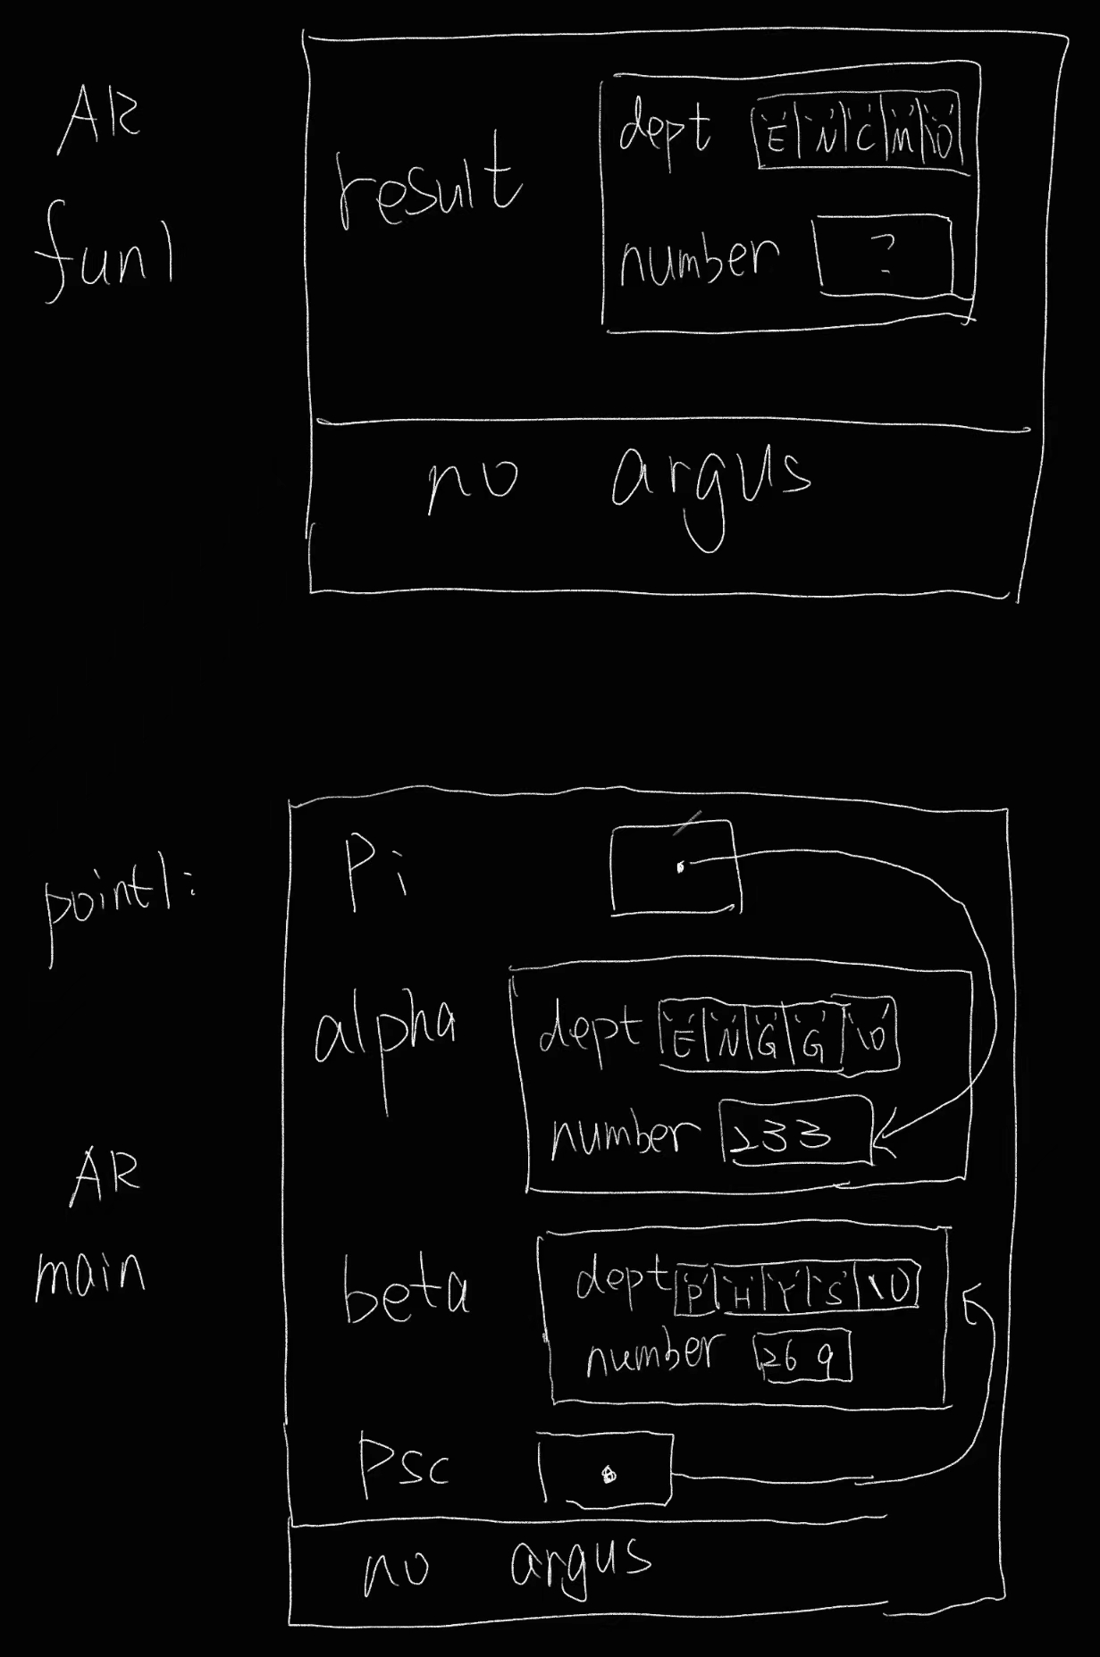Point 2:

# Exercise B

struct cplx

cplx_add(struct cplx z1, struct cplx z2)

{

struct cplx result;

result.real = z1.real + z2.real;

result.imag = z1.imag + z2.imag;

return result;

}

void cplx_subtract(struct cplx z1, struct cplx z2, struct cplx* difference)

{

struct cplx result;

result.real = z1.real - z2.real;

result.imag = z1.imag - z2.imag;

*difference = result;

}

void cplx_multiply(const struct cplx* pz1, const struct cplx* pz2, struct cplx* product)

{

struct cplx result;

result.real = pz1->real * pz2->real;

result.imag = pz1->imag * pz2->imag;

*product = result;

}

**You can check out the complete code in the file called “source code”.**

**I only wrote down the three definitions in the PDF.**

# Exercise C

/*

* File Name: lab3_exe_B.c

* Assignment: Lab 3 Exercise B

* Lab section: (B01)

* Completed by: Shanzi Ye

* Submission Date: May 24,2022

*/

#include <stdio.h>

#include <string.h>

#include <stdlib.h>

#include<math.h>

const int ARRAY_SIZE = 10;

/* a structure that represents a point on a Cartesian coordinates system. */

struct point

{

char label[3]; // a label for a point

double x ; // x coordinate for point in a Cartesian coordinate system

double y; // y coordinate for point in a Cartesian coordinate system

double z; // z coordinate for point in a Cartesian coordinate system

};

void display_struct_point(struct point x);

double distance (const struct point* a, const struct point* b);

int search(const struct point* struct_array, const char* label, int n);

int main(void)

{

struct point alpha = { "A1", 2.3, 4.5} ;

struct point *stp = &alpha;

printf("Size of struct-point in our Linux lab is: %d bytes.\n",

(int) sizeof(struct point));

printf("Size of strcut-point pointer in our Linux lab is: %d bytes.\n",

(int) sizeof(stp));

printf("Size of strcut that stp points to is: %d bytes.\n",

(int) sizeof(*stp));

display_struct_point(*stp);

struct point sigma = { "C1", 12.3, 14.5, 56.00 } ;

struct point omega = { "D1", 125.9, 130.0, 97.00 } ;

struct point theta = { "E1", 5.9, 303.0, 7.00 } ;

display_struct_point(sigma);

display_struct_point(omega);

printf("\nThe distance between sigma and omega is: %10.2f", distance(&sigma, &omega));

printf("\nThe distance between sigma and theta is: %10.2f", distance(&sigma, &theta));

system("pause");

return 0;

}

void display_struct_point(struct point x)

{

printf("\nPoint: %s <%.2lf, %.2lf, %.2lf>", x.label, x.x, x.y, x.z);

}

double distance(const struct point* p1, const struct point* p2)

{

double distance_3d = sqrt(pow((p1->x - p2->x), 2) + pow((p1->y - p2->y), 2) + pow((p1->z - p2->z), 2));

return distance_3d;

/*This funciton is incomplete and needs to be changed and complted by

the students to calculate and return the distance betwn the two three-D points*/

}

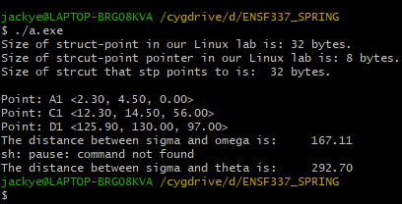

# Exercise D

/*

* File Name: lab3_exe_D.c

* Assignment: Lab 3 Exercise D

* Lab section: (B01)

* Completed by: Shanzi Ye

* Submission Date: May 24,2022

*/

#include <stdio.h>

#include <string.h>

const int ARRAY_SIZE = 10;

/* a structure that represents a point on a Cartesian coordinates system. */

struct point

{

char label[3]; // a label for a point

double x ; // x coordinate for point in a Cartesian coordinate system

double y; // y coordinate for point in a Cartesian coordinate system

double z; // z coordinate for point in a Cartesian coordinate system

};

void display_struct_point(struct point x);

void populate_struct_array(struct point* array, int n);

int search(const struct point* struct_array, const char* label, int n);

int main(void)

{

struct point struct_array[ARRAY_SIZE];

int i;

int position;

populate_struct_array(struct_array, ARRAY_SIZE);

printf("\nArray of point structures contains: \n");

for(i=0; i < 10; i++)

display_struct_point(struct_array[i]);

printf("\nNow testing function search ...\n");

position = search(struct_array, "v0", ARRAY_SIZE);

if(position != -1)

printf("\nstruct_array[%d] contains %s", position,

struct_array[position].label);

else

printf("\nstruct_array doesn't have label: %s.", "v0");

position = search(struct_array, "E1", ARRAY_SIZE);

if(position != -1)

printf("\nstruct_array[%d] contains %s", position,

struct_array[position].label);

else

printf("\nstruct_array doesn't have label: %s.", "E1");

position = search(struct_array, "C5", ARRAY_SIZE);

if(position != -1)

printf("\nstruct_array[%d] contains %s", position,

struct_array[position].label);

else

printf("\nstruct_array doesn't have label: %s.", "C5");

position = search(struct_array, "B7", ARRAY_SIZE);

if(position != -1)

printf("\nstruct_array[%d] contains %s", position,

struct_array[position].label);

else

printf("\nstruct_array doesn't have label: %s.", "B7");

position = search(struct_array, "A9", 10);

if(position != -1)

printf("\nstruct_array[%d] contains %s", position,

struct_array[position].label);

else

printf("\nstruct_array doesn't have label: %s.", "A9");

position = search(struct_array, "E11", ARRAY_SIZE);

if(position != -1)

printf("\nstruct_array[%d] contains %s", position,

struct_array[position].label);

else

printf("\nstruct_array doesn't have label: %s.", "E11");

position = search(struct_array, "M1", ARRAY_SIZE);

if(position != -1)

printf("\nstruct_array[%d] contains %s", position,

struct_array[position].label);

else

printf("\nstruct_array doesn't have label: %s.", "M1");

return 0;

}

void display_struct_point(struct point x)

{

printf("\nPoint: %s <%.2lf, %.2lf, %.2lf>", x.label, x.x, x.y, x.z);

}

int search(const struct point* struct_array, const char* label, int n)

{

int noFindFlag = 0;

int i;

for (i = 0; i < n; i++)

{

int j = 0;

while (label[j] != '\0')

{

if (struct_array[i].label[j] != label[j])

{

noFindFlag = 1;

break;

}

else

{

noFindFlag = 0;

}

j++;

}

if (noFindFlag == 0)

{

return i;

}

}

return -1;

}

void populate_struct_array(struct point* array, int n)

{

int i;

char ch1 = 'A';

char ch2 = '9';

char ch3 = 'z';

for( i = 0; i < 10; i++)

{

/* generating some random values to fill them elements of the array: */

array[i].x = (7 * (i + 1) % 11) * 100 - i /2;

array[i].y = (7 * (i + 1) % 11) * 120 - i / 3;

array[i].z = (7 * (i + 1) % 11) * 150 - i /4;

if(i % 2 == 0)

array[i].label[0] = ch1++;

else

array[i].label[0] = ch3--;

array[i].label[1] = ch2--;

array[i].label[2] = '\0';

}

}

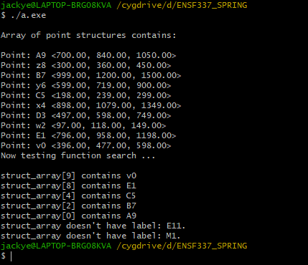

# Exercise E

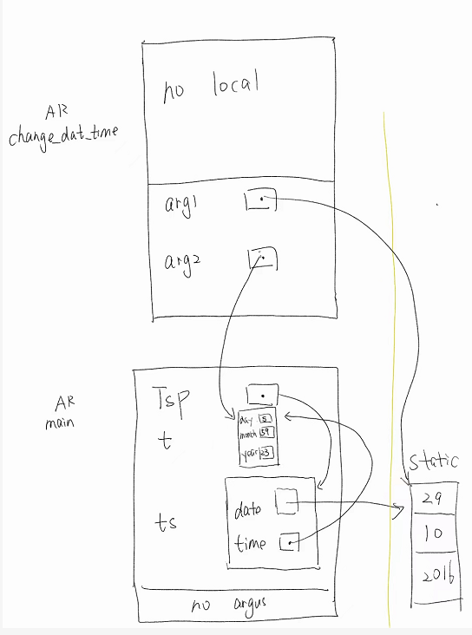

# Exercise F

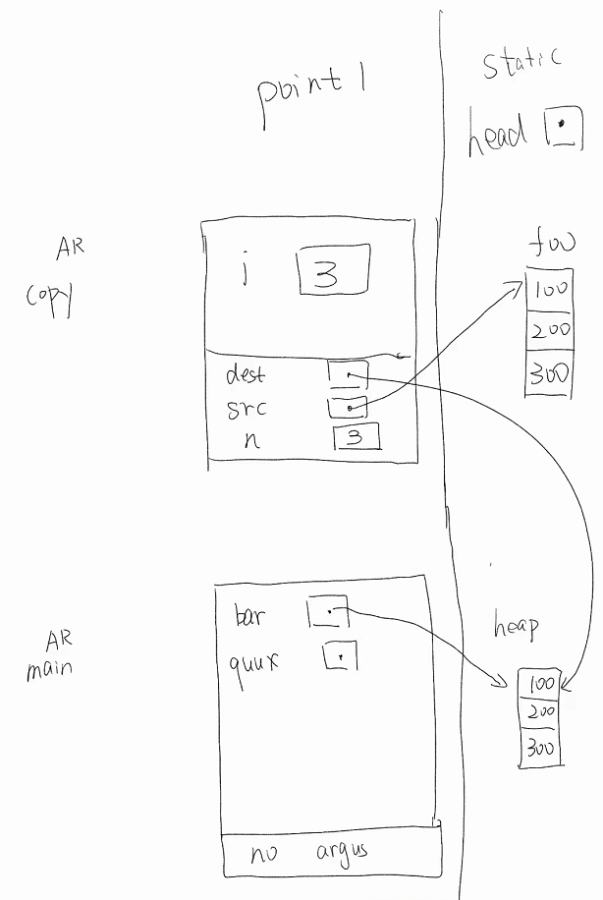Point 1:

Point 2:

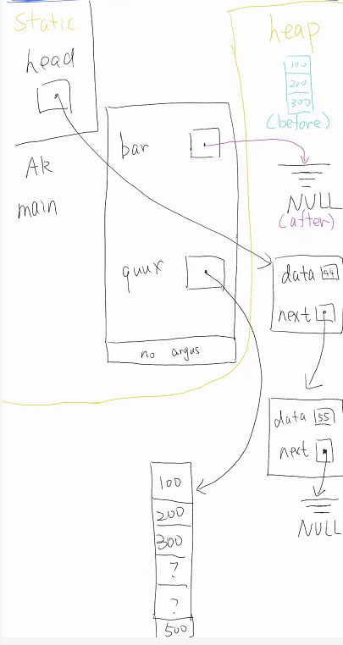

# Exercise G

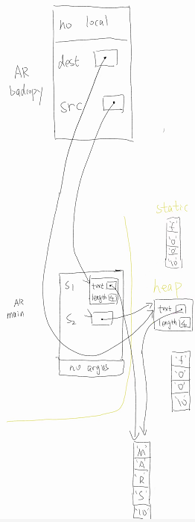

# Exercise I

/*

* File Name: lab3_exe_I.c

* Assignment: Lab 3 Exercise I

* Lab section: (B01)

* Completed by: Shanzi Ye

* Submission Date: May 24,2022

*/

#define _CRT_SECURE_NO_WARNINGS

#include <stdio.h>

#include <stdlib.h>

#include "lab3exe_I.h"

int main(void) {

char input_filename[30] = "D:/lab3exe_I.txt";

char output_filename[30]= "lab3exe_I_output.txt";

IntVector intVec;

intVec.number_of_data = 0;

read_text_file(&intVec, input_filename);

//display_single_column(&intVec);

display_multiple_column(&intVec, 4, output_filename);

return 0;

}

void read_text_file (IntVector* vec, const char* input_filename){

int nscan;

FILE *fp = fopen (input_filename, "r");

if(fp == NULL){

fprintf(stdout, "Sorry cannot open the text file %s.\n", input_filename);

exit(1);

}

do{

nscan = fscanf(fp,"%d", &vec->storage[vec->number_of_data]);

if(nscan == 1)

(vec->number_of_data)++;

else if (nscan != EOF){

fprintf(stderr, "Invalid data in %s.\n", input_filename);

exit(1);

}

}while ((nscan != EOF) & (vec->number_of_data < MAX_CAPACITY));

fclose(fp);

}

void display_single_column(const IntVector* intV){

int i;

for (i = 0; i < intV ->number_of_data; i++ )

printf("%10d\n", intV ->storage[i]);

}

void display_multiple_column(const IntVector *intV, int col, const char* output_filename)

{

int a1 = intV->number_of_data / col;

int a2 = intV->number_of_data % col;

int i;

int j;

int arrayindex = 0;

for (i = 0; i < a1; i++)

{

for (j = 0; j < col; j++)

{

printf("%10d", intV->storage[arrayindex]);

arrayindex++;

}

printf("\n");

}

for (int k = 0; k<a2;k++)

{

printf("%10d",intV->storage[arrayindex]);

arrayindex++;

}

// STUDENTS MUST COMPLETE THE DEFINITION OF THIS FILE

}

# Exercise J

Point1：

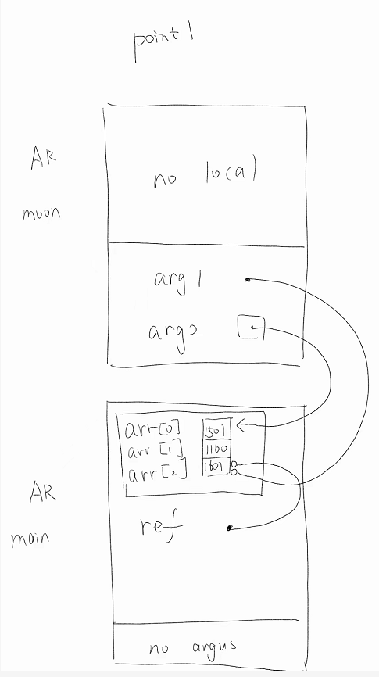

Point2：

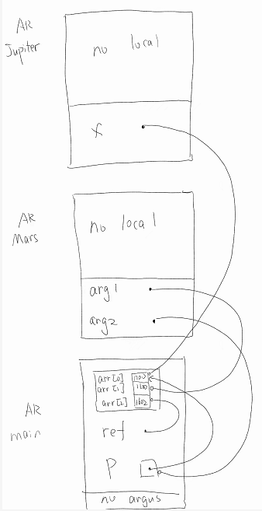

//The picture is a little bit vague, arr[0] is 1700, arr[1] is 1100, arr[2] is 1602