# **THANK YOU FOR PURCHASING OUR ITEM , YOU REALLY HELP US TO IMPROVE AND DEVELOP NEW GAME SOURCE CODE . THANK YOU FOR YOUR SUPPORT , YOU ARE REALLY AWESOME . THANK YOU SO MUCH .**

HOW TO UPLOAD TO PLAYSTORE

1. First make sure you have prepare all image + aab file   
   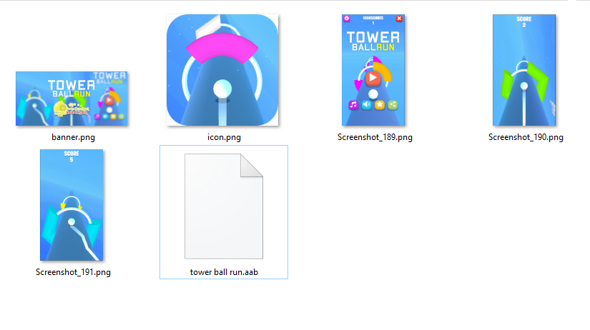  
   Note :   
   1 Banner : 1024 x 500   
   3 Screenshots : 16:9 or 9:16   
   1 Icon : 512x512
2. Go to playstore console page : <https://play.google.com/apps/publish/>  
   and click **Create Applications :**   
   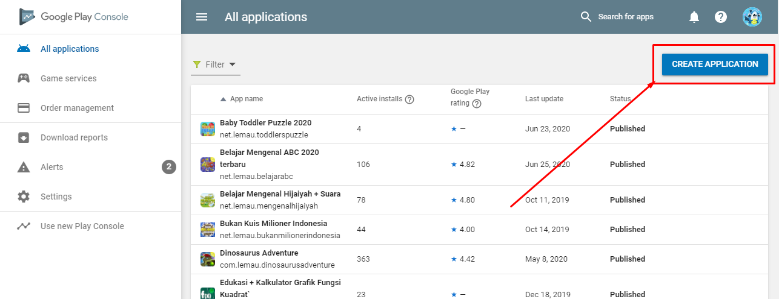
3. Type your game name and select your default language  
   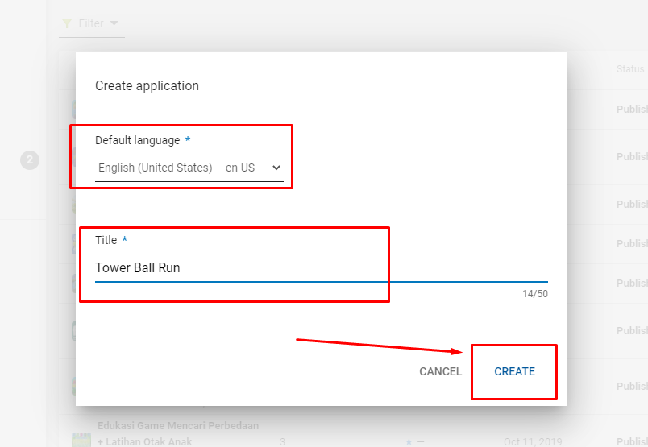

# **A. STORE LISTING**

1. Fill all Title , Short Descriptions and Full Descriptions   
   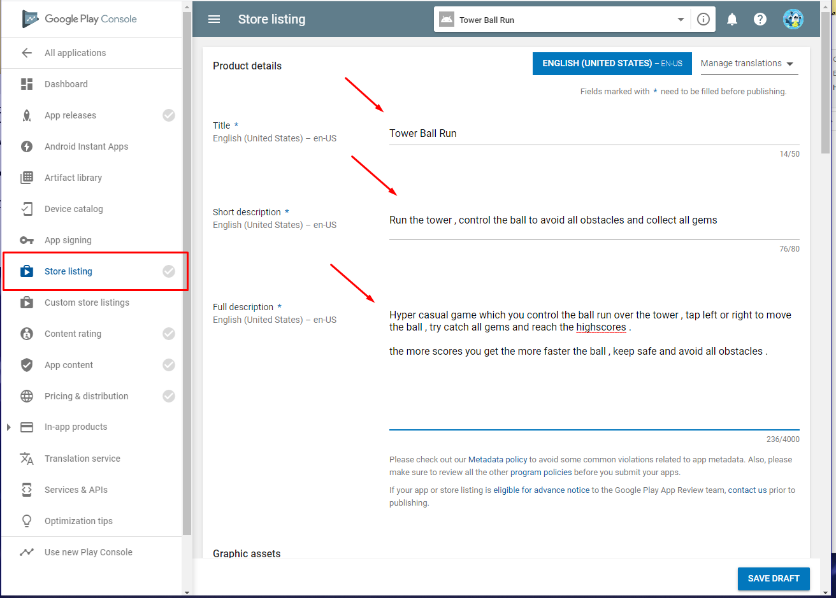
2. Add your icon , screenshots and Banner image  
   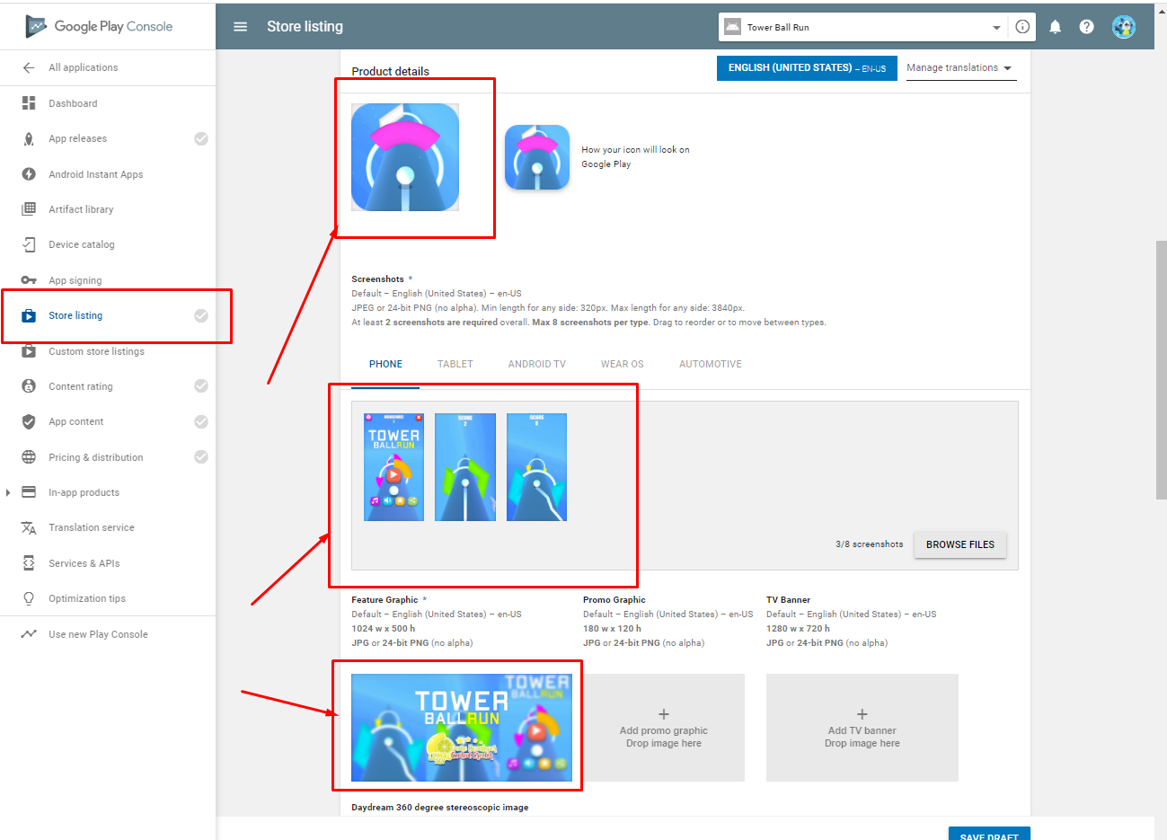
3. Select your game Categories + Email , dont forget to **Save Draft** before you **Manage Tags**  
   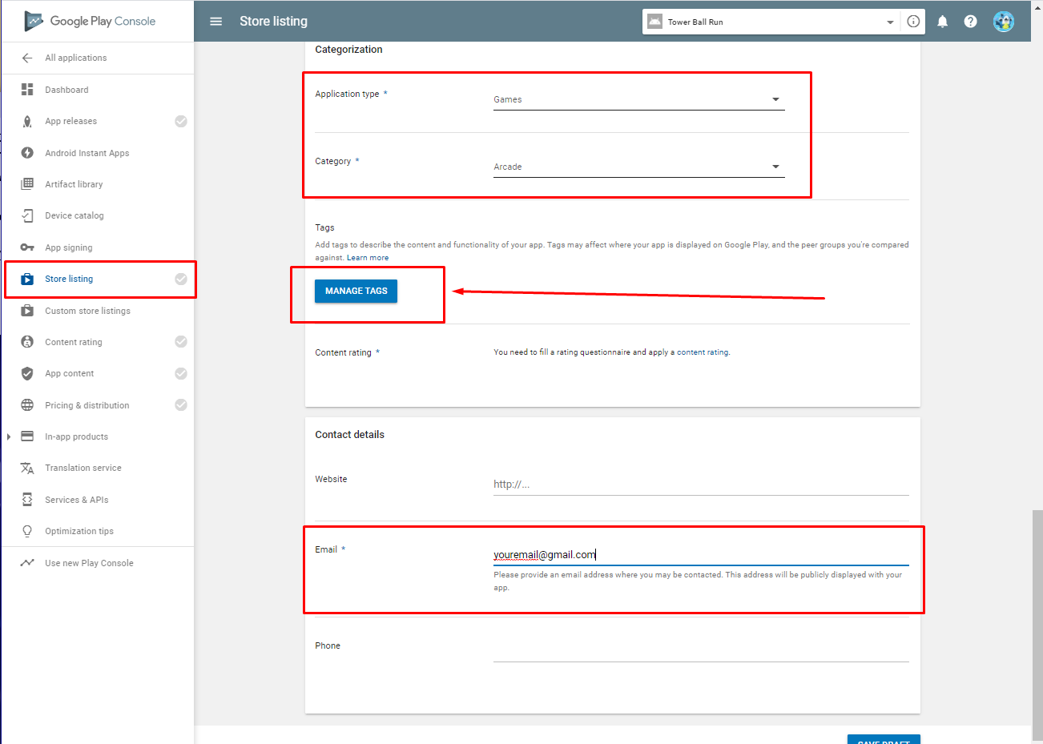
4. Select your tags  
   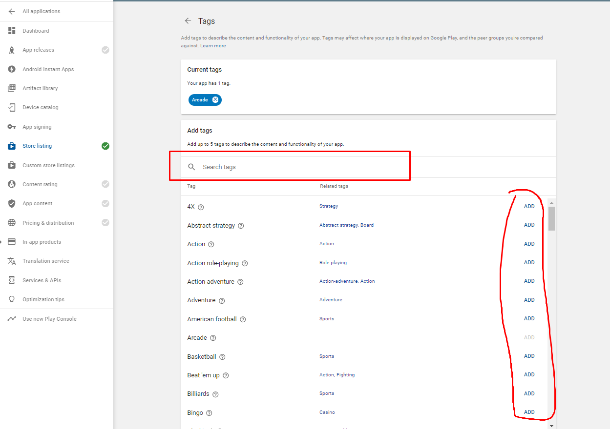

# **B. APP RELEASE**

1. 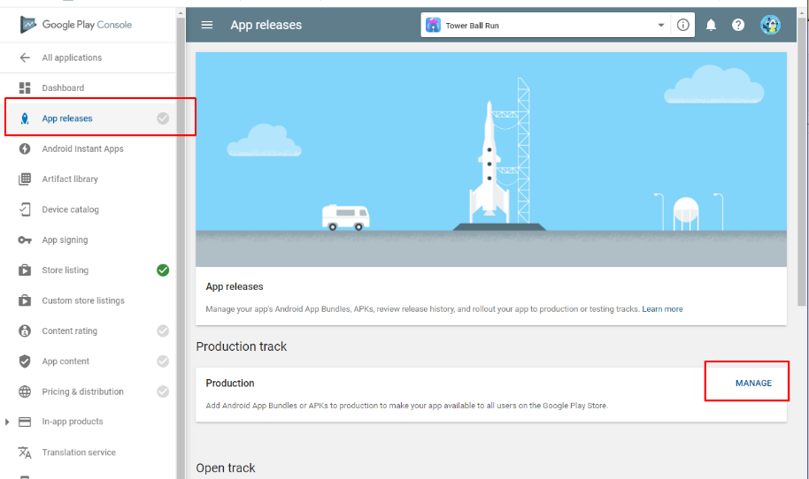
2. 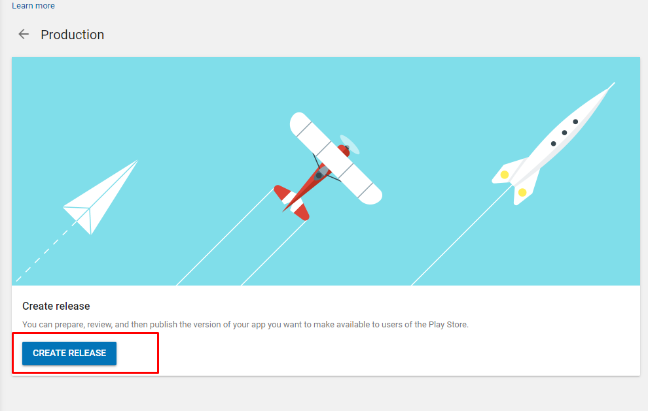
3. If you upload **AAB File you SHOULD tap CONTINUE** , else you can opt out  
   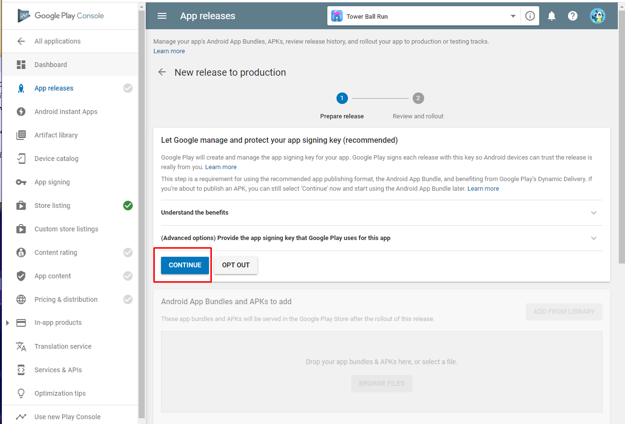
4. Drag and drop your aab file and wait until completed  
   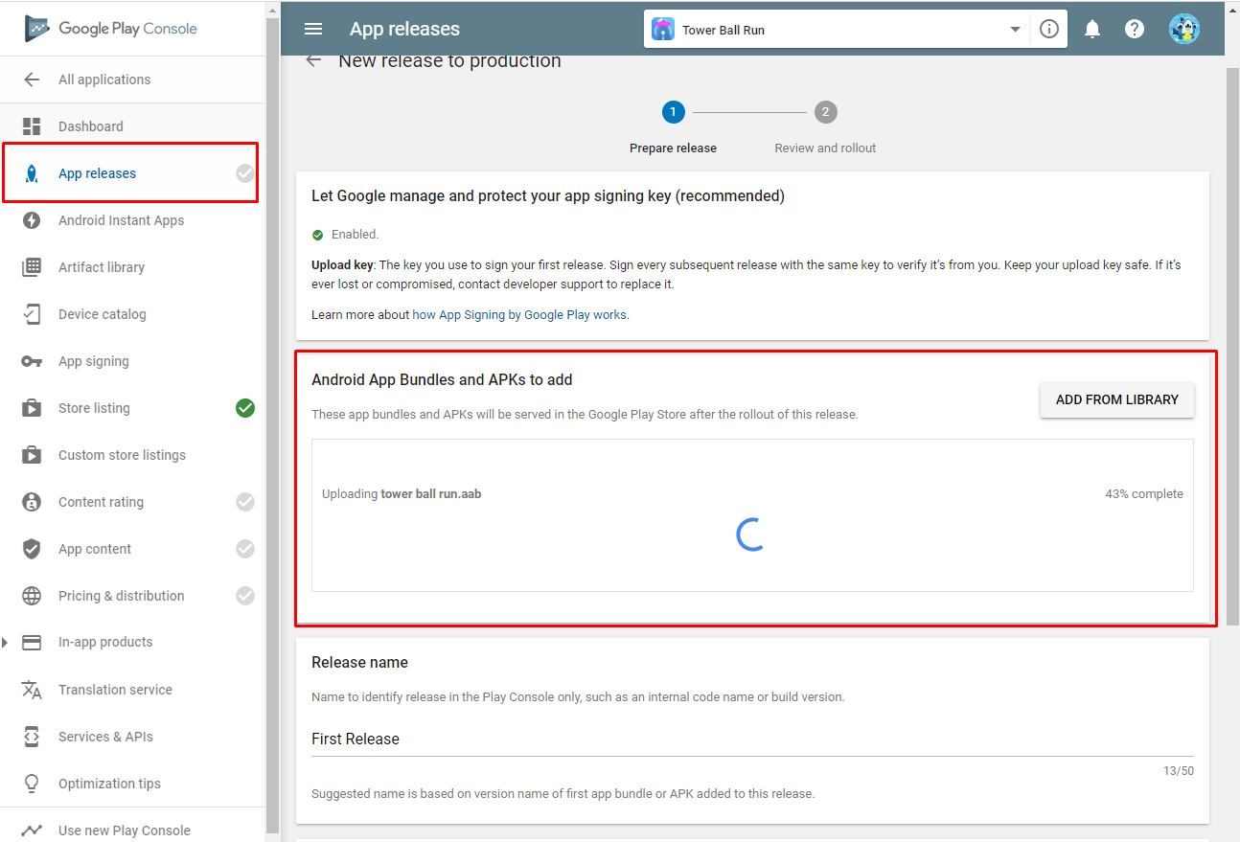
5. Fill release name and release note , then Save  
   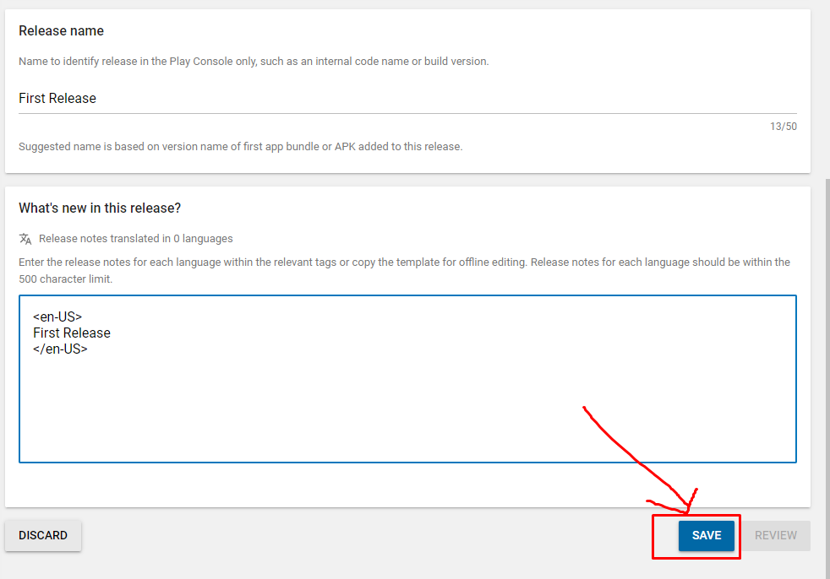

# **C. CONTENT RATING**

1. 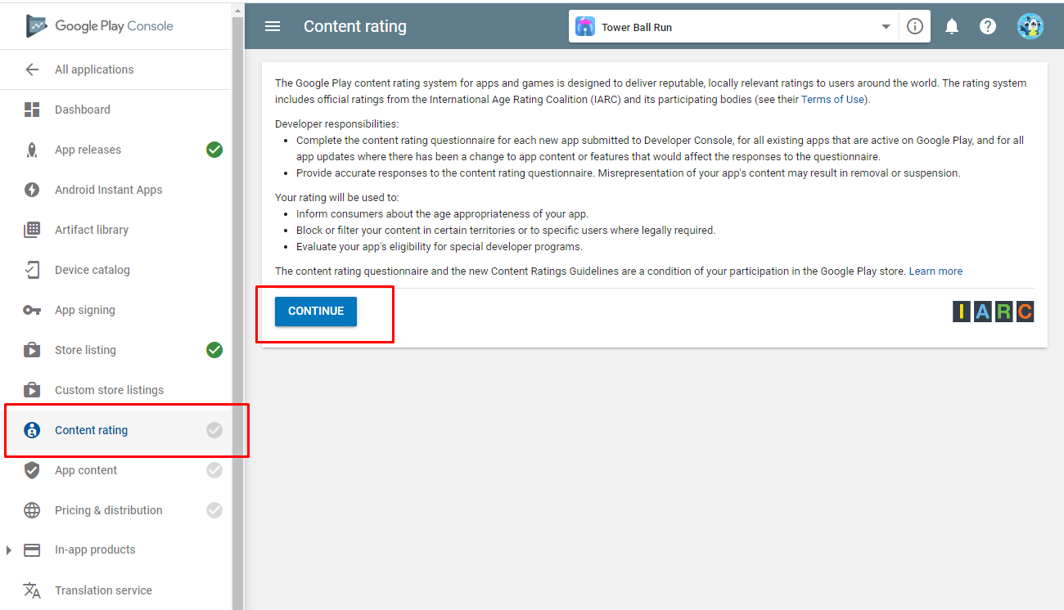
2. Type your email and select you game categories   
   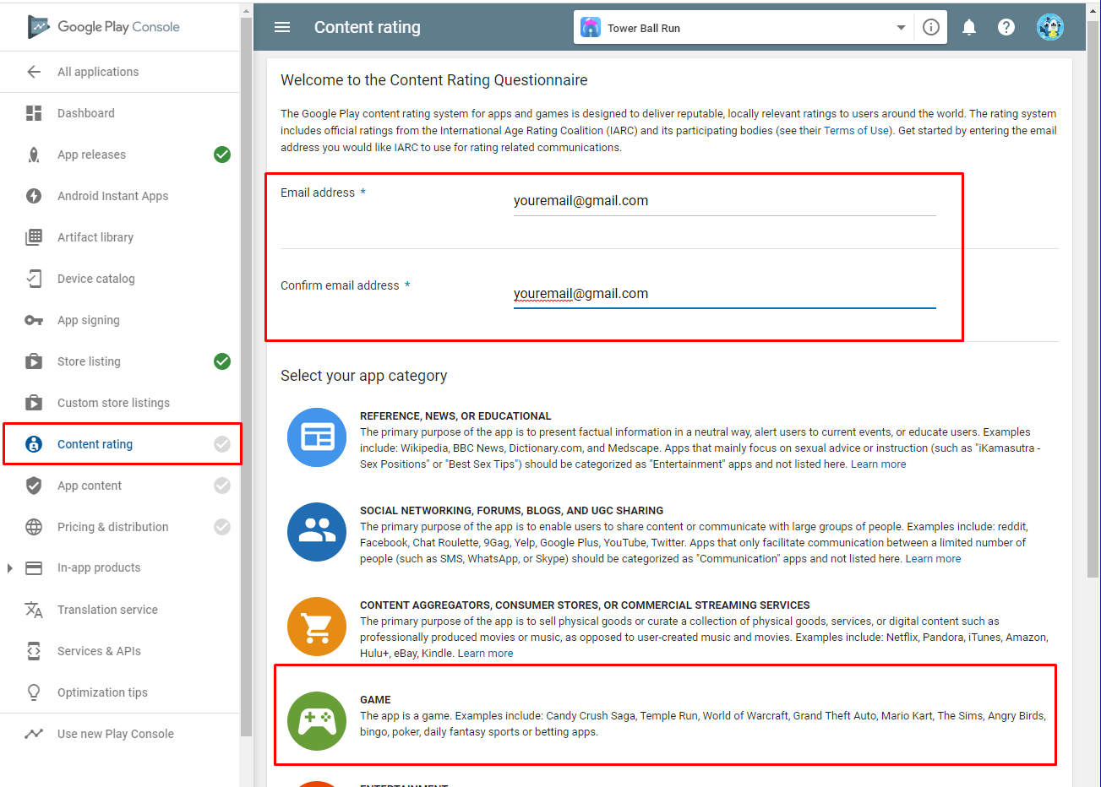
3. Fill all selection , make sure it suitable with your apps  
   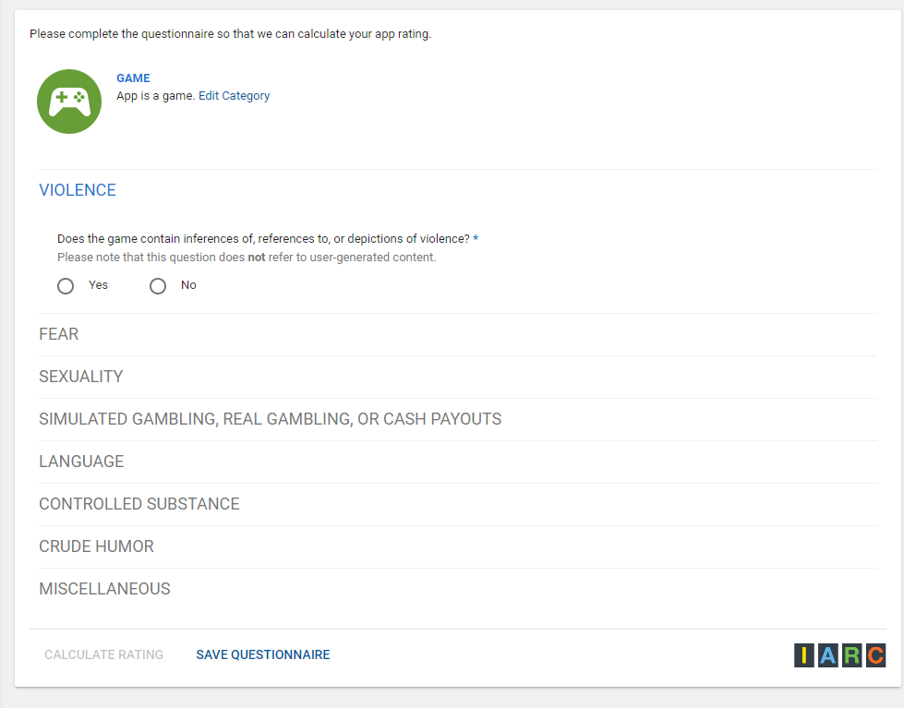
4. Apply the rating  
   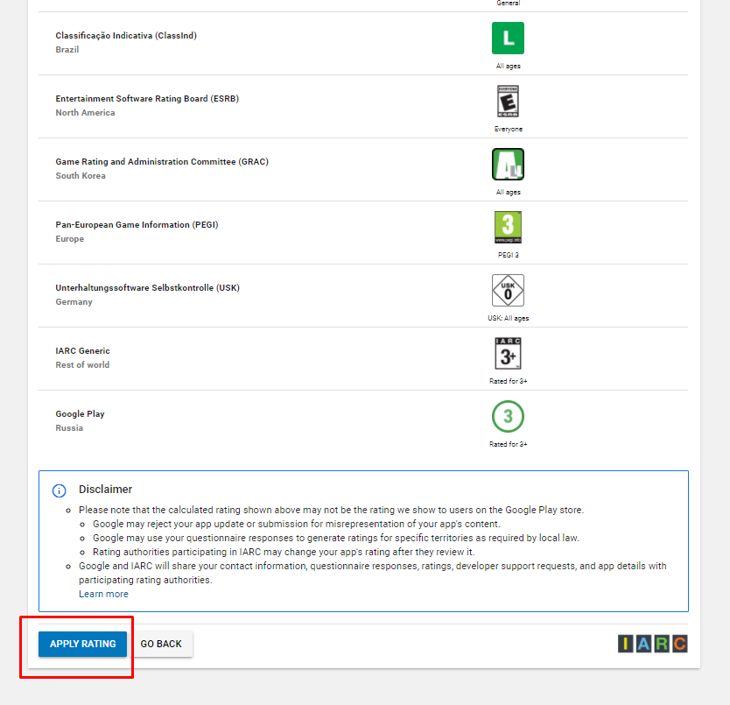

# **D. APP CONTENT**

1. Fill all App Content  
   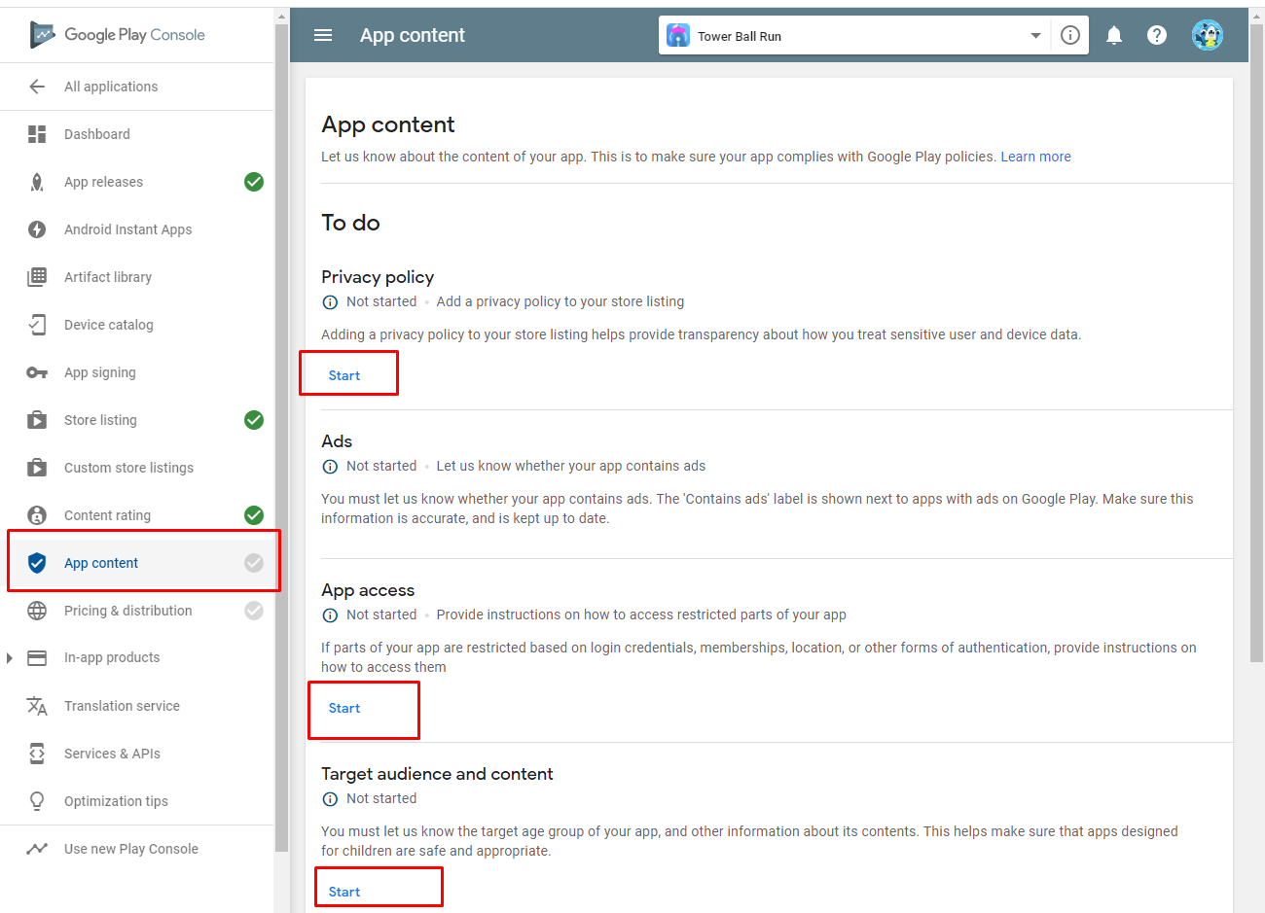
2. **Privacy Policy :**  
   you can generate your app privacy here : <http://appsmoment.net/google/>  
   and paste on your site , blogspot, or google document  
   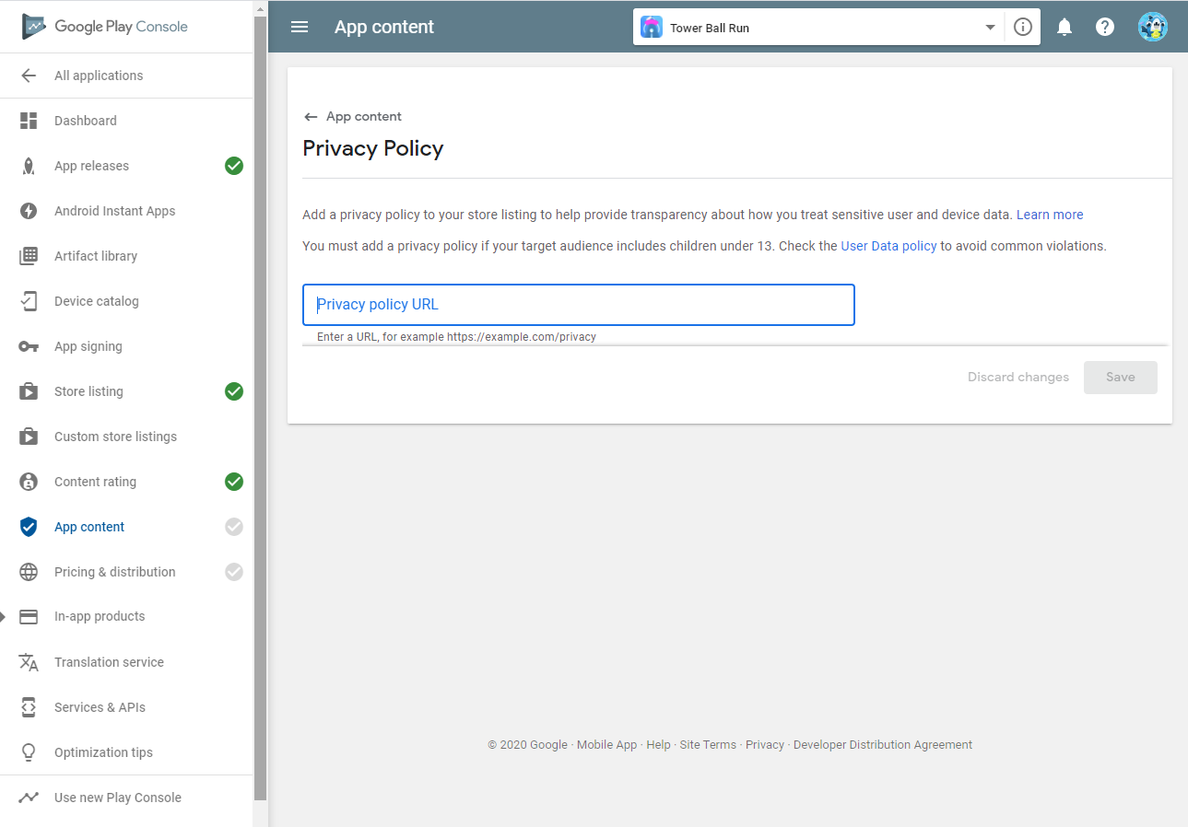
3. **App Access :   
   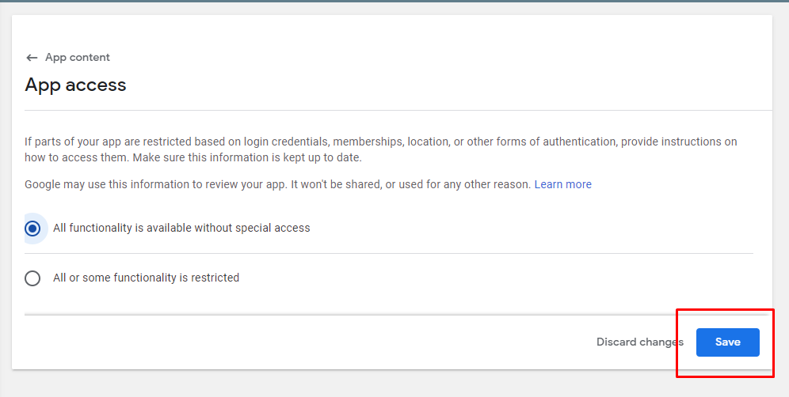**
4. **ADS  
   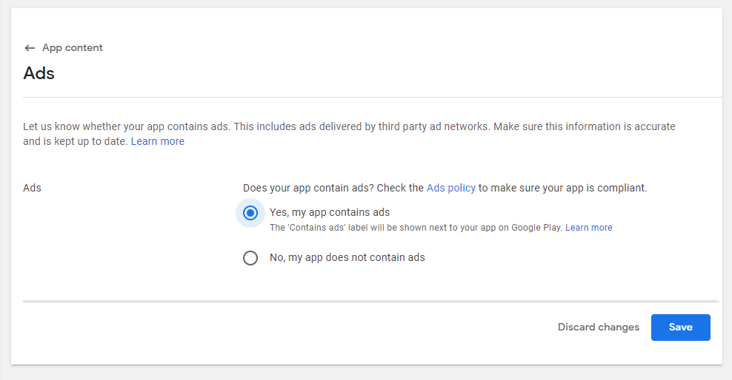**
5. **Target Audience and content**on this section you must be carefull , cause many rejection  
   you should sure if your game looks like kids game or not , for kids or not ,   
     
   note : if your game not for kids, avoid all kids “word” on desciptions and appel not for children 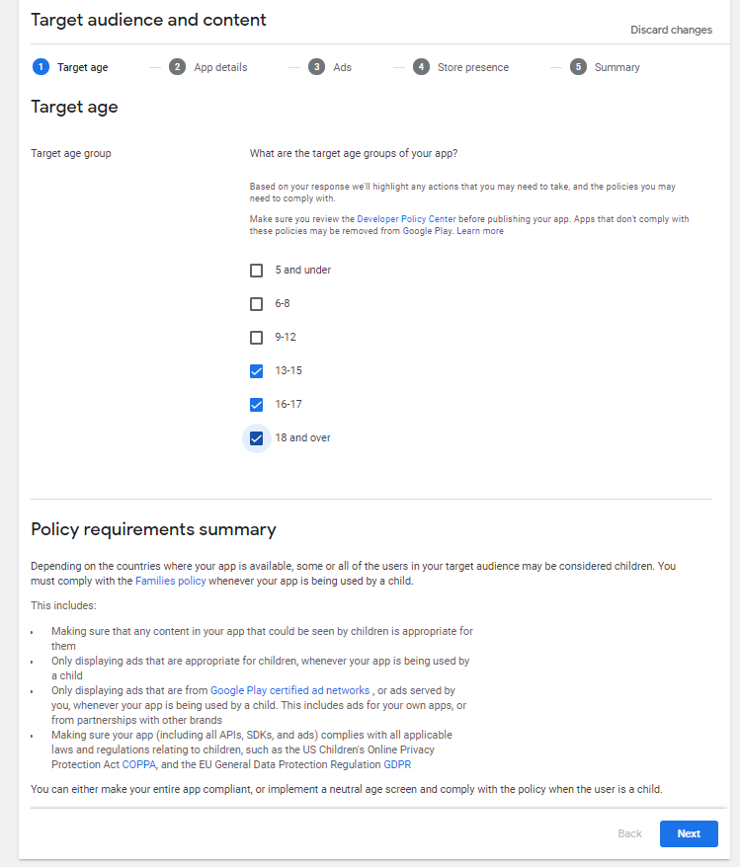  
   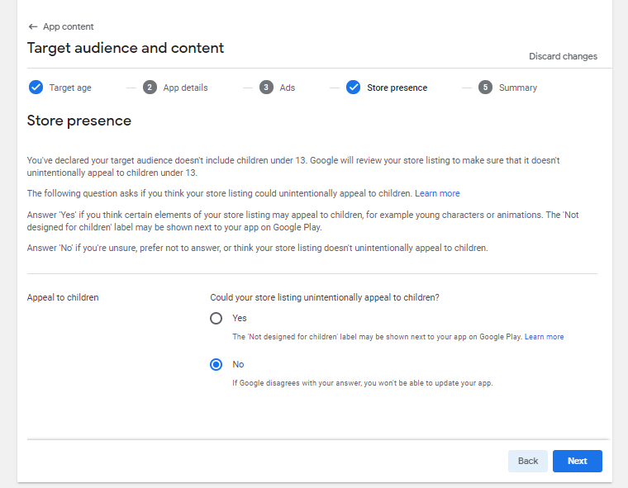  
   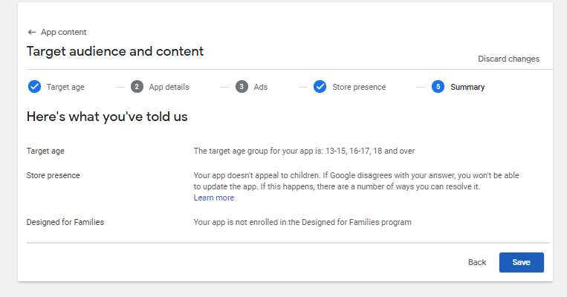

# **E. PRICING & DISTRIBUTION**

1. 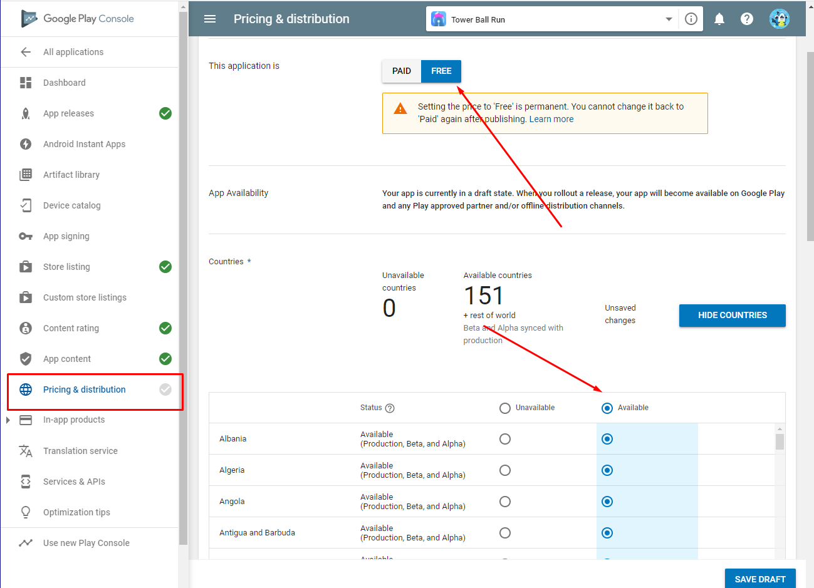
2. 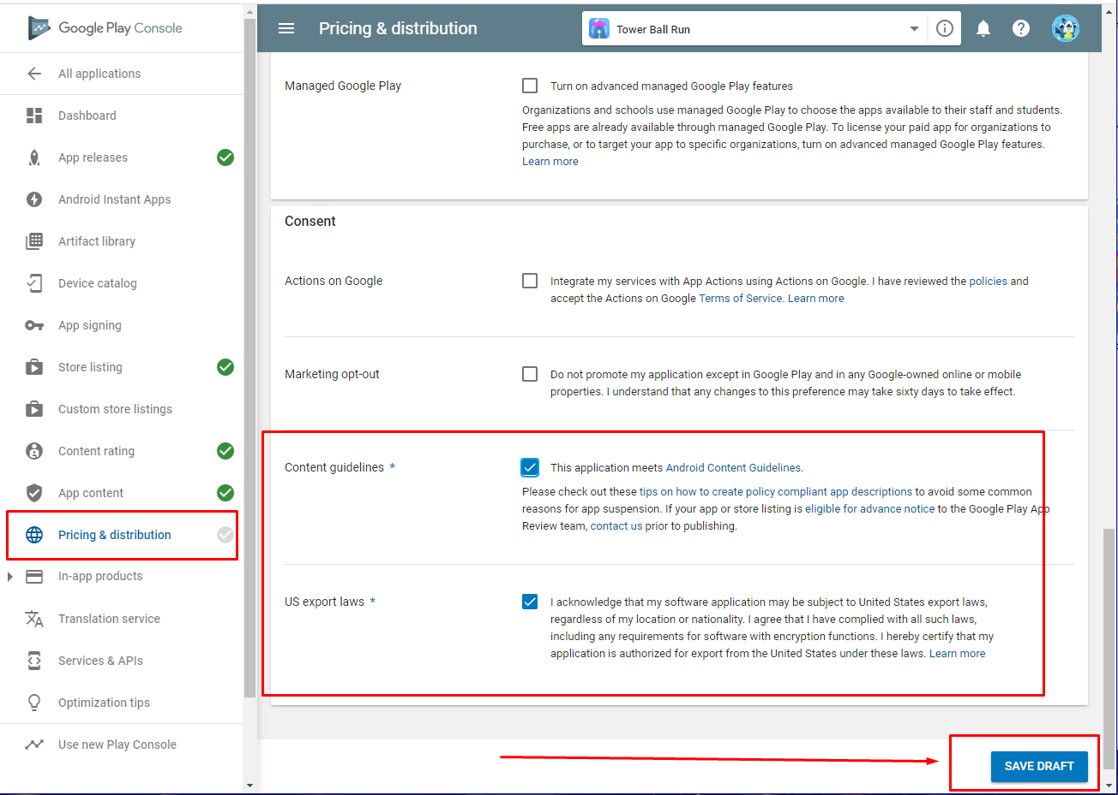

**Then after all you see this on bottom, you can click it**

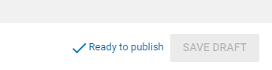

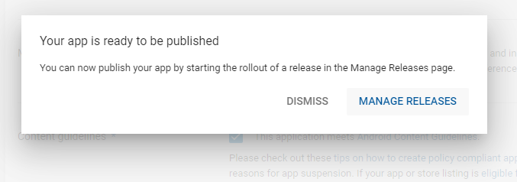

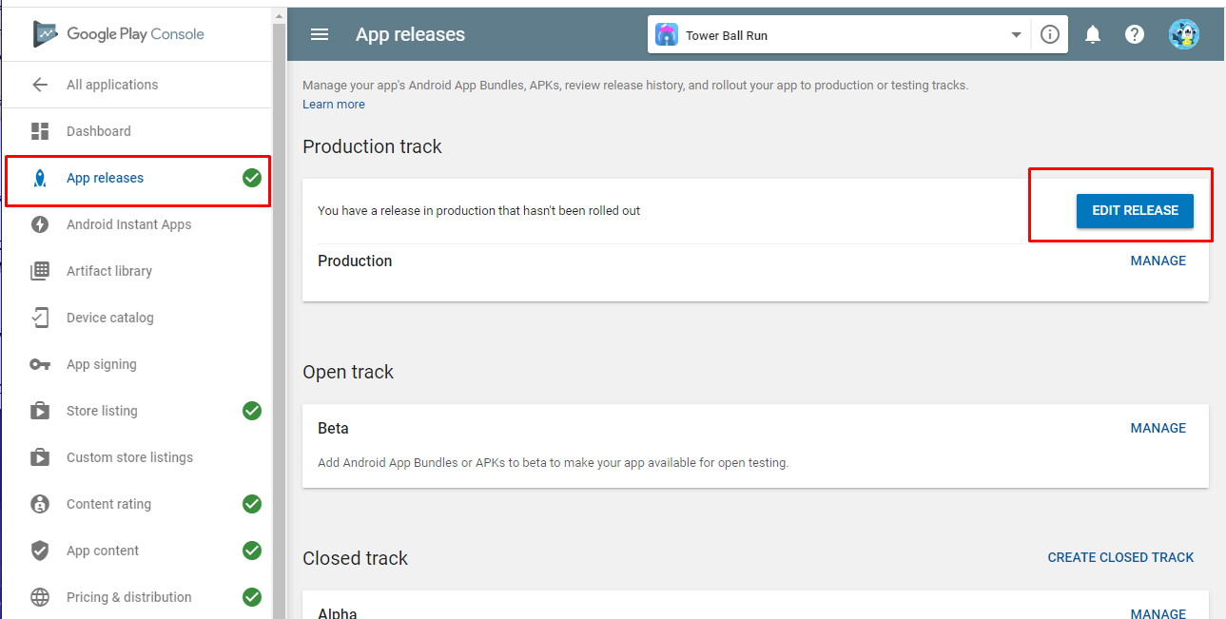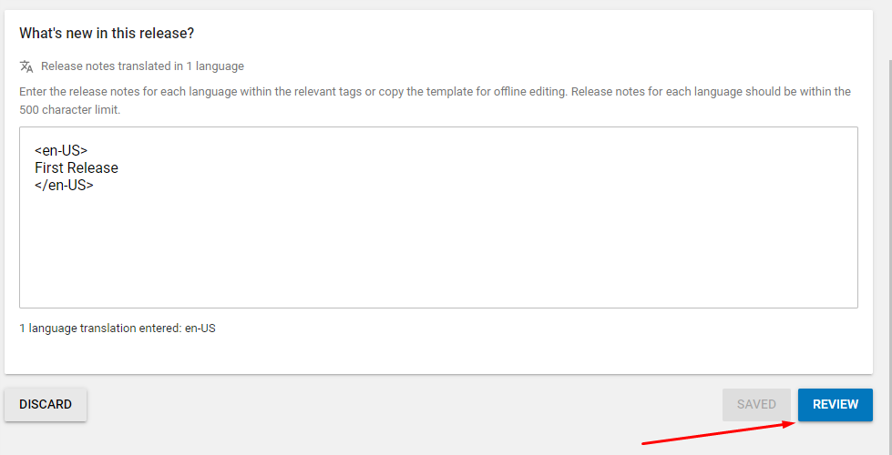

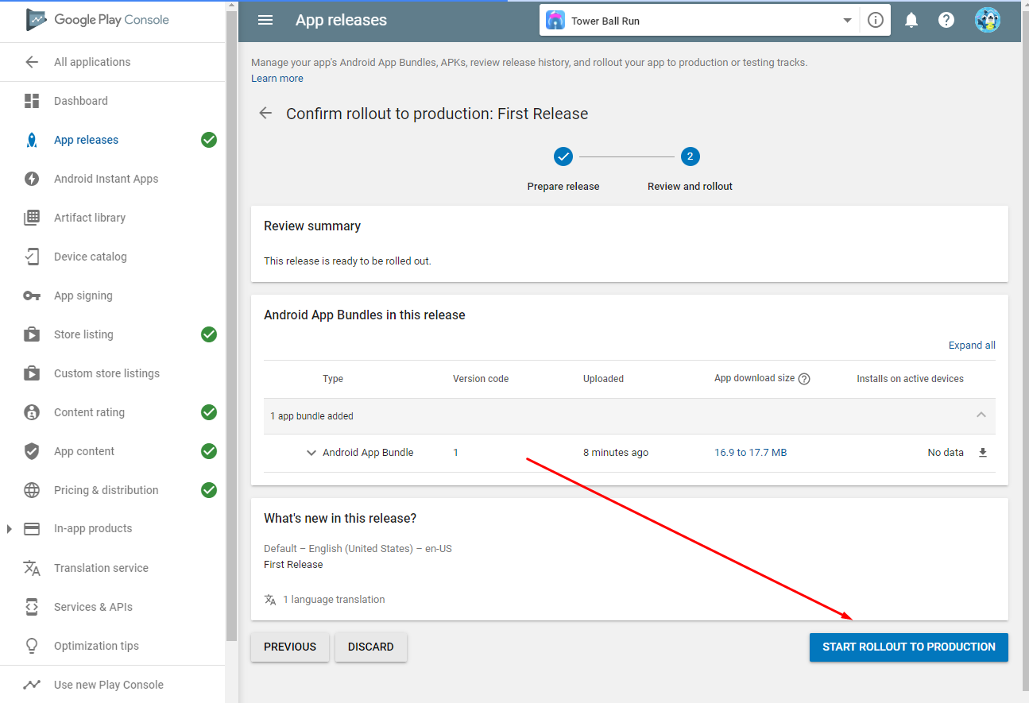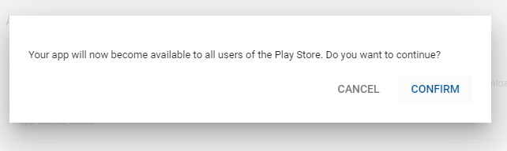

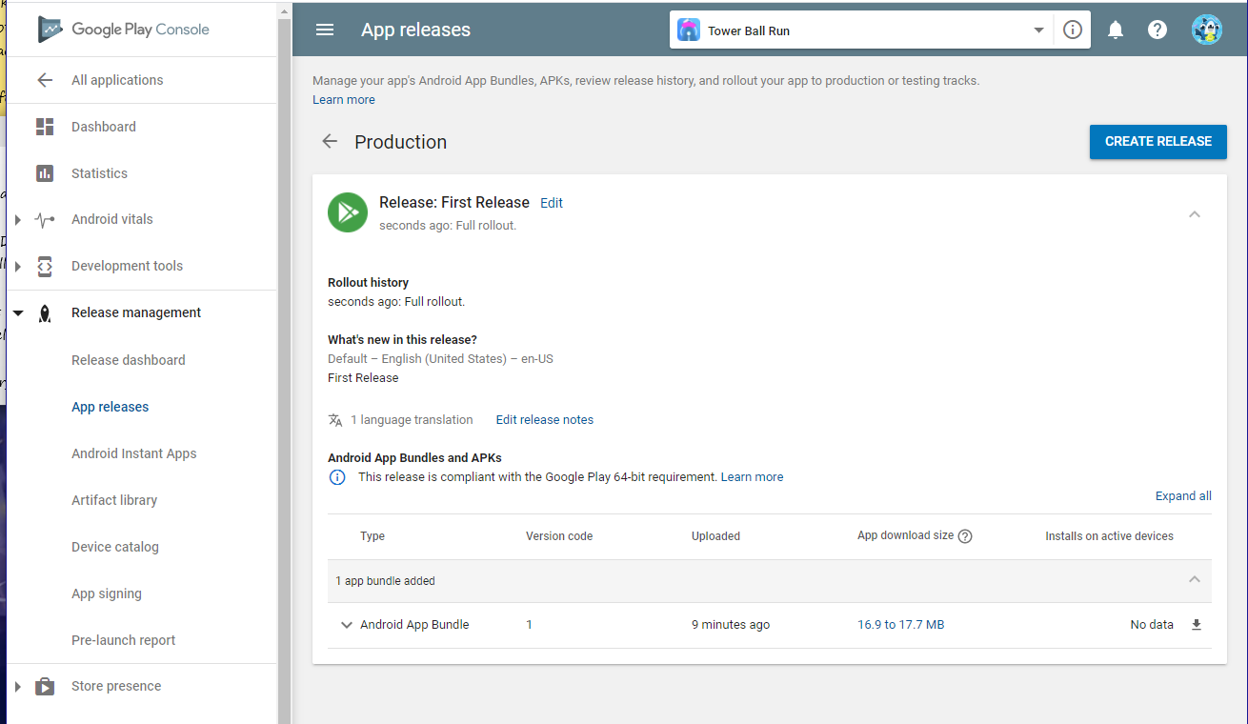

**Then you just need to wait until it reviewed and published**

Thanks you for following this Documentation , if you have more knowledge about reskining you can skip some step on this documentation , once again I really thank you for your support by buying this source code , I hope this help you out to reskin this game . and also if you have problem with this SC don’t forget to email me or comment on this item website marketplace .

If you have more interesting , like adding more features , more levels , or want order another Quality Source code just email me and we can talk much more there . thank you so much .

Best Regards,

MobileGTs Team