# **GETTING STARTED**

## **Requirments :**

1. 64 BIT COMPUTER SYSTEM
2. Unity Account
3. UNITY LTS Release **2019.4.8f1** (HIGHLY RECOMMEND USING SAME VERSION OF UNITY)
4. JAVA SDK 8 VERSION ( REALLY RECOMMENDED )
5. ANDROID SDK (FROM UNITY OR ANDROID STUDIO)
6. UNITY NDK

## **Step To Follow :**

1. Install UnityHub (if you already have it , you can skip )
2. Install Unity Version from Unity Archive
3. Install Java SDK
4. Setup Unity Android Prefrence
5. Ready To Go

# **THANK YOU SO MUCH FOR PURCHASING**

## **Download & Setup Unity3D :**

## Download UnityHub

1. Please go to <https://unity3d.com/get-unity/download>
2. Click on ***Download Unity Hub*** then install  
   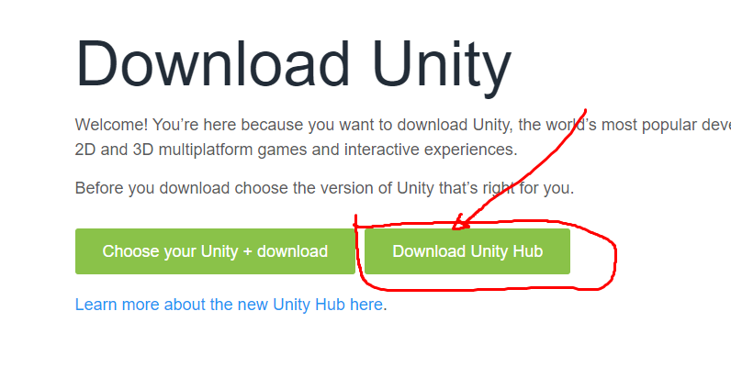

## Install Same Unity Version

This is really important that you need same Version as Project’s Unity Version , Make sure you have to choose Right Version**(HIGHLY RECOMMENDED)** to avoid error feature

1. Please go to <https://unity3d.com/get-unity/download/archive>
2. There are tab available there , you can click one of them and make sure you choose same version of unity

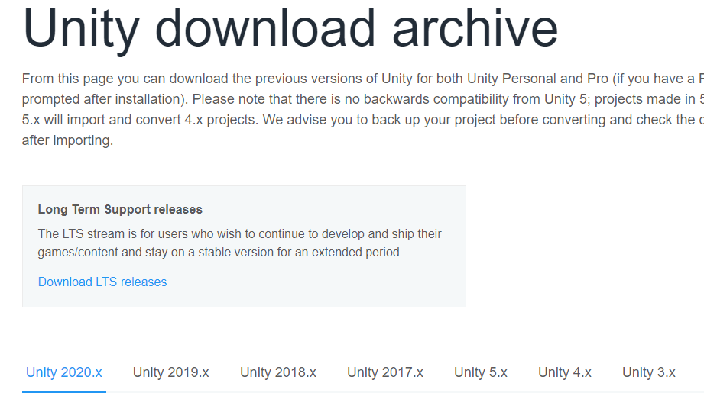

1. If you have choose right version , try click on ***UnityHub Button*** and your unityhub will open directly  
   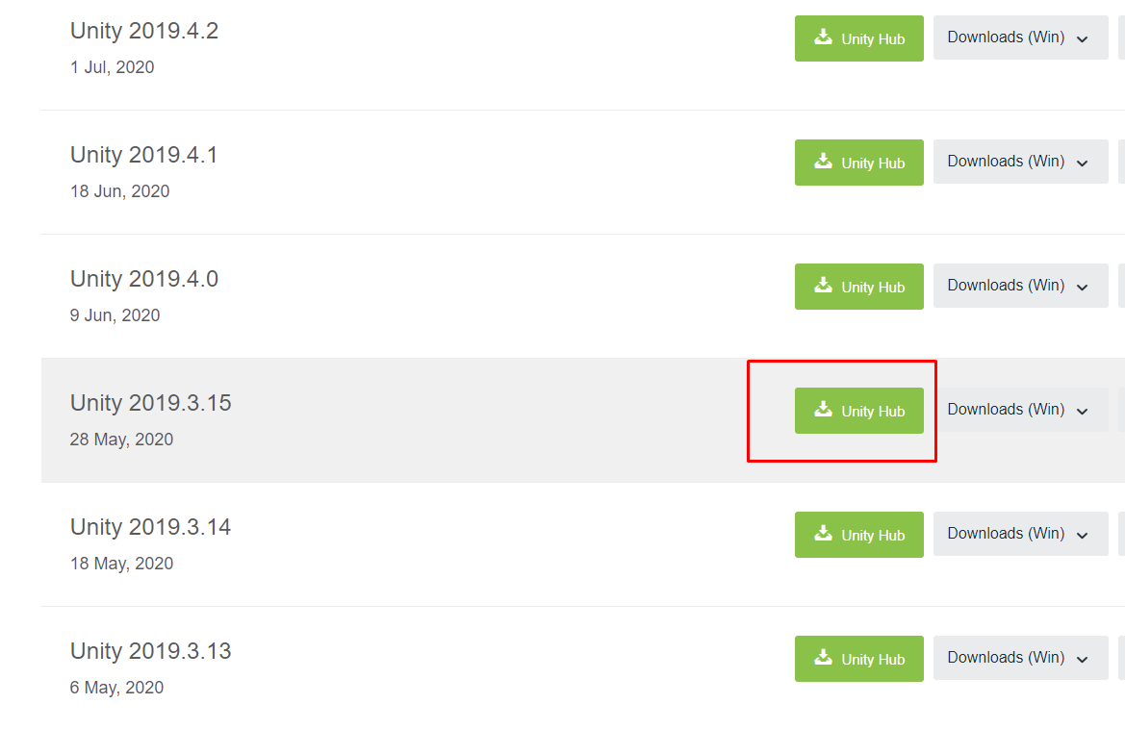

: this is example version

1. This windows will open up after you click that , you should pick ***Android Build Support + Android SDK & NDK Tools***  
   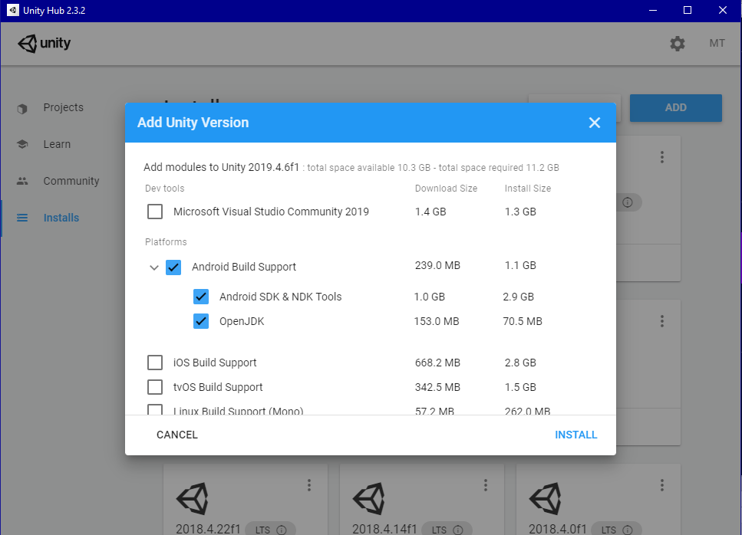**Note :** Sometime OpenJDK is not installed so i recommend you to download and install from java site   
   Note2 : If you already have SDK + NDK you dont need to download it, you can just assign it later on unity android prefrences
2. Next and wait until Download and Install finished ( around 4-5GB download )  
   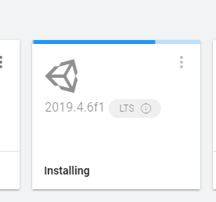

## **Download & Install JavaSDK :**

1. You can go to JavaSDK8   
   <https://www.oracle.com/java/technologies/javase/javase-jdk8-downloads.html>
2. Choose 64 bit version and install it to your computer

## **Setup Unity Android Prefrences :**

This is really important to setup the unity on begining , so we need to make new project to do that

1. Open Your UnityHub
2. Click New on right corner , you can click arrow and choose any version of that
3. Then select on Create button  
   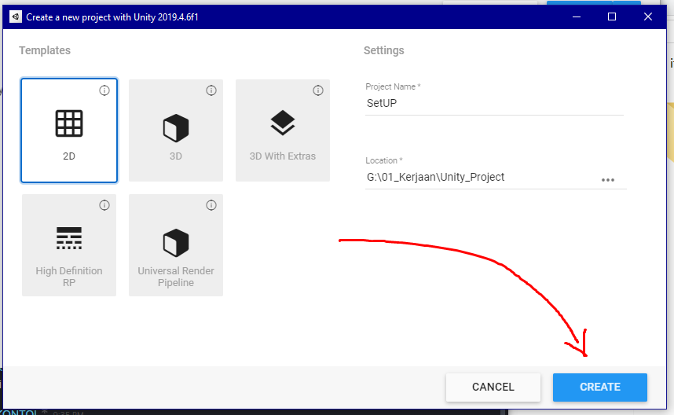
4. Then go to build settings by go to File > Build Settings or you can use CTRL+SHIFT+B  
   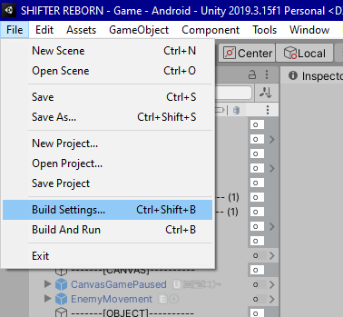
5. Click on android and click Switch Platform  
   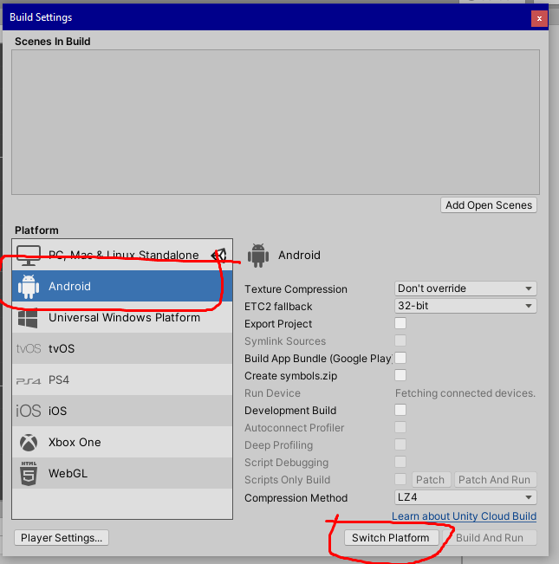
6. Then go to Edit > Prefrences  
   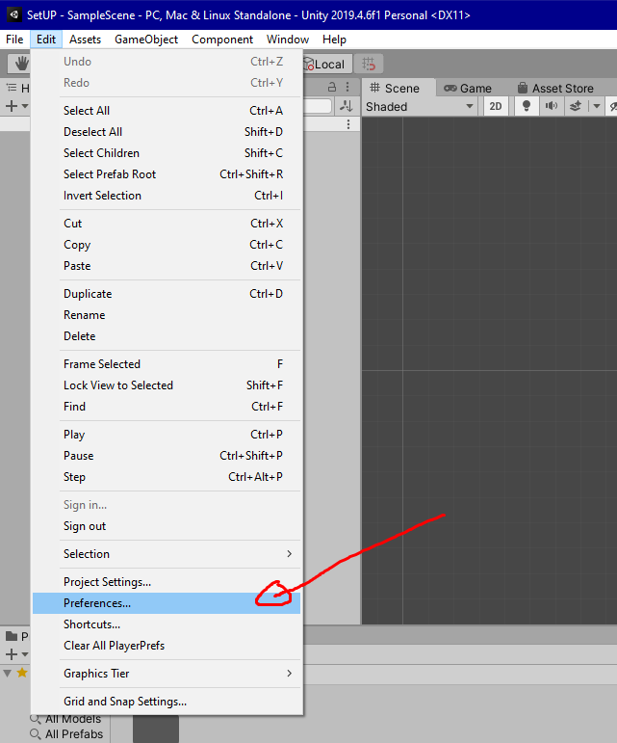
7. Then go to External Tools   
   Select JDK you have installed and check all three on android SDK , NDK and Gradle  
   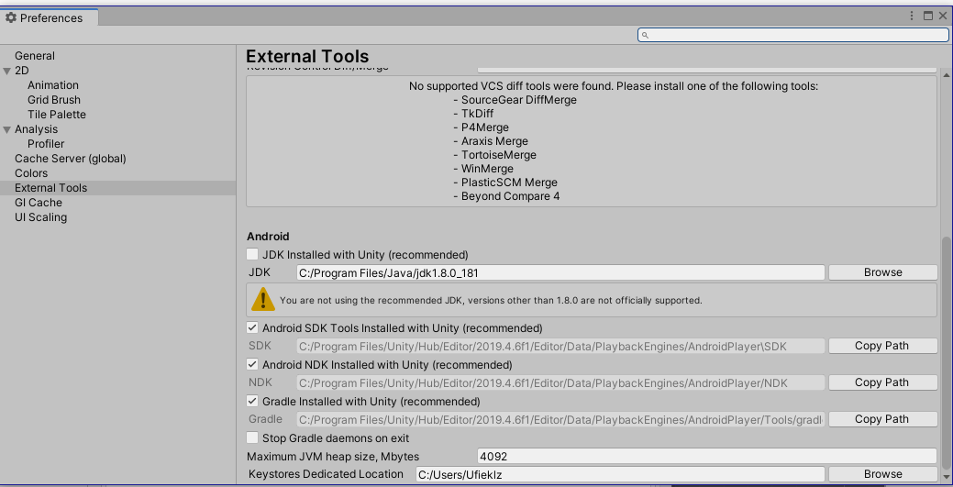

You are ready to go