# **THANK YOU FOR PURCHASING OUR ITEM , YOU REALLY HELP US TO IMPROVE AND DEVELOP NEW GAME SOURCE CODE . THANK YOU FOR YOUR SUPPORT , YOU ARE REALLY AWESOME . THANK YOU SO MUCH .**

# OPEN PROJECT ON UNITY

1. Open your Unity Hub and Select “ADD”  
   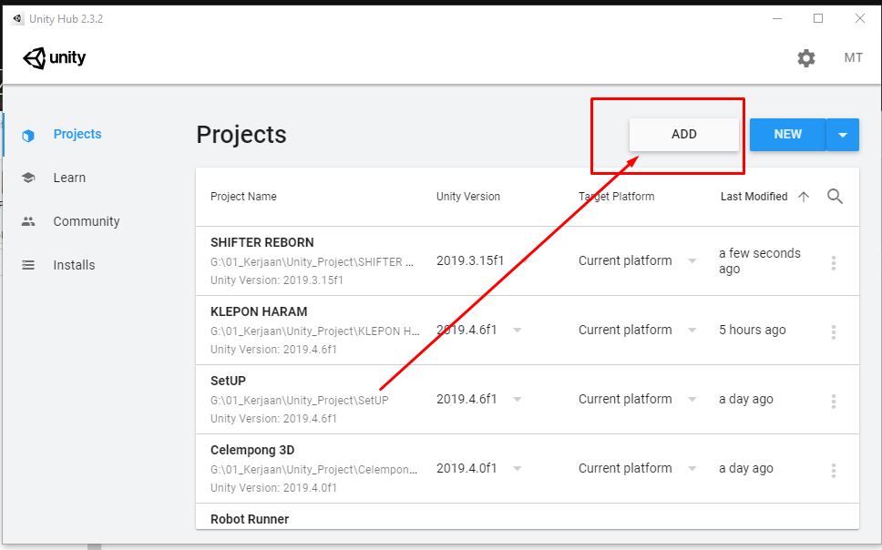
2. Then Locate your Project File ( After Extract From Downloadable ZIP File ) NOTE : Extract to Short Path ex : **d:\File\GameProject\** this avoid you from error later  
   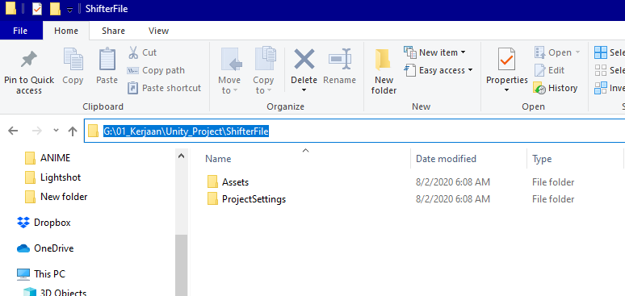
3. Then click on the list of the selected project  
   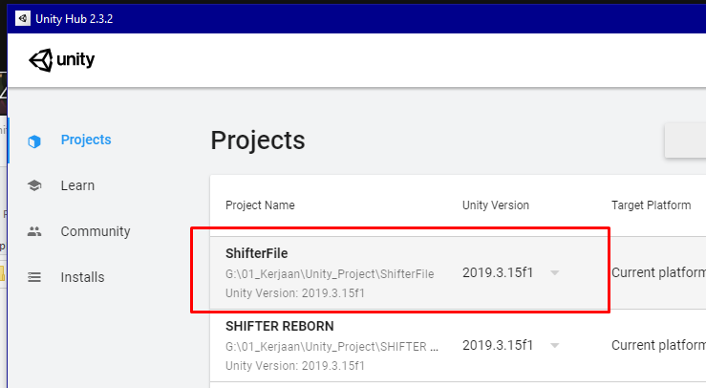

# SWITCH PLATFORM TO ANDROID

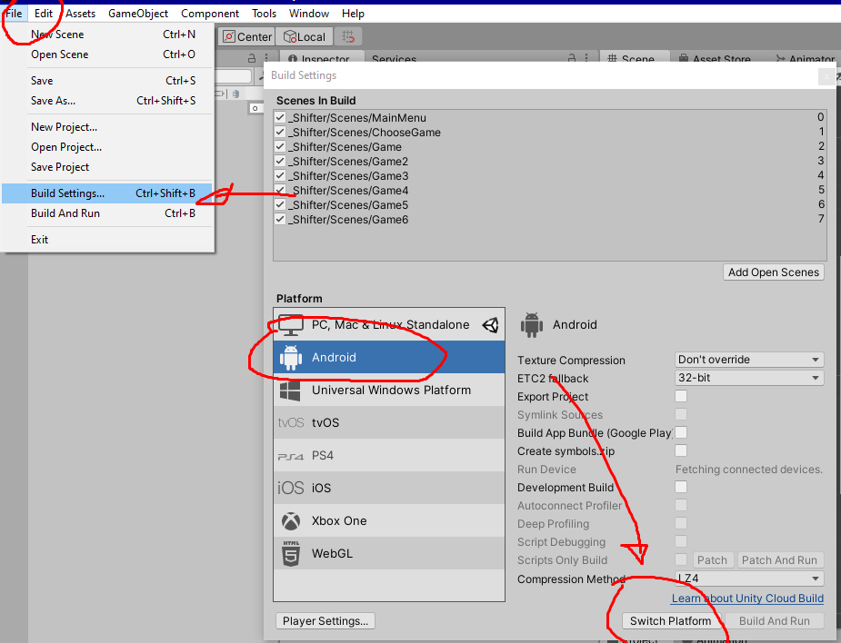

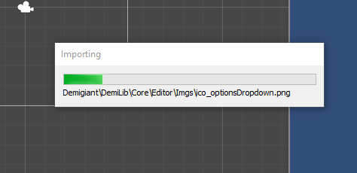

After swhitcing it will take more time to generate all files , so please patient , it depend on your sistem

# OPEN FIRST SCENE MAINMENU

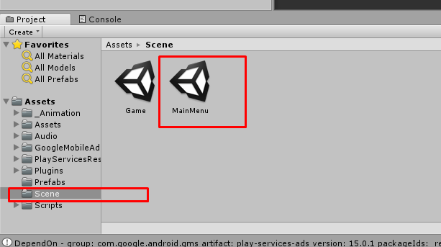

# RESOLVE THE GAME (NEED INTERNET CONNECTIONS)

After you open and switching to android platform , don’t forget to import GoogleMobileAds.UnityPackage ( I have also included it )

1. Click twice on GoogleMobileAds  
   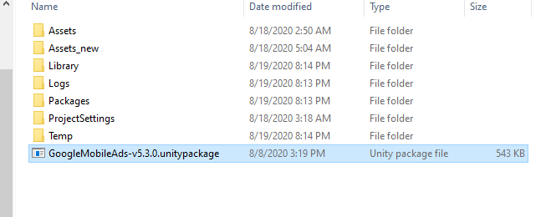
2. Then click import  
   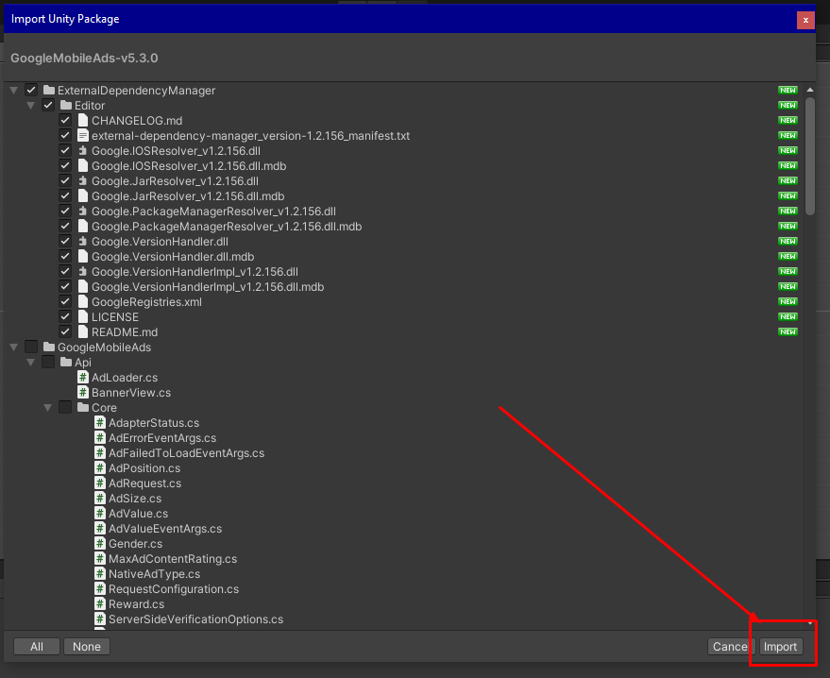
3. After that you will found this pop up , and click add selected registries   
   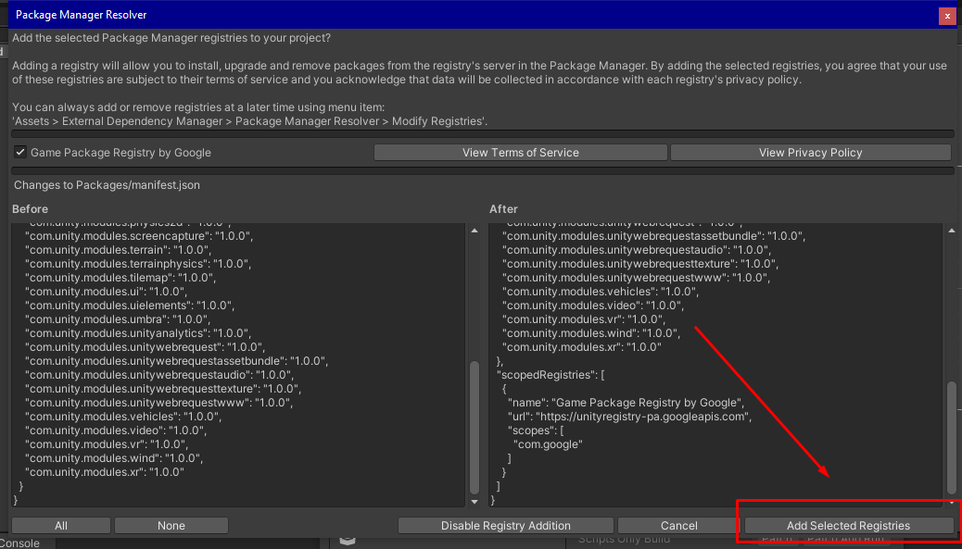
4. Then apply .  
   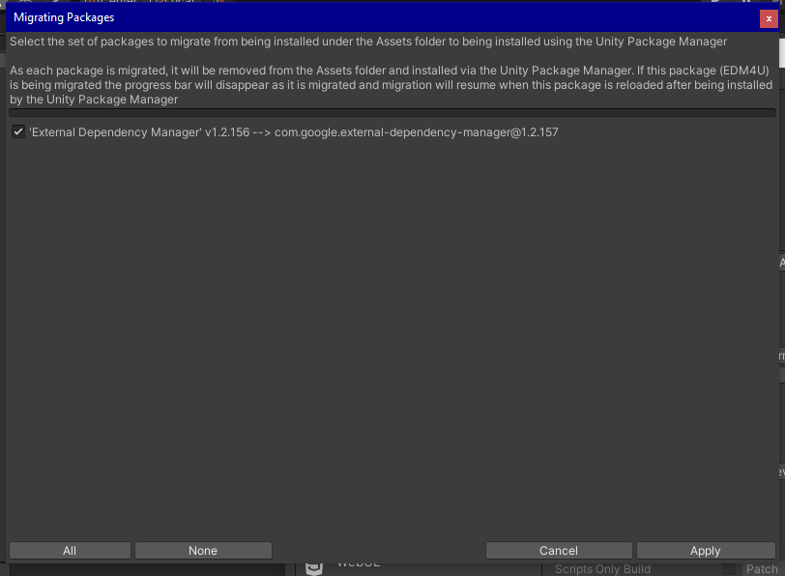
5. After that you can go to assets > external > android resolver > force resolve   
   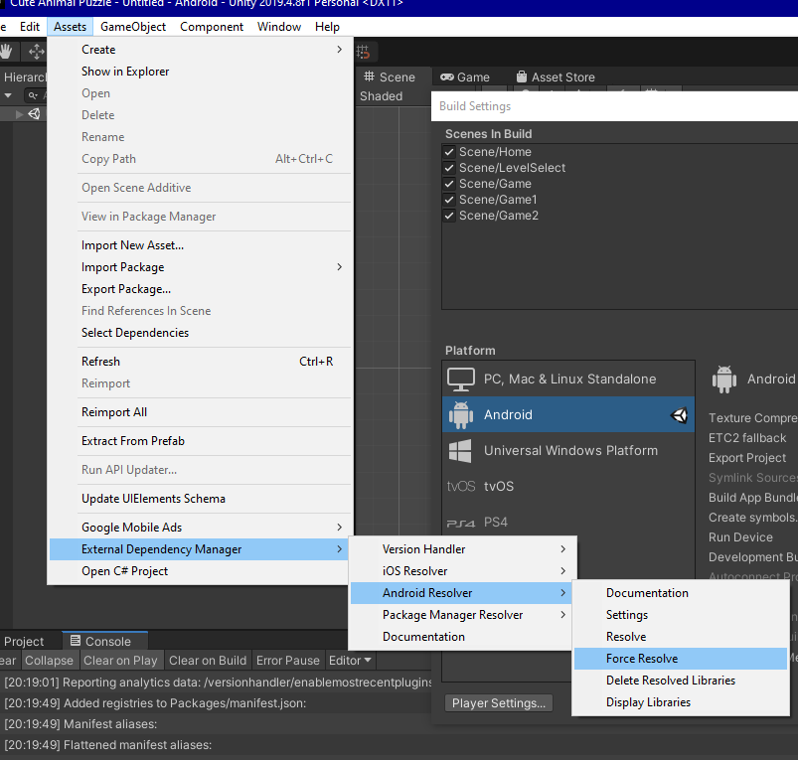

# SETTING ADMOB BANNER AND INTERSTISIAL

1. Go To Project Manager on Bottom Side , Type “Initialize” and open on IDE Editor , you can use MonoDevelop or Visual Code Editor or other text editor  
   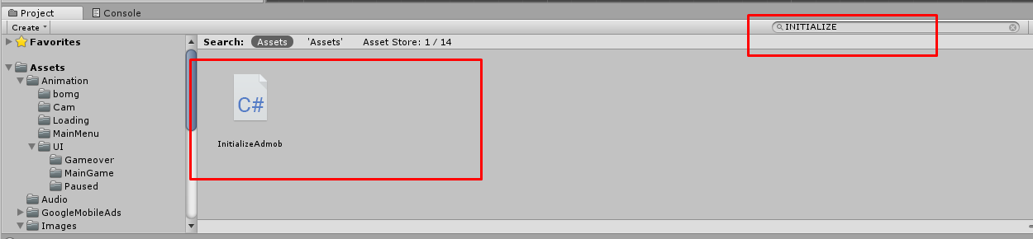  
   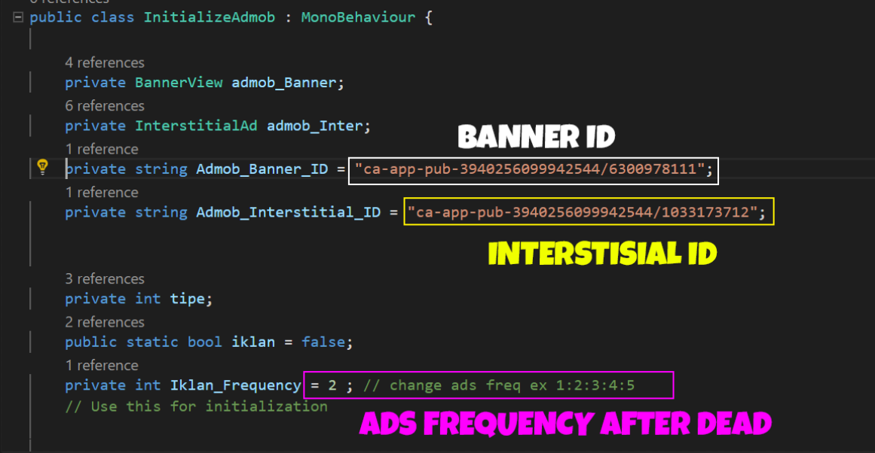  
     
   Banner ID : change with your Ca-App-pub ID Banner  
   Interstisial ID : Change with your Ca-App-pub ID Interstisial  
   Ads Freq : Freq Ads will Show up After game over , you can change with 1 for every each game over ads will show up

# Add Admob APP ID

1. Go to assets > Google Mobile Ads > Settings  
   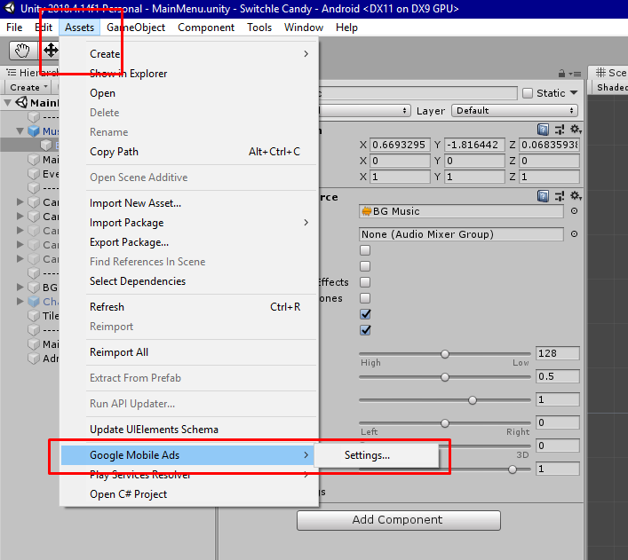
2. Check list and add your admob app ID  
   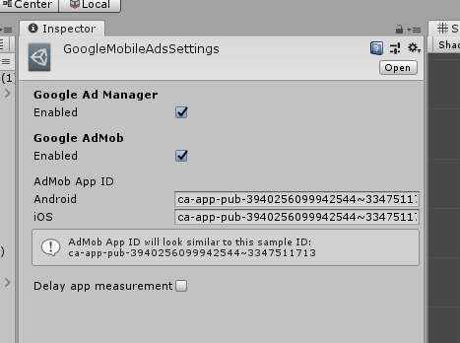

# RESKIN GAME IMAGE ASSETS

There are some images need to be replaced or reskinned , its basic knowledge for everyone who bought Source code , you need knowledge about using Photo or Image editor like photoshop , Gimp , and other Image editor .

1. You can check on Project Manager , Go to Images , and you will see images and folder separated there :   
   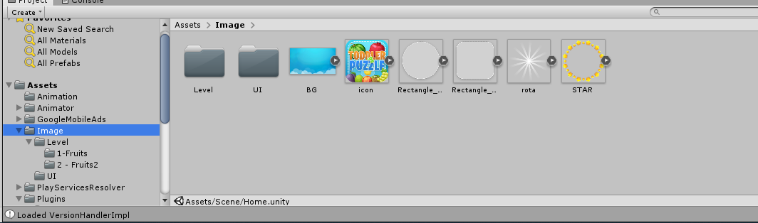
2. You can also right click on one of them and Show on Explorer : on windows path you can chek on   
   **“\Image\”**
3. You Can Replace all with your Images . included ICON , Game Title and BG

# RELAYOUT GAME UI ON EACH GAMESCENE

All of UI on this game is based on Animator system , so you need advance knowledge about Animator System . there are many reference to use and edit animator system : you can also search about Animator / animation UI on Youtube .

# CHANGE NAME PACKAGE AND VERSION

1. Go To File > Build Settings and click Player Settings on bottom left side :   
   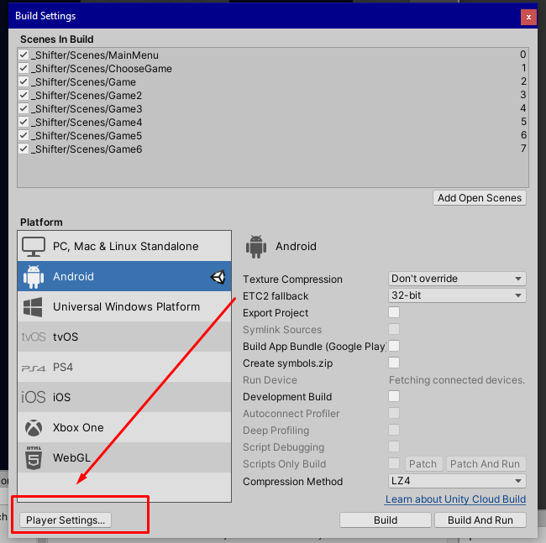
2. Go to ***Other Settings*** , and change your Name Package , version and build version code  
   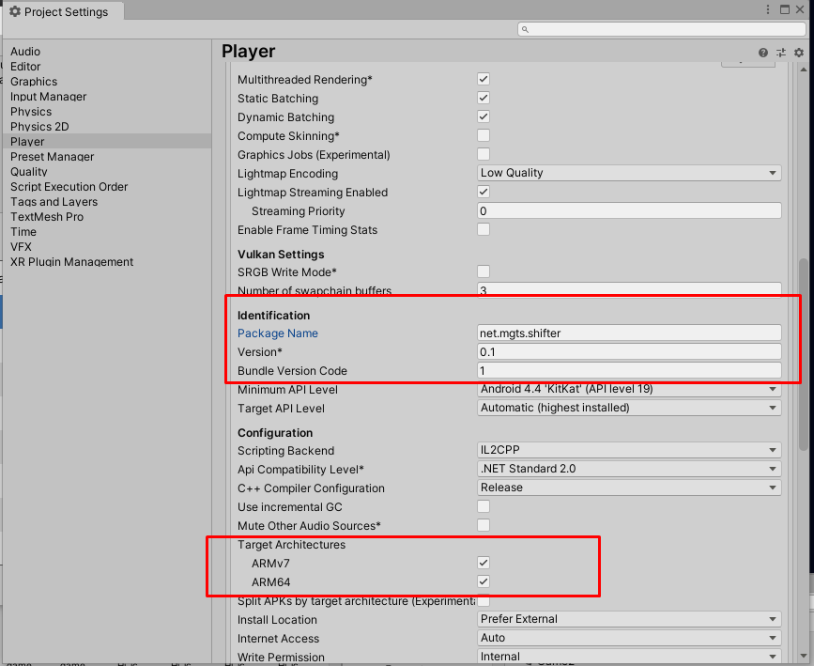

# CHANGE GAME NAME ON PHONE DISPLAY

1. On player Settings , view on top side , change Company Name and **Product Name** with your Name ex: this pic   
   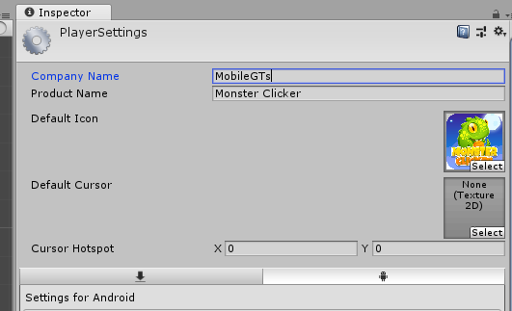

# CHANGE GAME ICON

1. Go to images > then open icon.png on your image editor , replace with your new Icon   
   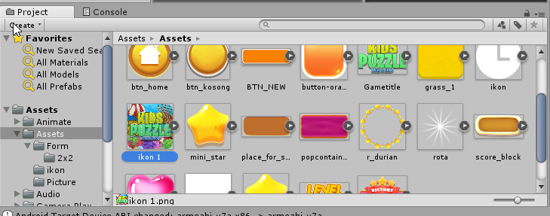

# MAKE KEYSTORE AND BUILD AN APK FILE

1. Go to Player Settings > Publishing Settings > click on Create New Keystore > and fill your password ,
2. On alias click create a new key and fill are information there :   
   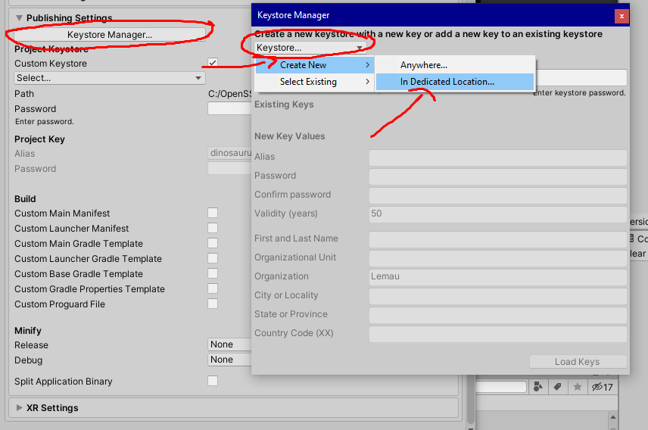  
     
   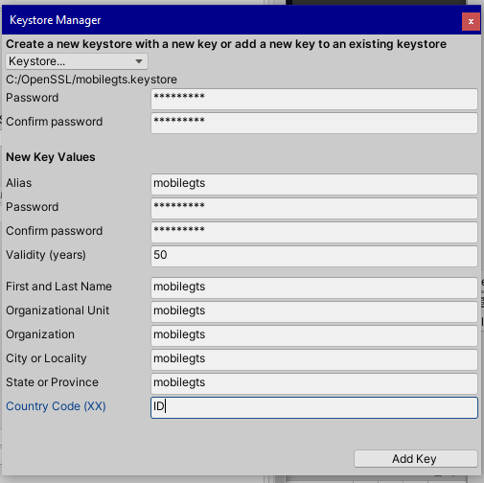  
   then click on create key
3. After that select your alias , and fill the password form , if ready you can go to , Build Settings , Then Click on Build Button   
   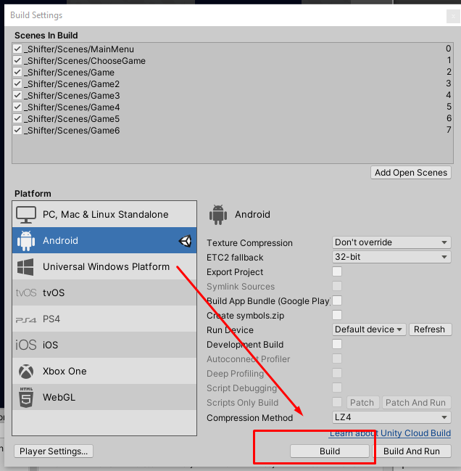
4. Congratulations , you have success build an APK file : then you can try on your phone or your emulator software :   
   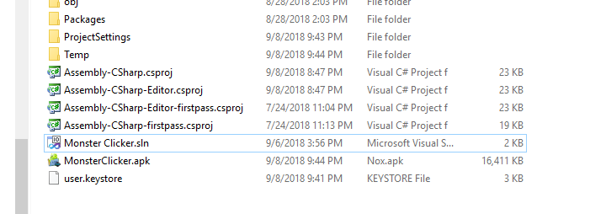

Thanks you for following this Documentation , if you have more knowledge about reskining you can skip some step on this documentation , once again I really thank you for your support by buying this source code , I hope this help you out to reskin this game . and also if you have problem with this SC don’t forget to email me or comment on this item website marketplace .

If you have more interesting , like adding more features , more levels , or want order another Quality Source code just email me and we can talk much more there . thank you so much .

Best Regards,

MobileGTs Team