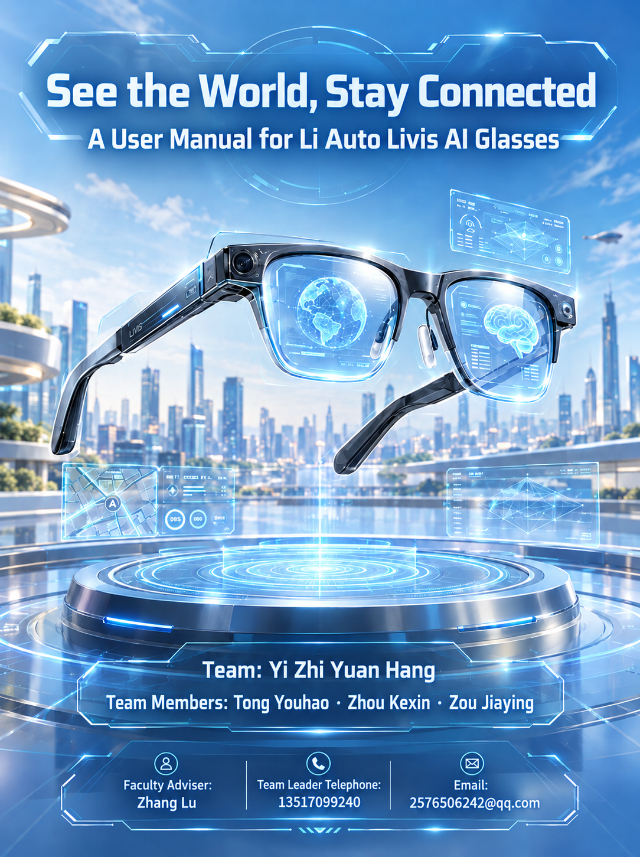

Li Auto Livis AI Glasses User Manual
Li Auto Livis AI Glasses User Manual
Prepared: 2026-10-12
Product: Li Auto Livis AI Glasses
Software applicability: Subject to the installed version and service availability
This competition-case manual does not replace official instructions. The U.S. target market does not establish local availability, certification, or a service network. Confirm regional services and unpublished details with the manufacturer or seller.

Contents
1 About This Manual 5
1.1 Purpose and Scope 5
1.2 How to Use This Manual 5
1.3 Warnings, Cautions, and Notes 5
1.4 Product and Software Versions 5
2 Product Overview 6
2.1 Product Introduction 6
2.2 Main Features 6
2.3 Intended Use and Limitations 7
2.4 Companion App and Services 7
3 Product Components and Package Contents 8
3.1 Package Contents 8
3.2 Glasses Overview 8
3.3 Charging Case Overview 8
3.4 Buttons, Touch Controls, and Status Indicators 9
4 Technical Specifications 11
4.1 Dimensions, Weight, and Materials 11
4.2 Frame and Lens Options 11
4.3 Camera and Imaging Specifications 12
4.4 Audio and Wireless Connectivity 12
4.5 Battery and Charging 13
4.6 Ingress Protection and Operating Conditions 13
4.7 Performance Test Conditions 13
5 Safety Warnings 14
5.1 General Safety Precautions 14
5.2 Wearing and Lens Safety 14
5.3 Hearing Protection 14
5.4 Driving and Situational Awareness 14
5.5 Battery and Charging Safety 14
5.6 Water, Dust, and Temperature Precautions 15
5.7 Children and Small Parts 15
5.8 Damage and Abnormal Operation 15
6 Getting Started 16
6.1 Before You Begin 16
6.2 Initial Charging 16
6.3 Installing and Setting Up the Companion App 16
6.4 Connecting and Pairing 17
6.5 Required Permissions and Account Settings 17
6.6 Wearing and Adjustment 18
6.7 First-Use Checklist 18
7 Everyday Operation 19
7.1 Button and Touch Control Reference 19
7.2 Taking Photos 19
7.3 Recording Videos 19
7.4 Recording Audio and Reviewing Recordings 20
7.5 Music Playback and Volume Control 20
7.6 Receiving and Making Calls 20
7.7 Using the AI Assistant 21
7.8 Viewing and Transferring Photos and Videos 21
7.9 Compatible Devices and Optional Features 22
8 Charging and Battery Management 23
8.1 Charging the Glasses 23
8.2 Wired Charging of the Case 23
8.3 Wireless Charging of the Case 24
8.4 Checking Battery and Charging Status 24
8.5 Factors Affecting Battery Life 24
8.6 Long-Term Storage 25
9 Privacy and Data Use 26
9.1 Photography and Recording Considerations 26
9.2 App Permissions and Personal Data 26
9.3 Sharing and Deleting Content 26
9.4 Limitations of AI-Generated Responses 26
9.5 Preparing for Transfer or Discontinued Use 27
10 Cleaning, Care, and Software Updates 28
10.1 Cleaning the Lenses and Frame 28
10.2 Caring for Charging Contacts and the Case 28
10.3 Carrying and Storage 29
10.4 Checking for and Installing Updates 29
11 Troubleshooting 30
11.1 Connection or Pairing Issues 30
11.2 Charging Issues 30
11.3 Photo or Video Issues 31
11.4 Audio or Call Issues 31
11.5 AI Assistant Not Responding 31
11.6 File Synchronization Issues 32
11.7 When to Stop Use and Contact Support 32
12 After-Sales Service and Warranty Terms 33
12.1 Scope 33
12.2 Warranty Period and Coverage 33
12.3 Exclusions 33
12.4 Requesting Service 33
12.5 Information Required for Service 34
12.6 Service Channels and Regional Limitations 34
13 Appendix A: Quick Reference Guide 35
14 Appendix B: Bilingual Glossary 36

1 About This Manual

1.1 Purpose and Scope
This manual is intended for users of Li Auto Livis AI Glasses (the “glasses”) and the charging case. It covers functions, specifications, setup, operation, safety, privacy, care, troubleshooting, and after-sales information. Use it together with the product label, official supplied documentation, and instructions in the Li Auto AI Assistant App (理想同学App).

1.2 How to Use This Manual
• Read Chapter 5, Safety Warnings, before first use.
• Follow Chapter 6, Getting Started, for charging, connection, and fit checks.
• See Chapter 7 for everyday operation.
• See Chapter 8 for battery management.
• See Chapter 9 for photography and personal data.
• See Chapter 10 for cleaning and updates.
• Use Chapter 11 to troubleshoot.
• Request support under Chapter 12 if the issue persists.
• See Appendix A for common controls.

1.3 Warnings, Cautions, and Notes
• WARNING identifies a risk of personal injury and the action needed to avoid it.
• NOTICE identifies a risk of equipment damage, data loss, or an unsuccessful operation.
• NOTE provides additional information about a function or task.
Read the relevant message before proceeding. Arrows, numbers, and colors support the written instructions.

1.4 Product and Software Versions
Check the model and software on the label, packaging, or app. Functions depend on configuration, version, account, network, language, region, and services.

2 Product Overview

2.1 Product Introduction
Livis combines eyewear, a first-person camera, open-ear audio, and an AI assistant in a wearable device. It runs Livis OS and works with the Li Auto AI Assistant App on a phone. Buttons, touch controls, and voice commands support everyday capture, audio, calls, and information assistance. Wearing weight and optical performance vary with the frame and lens configuration.

2.2 Main Features
Table 1. Main Features and Requirements
Function | Use and Conditions
First-person imaging | Photos, Live Photo, and video; keep the view clear and follow recording rules.
Open-ear audio and calls | Music, phone calls, and spoken feedback; require the relevant Bluetooth connection and services.
Recording and summaries | Record meetings or learning sessions with transcription, speaker identification, and AI summaries; obtain required consent first.
AI assistance | Voice and visual questions, deep research, and memory features; generally require a phone, network, and valid account.
Vehicle integration | Controls, information, and audio integration for supported vehicles; depend on vehicle, software, account authorization, and region.
Wireless charging case | The case supports USB-C and Qi charging; place the glasses inside to recharge them.

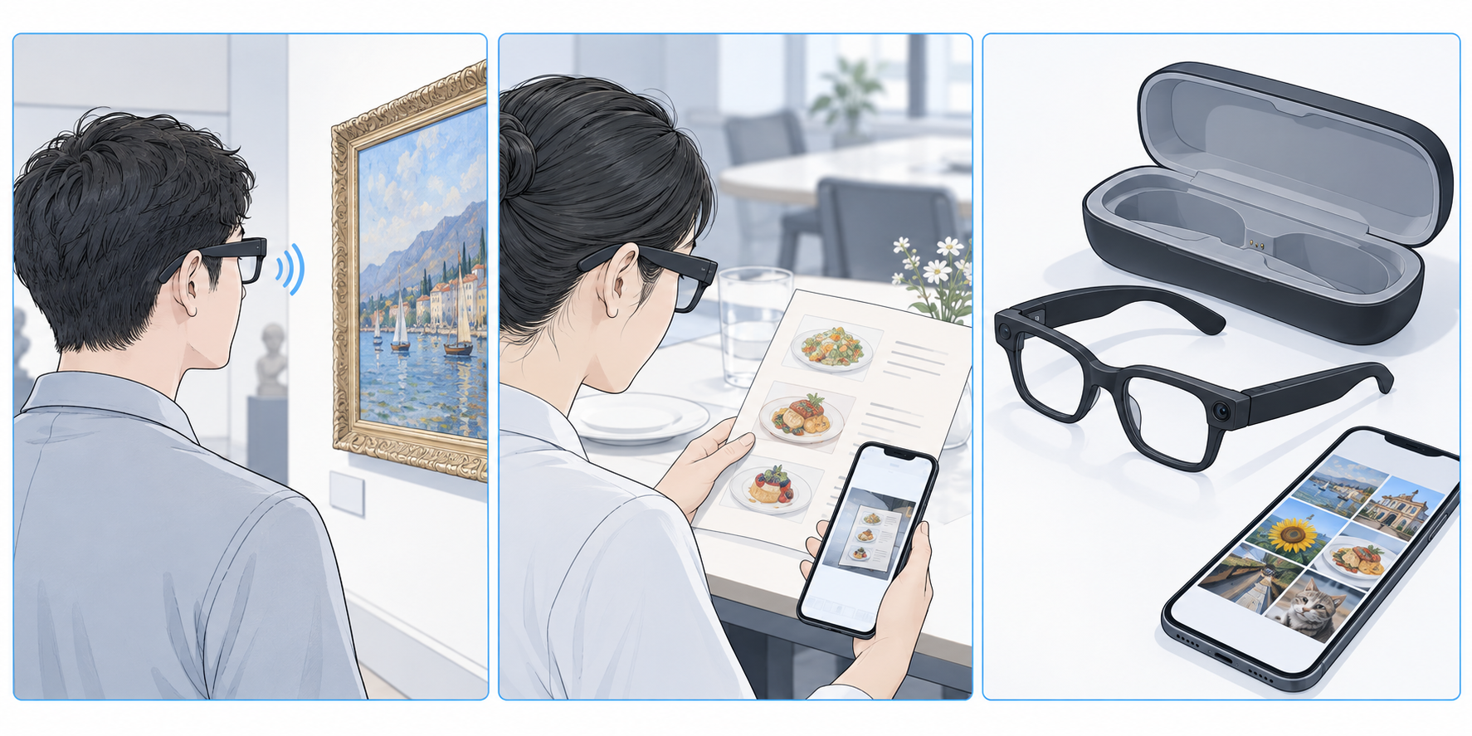
Figure 1. Everyday workflow: capture, spoken assistance, and phone review.
AI-generated concept; does not establish actual structure or regional availability.

2.3 Intended Use and Limitations
The product is intended for everyday wear, audio communication, personal capture, and AI-assisted information. It is not industrial protective eyewear, a medical device, or a driving decision tool. AI recognition and answers may be incorrect; verify important information independently. Nearby people may hear open-ear audio.

2.4 Companion App and Services
The app is 理想同学App; the English name is descriptive, not a confirmed U.S. listing. Follow its current interface for connection, media, settings, and updates. Confirm U.S. download, registration, language, and services; music and vehicle functions also depend on third parties and compatibility.

3 Product Components and Package Contents

3.1 Package Contents
After unpacking, check that the glasses, charging case, and lens configuration match your order and that all parts are undamaged. Inclusion of a USB-C cable, cleaning cloth, pouch, quick-start card, or power adapter depends on the packing list for your purchased version.
For missing items, incorrect configuration, or damage, retain the packaging and proof of purchase and contact the original seller.

3.2 Glasses Overview
The glasses include the frame and lenses, temples, silicone nose pads, titanium-alloy hinges, and components for capture, sound pickup, and audio playback. The three core areas are the touchpad, recording button, and privacy indicator. Identify these areas and keep the camera, indicator, and microphone openings clear. The original dimension drawing below is not a disassembly or modification guide.
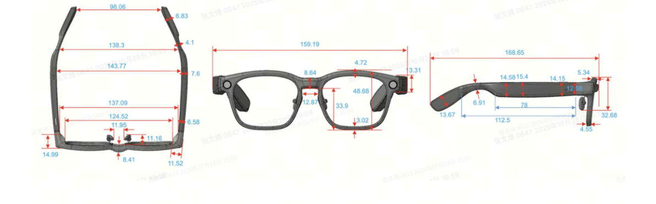
Figure 2. Product appearance and dimensions.
Source: Livis communication manual; dimensions in millimeters.

3.3 Charging Case Overview
The case stores and recharges the glasses via USB-C or Qi. Place them naturally into the shaped recess without squeezing the frame or forcing the lid. Check the actual unit for port position, contacts, and indicators.
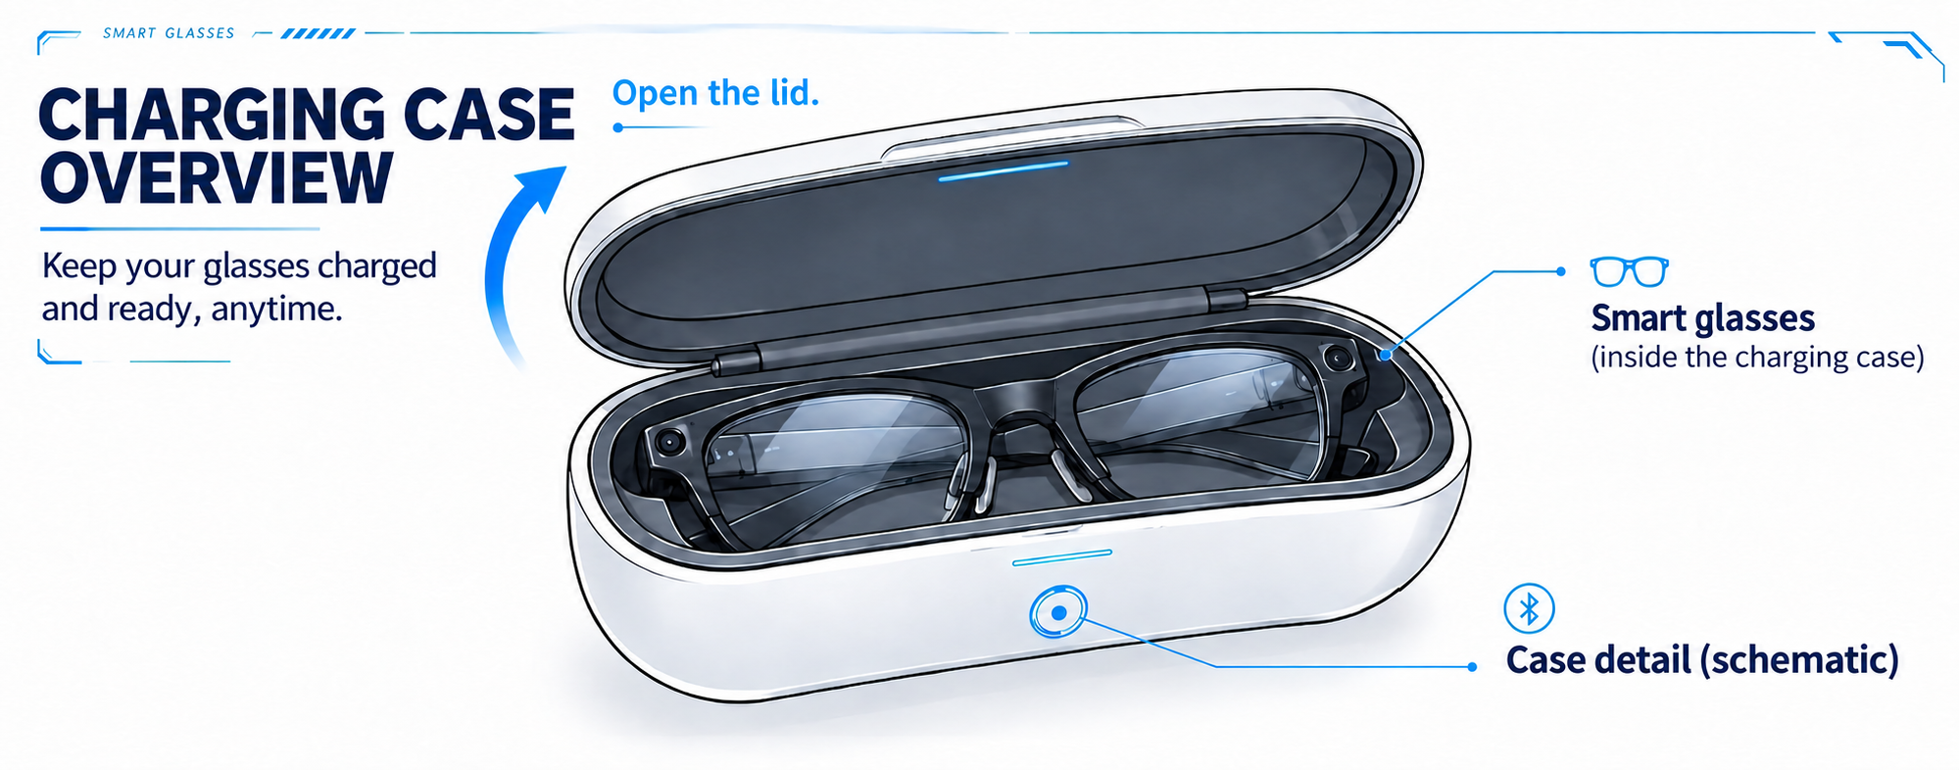
Figure 3. Charging case overview.
AI-generated concept; check the actual unit for appearance.

3.4 Buttons, Touch Controls, and Status Indicators
Table 2. Control Guide
Area | Action and Result
Touchpad | Tap: play/pause or answer. Double-tap: next track, end/reject a call, or exit AI. Triple-tap: previous track. Swipe forward/backward: raise/lower volume. Press and hold: wake the assistant.
Recording button | Press once: take a photo. Press twice: start/stop video; during audio recording, stop recording. Press and hold: start audio recording.
Privacy indicator | Steady white during video recording; covering it prevents photos and videos. The source does not list all colors or blinking patterns.

NOTE
The same gesture has different uses in different states. Check whether a call, playback, or recording is active before operating. Check the current official instructions for hold duration and feedback.
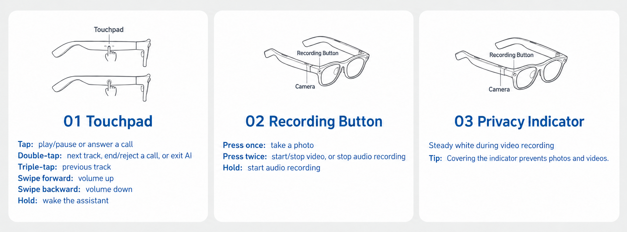
Figure 4. Touchpad, recording button, and privacy indicator.
Source: Livis communication manual; 01–03 correspond to the control table.
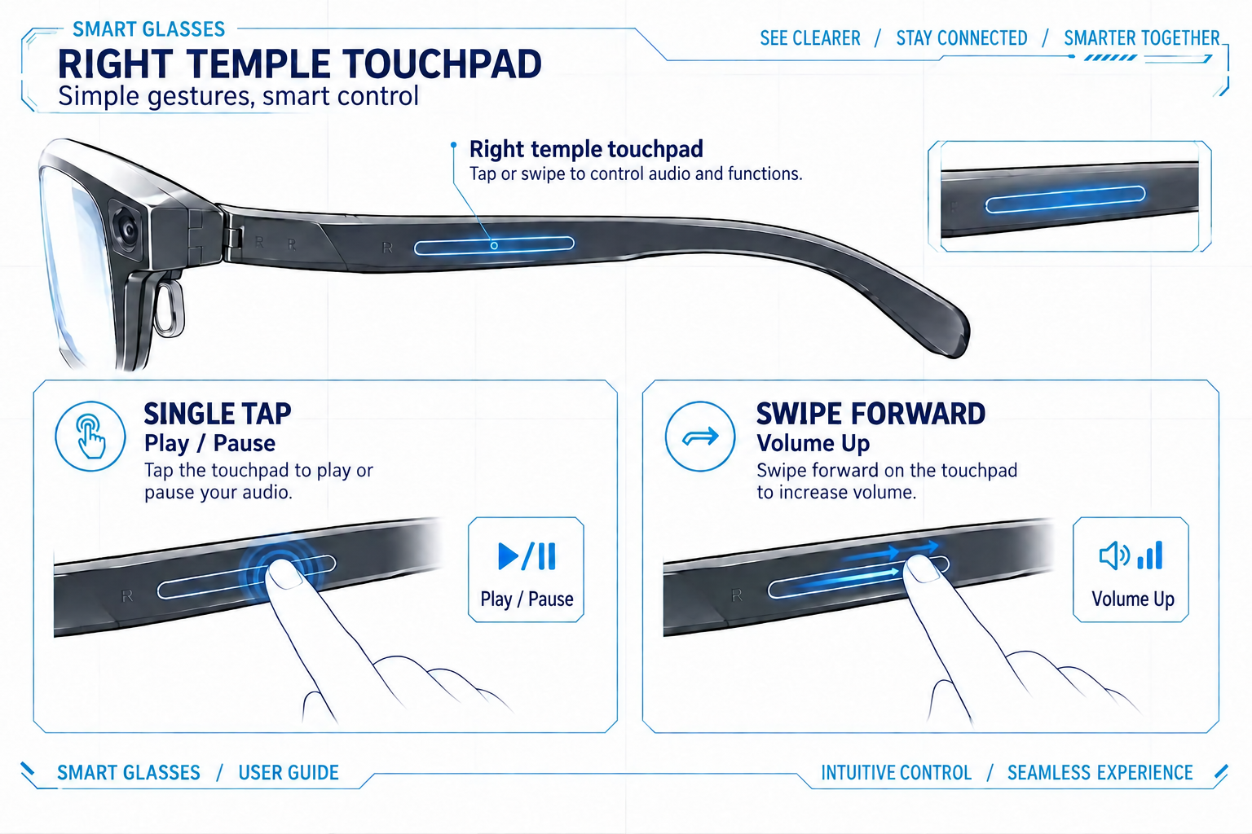
Figure 5. Touch control illustration.
AI-generated concept; follow the text and actual hardware.

4 Technical Specifications

4.1 Dimensions, Weight, and Materials
Table 3. Dimensions, Weight, and Materials
Item | Specification
Frame weight | 36 g (approximately 1.27 oz), frame only, excluding lenses
Frame face-width spacing | 134–137 mm (approximately 5.28–5.39 in); after custom heat bending, approximately 134–136 mm
Temple length | 169 mm (approximately 6.65 in); drawing labels 168.85 mm
Frame material | TR90; titanium-alloy hinges and silicone nose pads
Finishes | glossy or matte; classic black, tech gray, olive green

4.2 Frame and Lens Options
ZEISS options include non-prescription blue-light-filtering, tinted sunglass, photochromic, and prescription lenses, with custom ZEISS and Superb prescription series. Have a professional confirm prescription, refractive index, and lens type. The original design targets Chinese facial profiles; try the glasses on and check nose, ear, and temple pressure.
• Frame finishes: glossy translucent or matte.
• Frame colors: classic black, tech gray, and olive green.
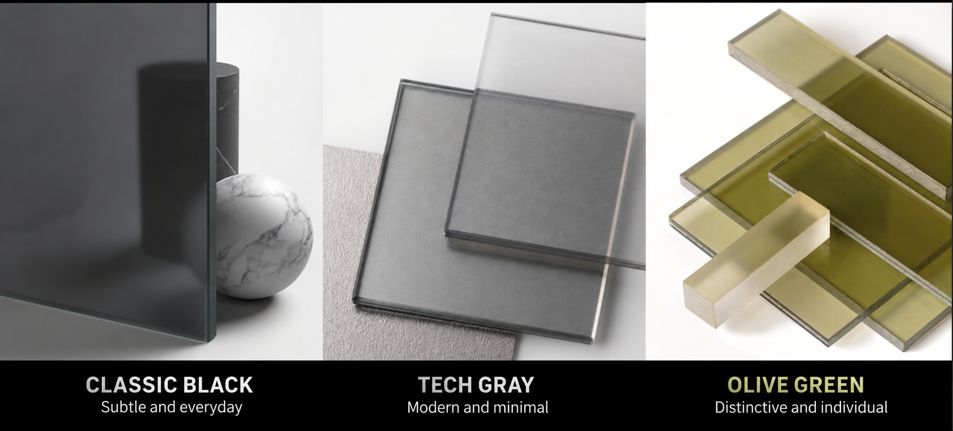
Figure 6. Frame colors.
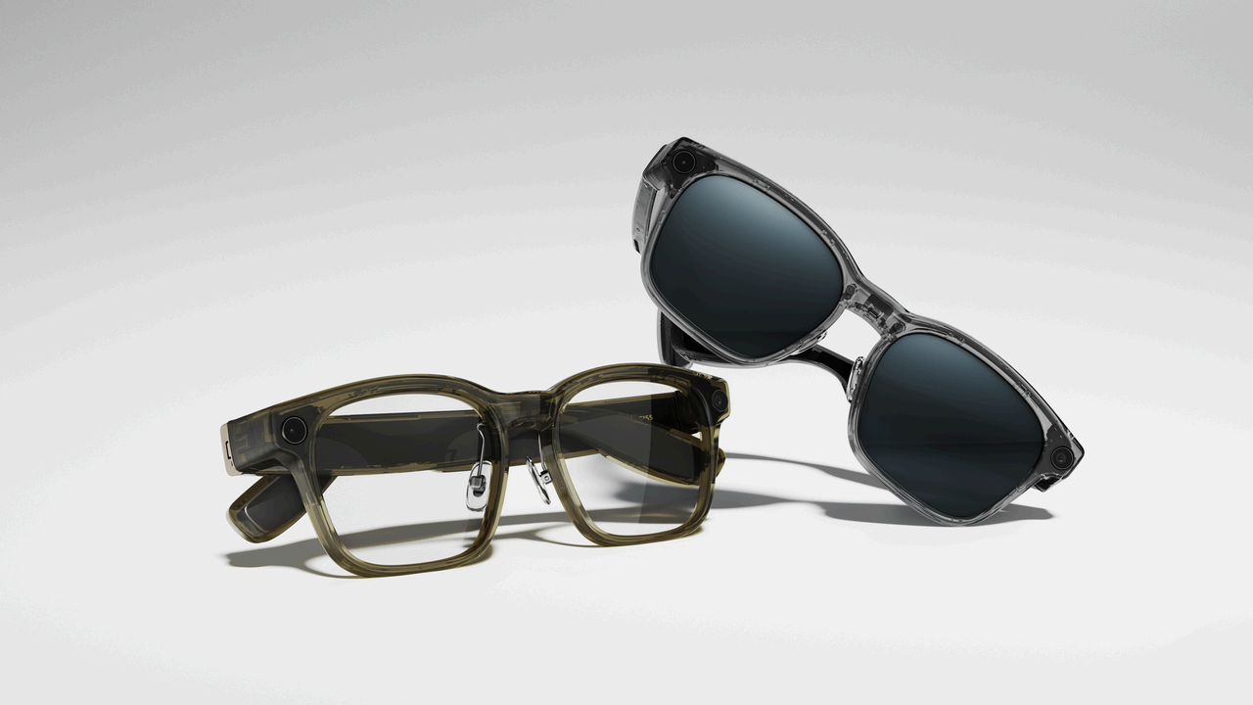
Figure 7. Product appearance examples.
Source: Livis communication manual; configuration may differ.

4.3 Camera and Imaging Specifications
Table 4. Camera and Imaging Specifications
Item | Specification
Camera | 12 MP, Sony IMX681
Optics | 1G+4P; f/2.2; 105° ultra-wide angle
Photos | 4032 × 3024 pixels
Video | 1080p / 30 fps; up to 3 minutes per clip
Stabilization and Live Photo | EIS; approximately 3 seconds of motion, subject to version
Aspect ratios | 3:4, 4:3, 16:9, 9:16

4.4 Audio and Wireless Connectivity
Table 5. Audio and Wireless Connectivity
Item | Specification
Audio | open-ear spatial audio, dual-magnetic-circuit speakers
Microphones | 360° omnidirectional recording; source describes speech pickup within 3 m (9.84 ft)
Bluetooth | Bluetooth 5.4; up to 2 simultaneous connections and 8 paired-device relationships

Noise, distance, and speaker direction affect recording.

4.5 Battery and Charging
Table 6. Battery Capacity and Charging Times
Item | Source Data
Glasses battery | 240 mAh; graphite-anode battery
Typical battery life | 18.8 h; varies with use
Glasses charging | approximately 30 min to 80%; 60 min to 100%
Case battery | 1700 mAh; approximately 4 full glasses charges
Wired case charging | USB-C; approximately 50 min to 80%; 90 min to 100%
Wireless case charging | Qi; up to 15 W; approximately 2 h 15 min to 80%, 3 h to 100%
Total video recording time | stated as 41 min, not the per-clip limit

4.6 Ingress Protection and Operating Conditions
The glasses are rated IP54, providing limited dust and splash protection, not complete dust exclusion or immersion protection.
NOTICE
Do not swim, shower, or rinse the electronic frame. Keep the case dry and avoid excessive heat, condensation, and very cold conditions. Confirm numerical temperature limits from official labeling or instructions.

4.7 Performance Test Conditions
Charging and battery-life figures are typical values. Actual results vary with ambient temperature, battery condition, charging equipment, and use. A full wired case charge takes approximately 90 minutes. Typical 18.8-hour use, 41-minute total video recording, and case recharge capacity are different measures and must not be added to calculate continuous operation.
Approximately 300 ms wake-up, 800 ms ordinary-task response, and 715 ms capture are laboratory results, not fixed times guaranteed on every use. Network conditions, task complexity, and test methods affect actual response.
Unit conversions: 1 in = 25.4 mm; 1 oz ≈ 28.3495 g.

5 Safety Warnings
This chapter contains important safety information for the glasses and case. Read it before charging or wearing them for the first time, and make it available to other users.

5.1 General Safety Precautions
WARNING
Do not disassemble, modify, puncture, or repair the glasses or case yourself. Damage to batteries and circuits may cause short circuits, heat, or injury. Avoid drops, pressure, and strong impacts. Stop use and contact support for structural damage or exposed circuits. Applicable terms and law determine any warranty effects; this manual does not replace the warranty policy.

5.2 Wearing and Lens Safety
NOTICE
For prescription-lens replacement or frame adjustment, contact product support or a qualified optical professional. Do not pry out lenses, heat-bend the frame, or open the temples. The product is not industrial impact-protection eyewear for chemical splashes, grinding, or strong laser exposure. Stop wearing it for redness, itching, or dizziness and seek medical advice if symptoms persist.

5.3 Hearing Protection
WARNING
Prolonged high-volume listening may damage hearing. Start low and increase gradually to a comfortable level. Open-ear audio does not make high volume safe. Do not keep raising volume to mask noise. Pause for ringing, reduced hearing, or discomfort, and keep volume considerate in public.

5.4 Driving and Situational Awareness
NOTICE
Stay aware while walking, cycling, driving, or operating machinery, and follow local law. Do not let capture, phone viewing, voice questions, or settings distract you. Stop safely for complex tasks. Vehicle functions do not replace driver judgment or official vehicle instructions; verify results against actual vehicle conditions.

5.5 Battery and Charging Safety
WARNING
Use undamaged charging equipment matching the labeled input requirements. Do not use damaged cables or charge through wet ports, under coverings, or with poor ventilation. For unusual heat, smoke, odor, swelling, or deformation, disconnect external power if safe, stop use, and contact support. Do not touch leakage or try charging again. Move away and contact local emergency services if the hazard cannot be controlled.

5.6 Water, Dust, and Temperature Precautions
NOTICE
IP54 is not waterproof or completely dustproof. Avoid immersion, showering, running-water rinsing, heavy sweat accumulation, and dusty work. Wipe away moisture and dry fully before placing the glasses in the case. Keep the case dry and away from sun-heated vehicles, heat sources, and condensation. Return the device to moderate indoor conditions before use or charging.

5.7 Children and Small Parts
WARNING
Keep small product, accessory, and packaging parts away from young children and pets to prevent swallowing, entanglement, or battery damage. Supervise children and ensure a suitable fit, moderate volume, and understanding of privacy and safety rules.

5.8 Damage and Abnormal Operation
Stop wearing and charging for broken lenses or temples, unusual heat or odor, liquid entry, or corroded charging contacts. Do not glue parts, clean internally with metal tools, or repeatedly power the device to test a fault.
• Record when and how the issue occurred and request support under Chapter 12.
• Use routine troubleshooting in Chapter 11 only for ordinary connection or settings problems.

6 Getting Started

6.1 Before You Begin
Check for damage and the correct lenses, then read Chapter 5. Prepare a compatible phone, account, and stable network. Confirm phone system requirements and U.S. availability through official download information.

6.2 Initial Charging
1. Check that the glasses and case contact areas are dry and clean.
2. Fold the temples naturally and fit the glasses securely into the shaped recess without force.
3. Charge the case with suitable USB-C equipment matching its input requirements. Check actual device or app status.
NOTE
Ensure sufficient power for first use; no fixed first-charge duration is required. Stop for unusual heat and follow Chapter 5.
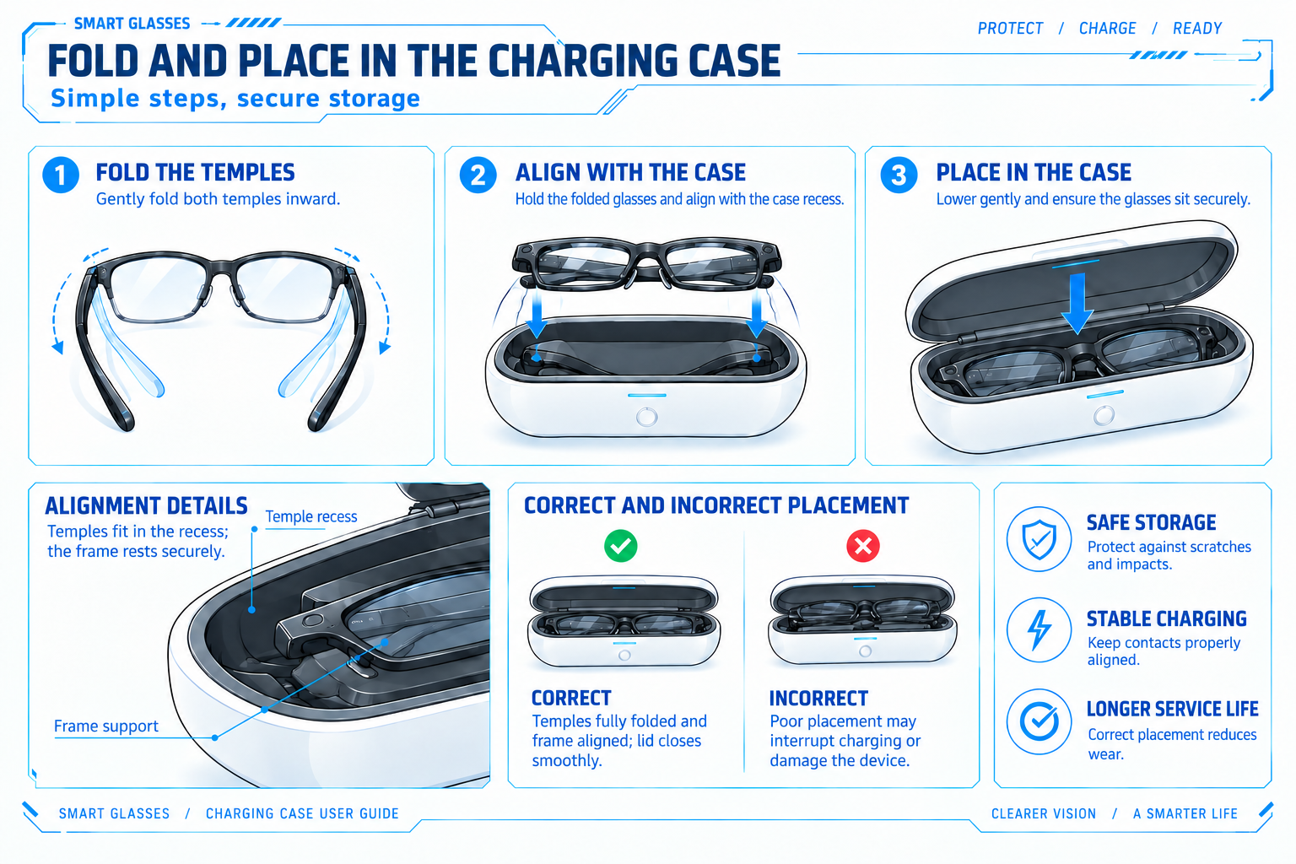
Figure 8. Charging and placement guide.
AI-generated concept; actual case layout takes precedence.

6.3 Installing and Setting Up the Companion App
1. Obtain 理想同学App through a download route provided by Li Auto and check the developer. Do not use an unknown installation package.
2. Read the terms and privacy policy, then sign in or register as prompted.
3. Open the glasses section or device-management entry to add the device. Labels may vary by version.

6.4 Connecting and Pairing
1. Enable phone Bluetooth and keep the powered glasses close to the phone.
2. Choose the glasses under Add Device in the app and follow its current instructions to make them discoverable or ready to pair.
3. Check the device name and confirm pairing, including any phone-system Bluetooth request.
4. Wait for the app to show a connection, then test audio or a photo. If Bluetooth connects but the app does not recognize the glasses, use Section 11.1.
NOTE
Follow current app guidance for first pairing.
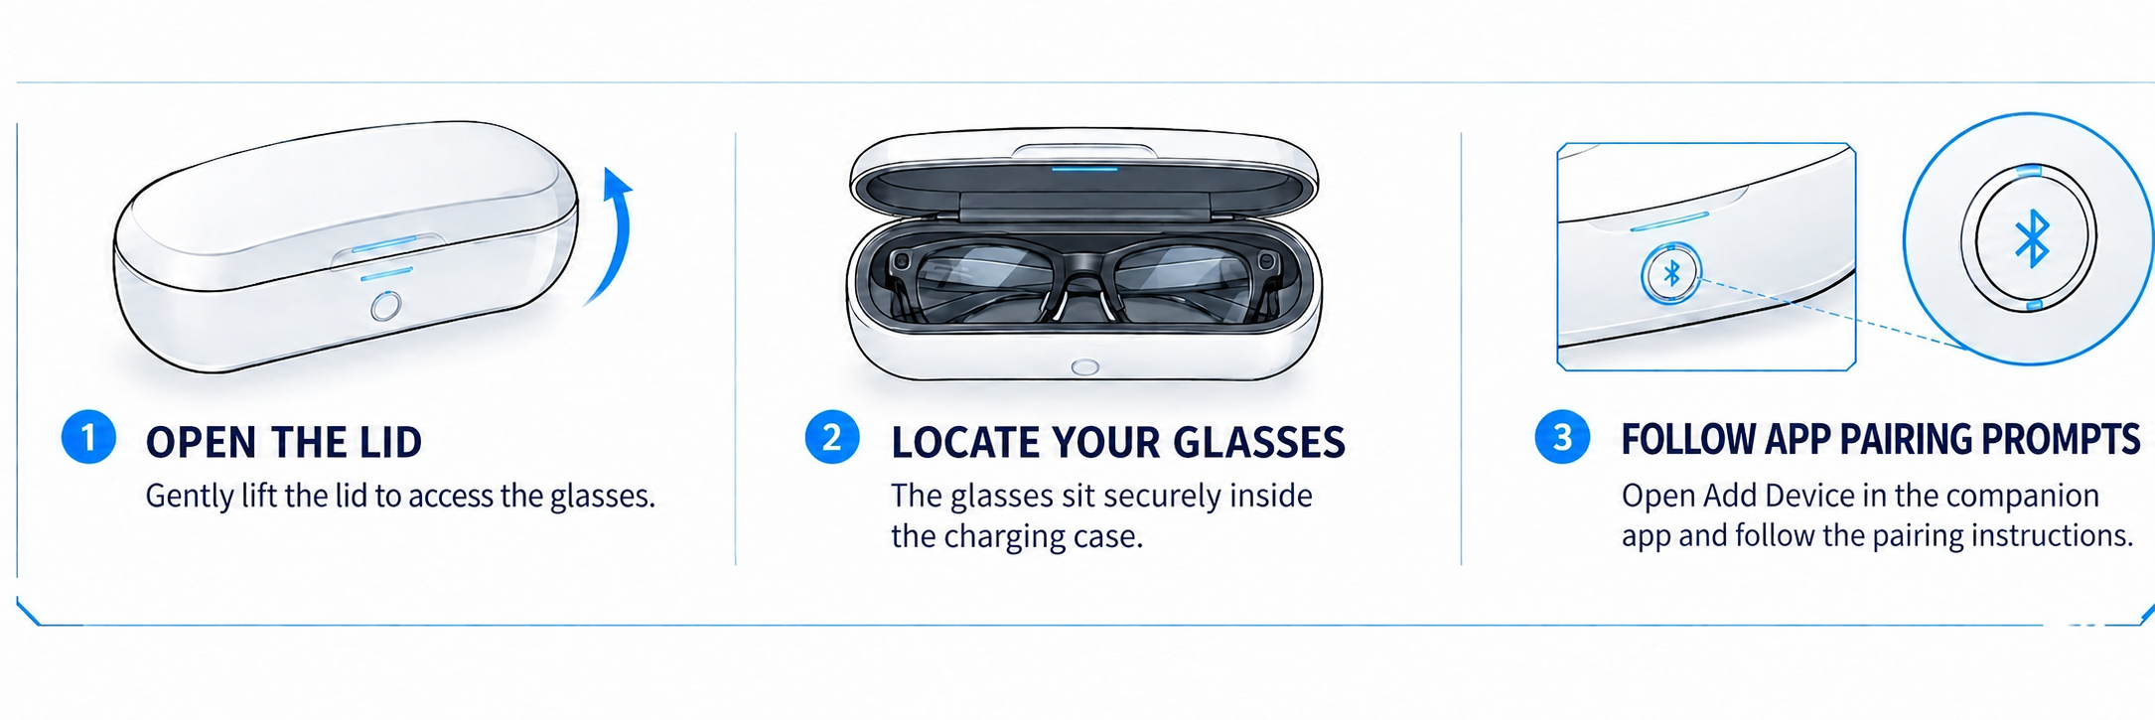
Figure 9. Bluetooth pairing and connection steps.
AI-generated schematic; follow current app guidance, not assumed case controls.

6.5 Required Permissions and Account Settings
Grant permissions according to the system and functions you need:
• Bluetooth or Nearby Devices for connection.
• Photos or storage for importing and saving media.
• Microphone access when the app needs phone audio.
• Notifications for related alerts.
• Location only when a relevant feature requires it.
• Network access for online AI, services, and updates.
Declining an optional permission may leave unrelated functions available.

6.6 Wearing and Adjustment
1. Hold both temples and place the glasses gently on the nose and ears. Check stability and comfortable pressure.
2. Keep lenses clear and the camera and indicator unobstructed. Seek professional help for substantial adjustment.
3. Take a test photo and review it on the phone to check the view.
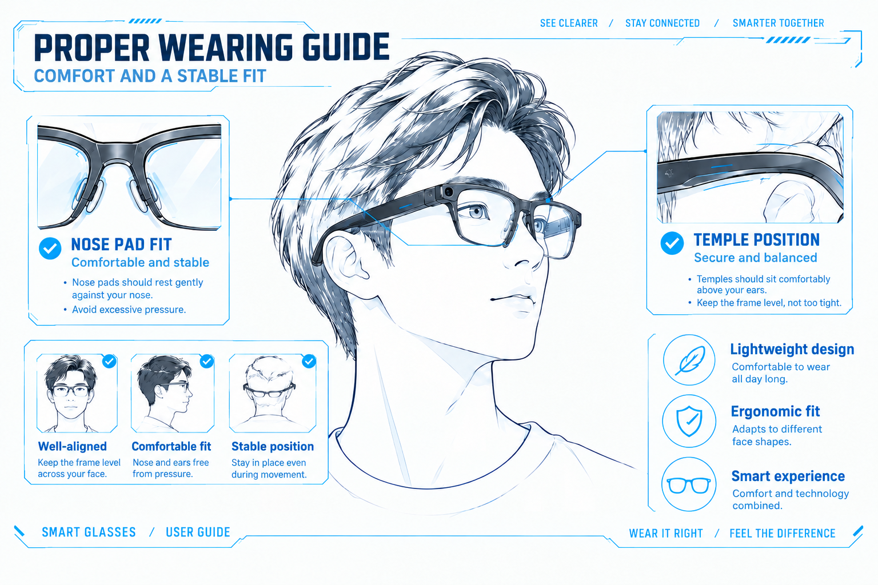
Figure 10. Wearing and fit guide.
AI-generated concept illustration.

6.7 First-Use Checklist
Table 7. First-Use Checklist
Check | Completion
Connection | App recognizes and connects to the glasses
Fit | Comfortable and stable; camera and indicator clear
Audio | Audible at low volume; tap pauses playback
Capture | Test photo appears in the app after one button press
AI / Assistant | Assistant responds to 理想同学 or a touchpad hold when network and service are available
Privacy | Recording is permitted in the test setting

7 Everyday Operation

7.1 Button and Touch Control Reference
Distinguish the recording button from the touchpad: the button controls photos, video, and audio recording; the touchpad controls playback, volume, calls, and AI. See Appendix A for the full reference. A touchpad double-tap is not two recording-button presses.
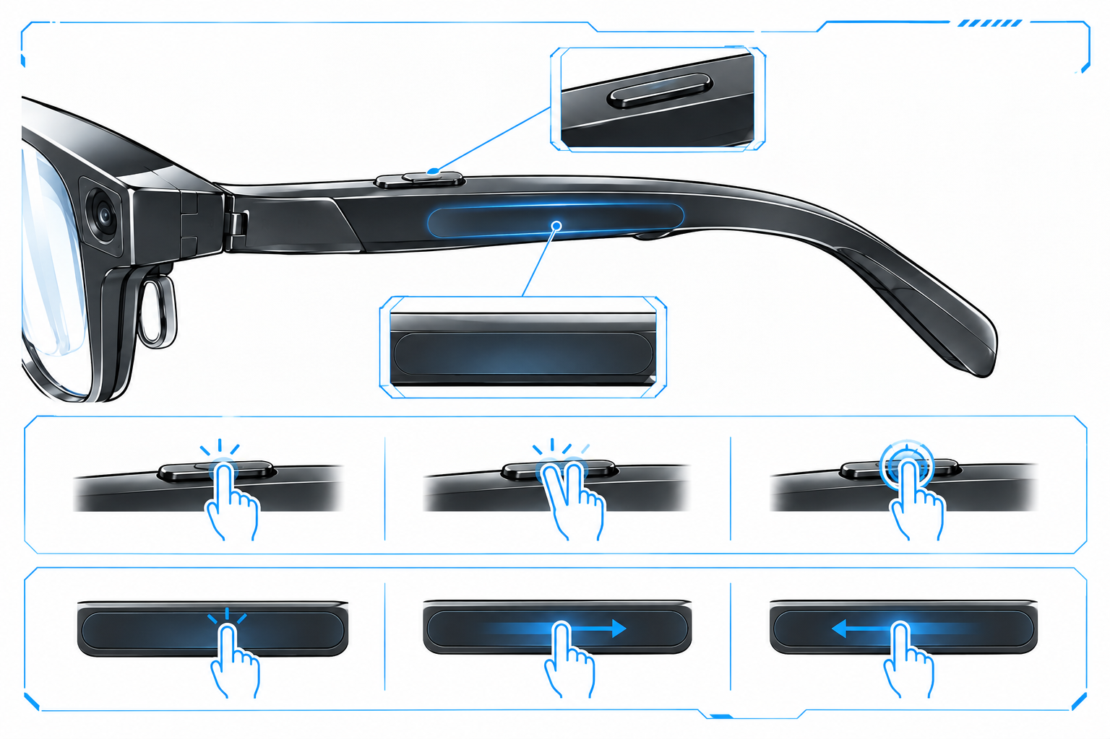
Figure 11. Recording button and touch area.
AI-generated concept; follow the chapter controls and actual device.

7.2 Taking Photos
Before use: ensure power, a clear camera and privacy indicator, and permission to photograph. Obtain required permission for people or sensitive material.
• Hold your head steady and press the recording button once.
• Review the photo in the app media section.
• For blur, improve lighting, clean the camera, and retry while steady.

7.3 Recording Videos
Before use: ensure adequate power and storage and an unobstructed privacy indicator.
• Press the recording button twice to start and twice again to stop video.
• The privacy indicator stays white during recording. The maximum stated duration is 3 minutes per clip.
• Open the completed file in the app. The 41-minute figure is total video recording time, not the per-clip limit.
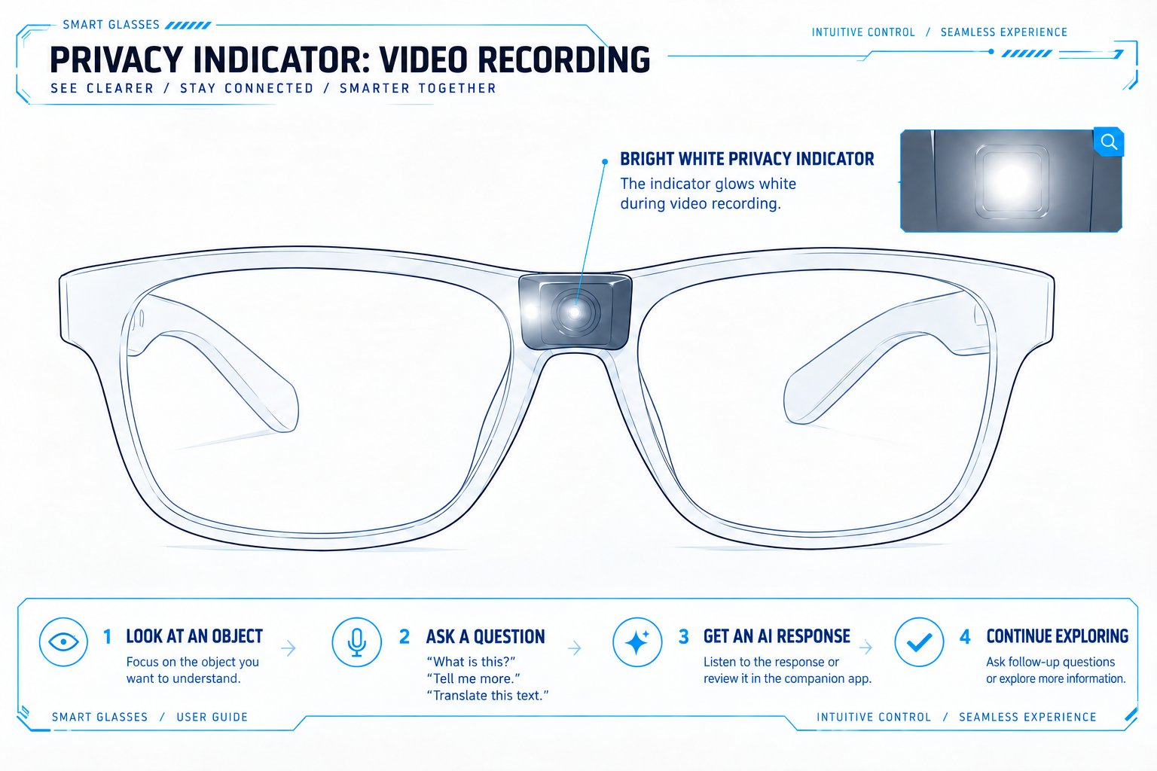
Figure 12. Privacy indicator during video recording.
AI-generated concept; actual hardware appearance may differ.

7.4 Recording Audio and Reviewing Recordings
• Obtain required consent, then hold the recording button to start audio recording.
• Press it twice during recording to stop. Keep microphone openings clear and reduce noise.
• Review recordings and available transcripts or summaries in the app.
• Transcription, speaker identification, and action extraction may be wrong; verify against the original audio.

7.5 Music Playback and Volume Control
• Connect an audio source. Tap the touchpad to play/pause, double-tap for next, and triple-tap for previous.
• Swipe forward to increase volume and backward to decrease it. Start low and adjust to a comfortable level.

7.6 Receiving and Making Calls
• Tap to answer an incoming call; double-tap during a call to end it.
• Double-tap an incoming call to reject it. To call, choose a contact on the phone and select glasses audio.
• Confirm app version, contact access, and service support before voice dialing.
NOTICE
Do not manage contacts or perform complex interactions while driving or in hazardous conditions.

7.7 Using the AI Assistant
Before use: ensure a connection and the required account, network, and AI service.
• Say 理想同学 (Lǐxiǎng Tóngxué) or hold the touchpad, then ask clearly.
• Double-tap to exit. Keep the subject in the camera view for visual questions and avoid unrelated people or sensitive material. Responses are spoken or shown on available app pages, depending on version.
Deep research, memory, and summaries are assistive. Verify important facts and use professional sources for medical, legal, financial, or driving matters. English terminology does not establish an English wake word or service; check actual language settings.
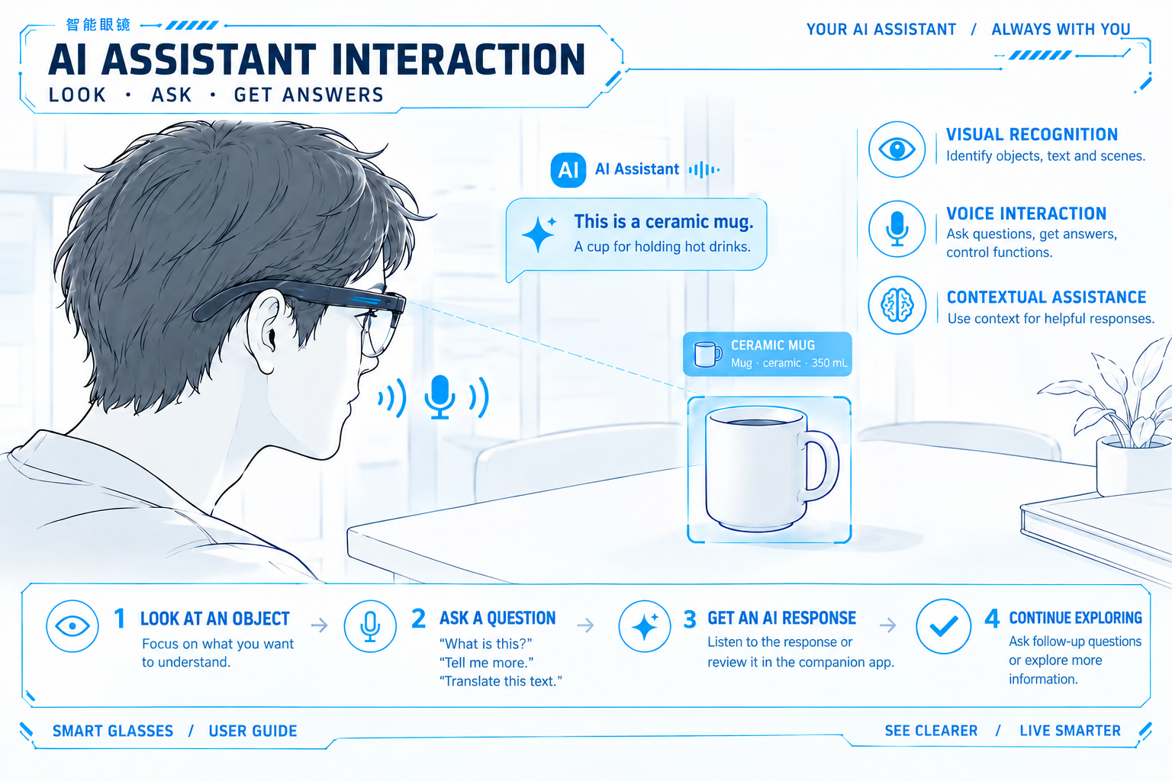
Figure 13. AI assistant interaction.
AI-generated concept; use the text for actual operating guidance.

7.8 Viewing and Transferring Photos and Videos
1. Connect the glasses and open the media-management entry in the app to find recent captures.
2. Select photos or videos and import, save, or transfer them as prompted; grant the relevant Photos or storage permission.
3. Keep the devices close until transfer completes, then open the files on the phone to verify them. Delete originals only after confirming the backup.
NOTE
Transfer method and speed depend on the current app.

7.9 Compatible Devices and Optional Features
Up to two devices may connect simultaneously, with eight retained pairings. Check audio output and active connections when switching devices. Vehicle control, driver-specific audio, and task integration require compatible vehicles, software, and account authorization.

8 Charging and Battery Management

8.1 Charging the Glasses
Ensure the glasses and case contacts are dry and clean, fold the temples naturally, and place the glasses inside. Do not bend the frame or force the lid. Check actual device or app charging status; if charge does not increase, see Section 11.2.
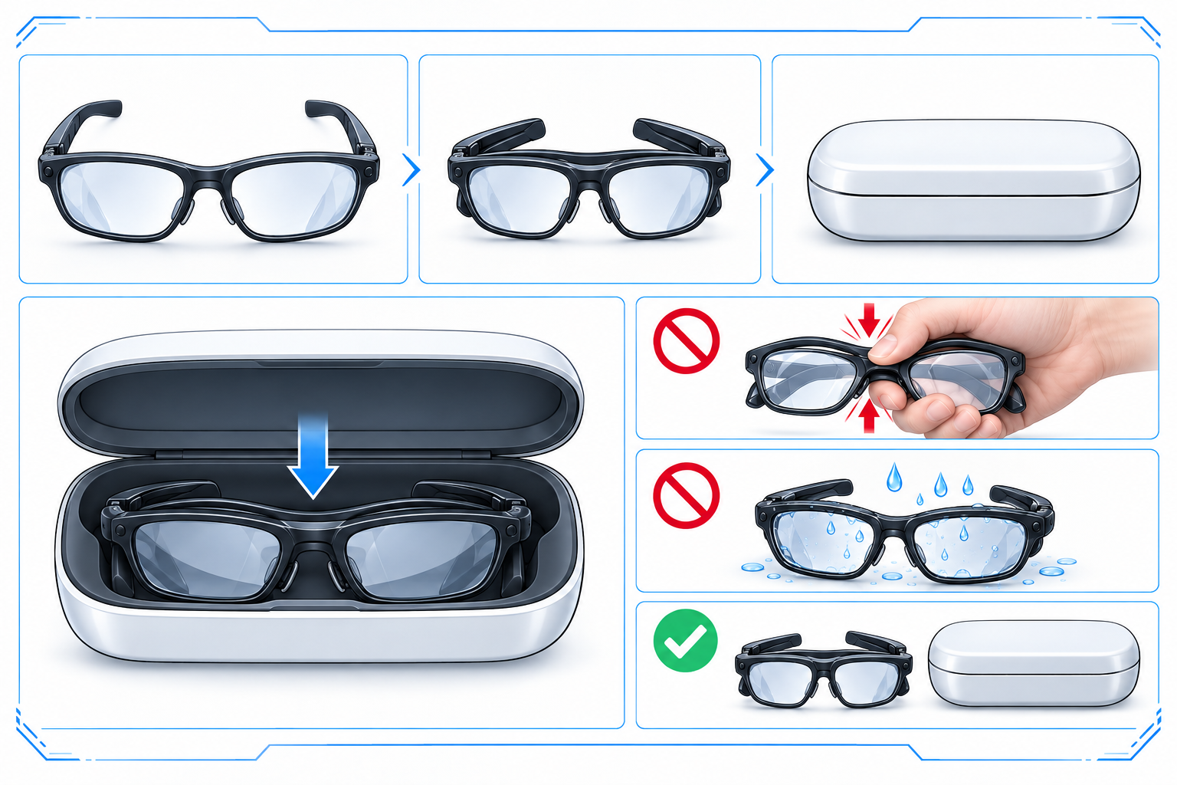
Figure 14. Fold temples and store the glasses.
AI-generated; follow the actual case recess.

8.2 Wired Charging of the Case
Connect a suitable USB-C cable and a power source matching the case input requirements. Use a dry, stable, ventilated surface and do not cover it.
Typical case charging times:
• From 0 to 80%: approximately 50 minutes.
• From 0 to 100%: approximately 90 minutes.
Power source, cable, temperature, and battery condition affect results. Check the label for input requirements.

8.3 Wireless Charging of the Case
The case supports Qi charging up to 15 W. Position and align it as the charger instructs, with no metal or foreign objects between them. Confirm charging and keep it stable; realign or use wired charging if it does not respond.
NOTICE
Up to 15 W does not require a charger above 15 W or guarantee maximum power in every condition.

8.4 Checking Battery and Charging Status
Open the companion app and enter the glasses or device page to view battery and charging status. Recharge low batteries to avoid interrupting capture, calls, and other functions.
Use app prompts and device indicators to check charging. Indicator colors and patterns depend on actual product instructions. For charging failure, check power, cable, and placement under Section 11.2. Contact support if the issue persists.
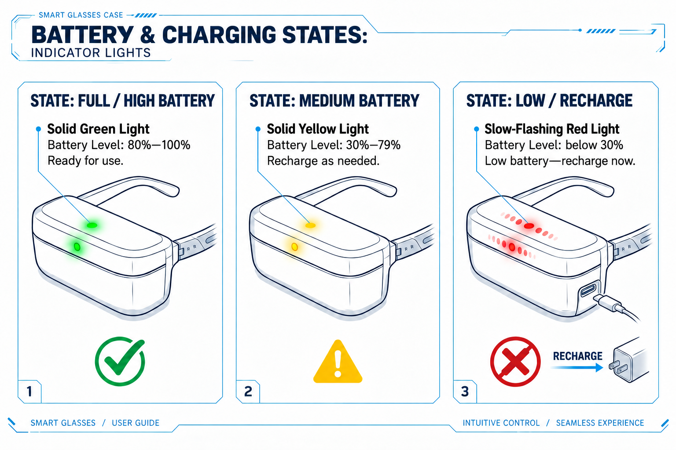
Figure 15. Battery indicator illustration.
AI-generated schematic; actual indicator meanings take precedence.

8.5 Factors Affecting Battery Life
Video, frequent visual questions, higher volume, repeated transfers, weak connections, and extreme temperatures can increase power use. The typical 18.8-hour figure does not guarantee the same duration under continuous heavy load. Check glasses and case charge before a long outing and reduce unnecessary high-load use.

8.6 Long-Term Storage
Clean and dry before extended storage, keep in a cool, dry place with some charge, and check the glasses and case periodically. Avoid prolonged depletion.

9 Privacy and Data Use

9.1 Photography and Recording Considerations
NOTICE
Check whether capture is allowed. Follow hospital, school, workplace, museum, and theater rules; avoid identification, screens, trade secrets, and private activities. The indicator is not consent. It stays white during video; covering it prevents capture. Do not cover, modify, or bypass it. Obtain legally required recording consent; U.S. state and interstate rules vary. Participation alone does not always permit recording. Avoid distraction while driving or cycling.

9.2 App Permissions and Personal Data
• Manage Bluetooth, Photos, microphone, notifications, and necessary location access in phone settings. Grant only what is needed; disabling access may affect related functions. Applicable privacy policies govern collection, transfer, storage, and deletion for accounts, memory, and transcripts. Do not assume local-only processing or a particular server location.
• U.S. privacy rights depend on state law, the covered entity, and eligibility. Where applicable, use the official privacy-policy process to request access, correction, deletion, or an opt-out from particular processing. This manual does not guarantee identical rights for every user.

9.3 Sharing and Deleting Content
• Before sharing photos, videos, recordings, or AI summaries, check for privacy, protected material, and trade secrets. Save any needed originals before deletion. Phone copies, glasses files, app records, and cloud data may be separate; deleting one does not establish deletion everywhere. Review the content and recipients before publishing, and do not present unchecked transcripts or AI summaries as verified facts.

9.4 Limitations of AI-Generated Responses
• AI may be inaccurate or incomplete because of network conditions, noise, camera angle, recognition, or interpretation errors. Use appropriate professional sources for medical, legal, financial, and safety matters. Verify citations and conclusions in research reports. For vehicle control, navigation, or status, rely on actual conditions and official guidance. Memory and summaries may omit or misremember details; confirm important arrangements yourself.

9.5 Preparing for Transfer or Discontinued Use
1. Export needed photos, videos, and recordings, then open the backups to verify them.
2. Use available app functions to delete relevant device and account content, including separate memory, recollection, or cloud controls.
3. Unbind in the app and remove phone or other pairings as officially instructed. If a factory-reset function exists, follow the model-specific official steps.
4. Confirm the device is no longer linked to your account. Ask support if deletion scope is unclear; do not invent a reset key combination. Use an appropriate electronics and battery recycler for disposal.

10 Cleaning, Care, and Software Updates

10.1 Cleaning the Lenses and Frame
• Remove glasses from power and the case. Lift loose dust gently with a clean, soft lens cloth; do not rub hard over grit. Follow applicable ZEISS and manufacturer lens instructions, not general lens-care methods applied to the electronic frame.
• Without explicit guidance, do not rinse, immerse, or spray liquid onto the frame. Use a clean, dry, soft cloth and keep openings and ports dry.
NOTICE
Avoid rough paper, clothing, abrasives, acetone, and strongly acidic or alkaline cleaners. Check manufacturer guidance before alcohol-containing products. Do not remove lenses, temples, or hinges for cleaning.
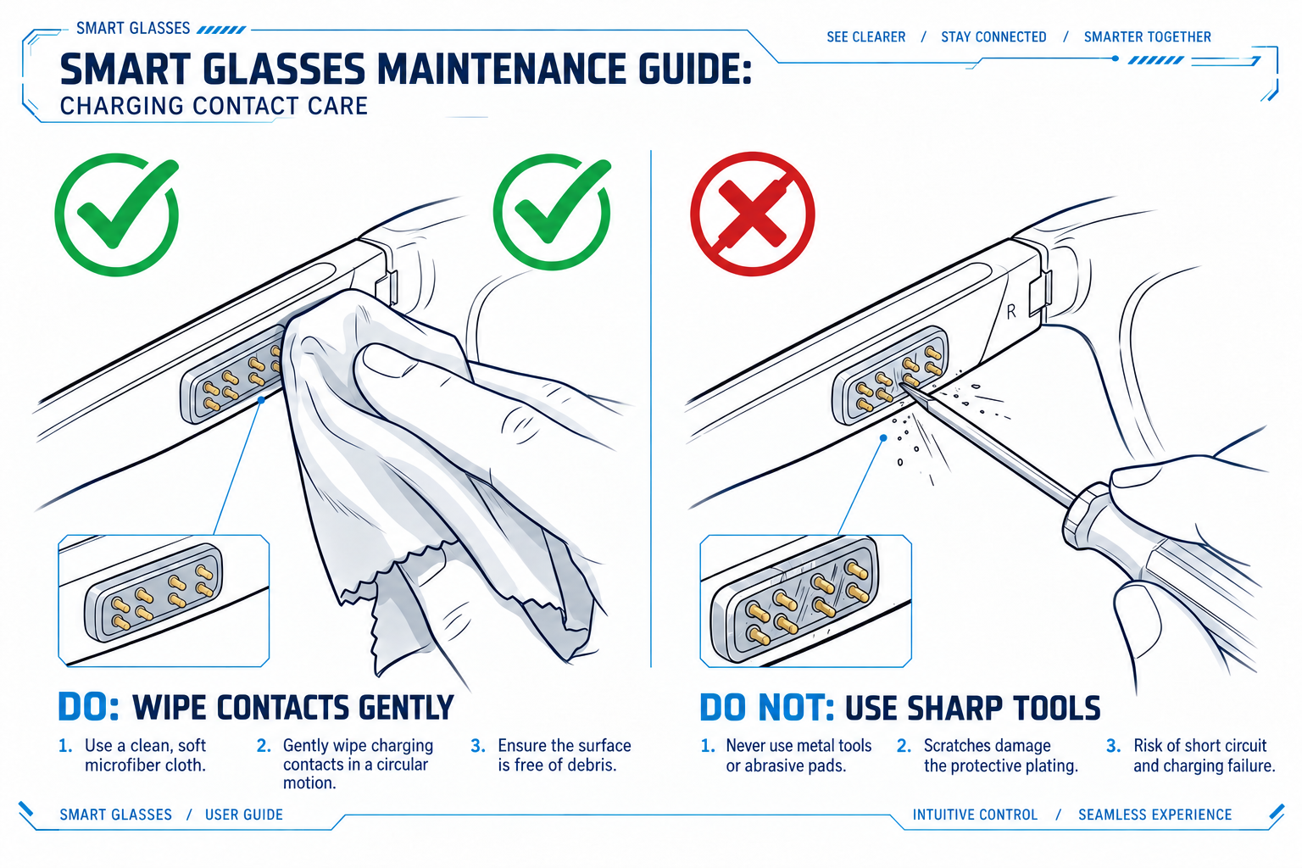
Figure 16. Charging contact care.

10.2 Caring for Charging Contacts and the Case
• Disconnect the cable and remove the case from the wireless charger before cleaning. Wipe accessible charging areas with a dry, soft cloth; avoid metal tools and liquid inside.
• Ask support about corrosion, deformation, or debris that will not lift gently.
• Ensure complete dryness before charging.
• Keep wireless charging surfaces free of foreign objects and aligned correctly.

10.3 Carrying and Storage
• Use the case for protection when not wearing the glasses; ensure they are dry.
• Keep away from keys and sharp objects and do not compress the lid.
• Avoid heat, moisture, sun, and dust. Check storage charge under Section 8.6.
• After liquid exposure or strong impact, do not resume charging solely because the exterior looks normal.

10.4 Checking for and Installing Updates
1. Connect the glasses and phone, meet the app’s battery requirement, and ensure a stable network.
2. Check for updates in the glasses or device page and read release notes and compatibility conditions.
3. Download and install as prompted. Maintain the connection and avoid capture, unbinding, or deliberately interrupting power during the update.
4. Wait for completion, reconnect or restart if prompted, then test basic capture and audio.
Actual releases determine update timing and new functions. If an update fails, record the error and check connection and network under Chapter 11. Contact support for repeated failures; do not use unofficial firmware or an unverified forced reset.

11 Troubleshooting
Check safety first. For unusual heat, swelling, odor, liquid entry, or visible damage, stop under Section 11.7. For ordinary functional issues, work through the appropriate table and retest the original issue after each action. Do not repeatedly delete accounts or factory-reset without a diagnosis.

11.1 Connection or Pairing Issues
Table 8. Connection and Pairing Checks
Check | Action
Power | Recharge in the case and check availability
Bluetooth and permissions | Enable Bluetooth and required Nearby Devices access
Distance and interference | Move closer and away from interference
Pairing state | Follow current Add Device guidance, not assumed case-button combinations
Active connections and account | Check the two-active-connection limit and account link; do not erase all pairings unnecessarily
App version | Update and reopen the app

Retest: confirm app recognition and try audio or a photo. If it still fails, restart the app or phone and record system version, device name, and error before requesting support.

11.2 Charging Issues
Table 9. Charging Checks
Check | Action
Placement | Fold naturally and reseat without force
Case charge | Charge the case with suitable USB-C equipment
Cable and power | Check compatibility and try an undamaged suitable cable and source
Contacts | Clean with a dry soft cloth; stop for corrosion or deformation
Wireless alignment | Remove objects, realign, or use wired charging
Conditions | Move to moderate, dry conditions without sudden temperature changes

Retest: check actual device or app status and confirm charge increases. Stop for persistent failure, unusual heat, swelling, or odor; do not repeatedly retry charging.

11.3 Photo or Video Issues
Table 10. Photo and Video Checks
Check | Action
Indicator obstruction | Clear the privacy indicator; do not cover it
Correct control | One button press for a photo; two to start/stop video
Power and storage | Recharge, check available space, back up before deletion
Image quality | Clean the camera gently, improve lighting, keep steady
Clip limit | Check current duration settings; source states up to 3 min
Software | Confirm applicable updates completed

Retest: capture a photo or short video and open it in the app. Record errors and request support for persistent corruption or capture failure.

11.4 Audio or Call Issues
Table 11. Audio and Call Checks
Check | Action
Volume and output | Raise from low volume and select the glasses as phone output
Other devices | Check competing playback and switch output on the source
Connection | Move closer to the source and reduce obstructions
Call pickup | Clear external microphone obstructions and move somewhere quiet
Sound leakage | Lower volume or use a suitable private method for sensitive calls

Retest with a short audio sample or a convenient test call and confirm intelligibility. Do not test faults at maximum volume.

11.5 AI Assistant Not Responding
Table 12. AI Assistant Checks
Check | Action
Wake method | Say 理想同学 or hold the touchpad; avoid an unsupported English wake word
Phone connection | Confirm app recognition and required background operation
Network and account | Check network, sign-in, and regional service support
Environment and language | Reduce noise, speak clearly, check supported language
Exit state or version | Wake again and check app/device updates

Retest with a short ordinary question. If audio works but AI does not, distinguish network/service availability from hardware faults and record time and errors for support.

11.6 File Synchronization Issues
Table 13. File Synchronization Checks
Check | Action
Connection | Keep devices close with an app connection
Permissions | Grant Photos/storage access needed for import
Free space | Remove verified backups as appropriate and free phone space
Transfer incomplete | Wait for large files to finish; avoid disconnecting
App or file state | Update the app and retry one file; record errors

Retest with one small file and open it before transferring larger files. Do not delete originals until backup integrity is confirmed. Request support if failure persists.

11.7 When to Stop Use and Contact Support
Stop use for unusual heat, smoke, swelling, odor, leakage, broken lenses, frame or hinge damage, corroded contacts, major liquid entry, or abnormal behavior after strong impact. Disconnect external power if safe; do not force a restart or repair it yourself. Persistent ordinary faults also warrant support with the information in Section 12.5.

12 After-Sales Service and Warranty Terms

12.1 Scope
Before requesting service, confirm model, seller, and regional eligibility, and obtain the written warranty, returns, and repair terms applicable to your purchase.

12.2 Warranty Period and Coverage
Confirm duration, start date, covered parts, and repair or replacement remedies from verified purchase terms, warranty documentation, and applicable law. Competition materials do not establish a fixed period, free replacement, or universal cross-border coverage. Keep the order, receipt, and supplied terms. A commercial warranty should not be interpreted as removing applicable legal consumer rights.

12.3 Exclusions
Damage from accidents, misuse, liquid entry, or unauthorized modifications, and normal wear, may fall outside commercial coverage. Applicable warranty terms, assessment, and local law determine the result.
Third-party accessories or repair do not automatically void all warranty coverage. Coverage for resulting damage depends on the cause and applicable terms.

12.4 Requesting Service
1. Verify support through purchase documentation, official channels, or an available app entry. Do not send payment details to unknown support contacts.
2. Provide model, purchase details, and fault description and follow official troubleshooting within safe limits.
3. Before shipping, obtain a case number, address, packing instructions, costs, and lithium-battery guidance. Do not independently ship swollen or leaking devices.
4. Back up and handle personal data under Section 9.5; service may erase content. If damage prevents deletion, tell support rather than powering a hazardous device to erase it.
5. Review the assessment and authorize the remedy, then check functions and account state when the product returns.

12.5 Information Required for Service
Table 14. Information Required for Service
Information | What to Prepare
Product identity | Product name, model, available serial or device ID
Purchase evidence | Date, seller, order number, receipt, and warranty documents
Fault record | Symptoms, first occurrence, frequency, errors, and attempted steps
Versions and conditions | Phone, app, glasses versions, and any liquid/impact exposure
Contact and shipping | Required contact details; never disclose passwords

12.6 Service Channels and Regional Limitations
For after-sales support, contact the companion app, manufacturer’s official channels, or original seller. Confirm eligibility, service region, and shipping requirements.
Cross-border purchases may need return to the original sales region. Confirm shipping costs, duties, and lithium-battery transport requirements before sending the product. Repair, lens service, and delivery times vary by region; use the information confirmed by the receiving service channel.

13 Appendix A: Quick Reference Guide
Task | Control | Check
Photo | Press recording button once | Clear camera and indicator
Video | Press twice to start/stop | Steady white during video; source maximum 3 min per clip
Audio recording | Hold to start; press twice during recording to stop | Obtain required consent
Play/pause | Tap touchpad | Audio connected
Tracks | Double-tap next; triple-tap previous | Playback active
Volume | Swipe forward up; backward down | Start low
Calls | Tap answer; double-tap end/reject | Depends on incoming/active state
AI / Assistant | Say 理想同学 or hold touchpad; double-tap exit | Account, network, region supported
Glasses charging | Place dry glasses naturally in case | Confirm charging
Transfer | Import through app media controls | Verify backup before deletion

14 Appendix B: Bilingual Glossary
中文 | English
理想 AI 眼镜 Livis | Li Auto Livis AI Glasses
理想同学App | Li Auto AI Assistant App (descriptive translation)
理想同学（唤醒词） | 理想同学 / Lǐxiǎng Tóngxué (documented wake phrase)
镜架 / 镜腿 / 鼻托 | frame / temple / nose pad
记录按键 / 触控板 | recording button / touchpad
隐私提示灯 | privacy indicator
充电盒 / 充电触点 | charging case / charging contacts
第一视角拍摄 | first-person capture
开放式音频 | open-ear audio
动态照片 / 电子防抖 | Live Photo / electronic image stabilization (EIS)
配对 / 绑定 / 同步 | pairing / account binding / synchronization
无线升级 | over-the-air (OTA) update
视觉问答 / 深度研究 | visual questions / deep research
典型续航 / 单段录像时长 | typical battery life / per-clip recording duration
处方镜片 | prescription lenses

