1. 关于本说明书 / About This Manual

1.1 说明书用途与适用范围 / Purpose and Scope
本说明书面向理想 AI 眼镜 Livis（以下简称“眼镜”）及配套充电盒的使用者，介绍产品功能、技术规格、首次设置、日常操作、安全、隐私、保养、故障排查和售后信息。请结合产品标签、正式随附资料和理想同学App中的说明使用本产品。
This manual is intended for users of Li Auto Livis AI Glasses (the “glasses”) and the charging case. It covers functions, specifications, setup, operation, safety, privacy, care, troubleshooting, and after-sales information. Use it together with the product label, official supplied documentation, and instructions in the Li Auto AI Assistant App (理想同学App).

1.2 如何阅读本说明书 / How to Use This Manual
首次使用前先阅读第5章，再按第6章完成充电、连接和佩戴检查。日常功能见第7章；电池管理见第8章；拍摄和个人数据事项见第9章。清洁和更新见第10章，遇到异常时按第11章逐项排查，仍无法解决时按第12章申请支持。操作速查见附录A。
Read Chapter 5 before first use, then follow Chapter 6 for charging, connection, and fit checks. See Chapter 7 for everyday functions, Chapter 8 for battery management, and Chapter 9 for photography and personal data. Chapter 10 covers care and updates. Use Chapter 11 to troubleshoot, and Chapter 12 to request support if the issue persists. Appendix A provides a quick reference.

1.3 警告、注意和提示的含义 / Warnings, Cautions, and Notes
警告：提示可能造成人身伤害的风险，以及应采取的避免措施。注意：提示可能导致设备损坏、数据丢失或操作失败的情况。提示：提供帮助理解功能或完成操作的补充信息。请先阅读相关提示，再执行步骤。图示中的箭头、编号和颜色仅用于辅助理解。
WARNING identifies a risk of personal injury and the action needed to avoid it. NOTICE identifies a risk of equipment damage, data loss, or an unsuccessful operation. NOTE provides additional information about a function or task. Read the relevant message before proceeding. Arrows, numbers, and colors in illustrations support the written instructions.

1.4 产品与软件版本说明 / Product and Software Versions
在标签、包装或App核对型号和软件。功能受配置、版本、账号、网络、语言、地区和服务影响。手册中计划上线的功能不等于已经可用，以实际更新与兼容说明为准。
Check model and software on the label, packaging, or app. Functions depend on configuration, version, account, network, language, region, and services. Planned features are not confirmed availability; check actual updates and compatibility.

2. 产品概述 / Product Overview

2.1 产品简介 / Product Introduction
Livis 将眼镜、第一视角相机、开放式音频和AI助手集成于可佩戴设备中。产品采用 Livis OS 系统，配合手机上的理想同学App使用。它通过按键、触控和语音完成交互，可用于记录日常场景、收听音频、通话及获取辅助信息。镜架与镜片配置不同，佩戴重量和光学效果也会不同。
Livis combines eyewear, a first-person camera, open-ear audio, and an AI assistant in a wearable device. It runs Livis OS and works with the Li Auto AI Assistant App on a phone. Buttons, touch controls, and voice commands support everyday capture, audio, calls, and information assistance. Wearing weight and optical performance vary with the frame and lens configuration.

2.2 主要功能 / Main Features
功能 / Function | 用途与条件 / Use and Conditions
第一视角影像 / First-person imaging | 照片、Live Photo及视频；保持视野清晰并遵守拍摄规定。  Photos, Live Photo, and video; keep the view clear and follow recording rules.
开放式音频与通话 / Open-ear audio and calls | 音乐、手机通话及语音反馈；依赖适用的蓝牙连接与服务。  Music, phone calls, and spoken feedback; require the relevant Bluetooth connection and services.
录音与总结 / Recording and summaries | 记录会议、学习等内容，支持转写、说话人区分及AI总结；先取得必要同意。  Record meetings or learning sessions with transcription, speaker identification, and AI summaries; obtain required consent first.
AI问答 / AI assistance | 语音问答、视觉问答、深度研究及记忆类功能；通常需要手机、网络及有效账号。  Voice and visual questions, deep research, and memory features; generally require a phone, network, and valid account.
车辆联动 / Vehicle integration | 适用车型的控制、信息查询及音频联动；受车型、车机版本、账号授权和地区限制。  Controls, information, and audio integration for supported vehicles; depend on vehicle, software, account authorization, and region.
无线充电盒 / Wireless charging case | 充电盒支持USB-C有线和Qi无线充电，眼镜放入盒中补能。  The case supports USB-C and Qi charging; place the glasses inside to recharge them.

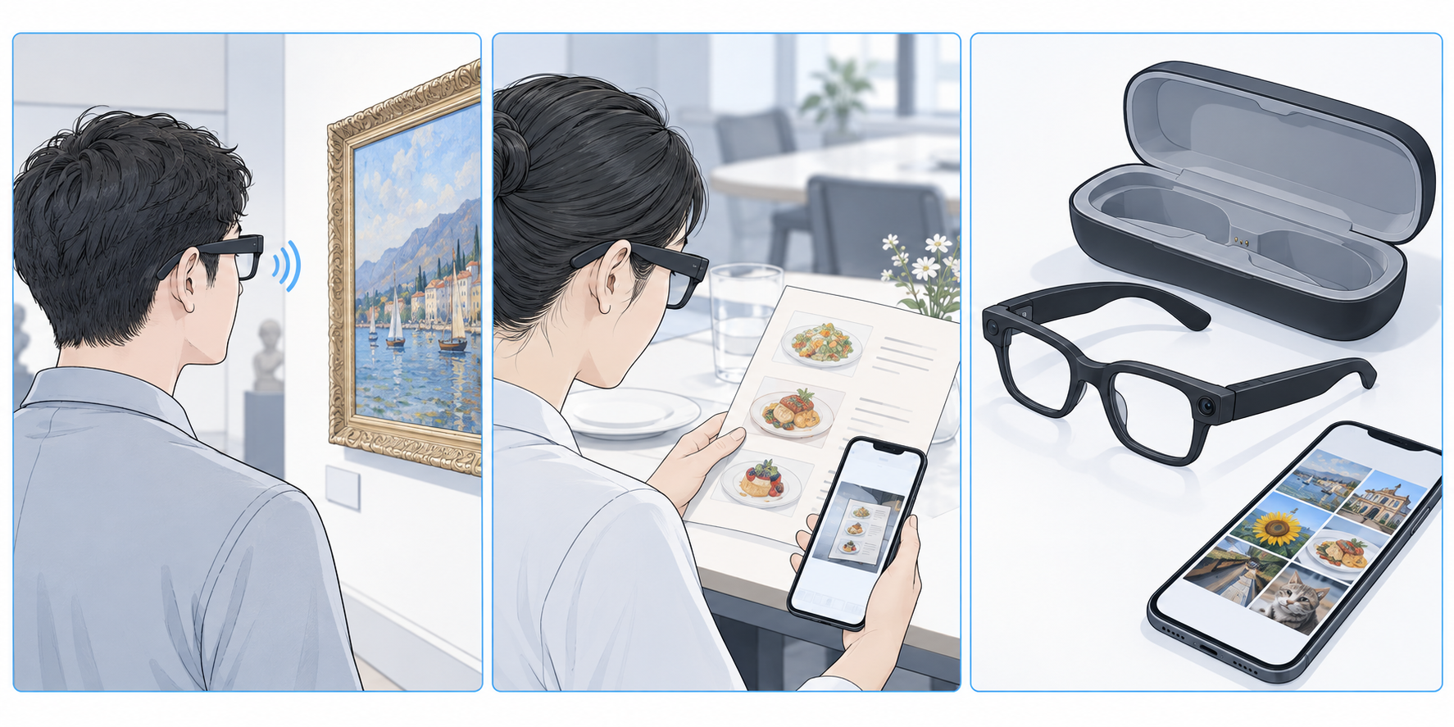
图2-1 日常使用流程概念示意：采集场景、语音辅助、手机查看。AI生成，不代表实物结构或已验证的地区功能。
Figure 2-1. Conceptual workflow: capture, spoken assistance, and phone review. AI-generated; not a hardware or verified regional-function reference.

2.3 预期用途与使用限制 / Intended Use and Limitations
本产品用于日常佩戴、音频通信、个人影像记录及AI辅助信息获取，不作为工业防护眼镜、医疗设备或驾驶决策工具。AI识别和回答可能出错，重要信息应独立核实。开放式音频可能被周围人员听见。传播手册没有说明眼镜配备显示屏；本文不将语音或手机反馈描述为镜片中的AR显示。
The product is intended for everyday wear, audio communication, personal capture, and AI-assisted information. It is not industrial protective eyewear, a medical device, or a driving decision tool. AI recognition and answers may be incorrect; verify important information independently. Nearby people may hear open-ear audio. The communication manual does not specify a display in the glasses; this manual does not present spoken or phone-based feedback as an AR lens display.

2.4 配套应用与服务 / Companion App and Services
配套应用为“理想同学App”；英文名称是描述性译名，不代表美国商店正式名称。连接、媒体、设置和更新按当前界面操作。使用前确认美国下载、注册、语言和服务支持，音乐及车辆功能还受第三方服务和兼容性限制。
The app is 理想同学App; the English name is descriptive, not a confirmed U.S. listing. Follow its current interface for connection, media, settings, and updates. Confirm U.S. download, registration, language, and services; music and vehicle functions also depend on third parties and compatibility.

3. 产品部件与包装内容 / Product Components and Package Contents

3.1 包装内容 / Package Contents
核对眼镜、随附充电盒及所购镜片。手册未列完整包装清单，USB-C线、清洁布、袋、入门卡或适配器是否随附，以订单和实物清单为准。缺件或损坏时保留包装并联系卖家。
Check the glasses, included case, and ordered lenses. The source gives no complete packing list; check your order and package for a cable, cloth, pouch, guide, or adapter. Retain packaging and contact the seller for missing or damaged items.

3.2 眼镜部件示意图 / Glasses Overview
眼镜包含镜框和镜片、镜腿、硅胶鼻托、钛合金转轴，以及用于拍摄、收音和播放音频的部件。三个核心操作区域为触控板、记录按键和隐私提示灯。使用前辨认这些区域，避免遮挡镜头、提示灯和收音开孔。下图为传播手册原始产品尺寸图；标注尺寸不作为自行拆卸或改装依据。
The glasses include the frame and lenses, temples, silicone nose pads, titanium-alloy hinges, and components for capture, sound pickup, and audio playback. The three core control areas are the touchpad, recording button, and privacy indicator. Identify these areas before use and keep the camera, indicator, and microphone openings clear. The following original source diagram shows dimensions; it is not a disassembly or modification guide.
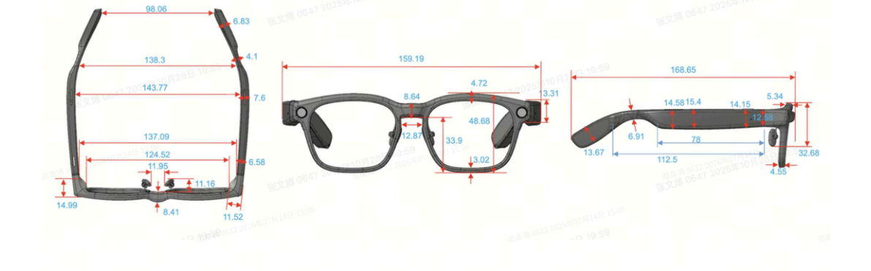
图3-1 产品外观与尺寸图。来源：1.pdf第5页；原图标注为毫米。
Figure 3-1. Product appearance and dimensions. Source: 1.pdf, page 5; original labels are in millimeters.

3.3 充电盒部件示意图 / Charging Case Overview
充电盒用于收纳和补能，支持USB-C及Qi。按盒内形状自然放置，不挤压镜框或强行合盖。接口、接触结构和提示以实物为准；手册未确认独立配对键，不使用假定的盒上按键流程。
The case stores and recharges the glasses via USB-C or Qi. Fit the glasses naturally into the recess; do not squeeze the frame or force the lid. Check the actual ports, contacts, and indicators. No separate pairing key is confirmed; do not use an assumed case-button procedure.

3.4 按键、触控区域与状态提示 / Buttons, Touch Controls, and Status Indicators
操作区域 / Area | 操作及结果 / Action and Result
触控板 / Touchpad | 单击：播放/暂停、接听。双击：下一首；结束或拒接电话；退出AI。三击：上一首。前滑/后滑：提高/降低音量。长按：唤醒理想同学。  Tap: play/pause or answer. Double-tap: next track, end/reject a call, or exit AI. Triple-tap: previous track. Swipe forward/backward: raise/lower volume. Press and hold: wake the assistant.
记录按键 / Recording button | 单击：拍照。双击：开始/停止视频；录音时双击停止录音。长按：开始录音。  Press once: take a photo. Press twice: start/stop video; during audio recording, stop recording. Press and hold: start audio recording.
隐私提示灯 / Privacy indicator | 录像时白色常亮；提示灯被遮挡时不能拍照或录像。手册未列出所有状态的灯色和闪烁含义。  Steady white during video recording; covering it prevents photos and videos. The source does not list all colors or blinking patterns.

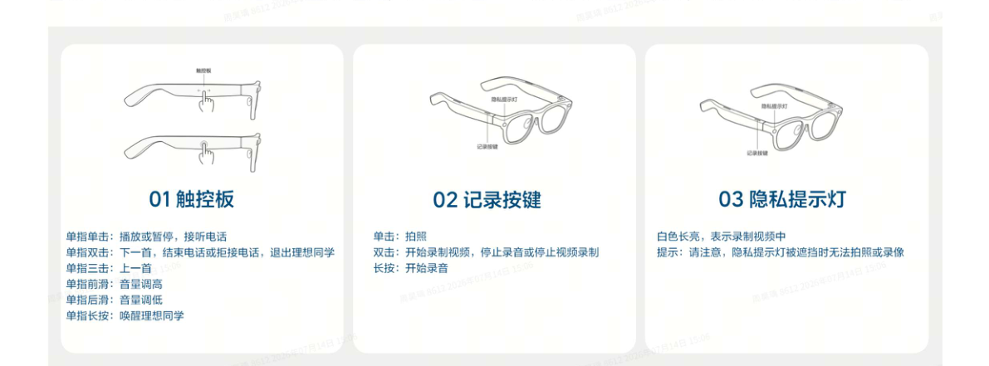
图3-2 触控板、记录按键及隐私提示灯。来源：2.pdf第13页；编号01—03对应上表三个区域。
Figure 3-2. Touchpad, recording button, and privacy indicator. Source: 2.pdf, page 13; numbers 01–03 correspond to the three areas in the table above.
提示：同一操作在不同状态下有不同用途。先确认是否正在通话、播放或录音，再操作。长按时长和操作反馈以当前正式说明为准。
NOTE: The same gesture has different uses in different states. Check whether a call, playback, or recording is active before operating. Check the current official instructions for hold duration and feedback.

4. 技术规格 / Technical Specifications

4.1 尺寸、重量与材料 / Dimensions, Weight, and Materials
项目 / Item | 规格 / Specification | 来源 / Source
镜架重量 / Frame weight | 36 g（约1.27 oz），仅镜架，不含镜片 / frame only, excluding lenses | 1.pdf p.4; 2.pdf p.2
镜架面宽间距 / Frame face-width spacing | 134–137 mm（约5.28–5.39 in）；定制热弯后约134–136 mm / after custom heat bending, approximately 134–136 mm | 1.pdf p.5
镜腿长度 / Temple length | 169 mm（约6.65 in）；尺寸图标168.85 mm / drawing labels 168.85 mm | 1.pdf p.5
镜架材料 / Frame material | TR90；钛合金转轴、硅胶鼻托 / TR90; titanium-alloy hinges and silicone nose pads | 2.pdf pp.2–3
外观 / Finishes | 亮光或哑光；经典黑、科技灰、橄榄绿 / glossy or matte; classic black, tech gray, olive green | 1.pdf p.4; 2.pdf p.4

4.2 镜架与镜片选项 / Frame and Lens Options
镜片包括蔡司平光防蓝光、单色墨镜、感光变色及处方镜片；处方提供定制蔡司和Superb系列。度数、折射率和类型由专业人员按处方与订单确认。原设计针对中国脸型优化，购买前试戴，检查鼻托、耳部和镜腿压力。
ZEISS options include non-prescription blue-light-filtering, tinted, photochromic, and prescription lenses, with custom and Superb prescription series. Have a professional confirm prescription, index, and type. The original design targets Chinese facial profiles; try it on and check nose, ear, and temple pressure.
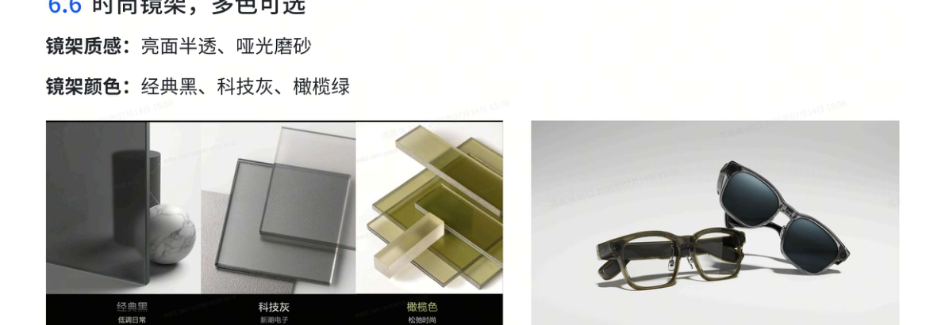
图4-1 镜架配色与外观示例。来源：2.pdf第4页；以购买配置为准。
Figure 4-1. Frame colors and appearance examples. Source: 2.pdf, page 4; your purchased configuration may differ.

4.3 相机与影像规格 / Camera and Imaging Specifications
项目 / Item | 规格 / Specification | 来源 / Source
相机 / Camera | 1200万像素，Sony IMX681 / 12 MP, Sony IMX681 | 1.pdf p.7
光学 / Optics | 1G+4P；F/2.2；105°超广角 / 1G+4P; f/2.2; 105° ultra-wide angle | 1.pdf p.7
照片 / Photos | 4032 × 3024 像素 / pixels | 1.pdf p.7
视频 / Video | 1080p / 30 fps；单段最高3分钟 / up to 3 minutes per clip | 1.pdf pp.7–8
防抖与动态照片 / Stabilization and Live Photo | EIS；Live Photo记录约3秒动态内容，见实际版本 / EIS; approximately 3 seconds of motion, subject to version | 1.pdf pp.7–8
画幅 / Aspect ratios | 3:4、4:3、16:9、9:16 / 3:4, 4:3, 16:9, 9:16 | 1.pdf p.8

4.4 音频与无线连接 / Audio and Wireless Connectivity
项目 / Item | 规格 / Specification | 来源 / Source
音频 / Audio | 开放式空间音频，双磁路扬声器 / open-ear spatial audio, dual-magnetic-circuit speakers | 1.pdf pp.8–9
麦克风 / Microphones | 360°全向录音，3米内人声拾取描述 / 360° omnidirectional recording; source describes speech pickup within 3 m (9.84 ft) | 1.pdf p.9
蓝牙 / Bluetooth | Bluetooth 5.4；最多同时连接2台设备，可保留8台设备绑定关系 / up to 2 simultaneous connections and 8 paired-device relationships | 1.pdf p.10; 2.pdf p.1

拾音效果受噪声、距离和方向影响。手册未公布Wi-Fi版本及存储容量，本文不填入推测数值。
Noise, distance, and direction affect recording. The source does not specify a Wi-Fi version or storage capacity; no values are assumed.

4.5 电池与充电 / Battery and Charging
项目 / Item | 手册数据 / Source Data | 来源 / Source
眼镜电池 / Glasses battery | 240 mAh；石墨负极电池 / graphite-anode battery | 2.pdf p.4
典型续航 / Typical battery life | 18.8小时；实际受使用方式影响 / 18.8 h; varies with use | 1.pdf p.5
眼镜充电 / Glasses charging | 0–80%约30分钟；0–100%约60分钟 / approximately 30 min to 80%; 60 min to 100% | 2.pdf p.4
充电盒电池 / Case battery | 1700 mAh；约4次眼镜完整充电 / approximately 4 full glasses charges | 1.pdf p.7; 2.pdf p.5
充电盒有线 / Wired case charging | USB-C；0–80%约50分钟；0–100%约90分钟 / approximately 50 min to 80%; 90 min to 100% | 2.pdf p.4
充电盒无线 / Wireless case charging | Qi；最高支持15 W；0–80%约2小时15分，0–100%约3小时 / up to 15 W; approximately 2 h 15 min to 80%, 3 h to 100% | 2.pdf p.5
视频录制总时长 / Total video recording time | 手册标示41分钟，不等于单段时长 / stated as 41 min, not the per-clip limit | 1.pdf p.8

4.6 防护等级与使用环境 / Ingress Protection and Operating Conditions
眼镜防护等级为IP54：可提供一定防尘和防溅水保护，不代表完全防尘或可浸水。请勿游泳、淋浴或用水冲洗电子镜架。传播手册未给出充电盒防护等级，也未给出工作、充电及存储温度范围；保持充电盒干燥，避免高温、凝露和过冷环境，具体温度限制按正式标签或说明核实。
The glasses are rated IP54, providing limited dust and splash protection rather than complete dust exclusion or immersion protection. Do not swim, shower, or rinse the electronic frame. The source does not state a case ingress-protection rating or operating, charging, and storage temperature ranges. Keep the case dry, avoid excessive heat, condensation, and very cold conditions, and confirm numerical limits from official labeling or instructions.

4.7 性能数据的测试条件 / Performance Test Conditions
充电和续航数据为手册典型值，不是用户保证。手册充电时间有差异，本稿采用2.pdf第4—5页专门章节：充电盒有线满充约90分钟。18.8小时续航、41分钟总录像和充电盒补能是不同指标，不应相加。
Charging and battery-life figures are typical, not guaranteed. Source sections differ; this manual follows the dedicated battery section in 2.pdf, pages 4–5, including approximately 90 minutes for a full wired case charge. The 18.8-hour use, 41-minute total video, and case recharge measures must not be added.
手册列300 ms唤醒、800 ms普通任务响应和715 ms抓拍实验室数据；任务、网络和测试方法会改变结果，不能视为固定等待时间。换算：1 in = 25.4 mm，1 oz ≈ 28.3495 g。
Laboratory figures include 300 ms wake-up, 800 ms task response, and 715 ms capture. Task, network, and method affect results; these are not fixed waiting times. Conversions: 1 in = 25.4 mm; 1 oz ≈ 28.3495 g.

附录 A：操作速查表 / Appendix A: Quick Reference Guide
目的 / Task | 操作 / Control | 检查 / Check
拍照 / Photo | 记录键单击 / Press recording button once | 镜头和隐私灯无遮挡 / Clear camera and indicator
录像 / Video | 记录键双击开始/停止 / Press twice to start/stop | 录像白灯常亮；手册单段最高3分钟 / Steady white during video; source maximum 3 min per clip
录音 / Audio recording | 记录键长按开始；录音时双击停止 / Hold to start; press twice during recording to stop | 先取得必要同意 / Obtain required consent
播放暂停 / Play/pause | 触控板单击 / Tap touchpad | 音频已连接 / Audio connected
切歌 / Tracks | 触控板双击下一首、三击上一首 / Double-tap next; triple-tap previous | 当前为播放状态 / Playback active
音量 / Volume | 触控板前滑提高、后滑降低 / Swipe forward up; backward down | 低音量起调 / Start low
通话 / Calls | 单击接听；双击结束或拒接 / Tap answer; double-tap end/reject | 依来电或通话状态 / Depends on incoming/active state
AI / Assistant | 说“理想同学”或长按触控板；双击退出 / Say 理想同学 or hold touchpad; double-tap exit | 账号、网络、地区支持 / Account, network, region supported
眼镜充电 / Glasses charging | 干燥后自然放入充电盒 / Place dry glasses naturally in case | 确认充电状态 / Confirm charging
传输 / Transfer | 按App媒体管理流程导入 / Import through app media controls | 打开备份后再删原件 / Verify backup before deletion

附录 B：中英文术语表 / Appendix B: Bilingual Glossary
中文 | English
理想 AI 眼镜 Livis | Li Auto Livis AI Glasses
理想同学App | Li Auto AI Assistant App (descriptive translation)
理想同学（唤醒词） | 理想同学 / Lǐxiǎng Tóngxué (documented wake phrase)
镜架 / 镜腿 / 鼻托 | frame / temple / nose pad
记录按键 / 触控板 | recording button / touchpad
隐私提示灯 | privacy indicator
充电盒 / 充电触点 | charging case / charging contacts
第一视角拍摄 | first-person capture
开放式音频 | open-ear audio
动态照片 / 电子防抖 | Live Photo / electronic image stabilization (EIS)
配对 / 绑定 / 同步 | pairing / account binding / synchronization
无线升级 | over-the-air (OTA) update
视觉问答 / 深度研究 | visual questions / deep research
典型续航 / 单段录像时长 | typical battery life / per-clip recording duration
处方镜片 | prescription lenses

附录 C：资料来源 / Appendix C: Sources
页码对应拆分文件1.pdf与2.pdf。查阅日期：2026年10月12日。本文未进行独立实机或认证验证。
Pages refer to split files 1.pdf and 2.pdf. Reviewed October 12, 2026; no independent device or certification testing was performed.
资料 / Source | 使用范围 / Use
S1. 理想AI眼镜Livis—传播手册，拆分1.pdf，第1—10页  Livis communication manual, split 1.pdf, pp.1–10 | 功能概述、镜架与镜片、尺寸与IP54、相机、视频、音频。  Features, frame/lenses, dimensions/IP54, camera, video, audio.
S2. 同上，拆分2.pdf，第1—14页  Same source, split 2.pdf, pp.1–14 | 连接、材质、佩戴、电池及充电、AI与软件、操作速查、App。  Connectivity, materials, fit, battery/charging, AI/software, controls, app.
S3. 原目录、5-8章.docx、9-12节.docx  Original outline and supplied Chapters 5–12 | 章节结构与原有内容基础，冲突数据以S1/S2核对。  Structure and original content; conflicting data checked against S1/S2.

图3-1、图4-1摘自指定传播手册；图6-1沿用团队提供的原稿图，须由团队核实其来源和使用权。若采用新增AI概念图，应在AI使用报告中记录，概念图不作为真实硬件结构依据。
Figures 3-1 and 4-1 are taken from the designated source. Figure 6-1 is retained from the supplied draft; the team should verify its provenance and usage rights. Record any added AI concept illustration in the AI-use report; it is not a hardware reference.

