Li Auto Livis AI Glasses
User Manual
  - English Edition · United States Target Market
Team name: To be completed
Team members: To be completed
Faculty adviser(s): To be completed
Team leader telephone and email: To be completed
Version: 4.0 · Detailed illustrated review draft
Prepared: October 12, 2026
The U.S. competition target market does not establish local availability, certification, or a service network. Consult official supplied instructions as well.

Contents
1. Product Overview
1.1 About This Manual
1.2 Product Introduction
1.3 Components and Package Contents
2. Technical Specifications
3. Operating Instructions
3.1 Getting Started
3.2 Everyday Operation
3.3 Charging and Battery Management
3.4 Privacy and Data Use
3.5 Cleaning, Care, and Updates
3.6 Troubleshooting
4. Safety Warnings
5. After-Sales Terms

1. Product Overview

1.1 About This Manual

1.1.1 Purpose and Scope
This manual is intended for users of Li Auto Livis AI Glasses (the “glasses”) and the charging case. It covers functions, specifications, setup, operation, safety, privacy, care, troubleshooting, and after-sales information. Use it together with the product label, official supplied documentation, and instructions in the Li Auto AI Assistant App (理想同学App).

1.1.2 How to Use This Manual
Read Module 4, Safety Warnings, before setup under Section 3.1. Module 1 covers product and components, Module 2 specifications, Module 3 operation, charging, privacy, care, and troubleshooting, and Module 5 service. See Section 3.2.10 for controls.

1.1.3 Warnings, Cautions, and Notes
WARNING identifies a risk of personal injury and the action needed to avoid it. NOTICE identifies a risk of equipment damage, data loss, or an unsuccessful operation. NOTE provides additional information about a function or task. Read the relevant message before proceeding. Arrows, numbers, and colors in illustrations support the written instructions.

1.1.4 Product and Software Versions
Check model and software on the label, packaging, or app. Functions depend on configuration, version, account, network, language, region, and services. Planned features are not confirmed availability; check actual updates and compatibility.

1.2 Product Introduction

1.2.1 Product Introduction
Livis combines eyewear, a first-person camera, open-ear audio, and an AI assistant in a wearable device. It runs Livis OS and works with the Li Auto AI Assistant App on a phone. Buttons, touch controls, and voice commands support everyday capture, audio, calls, and information assistance. Wearing weight and optical performance vary with the frame and lens configuration.
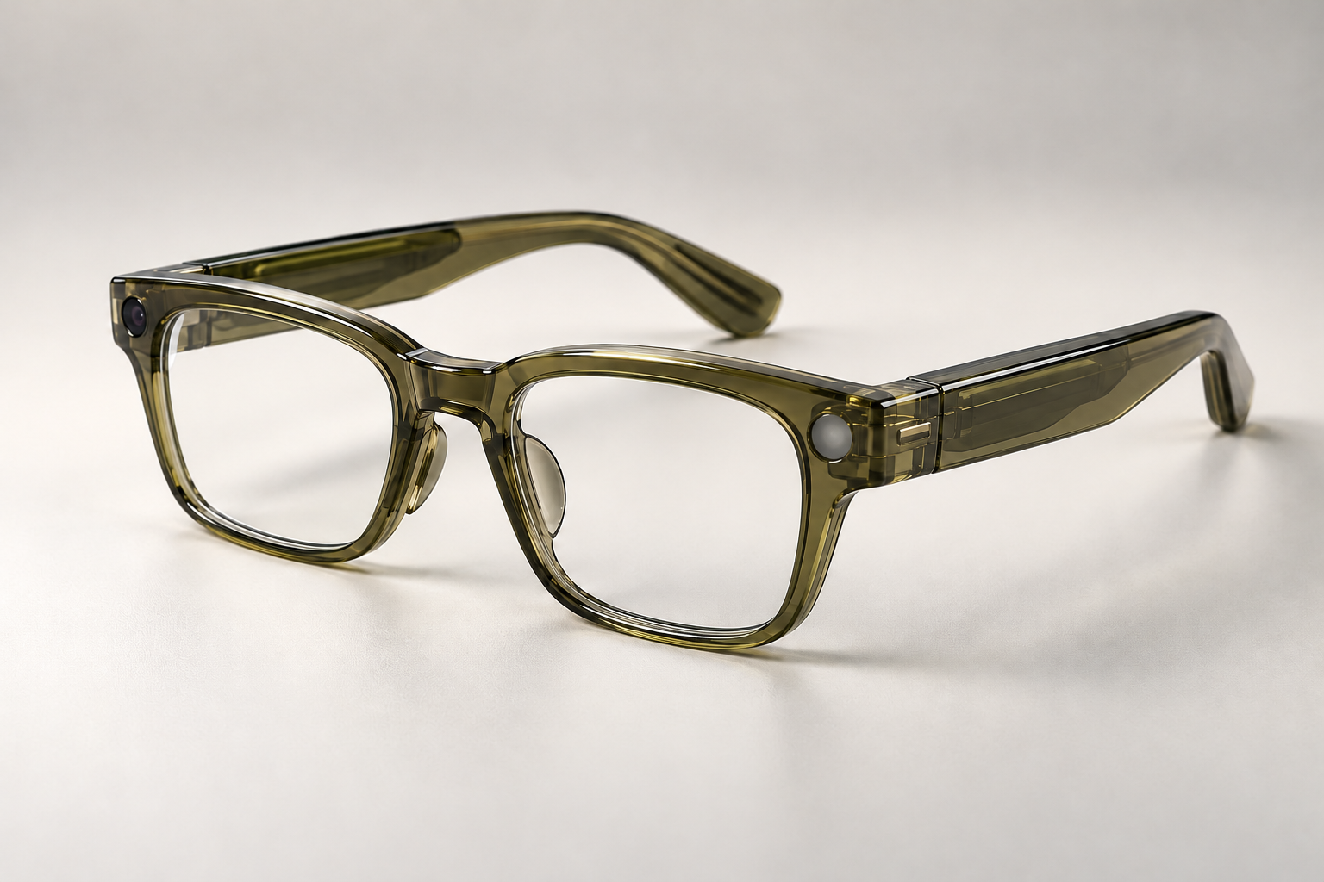
Figure 1-1. Product appearance concept. Illustrates frame appearance, not verified hardware structure.

1.2.2 Main Features
Function | Use and Conditions
First-person imaging | Photos, Live Photo, and video; keep the view clear and follow recording rules.
Open-ear audio and calls | Music, phone calls, and spoken feedback; require the relevant Bluetooth connection and services.
Recording and summaries | Record meetings or learning sessions with transcription, speaker identification, and AI summaries; obtain required consent first.
AI assistance | Voice and visual questions, deep research, and memory features; generally require a phone, network, and valid account.
Vehicle integration | Controls, information, and audio integration for supported vehicles; depend on vehicle, software, account authorization, and region.
Wireless charging case | The case supports USB-C and Qi charging; place the glasses inside to recharge them.
The table links functions to their prerequisites, helping users check phone, network, and vehicle requirements. Capture, audio, and AI in one wearable are key product features.
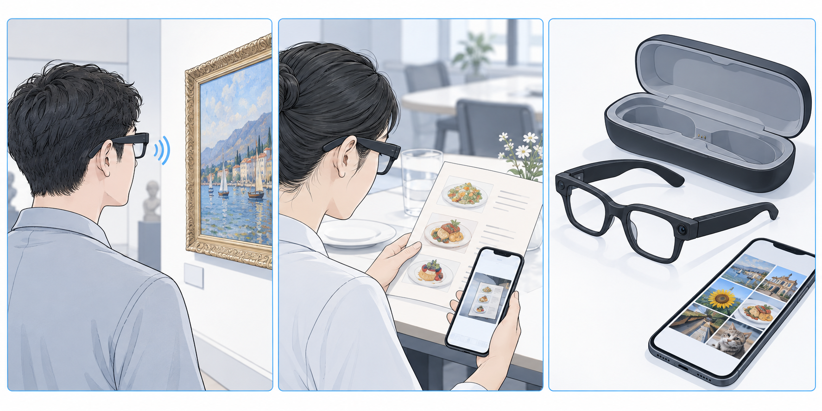
Figure 1-2. Conceptual workflow: capture, spoken assistance, and phone review. AI-generated; not a hardware or verified regional-function reference.
This illustration connects capture, spoken assistance, and phone review to explain the roles of the glasses and phone. Wearable interaction reduces reliance on handheld controls for some tasks, subject to account and regional support.

1.2.3 Intended Use and Limitations
The product is intended for everyday wear, audio communication, personal capture, and AI-assisted information. It is not industrial protective eyewear, a medical device, or a driving decision tool. AI recognition and answers may be incorrect; verify important information independently. Nearby people may hear open-ear audio. The communication manual does not specify a display in the glasses; this manual does not present spoken or phone-based feedback as an AR lens display.

1.2.4 Companion App and Services
Use the companion app for connection and management. The English name is descriptive, not a U.S. listing. Confirm download, accounts, language, and services.

1.3 Components and Package Contents

1.3.1 Package Contents
Check the glasses, included case, and ordered lenses. The source gives no complete packing list; check your order and package for a cable, cloth, pouch, guide, or adapter. Retain packaging and contact the seller for missing or damaged items.

1.3.2 Glasses Overview
The glasses include the frame and lenses, temples, silicone nose pads, titanium-alloy hinges, and components for capture, sound pickup, and audio playback. The three core control areas are the touchpad, recording button, and privacy indicator. Identify these areas before use and keep the camera, indicator, and microphone openings clear. The following original source diagram shows dimensions; it is not a disassembly or modification guide.
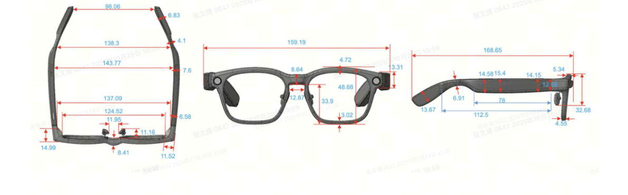
Figure 1-3. Product appearance and dimensions. Source: 1.pdf, page 5; original labels are in millimeters.
The three views help identify shape and dimensions and assess fit before purchase. The 36 g frame-only weight highlights lightweight design; comfort also depends on lenses and facial fit.

1.3.3 Charging Case Overview
The case stores and recharges the glasses via USB-C or Qi. Fit the glasses naturally into the recess; do not squeeze the frame or force the lid. Check the actual ports, contacts, and indicators. No separate pairing key is confirmed; do not use an assumed case-button procedure.

1.3.4 Buttons, Touch Controls, and Status Indicators
Area | Action and Result
Touchpad | Tap: play/pause or answer. Double-tap: next track, end/reject a call, or exit AI. Triple-tap: previous track. Swipe forward/backward: raise/lower volume. Press and hold: wake the assistant.
Recording button | Press once: take a photo. Press twice: start/stop video; during audio recording, stop recording. Press and hold: start audio recording.
Privacy indicator | Steady white during video recording; covering it prevents photos and videos. The source does not list all colors or blinking patterns.
The table maps gestures to functions for convenient operation without checking a phone. Meanings vary by playback, call, and recording state.
NOTE: The same gesture has different uses in different states. Check whether a call, playback, or recording is active before operating. Check the current official instructions for hold duration and feedback.

2. Technical Specifications

2.1 Dimensions, Weight, and Materials
Item | Specification | Source
Frame weight | 36 g (approximately 1.27 oz), frame only, excluding lenses | 1.pdf p.4; 2.pdf p.2
Frame face-width spacing | 134–137 mm (approximately 5.28–5.39 in); approximately 134–136 mm after custom heat bending | 1.pdf p.5
Temple length | Approximately 169 mm (6.65 in); drawing labels 168.85 mm | 1.pdf p.5
Frame material | TR90; titanium-alloy hinges and silicone nose pads | 2.pdf pp.2–3
Finishes | glossy or matte; classic black, tech gray, olive green | 1.pdf p.4; 2.pdf p.4
The table separates frame-only weight from fitting dimensions. TR90, titanium-alloy hinges, and silicone nose pads support the lightweight, fit-oriented design.

2.2 Frame and Lens Options
ZEISS options include non-prescription blue-light-filtering, tinted, photochromic, and prescription lenses, with custom and Superb prescription series. Have a professional confirm prescription, index, and type. The original design targets Chinese facial profiles; try it on and check nose, ear, and temple pressure.
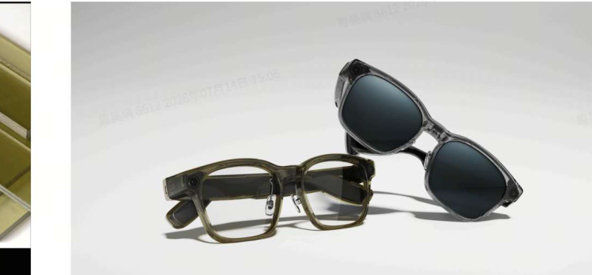
Figure 2-1. Frame colors and appearance examples. Source: 2.pdf, page 4; your purchased configuration may differ.
The image helps compare appearance and lens combinations across black, gray, and olive options. Color and finish do not imply different functions or protection; check the actual order.

2.3 Camera and Imaging Specifications
Item | Specification | Source
Camera | 12 MP, Sony IMX681 | 1.pdf p.7
Optics | 1G+4P; f/2.2; 105° ultra-wide angle | 1.pdf p.7
Photos | 4032 × 3024 pixels | 1.pdf p.7
Video | 1080p / 30 fps; up to 3 minutes per clip | 1.pdf pp.7–8
Stabilization and Live Photo | EIS; approximately 3 seconds of motion, subject to version | 1.pdf pp.7–8
Aspect ratios | 3:4, 4:3, 16:9, 9:16 | 1.pdf p.8
12 MP photos, 1080p video, and EIS support everyday first-person capture. Clip length and aspect ratios help select recording settings; lighting and stability still affect results.

2.4 Audio and Wireless Connectivity
Item | Specification | Source
Audio | open-ear spatial audio, dual-magnetic-circuit speakers | 1.pdf pp.8–9
Microphones | 360° omnidirectional recording; source describes speech pickup within 3 m (9.84 ft) | 1.pdf p.9
Bluetooth | Bluetooth 5.4; up to 2 simultaneous connections and 8 paired-device relationships | 1.pdf p.10; 2.pdf p.1
Open-ear audio and dual-device connectivity support everyday playback and calls. The table distinguishes active connections from retained pairings; eight pairings do not mean eight simultaneous streams.
Noise, distance, and direction affect recording. The source does not specify a Wi-Fi version or storage capacity; no values are assumed.

2.5 Battery and Charging
Item | Source Data | Source
Glasses battery | 240 mAh; graphite-anode battery | 2.pdf p.4
Typical battery life | 18.8 h; varies with use | 1.pdf p.5
Glasses charging | approximately 30 min to 80%; 60 min to 100% | 2.pdf p.4
Case battery | 1700 mAh; approximately 4 full glasses charges | 1.pdf p.7; 2.pdf p.5
Wired case charging | USB-C; approximately 50 min to 80%; 90 min to 100% | 2.pdf p.4
Wireless case charging | Qi; up to 15 W; approximately 2 h 15 min to 80%, 3 h to 100% | 2.pdf p.5
Total video recording time | stated as 41 min, not the per-clip limit | 1.pdf p.8
Separate glasses and case times help plan charging. USB-C and Qi offer alternative charging routes; battery life, video time, and recharge counts must not be added.

2.6 Ingress Protection and Operating Conditions
The glasses are rated IP54, providing limited dust and splash protection rather than complete dust exclusion or immersion protection. Do not swim, shower, or rinse the electronic frame. The source does not state a case ingress-protection rating or operating, charging, and storage temperature ranges. Keep the case dry, avoid excessive heat, condensation, and very cold conditions, and confirm numerical limits from official labeling or instructions.

2.7 Performance Test Conditions
Charging, battery life, and response are typical or laboratory figures affected by temperature, network, and use. For conflicting charging times, this draft follows 2.pdf, pages 4–5. Do not add battery life, video time, and recharge counts.

3. Operating Instructions

3.1 Getting Started

3.1.1 Before You Begin
Check for damage and the correct lenses, then read Section 4. Prepare a compatible phone, account, and stable network. Check official system requirements and U.S. availability; minimum phone OS versions are not specified in the source.

3.1.2 Initial Charging
1. Check that contact areas on the glasses and case are dry and clean.
2. Fold the temples naturally and place the glasses into the shaped recess. Make sure they sit securely; do not force them.
3. Charge the case with a suitable USB-C cable and power source matching its input requirements. Check the actual device or app status rather than assuming unverified indicator colors.
NOTE: Ensure sufficient power for first use; there is no fixed mandatory first-charge duration. Stop charging for unusual heat and follow Section 4.

3.1.3 Installing and Setting Up the Companion App
1. Obtain 理想同学App through a download route provided by Li Auto and check the developer. Do not use an unknown installation package.
2. Read the terms and privacy policy, then sign in or register as prompted.
3. Open the glasses section or device-management entry to add the device. Labels may vary by version.

3.1.4 Connecting and Pairing
1. Enable phone Bluetooth and keep the powered glasses close to the phone.
2. Choose the glasses under Add Device in the app and follow its current instructions to make them discoverable or ready to pair.
3. Check the device name and confirm pairing, including any phone-system Bluetooth request.
4. Wait for the app to show a connection, then test audio or a photo. If Bluetooth connects but the app does not recognize the glasses, use Section 3.6.1.
NOTE: Follow current app guidance for first pairing.

3.1.5 Required Permissions and Account Settings
Grant permissions according to the system and functions you use: Bluetooth or Nearby Devices for connection; Photos or storage for saving media; microphone access when the app needs phone audio; notifications for alerts; location only when a relevant feature requires it. Online AI, services, and updates need network access. Phone-camera permission is distinct from the camera in the glasses. Denying an optional permission need not disable unrelated functions.

3.1.6 Wearing and Adjustment
1. Hold both temples and place the glasses gently on the nose and ears. Check that the frame is stable without uncomfortable pressure.
2. Keep the lenses clear and the camera and indicator unobstructed. Contact a professional if substantial nose-pad or frame adjustment is needed.
3. Take a test photo and review it on the phone to check the view. Do not assume there is a viewfinder in the lenses.
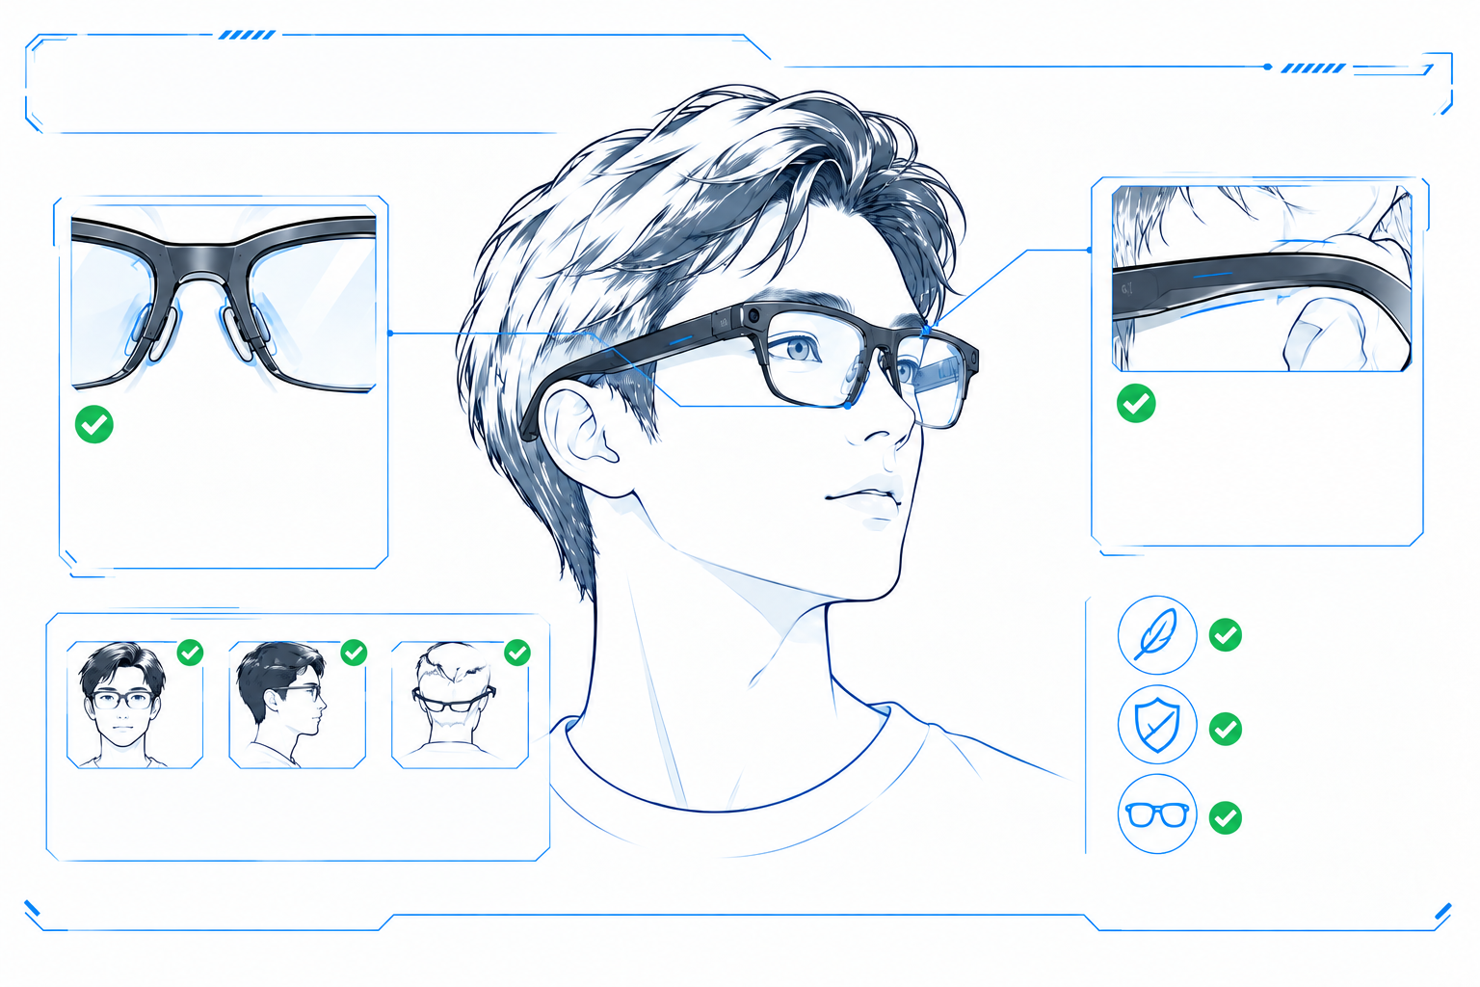
Figure 3-1. Fit checks. Retains the original fit layout: check nose pads, ear support, and stability.

3.1.7 First-Use Checklist
Check | Completion
Connection | App recognizes and connects to the glasses
Fit | Comfortable and stable; camera and indicator clear
Audio | Audible at low volume; tap pauses playback
Capture | Test photo appears in the app after one button press
AI / Assistant | Assistant responds to 理想同学 or a touchpad hold when network and service are available
Privacy | Recording is permitted in the test setting
The checklist verifies connection, fit, audio, capture, and privacy before regular use, helping identify setup issues early.

3.2 Everyday Operation

3.2.1 Button and Touch Control Reference
Distinguish the recording button from the touchpad: the button controls photos, video, and audio recording; the touchpad controls playback, volume, calls, and AI. See Section 3.2.10 for the full reference. A touchpad double-tap is not the same as two recording-button presses.
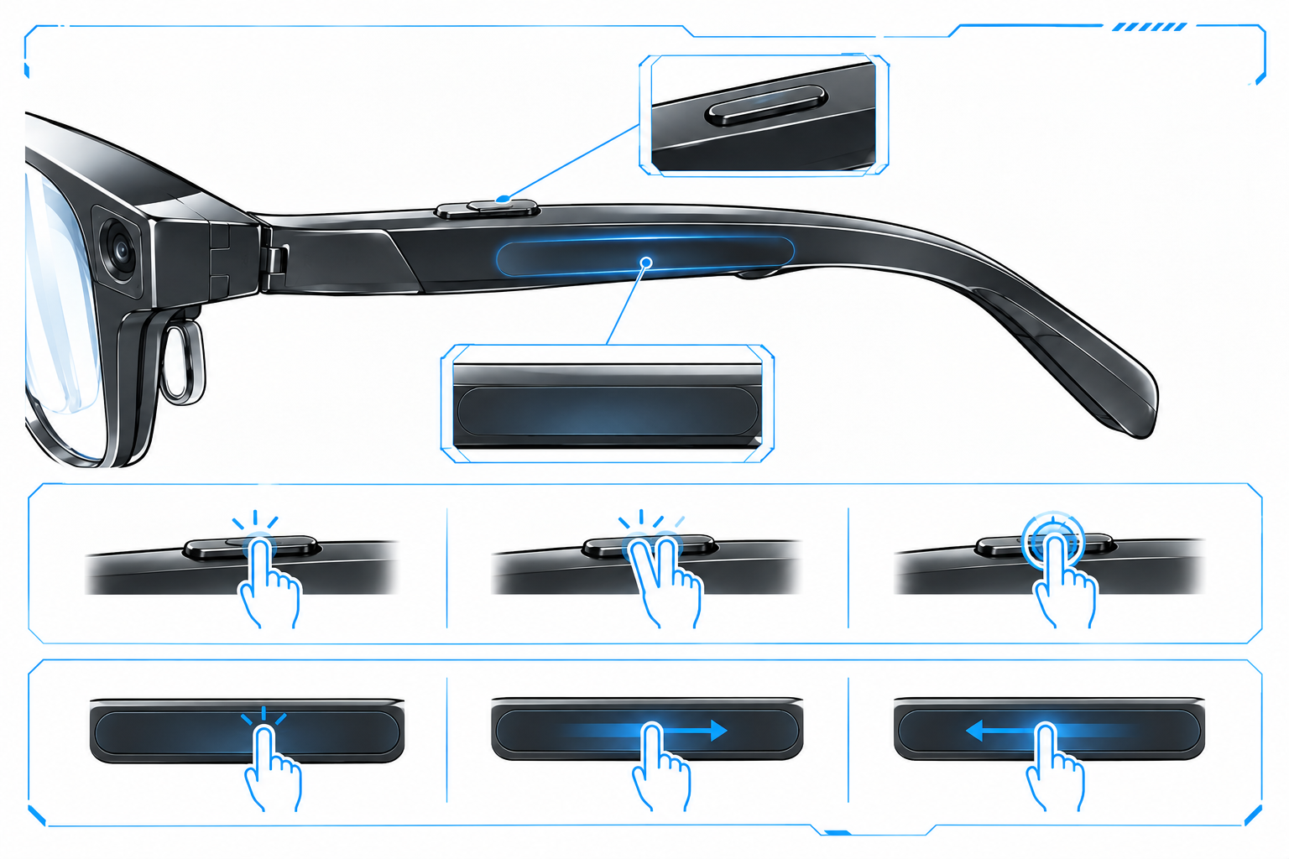
Figure 3-2. Recording button and touch area. Retains the original style; use the control table, not the illustration, for verified operations.

3.2.2 Taking Photos
Before use: sufficient power, clear camera and indicator, and permission to photograph.
Action: hold your head steady and press the recording button once.
Check: find and open the photo in the app to confirm clarity.
Note: obtain required permission for people or sensitive material.

3.2.3 Recording Videos
Before use: adequate power and storage, with a clear privacy indicator.
Action: press the recording button twice to start and twice to stop.
Check: the indicator stays white; open the completed file.
Note: the source maximum is 3 minutes per clip; 41 minutes is a separate total-recording measure.

3.2.4 Recording Audio and Reviewing Recordings
Before use: obtain required consent and keep microphones clear.
Action: hold the recording button to start; press twice during recording to stop.
Check: review the audio, transcript, or summary against the original.
Note: reduce noise; speaker identification, transcription, and action items may be wrong. Confirm start and stop from actual feedback.

3.2.5 Music Playback and Volume Control
Before use: connect an audio source and start playback.
Action: tap to play/pause, double-tap for next, triple-tap for previous; swipe forward/backward for volume up/down.
Check: increase from low to comfortable volume.
Note: confirm regional, account, and rights conditions for NetEase integration; other services may differ.

3.2.6 Receiving and Making Calls
Action: tap to answer, double-tap to reject an incoming call, or double-tap to end an active call.
To call: choose a contact on the phone and select glasses audio; confirm permissions and service before voice dialing.
Note: avoid contact management or complex interactions while driving or in hazardous conditions.

3.2.7 Using the AI Assistant
Before use: ensure a connection and the required account, network, and AI service. Say 理想同学 (Lǐxiǎng Tóngxué) or press and hold the touchpad, then ask clearly. Double-tap the touchpad to exit. For visual questions, keep the subject in the camera view and avoid unrelated people or sensitive information. Responses are spoken or shown on available app pages, depending on version; this manual does not depict an unsupported AR lens interface.
Deep research, AI memory, and recording summaries are assistive features. Verify important facts and use professional sources for medical, legal, financial, or driving matters. The English terminology in this manual does not establish an English wake word or English-language service; check actual language settings.

Figure 3-3. Everyday wear and assistance. Concepts for travel, reading, and conversation; regional services are not verified.

3.2.8 Viewing and Transferring Photos and Videos
1. Connect the glasses and open the media-management entry in the app to find recent captures.
2. Select photos or videos and import, save, or transfer them as prompted; grant the relevant Photos or storage permission.
3. Keep the devices close until transfer completes, then open the files on the phone to verify them. Delete originals only after confirming the backup.
NOTE: Transfer method and speed depend on the current app.

3.2.9 Compatible Devices and Optional Features
The source describes up to two simultaneous connections and eight paired-device relationships. Check audio output and the active connection when switching between a phone and computer. Vehicle controls, a driver-specific audio zone, and task integration require compatible vehicles, software, and account authorization. A planned source release date is not confirmation of delivery. Confirm supported vehicles and services in the United States separately.

3.2.10 Quick Reference Guide
Task | Control | Check
Photo | Press recording button once | Clear camera and indicator
Video | Press twice to start/stop | Steady white during video; source maximum 3 min per clip
Audio recording | Hold to start; press twice during recording to stop | Obtain required consent
Play/pause | Tap touchpad | Audio connected
Tracks | Double-tap next; triple-tap previous | Playback active
Volume | Swipe forward up; backward down | Start low
Calls | Tap answer; double-tap end/reject | Depends on incoming/active state
AI / Assistant | Say 理想同学 or hold touchpad; double-tap exit | Account, network, region supported
Glasses charging | Place dry glasses naturally in case | Confirm charging
Transfer | Import through app media controls | Verify backup before deletion

3.3 Charging and Battery Management

3.3.1 Charging the Glasses
Ensure the glasses and case contact areas are dry and clean. Fold the temples naturally and place the glasses inside without bending the frame or forcing the lid. Confirm charging from the actual device or app status. If charge does not increase, see Section 3.6.2. The source’s typical times are approximately 30 minutes to 80% and 60 minutes to 100% from empty.
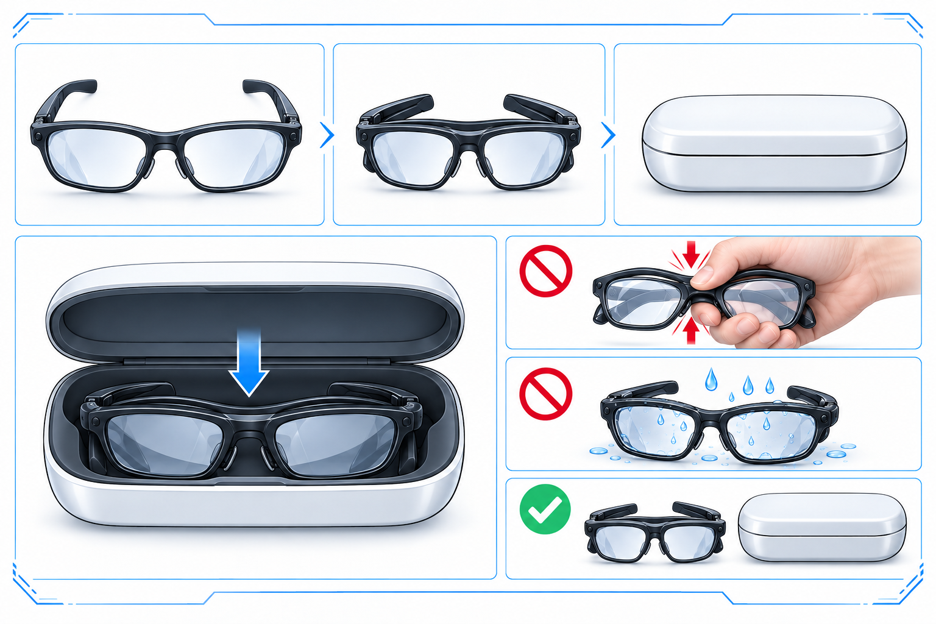
Figure 3-4. Fold temples and store. Fold temples, not the front frame; the case is schematic, so follow the actual recess.

3.3.2 Wired Charging of the Case
Connect a suitable USB-C cable to the case and a power source matching its input requirements. Place it on a dry, stable, ventilated surface without covering it. The dedicated battery section states approximately 50 minutes to 80% and 90 minutes to 100% from empty. Power source, cable, temperature, and battery condition affect results. Check the product label for charging input specifications.

3.3.3 Wireless Charging of the Case
The case supports Qi wireless charging, stated up to 15 W. Position it according to the charger instructions and align it with the charging area. Remove metal or other foreign objects between the devices. Confirm charging and keep the position stable; realign or use wired charging if there is no response. “Up to 15 W” does not require a charger above 15 W or guarantee maximum power in every condition.
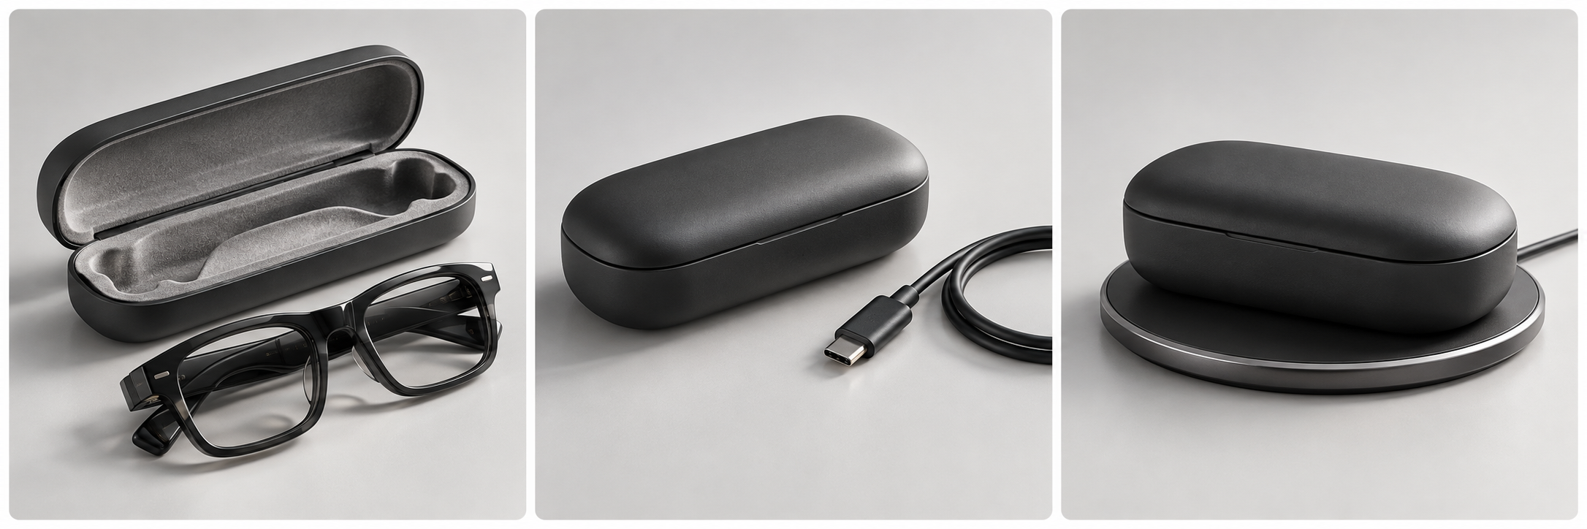
Figure 3-5. Wired and wireless charging concepts. Shows charging choices; the case is a conceptual prop, not a port-location reference.

3.3.4 Checking Battery and Charging Status
Check available battery and charging information in the app; fields vary by version. Confirm indicator meanings officially and do not assume separate percentages for both temples and the case.

3.3.5 Factors Affecting Battery Life
Video, frequent visual questions, higher volume, repeated transfers, weak connections, and extreme temperatures can increase power use. The typical 18.8-hour figure does not guarantee the same duration under continuous heavy load. Check glasses and case charge before a long outing and reduce unnecessary high-load use.

3.3.6 Long-Term Storage
Clean and dry before storing somewhere cool and dry with some charge. Check glasses and case periodically, avoid prolonged depletion, and follow official storage guidance.

3.4 Privacy and Data Use

3.4.1 Photography and Recording Considerations
Check whether photography or recording is allowed before use. Follow rules in hospitals, schools, workplaces, museums, and theaters, and avoid capturing identification, screens, trade secrets, or private activities. An indicator is not a substitute for consent. It stays white during video; covering it prevents photos and video. Do not cover, modify, or bypass it.
Obtain the consent required by applicable law before recording audio. U.S. rules vary by state and circumstances, and interstate conversations may involve more than one jurisdiction. Do not assume your participation alone always permits recording. Follow traffic rules and avoid distraction while driving or cycling.

3.4.2 App Permissions and Personal Data
Manage permissions by function. Applicable privacy policies govern account, memory, and transcript processing and deletion; do not assume local-only processing.
U.S. privacy rights depend on state law, the covered entity, and eligibility. Where applicable, use the official privacy-policy process to request access, correction, deletion, or an opt-out from particular processing. This manual does not guarantee identical rights for every user.

3.4.3 Sharing and Deleting Content
Before sharing photos, videos, recordings, or AI summaries, check for privacy, protected material, and trade secrets. Save any needed originals before deletion. Phone copies, glasses files, app records, and cloud data may be separate; deleting one does not establish deletion everywhere. Review the content and recipients before publishing, and do not present unchecked transcripts or AI summaries as verified facts.

3.4.4 Limitations of AI-Generated Responses
AI may be inaccurate or incomplete because of network conditions, noise, camera angle, recognition, or interpretation errors. Use appropriate professional sources for medical, legal, financial, and safety matters. Verify citations and conclusions in research reports. For vehicle control, navigation, or status, rely on actual conditions and official guidance. Memory and summaries may omit or misremember details; confirm important arrangements yourself.

3.4.5 Preparing for Transfer or Discontinued Use
1. Export needed photos, videos, and recordings, then open the backups to verify them.
2. Use available app functions to delete relevant device and account content, including separate memory, recollection, or cloud controls.
3. Unbind in the app and remove phone or other pairings as officially instructed. If a factory-reset function exists, follow the model-specific official steps.
4. Confirm the device is no longer linked to your account. Ask support if deletion scope is unclear; do not invent a reset key combination. Use an appropriate electronics and battery recycler for disposal.

3.5 Cleaning, Care, and Updates

3.5.1 Cleaning the Lenses and Frame
Remove the glasses from power and the case. Gently lift loose dust with a clean, soft lens cloth; do not rub hard when grit is present. Follow the applicable ZEISS and manufacturer guidance for lens stains rather than applying lens-care methods to the electronic frame. Without explicit guidance, do not rinse, immerse, or spray liquid onto the frame. Wipe with a clean, dry, soft cloth and keep openings and ports dry.
Do not use rough paper, clothing, abrasives, acetone, or strongly acidic or alkaline cleaners. Check manufacturer guidance before using alcohol-containing products on a specific lens coating or frame. Do not remove lenses, temples, or hinges for cleaning.

3.5.2 Caring for Charging Contacts and the Case
Disconnect the cable and remove the case from the wireless charger before cleaning. Wipe accessible charging areas gently with a dry, soft cloth. Avoid metal tools and liquid inside the case. Contact support for corrosion, deformation, or debris that cannot be removed gently. Ensure complete dryness before charging. Keep wireless charging surfaces free of metal and foreign objects and align them correctly.

3.5.3 Carrying and Storage
Use the case to protect lenses and frame when not wearing the glasses, ensuring they are dry first. Keep them away from keys and sharp objects and do not compress the lid. Avoid heat, moisture, direct sun, and heavy dust. Check charge during extended storage under Section 3.3.6. After liquid exposure or strong impact, do not resume charging solely because the exterior looks normal.

3.5.4 Checking for and Installing Updates
1. Connect the glasses and phone, meet the app’s battery requirement, and ensure a stable network.
2. Check for updates in the glasses or device page and read release notes and compatibility conditions.
3. Download and install as prompted. Maintain the connection and avoid capture, unbinding, or deliberately interrupting power during the update.
4. Wait for completion, reconnect or restart if prompted, then test basic capture and audio.
Actual releases determine update timing and new functions. If an update fails, record the error and check connection and network under Section 3.6. Contact support for repeated failures; do not use unofficial firmware or an unverified forced reset.

3.6 Troubleshooting
Check safety first. For unusual heat, swelling, odor, liquid entry, or visible damage, stop under Section 3.6.7. For ordinary functional issues, work through the appropriate table and retest the original issue after each action. Do not repeatedly delete accounts or factory-reset without a diagnosis.

3.6.1 Connection or Pairing Issues
Check | Action
Power | Recharge in the case and check availability
Bluetooth and permissions | Enable Bluetooth and required Nearby Devices access
Distance and interference | Move closer and away from interference
Pairing state | Follow current Add Device guidance, not assumed case-button combinations
Active connections and account | Check the two-active-connection limit and account link; do not erase all pairings unnecessarily
App version | Update and reopen the app
Retest: confirm app recognition and try audio or a photo. If it still fails, restart the app or phone and record system version, device name, and error before requesting support.

3.6.2 Charging Issues
Check | Action
Placement | Fold naturally and reseat without force
Case charge | Charge the case with suitable USB-C equipment
Cable and power | Check compatibility and try an undamaged suitable cable and source
Contacts | Clean with a dry soft cloth; stop for corrosion or deformation
Wireless alignment | Remove objects, realign, or use wired charging
Conditions | Move to moderate, dry conditions without sudden temperature changes
Retest: check actual device or app status and confirm charge increases. Stop for persistent failure, unusual heat, swelling, or odor; do not repeatedly retry charging.

3.6.3 Photo or Video Issues
Check | Action
Indicator obstruction | Clear the privacy indicator; do not cover it
Correct control | One button press for a photo; two to start/stop video
Power and storage | Recharge, check available space, back up before deletion
Image quality | Clean the camera gently, improve lighting, keep steady
Clip limit | Check current duration settings; source states up to 3 min
Software | Confirm applicable updates completed
Retest: capture a photo or short video and open it in the app. Record errors and request support for persistent corruption or capture failure.

3.6.4 Audio or Call Issues
Check | Action
Volume and output | Raise from low volume and select the glasses as phone output
Other devices | Check competing playback and switch output on the source
Connection | Move closer to the source and reduce obstructions
Call pickup | Clear external microphone obstructions and move somewhere quiet
Sound leakage | Lower volume or use a suitable private method for sensitive calls
Retest with a short audio sample or a convenient test call and confirm intelligibility. Do not test faults at maximum volume.

3.6.5 AI Assistant Not Responding
Check | Action
Wake method | Say 理想同学 or hold the touchpad; avoid an unsupported English wake word
Phone connection | Confirm app recognition and required background operation
Network and account | Check network, sign-in, and regional service support
Environment and language | Reduce noise, speak clearly, check supported language
Exit state or version | Wake again and check app/device updates
Retest with a short ordinary question. If audio works but AI does not, distinguish network/service availability from hardware faults and record time and errors for support.

3.6.6 File Synchronization Issues
Check | Action
Connection | Keep devices close with an app connection
Permissions | Grant Photos/storage access needed for import
Free space | Remove verified backups as appropriate and free phone space
Transfer incomplete | Wait for large files to finish; avoid disconnecting
App or file state | Update the app and retry one file; record errors
Retest with one small file and open it before transferring larger files. Do not delete originals until backup integrity is confirmed. Request support if failure persists.

3.6.7 When to Stop Use and Contact Support
Stop use for unusual heat, smoke, swelling, odor, leakage, broken lenses, frame or hinge failure, corroded contacts, major liquid entry, or abnormal behavior after strong impact. Disconnect external power if safe. Do not force a restart or repair it yourself. Persistent ordinary faults also warrant support with the information in Section 5.5. Confirm regional channels rather than assuming a dedicated U.S. service location.

4. Safety Warnings
This chapter contains important safety information for the glasses and case. Read it before charging or wearing them for the first time, and make it available to other users.

4.1 General Safety Precautions
WARNING: Do not disassemble, modify, puncture, or repair the glasses or case yourself. Damage to internal batteries and circuits may cause short circuits, heat, or injury. Avoid drops, pressure, and strong impacts. Stop use and contact support if the structure is damaged or circuits are exposed. Any warranty effect of repair is determined by applicable terms and law; this manual does not replace the warranty policy.

4.2 Wearing and Lens Safety
For prescription-lens replacement or frame adjustment, contact product support or a suitably qualified optical professional. Do not pry out lenses, heat-bend the frame, or open the temples yourself. The product is not industrial impact-protection eyewear and must not be used for chemical splashes, grinding, or strong laser exposure. Stop wearing it if you develop redness, itching, or dizziness; seek medical advice if symptoms persist.
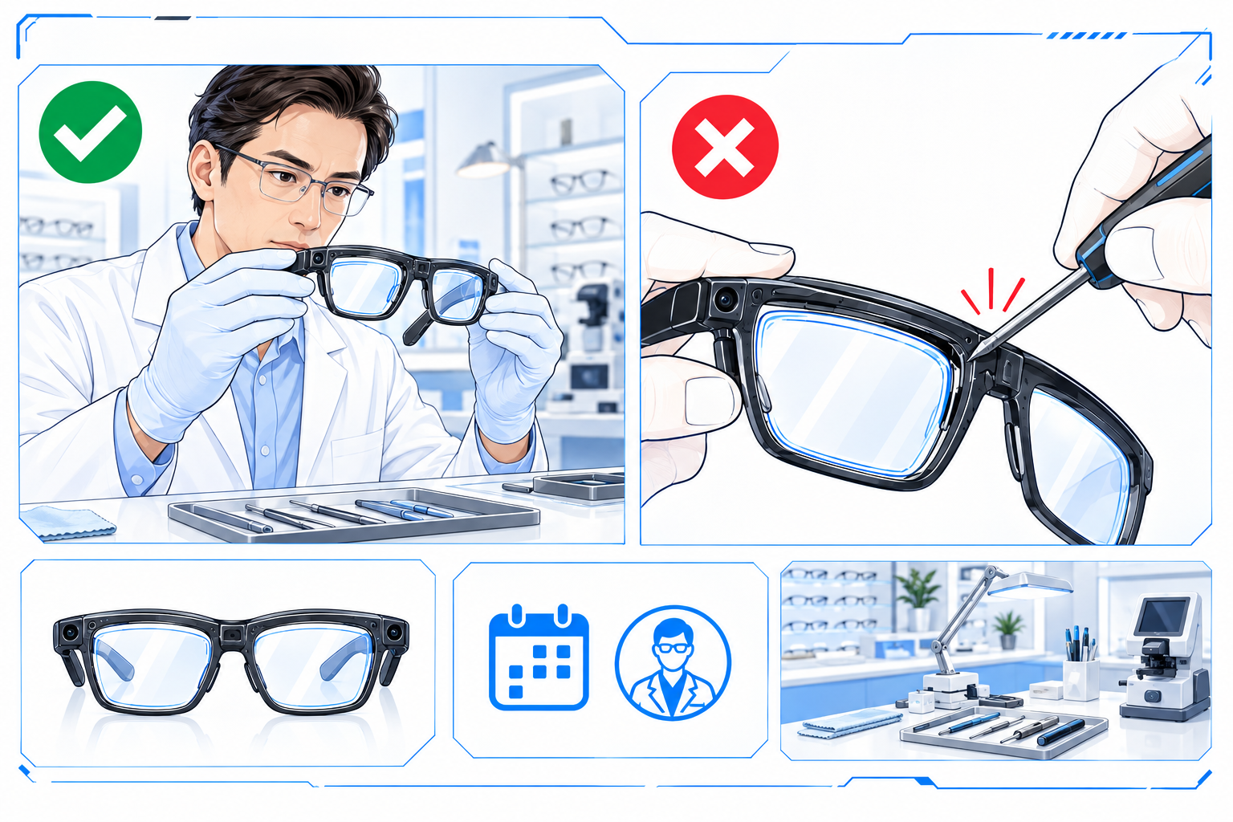
Figure 4-1. Professional lens service. Retains the original comparison style; seek professional service and do not pry lenses.

4.3 Hearing Protection
WARNING: Prolonged high-volume listening may damage hearing. Start at a low volume and increase gradually to a comfortable level. Open-ear audio does not make high-volume use safe; do not keep raising it to mask noise. Pause use if you notice ringing, reduced hearing, or discomfort. Keep volume considerate in public places.

4.4 Driving and Situational Awareness
Stay aware while walking, cycling, driving, or operating machinery, and follow local law. Do not let capture, phone viewing, voice questions, or settings distract you. Stop safely before performing complex tasks. Vehicle integration does not replace the driver’s judgment or official vehicle instructions; confirm command results against the actual vehicle state.

4.5 Battery and Charging Safety
WARNING: Use undamaged charging equipment that matches the labeled input requirements. Do not use damaged cables or charge through wet ports, under coverings, or in poorly ventilated conditions. If you notice unusual heat, smoke, odor, swelling, or deformation, disconnect external power if safe, stop use, and contact support. Do not touch leaking material or try charging again. Move away and contact local emergency services if the hazard cannot be controlled.

4.6 Water, Dust, and Temperature Precautions
IP54 does not mean waterproof or completely dustproof. Avoid immersion, showering, running-water rinsing, heavy sweat accumulation, and dusty work. Wipe moisture away with a soft cloth and let the glasses dry fully before placing them in the case. The source does not publish a case protection rating; keep it dry. Avoid sun-heated vehicles, heat sources, and condensation. If conditions are unsuitable, move indoors and let the device return to a moderate temperature before use or charging.

4.7 Children and Small Parts
WARNING: Keep the product, accessories, and small packaging parts away from young children and pets to prevent swallowing, entanglement, or battery damage. Supervise children, ensure a suitable fit and volume, and explain privacy and safety rules. The communication manual gives no minimum age; this manual does not invent a manufacturer age limit.

4.8 Damage and Abnormal Operation
Stop wearing and charging the product if lenses or temples are broken, unusual heat or odor occurs, liquid has entered, or charging contacts are corroded. Do not glue parts together, clean internally with metal tools, or repeatedly power it to test a fault. Record when and how the issue occurred and request support under Section 5. Routine troubleshooting in Section 3.6 is for ordinary connection or settings issues only.

5. After-Sales Terms

5.1 Scope
This chapter explains service preparation and process; it does not create a U.S. commercial warranty. The source gives no U.S. warranty policy or local service network. Before requesting service, confirm model, seller, and regional eligibility, and obtain the written warranty, returns, and repair terms applicable to the purchase.

5.2 Warranty Period and Coverage
Confirm duration, start date, covered parts, and repair or replacement remedies from verified purchase terms, warranty documentation, and applicable law. Competition materials do not establish a fixed period, free replacement, or universal cross-border coverage. Keep the order, receipt, and supplied terms. A commercial warranty should not be interpreted as removing applicable legal consumer rights.

5.3 Exclusions
The cause of damage may affect commercial coverage, including accident, misuse, liquid damage, unauthorized modification, or normal wear. Applicable terms, assessment, and law determine the result. Do not assume all coverage is void solely because of a third-party accessory or repair; check causation and applicable restrictions. Request reasons, a cost estimate, and an authorization process before paid repair.

5.4 Requesting Service
1. Verify support through purchase documentation, official channels, or an available app entry. Do not send payment details to unknown support contacts.
2. Provide model, purchase details, and fault description and follow official troubleshooting within safe limits.
3. Before shipping, obtain a case number, address, packing instructions, costs, and lithium-battery guidance. Do not independently ship swollen or leaking devices.
4. Back up and handle personal data under Section 3.4.5; service may erase content. If damage prevents deletion, tell support rather than powering a hazardous device to erase it.
5. Review the assessment and authorize the remedy, then check functions and account state when the product returns.

5.5 Information Required for Service
Information | What to Prepare
Product identity | Product name, model, available serial or device ID
Purchase evidence | Date, seller, order number, receipt, and warranty documents
Fault record | Symptoms, first occurrence, frequency, errors, and attempted steps
Versions and conditions | Phone, app, glasses versions, and any liquid/impact exposure
Contact and shipping | Required contact details; never disclose passwords
This table streamlines service requests. Versions, symptoms, and attempted steps help support assess the issue without repeated questions. Do not provide passwords.

5.6 Service Channels and Regional Limitations
Verify eligibility and contacts through official or seller channels. Confirm cross-border service regions, costs, duties, and battery transport; do not extend domestic timing to U.S. service.

5.7 Sources
Specifications and controls follow the designated Livis communication manual, split 1.pdf and 2.pdf. See table page references. Reviewed October 12, 2026.
Images include source dimensions and product photographs plus an AI-generated scene concept. Concept images do not verify component positions, dimensions, or regional service availability. Record AI use accurately in the AI report.

