Illogical dam policy in Japan

Yoshiyasu Takefuji

Typhoon on Oct.12 in 2019 in Japan revealed that the current dam control policy has the fatal defect.

The Shiroyama Dam is a multi-purpose dam on the main stream Sagami River in Sagamihara, Kanagawa Prefecture in Japan. It was designed to provide flood control, and industrial and drinking water to the cities of Yokohama, Kawasaki, Yokosuka, and the Shōnan area where the total capacity is 62,300,000 m³ and catchment area is 1201.3 km².

From Oct. 12, 2019, typhoon #19 has brought a record amount of rain in Japan which was, however, predicted by Japanese weather forecasts. This paper addresses the defect of the current illogical water stream dam policy in Japan. The problem of water streams control dam policy in Japan was discovered by the dataset of inflow and outflow, and reservoir level of Shiroyama Dam in this paper. Note that the lowest reservoir level of Shiroyama Dam is 95m while the maximum reservoir level is 125.5m.

Fig.1 shows inflow and outflow of Shiroyama Dam for 72 hours from Oct. 11, one day before typhoon #19 arrival to Oct. 13, one day after the typhoon #19.

Fig. 2 depicts the reservoir level of Shiroyama Dam for 72 hours from Oct. 11 to Oct. 13 in 2019.

As shown in Fig. 1, the value of total inflow is similar to that of total outflow. The current water strategy in Japan is to keep the same reservoir level of the dam. As long as the amount of outflow is greater than that of inflow, the reservoir level decreases. Contrarily, the amount of outflow is smaller than that of inflow, the reservoir level increases.

Fig. 2 shows the reservoir level of the beginning of Oct.11 is 119m as usual which can deduce that water stream dam policy is to keep the ideal 119m regardless of expected heavy rain. The same policy can be observed in other dams in Japan.

For flood control against the record amount of rain, all dams should be at the lowest reservoir level for minimizing the amount of outflow. For Shiroyama Dam, the reservoir level on Oct. 11 should be 95m instead of 119m. As long as the lowest reservoir level kept in the dams, the minimum outflow from the dams can be achieved for flood control. In the past, many people have died due to the release (outflow) of dams in Japan. The dam control policy should use the latest weather forecasts data.

Author recommends that the current water stream dam policy in Japan should be changed as soon as possible for saving human lives from predictable flood.

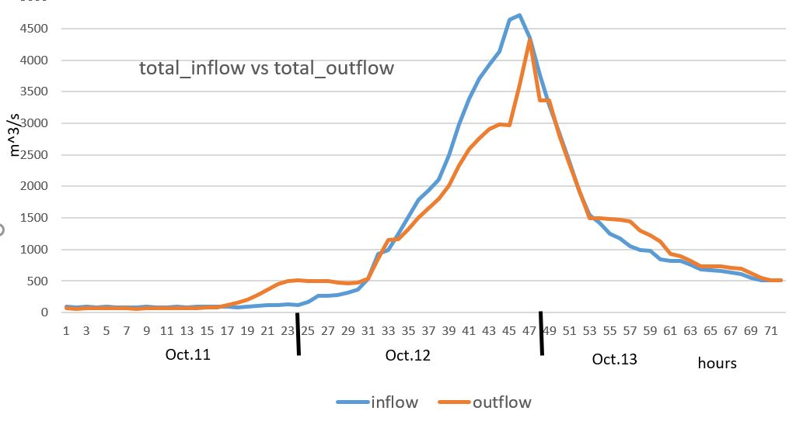
Fig. 1 Total_inflow and Total_outflow of Shiroyama Dam for 72 hours from Oct. 11 to Oct. 13 in 2019

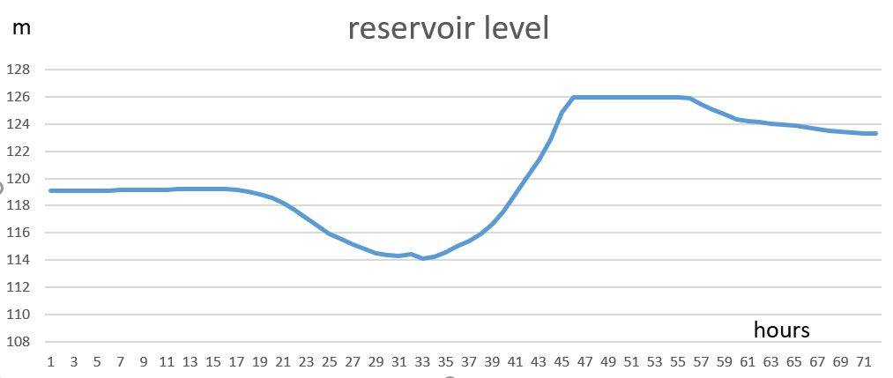
Fig. 2 Reservoir level of Shiroyama Dam for 72 hours from Oct. 11 to Oct. 13 in 2019

References:
- http://www.river.go.jp/kawabou/ipDamPast.do?init=init&obsrvId=0358500700001&gamenId=01-1103&fldCtlParty=no

