Design File:

Software

mouse1.tar composed of 81 files:

<https://github.com/ytakefuji/usb-mouse>

Hardware

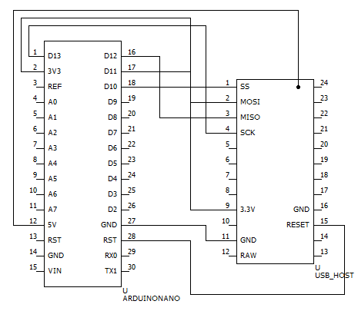

Circuit Diagram of Arduino Nano and mini USB-HOST

SPI connection is established between Arduino Nano and mini USB-HOST.

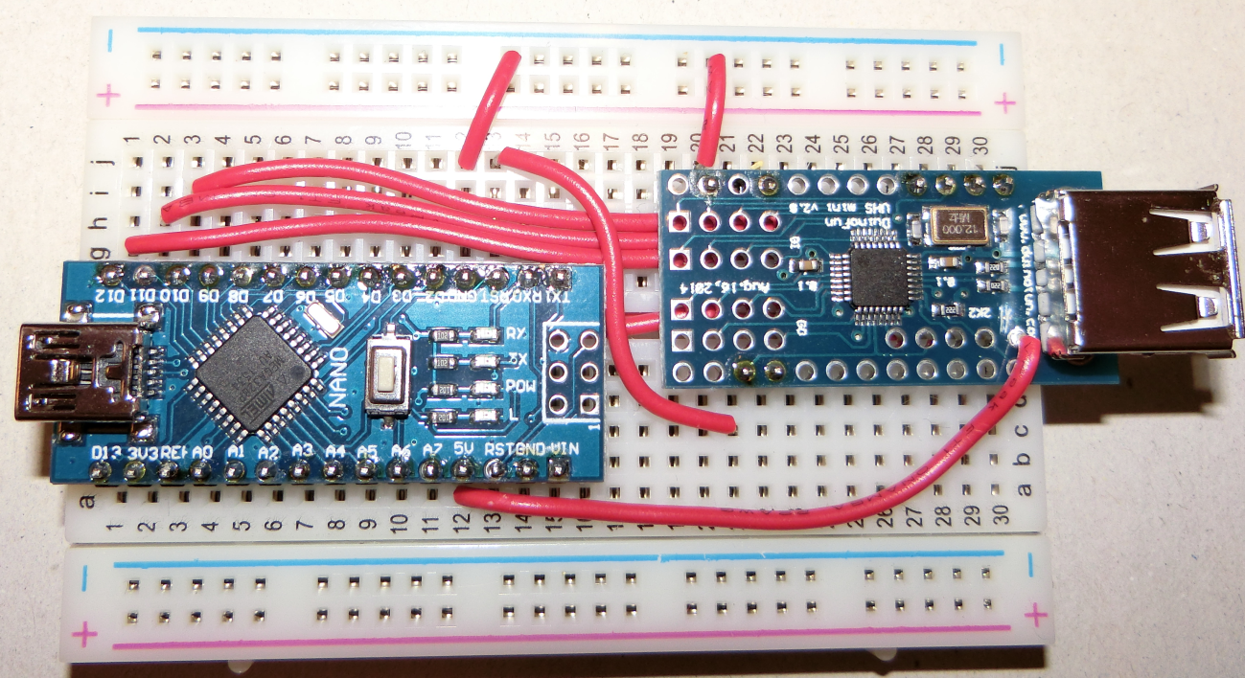

Implemented circuits

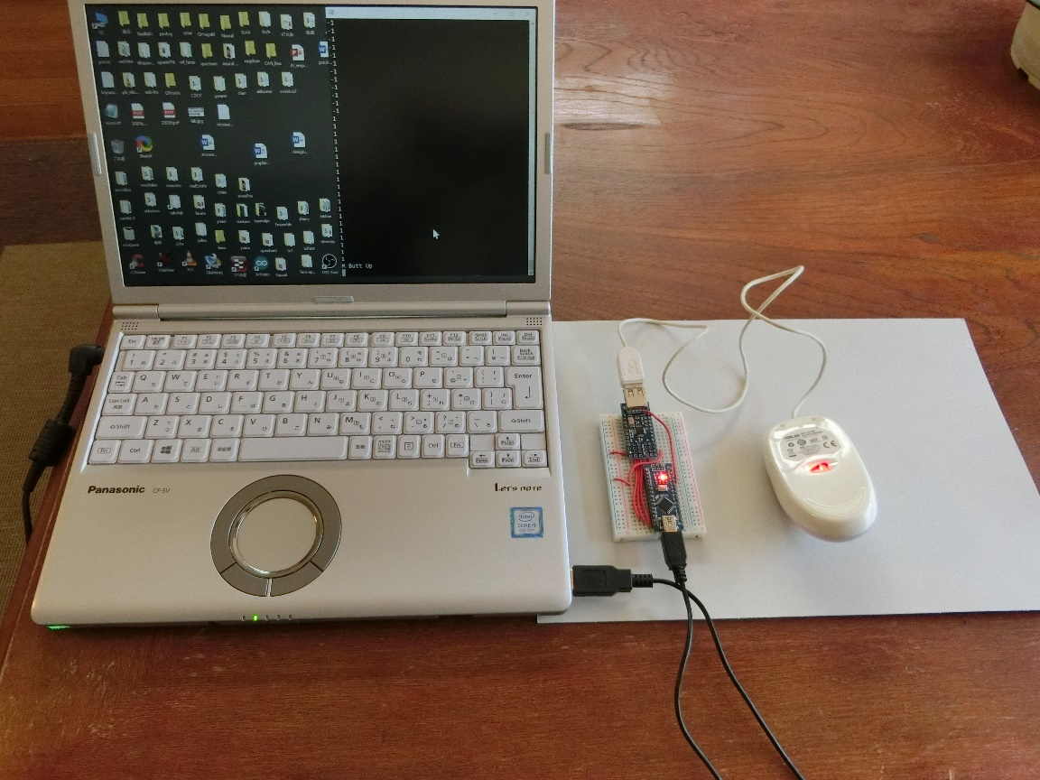

Implemented system