Yoshika Takezawa

CS 558, Computer Vision

Hw2

5/4/19

Code:

# yoshika takezawa

# 5/1/19

# Computer Vision hw2

# I pledge my honor that i have abided by the stevens honor system

# kms -> week 6 pg 10

# slic -> week 6 pg 41

import math

import random

import sys

import numpy as np

import cv2

# given a pixel's bgr values, and the array of centroids,

# will output the index of the shortest distance

def bgr_distance(pix, bgrlist):

# distance funct: sqrt((r-r1)^2+(g-g1)^2+(b-b1)^2)

b, g, r = pix

smallest = 200000

for l in range(len(bgrlist)):

b1, g1, r1 = bgrlist[l]

# temp skips the sqrt b/c we are just comparing

temp = (r-r1)**2+(g-g1)**2+(b-b1)**2

if (temp < smallest):

smallest = temp

index = l

return index

# k means segmentation takes image, randomly selects points as

# initial colors, processes image and colors until convergence

def kmeans(img, k=10):

mean_lst = []

cluster_lst = [[] for _ in range(k)]

rows = img.shape[0]

columns = img.shape[1]

# getting first k unique random samples

while(len(mean_lst) < k):

x = random.randint(0, columns-1)

y = random.randint(0, rows-1)

mean = [img.item(y, x, 0), img.item(y, x, 1), img.item(y, x, 2)]

if (mean in mean_lst):

continue

mean_lst.append(mean)

# iterating through pixels until convergence

while (1):

temp_lst = []

# iterating through pixels

for i in range(columns):

for j in range(rows):

p = [img.item(j, i, 0), img.item(j, i, 1), img.item(j, i, 2)]

ind = bgr_distance(p, mean_lst)

cluster_lst[ind].append(p)

# get mean for all clusters

for c in range(len(cluster_lst)):

temp = [(sum(l)//len(l)) for l in zip(*cluster_lst[c])]

temp_lst.append(temp)

# breaking condition

if np.all(temp_lst == mean_lst):

break

else:

mean_lst = temp_lst

for cl in cluster_lst:

cl.clear()

print(mean_lst)

# setting each pixel to its respective avg cluster color

for n in range(columns):

for m in range(rows):

curbgr = [img.item(m, n, 0), img.item(m, n, 1), img.item(m, n, 2)]

i = bgr_distance(curbgr, mean_lst)

img.itemset((m, n, 0), mean_lst[i][0])

img.itemset((m, n, 1), mean_lst[i][1])

img.itemset((m, n, 2), mean_lst[i][2])

return img

# given an image, square filter matrix and the length,

# outputs the filtered image

def filter(img, fm, len, channel):

height, width = img.shape

# create black image

res = np.zeros((height, width), dtype=img.dtype)

off = len//2

for j in range(off, height-off):

for i in range(off, width-off):

fval = block_sum(img, fm, len, j, i)

res.itemset((j, i), fval)

return res

# using the filtermatrix's weight distribution, adds all the values

def block_sum(img, fm, len, y, x):

total = 0.0

off = len//2

# iterating through each matrix element

for j in range(len):

for i in range(len):

curx = x + i - off

cury = y + j - off

total += img.item(cury, curx) * fm[j][i]

return total

def eudist(pix, clist):

y, x, b, g, r = pix

smallest = -100

index = 0

for l in range(len(clist)):

y1, x1, b1, g1, r1 = clist[l]

# temp skips the sqrt b/c we are just comparing

temp = ((x-x1)/2)**2 + ((y-y1)/2)**2 + (r-r1)**2+(g-g1)**2+(b-b1)**2

if (temp < smallest) | (smallest < 0):

smallest = temp

index = l

return index

def kmeans_5d(img, cent, S):

cluster_lst = [[] for _ in range(len(cent))]

rows = img.shape[0]

columns = img.shape[1]

iter = 0

while (1):

iter += 1

print(cent)

new_cent = []

# iterating through pixels

for i in range(columns):

for j in range(rows):

p = [j, i, img.item(j, i, 0), img.item(

j, i, 1), img.item(j, i, 2)]

# get list of centers within 2Sx2S neighborhood

eligible = []

for w in cent:

if (w[0] in range(p[0]-(2*S), p[0]+(2*S)+1)) & (w[1] in range(p[1]-(2*S), p[1]+(2*S)+1)):

eligible.append(w)

if (eligible == []):

print("hey")

continue

ind = eudist(p, eligible)

cluster_lst[cent.index(eligible[ind])].append(p)

# get mean for all clusters

for cc in range(len(cluster_lst)):

tempt = [(sum(l)//len(l)) for l in zip(*cluster_lst[cc])]

# ty, tx, _,_,_ = tempt

# tempt = [ty, tx, img.item(ty, tx, 0), img.item(ty, tx, 1), img.item(ty, tx, 2)]

new_cent.append(tempt)

# breaking condition, residual error

E = 0

for k in range(len(cent)):

E += abs(cent[k][0]- new_cent[k][0])

E += abs(cent[k][1]- new_cent[k][1])

E += abs(cent[k][2]- new_cent[k][2])

E += abs(cent[k][3]- new_cent[k][3])

E += abs(cent[k][4]- new_cent[k][4])

if np.all(new_cent == cent) | (iter==10) | (E <=15):

break

else:

cent = new_cent.copy()

for cl in cluster_lst:

cl.clear()

# setting each pixel to its respective avg cluster color

for gi in range(len(cluster_lst)):

for pix in cluster_lst[gi]:

py,px,_,_,_ = pix

img.itemset((py,px, 0), cent[gi][2])

img.itemset((py,px, 1), cent[gi][3])

img.itemset((py,px, 2), cent[gi][4])

return img

def SLIC(image, S=50):

height = image.shape[0]

width = image.shape[1]

# initializing centroids in middle of 50x50 blocks

centroids_coords = []

for y in range(S//2, height, S):

for x in range(S//2, width, S):

centroids_coords.append([y, x, image.item(y, x, 0),

image.item(y, x, 1), image.item(y, x, 2)])

# compute bgr gradients and move centroids to the smallest gradient

hsob = [[1, 2, 1],

[0, 0, 0],

[-1, -2, -1]]

vsob = [[1, 0, -1],

[2, 0, -2],

[1, 0, -1]]

# skipped sqrt in B/G/R_comb because will be squared later

B_x = filter(image[:, :, 0], hsob, 3, 0)

B_y = filter(image[:, :, 0], vsob, 3, 0)

B_comb = np.power(B_x, 2.0) + np.power(B_y, 2.0)

G_x = filter(image[:, :, 1], hsob, 3, 1)

G_y = filter(image[:, :, 1], vsob, 3, 1)

G_comb = np.power(G_x, 2.0) + np.power(G_y, 2.0)

R_x = filter(image[:, :, 2], hsob, 3, 2)

R_y = filter(image[:, :, 2], vsob, 3, 2)

R_comb = np.power(R_x, 2.0) + np.power(R_y, 2.0)

combined = B_comb + G_comb + R_comb

# in the 3x3 windows surrounding center, finds smallest gradient

for b in range(S//2, height, S):

for a in range(S//2, width, S):

index = (a//S) + ((b//S)*(width//S))

small_temp = -1

for t in range(b-1,b+2):

for u in range(a-1, a+2):

cur_grad = combined.item(t, u)

if (cur_grad < small_temp) | (small_temp < 0):

small_temp = cur_grad

centroids_coords[index] = [

t, u, image.item(t, u, 0), image.item(t, u, 1), image.item(t, u, 2)]

# use centroids as start for 5d kmeans

kmeans5d = kmeans_5d(image, centroids_coords, S)

return kmeans5d

if __name__ == '__main__':

# k means segamnetation (part 1)

wt_image = cv2.imread("white-tower.png", cv2.IMREAD_COLOR)

seg_result = kmeans(wt_image, 10)

cv2.imwrite('kmeans.png', seg_result)

# # SLIC (part 2)

slic_image = cv2.imread("wt_slic.png", cv2.IMREAD_COLOR)

slic_res = SLIC(slic_image, 50)

cv2.imwrite('slic.png', slic_res)

**K-means Segmentation:**

The k-means algorithm starts by randomly selecting pixels in the photo, extracting its RGB values, and making sure the other values do not coincide with other initial values. This is done to ensure that the initial seeds are within the photo’s color scheme. The program then iterates through the photo and decides which cluster is closest (in RGB values) to each pixel’s values. After the photo is processed, each cluster finds the average RGB value. If the old cluster means match the new means, the loop terminates; otherwise, the process is repeated. This was done in order to ensure that the resulting images would be consistent in respect to the colors

As shown from the photos, the same algorithm results in slightly different photos due to its random nature. Due to the random nature, the runtimes vary greatly such as the first photo taking 7 iterations, whereas the second photo took 23 iterations.

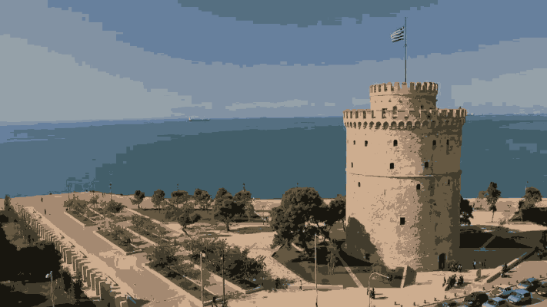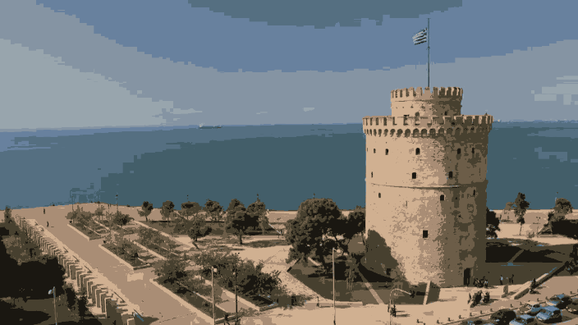

**SLIC:**

The concept behind SLIC is simple, but efficiently implementing it was tricky to handle. Following the algorithm outline from the assignment, centroids were instantiated at the centers of 50x50 blocks. These are later moved to the neighboring pixel with the smallest gradient in all color channels (RGB). The k-means part of the algorithm was modified to take in account of pixel distance and the RBG values. Additionally, once cluster means were decided, I chose to stick with the mean y,x,r,g,b values as opposed to y,x, img(y,x)’s rgb values because it produced stable mean values.

The following is the result of S=50, averaging all the values…

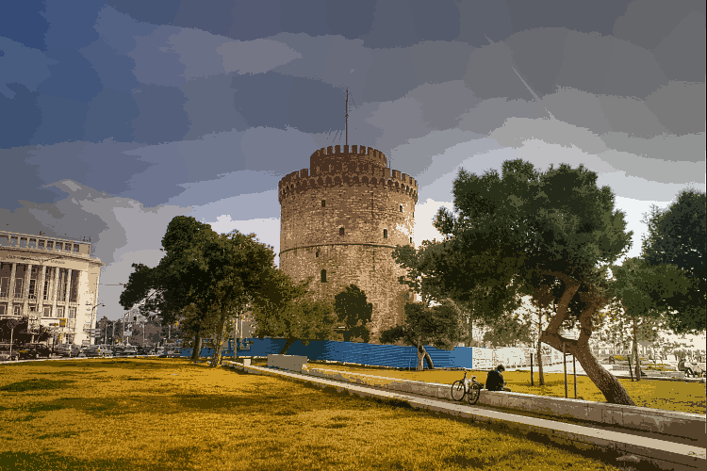

The following is the result of S=50, keeping the mean xy’s rgb values…

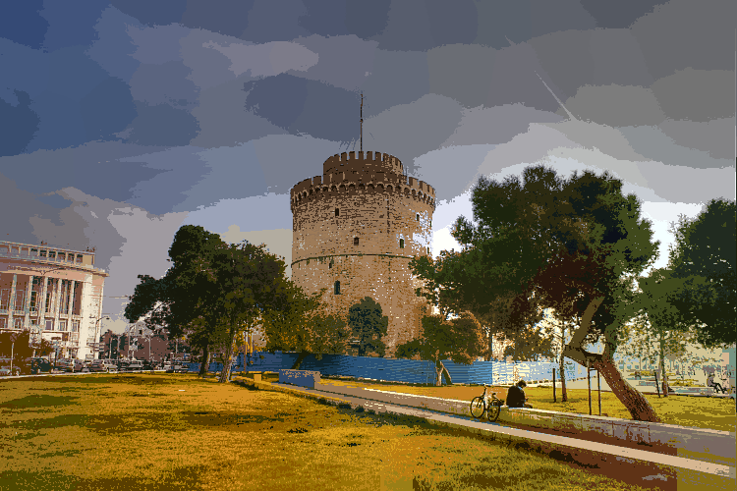

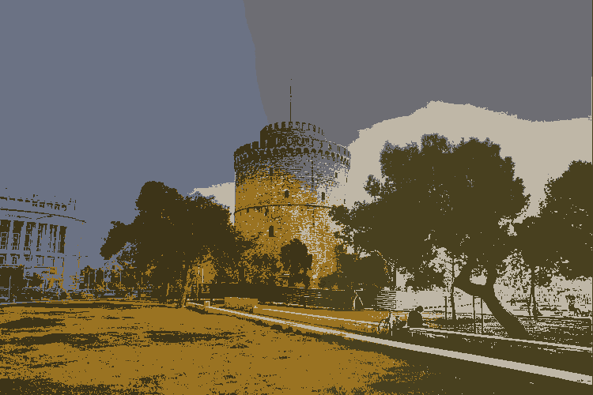The image to the left is the result of S=250.

From the article introducing the SLIC algorithm ([link](https://infoscience.epfl.ch/record/177415/files/Superpixel_PAMI2011-2.pdf)), on page 3, there is a high level implementation of it. I did attempt to replicate it, but even with S=150, the algorithm was too slow to process in a timely manner. (This code is in the zip under hw2_fail.py)

To make the process faster, the photo was iterated, identified which cluster centers were close to the pixel, and 5d Euclidean distance allowed the program to make a final decision on which cluster to go into.