|  |
| --- |
| **Online Education vs Face to Face Education** |

### CEIT111

### 23.01.2022

## PRESENTATION PROS

Muhammed Behlül Uğur 2567659

Yunus Teke 2508638

Muhammed Sinan 2508620

Mert Özen 2508554

Introduction

The amount of online learning available through the Internet and World Wide Web has exploded in the last couple of years. Particularly during the pandemic period, much investment has been made in the online-education sector, and the world has shifted towards online education irreversibly. For this reason, many problems occurred both on the student side and the teacher side. These problems should be determined clearly, and solution proposals should be suggested in the aftermath.

Definitions

Online Education

Online education encompasses all learning that is conducted virtually, in an online environment. It’s basically any type of training that employees or education that students can perform via most of the devices that can connect to the Internet.

Face to Face Education

Face to face education is an education or training that is provided in person whether it is a one-on-one session or in a group setting. This type of learning is stricter when it comes to flexibility. The students need to attend the course accordingly to the schedule.

Online Education

Asynchronous Learning and Synchronous Learning

One of the most important differences between face-to-face education and online education is that face to face education is two-way interaction (a.k.a. synchronous) while online education could be asynchronous.

**Advantages**

* Rapid and effective way of learning
* Comfortable
* Way easier to collaborate with teachers as well as study groups.
* Diversity of instructors.
* Time-saving i.e. time is precious, students and teachers can save their time and energy by not commuting to their schools every workday.
* Suitable for people with disabilities and for people who can’t afford a university degree or a training program.

**Disadvantages**

* Evaluation and measurement are usually inaccurate.
* Some teachers and students want to stay away from online education due to the lack of technical knowledge.
* Technical difficulties may occur occasionally.
* Excessive studying may result in health issues e.g., eyesight problems, spine problems.
* May create a sense of isolation, particularly in asynchronous lessons.

**Online Education Platforms**

Online education platforms have exploded in the last couple of years. Especially during the pandemic period, most employees started to work remotely. Therefore, many educational start-ups have been founded to meet the demand.

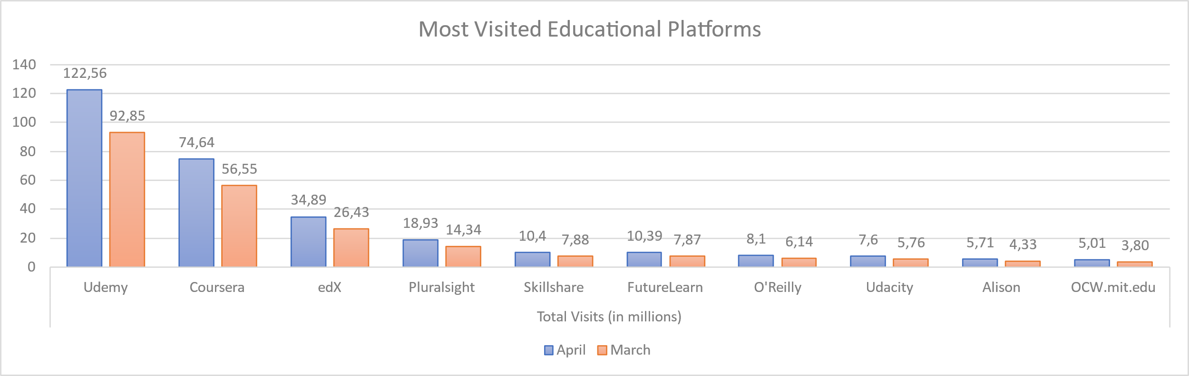

Visual 1. Most Visited Educational Platforms

As it could be seen on the graph e-learning websites has an intense growth during the first months of pandemic.

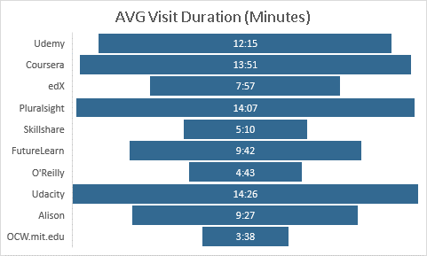

Visual 2. Average Visit Duration on Educational Platforms

Face to Face Education

**Advantages**

* Better interaction between teachers and students.
* More accurate assessment on exams.
* More convenient for social interaction.
* More materials can be used. e.g., labs, projections, experiments.
* Different activities can be provided by institutions.

**Disadvantages**

* May not be suitable for people with disabilities and bad economic backgrounds.
* Students may expend money and time when commuting to work or school.
* Students’ success levels and educational backgrounds may be incompatible with each other, and this may slow down the learning process.