The URL’s that I have found about the use of technology and technology integration:

<https://www.teachthought.com/technology/technology-use-integration/>

https://www.slideshare.net/abnmitch/technology-integration-vs-technology-use-321223

<https://www.educatorstechnology.com/2013/04/using-technology-vs-technology.html>

https://nces.ed.gov/pubs2003/tech_schools/chapter7.asp

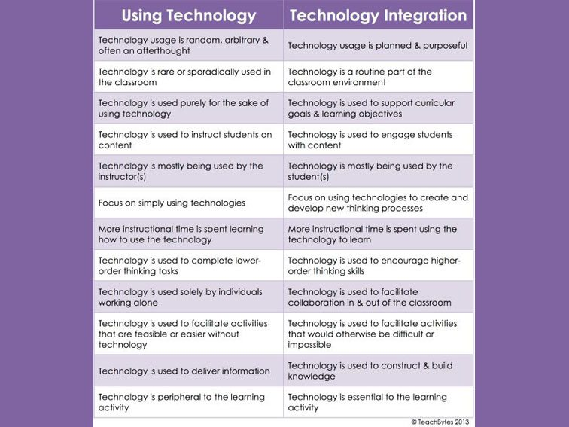

With the research I have done, I understand the difference between technology usage and technology integration. Technology usage is something that people are always doing as long as the technology is around them, basically using it, and it can be about anything; but the integration of technology has a purpose and must be planned. Also, Technology integration differs from technology usage by being more instructional in any case. For example, students are using their smartphones to text someone or call someone or smurf on the Internet, but when it comes to doing homework on the smartphone, it is called technology integration.

The URL’s that I have found about the examples of technology usage and integration:

<https://www.indiatoday.in/education-today/jobs-and-careers/story/10-uses-of-technology-in-21st-century-jobs-1358394-2018-10-08>

<https://study.com/academy/lesson/examples-of-technology-in-our-everyday-world.html>

<https://www.edutopia.org/technology-integration-guide-description>

https://edtechreview.in/trends-insights/insights/3424-5-ways-teachers-are-integrating-technology-into-the-classroom