Individual Project

Yunus TEKE

2508638

Computer Education and Instuctional Education Departmant

In the Individual Project, I am planning to code three web pages in which I explain some crypto market formations, trading strategies, and technical-fundamental analysis.

On the index page, I will be explaining the cryptocurrency trading strategies. There will be hyperlinks on the page that will be used to go to the other pages. I decided to use a table tag on the pages to place the contents where I wanted them.

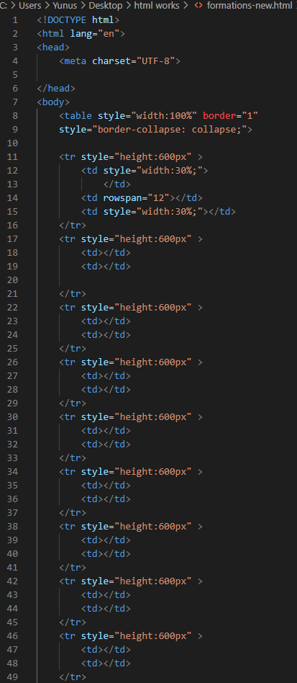

I have created a table, as seen in the image on the right. This table is supposed to have three columns and about 11 rows. The middle column was supposed to be empty, so I was going to write the content there. I emptied the middle column with the <rowspan> tag, and the draft of my webpage was set.

Since the articles on the web page will be relatively long, I want to make a table of contents so that people searching the web page for specific information can easily find what they are looking for.

For this, I use the <ul> and <li> listing commands that we learned earlier in the lesson. I use hyperlinks to jump to the subject title when I click on the subject titles I have listed.

metin içeren bir resim

Açıklama otomatik olarak oluşturuldu After specifying the topic titles, filling in the content on the first page, and setting up the table of contents, my first page was almost done. Then I adjusted the paragraph spacing, margins, heights, and colors on the page using CSS.

I designed the same table to code the other pages as well. While filling the web pages, I used a lot of Internet articles.

After I finished coding and designing the pages, I wanted to put a homepage button to make it easier to return to the main page (trading strategies) on the web pages where I explained the formations and technical analysis. I placed this button at the bottom right of the page with the help of CSS and HTML style tags.

That was it. I successfully created three web pages related to each other with hyperlinks.

**References**

*https://stackoverflow.com/questions/21671292/aligning-text-to-bottom-left-corner-inside-a-styled-element*

*https://www.freecodecamp.org/learn/responsive-web-design/basic-html-and-html5/create-a-bulleted-unordered-list*

*https://cryptopotato.com/crypto-technical-analysis-head-and-shoulders-pattern-triangles-and-wedges/*

*https://academy.binance.com/en/articles/what-is-technical-analysis*

*https://academy.binance.com/en/articles?page=1*