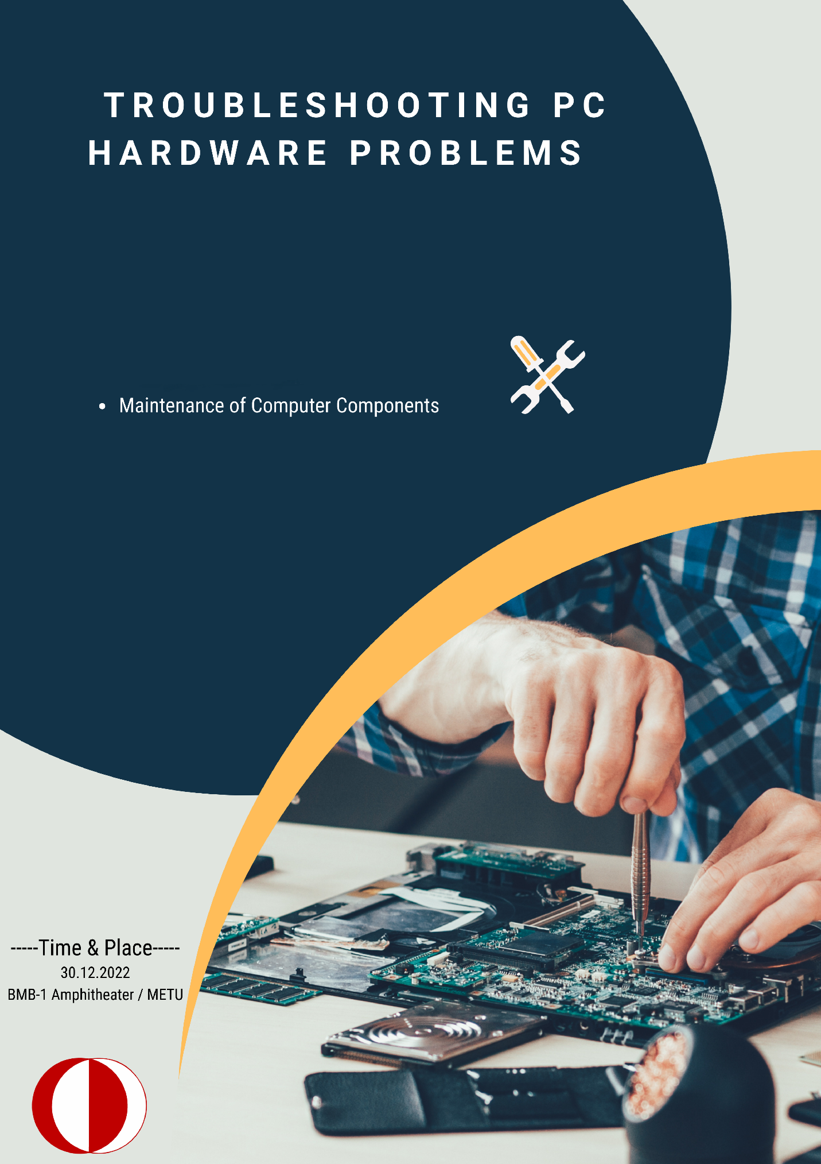

# Introduction

In this textbook, we will be discussing the maintenance of different components of a computer's hardware. The most basic one is case maintenance. The most harder one is cleaning the power supply’s inside. This workbook also includes the following components’ maintenance: Central Processing Unit(CPU), Graphics processing unit (GPU), Cpu fan, GPU fan, Random Access Memories, Power Supply and Case, motherboard, and other components in the case. In order to maintain your components for a long time, you have to clean your components. So in this textbook, you will find various tips for cleaning your computer.

## Table of Contents

* Case Cleaning and Dismounting the Components
* Motherboard Cleaning
* Dismounting the Central Process Unit (CPU) and Cleaning
* Cleaning the Graphical Processing Unit (GPU)
* Cleaning the Random Access Memory (RAM)
* Cleaning the Hard Disk and Solid State Drive
* Cleaning the Power Supply

# Case Cleaning and Dismounting the Components

The case is the outer shell of the computer that houses and protects all of the other components. So in order to clean the case, we have to open the case and empty it. Starting with the Cpu fan, all motherboard and its components must be dismounted one by one.

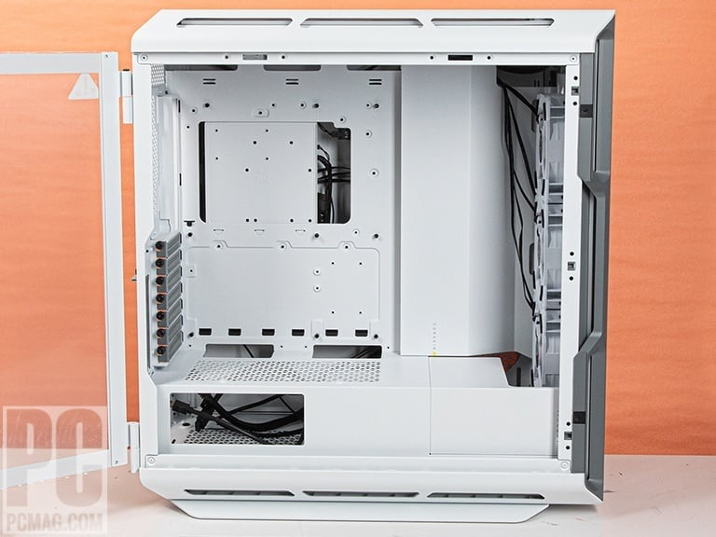

After dismounting all the components, you can just wash all the case and wait for it to dry up. After dismounting all the components, you can just wash all the case and wait for it to dry up. Do not clean the case before plugging off the cables in here.

.

# **Motherboard Cleaning**

The motherboard is the main circuit board in a computer and is responsible for connecting all of the other hardware components together. It contains sockets for all other components. While cleaning it, you should be starting with unplugging the every cable and component connected to it. You should take the visible dust which you can take with your hands, if there is any. Unplug the power cable comes from the powersupply first. Then, unplug every component inside the case.

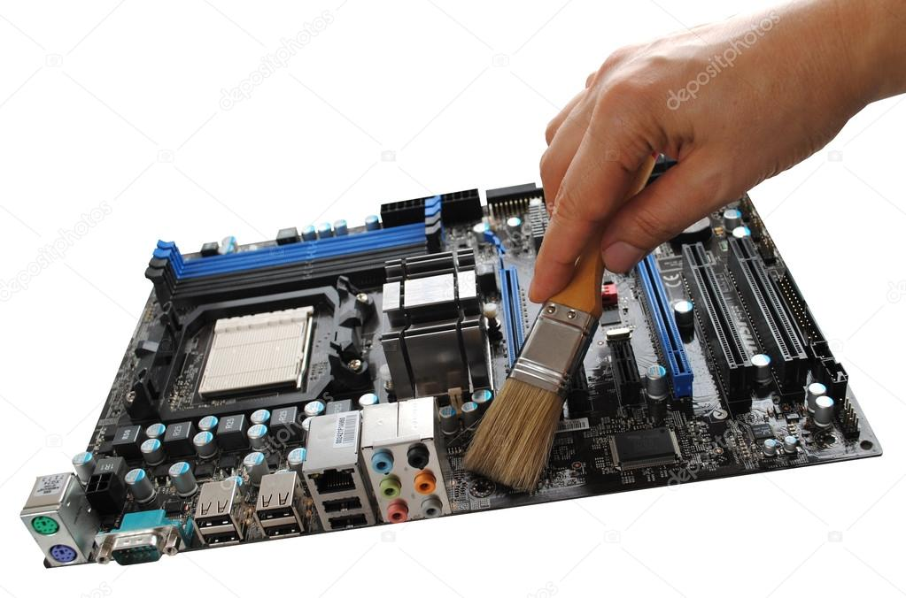:

.

You can always use a brush like in the photo left. They do not harm the components.

Isopropyl alcohol is oftenly used for cleaning electronics. If motherboard is so dirty and brush does not help, you may consider a isopropyl alcohol bath for your motherboard. Just make sure it is dry before powering it.

## Central Process Unit (CPU) Maintenance

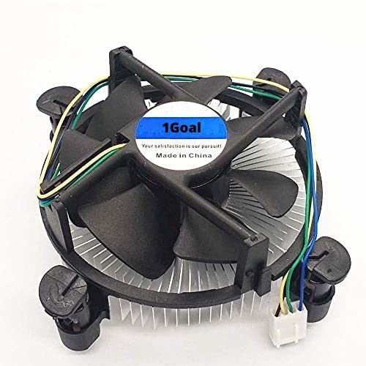The CPU, or central processing unit, is the brain of the computer. You should unplug the Cpu but in order to unplug the cpu, you should unplug the fan first. With a screwdriver, dismount four bolts at the corners of the fan. After dismounting the fan, you can now take the Cpu out of its socket. Usually Cpu does not require any cleaning but if there is any dust or thermal paste on the cpu, clean it with a cloth dipped in isopropyl alcohol. Isopropyl alcohol does not damage the most of the components. So we are goint to use it a lot but if you do not have any isopropyl alcohol, you can you use dry cloth or a air blower spray to clean the dust out of components like the CPU fan.

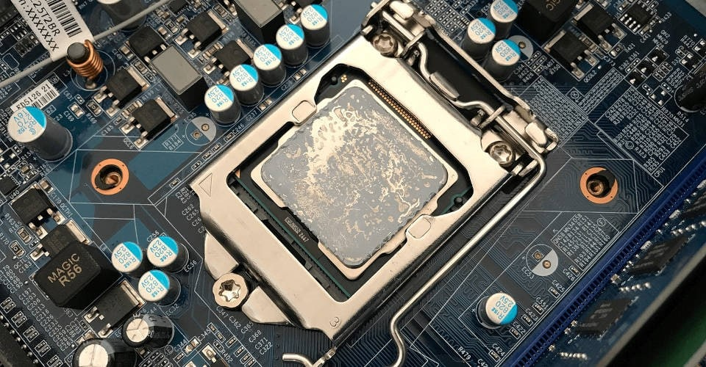Thermal paste is used for transfering the heat over CPU to CPU fan to cool the CPU. So it is very important for maintanence of your computer. You should do a research and buy the most trustworth thermal paste for your computer.

You may want to clean the old thermal paste residues first before putting a new thermal paste.

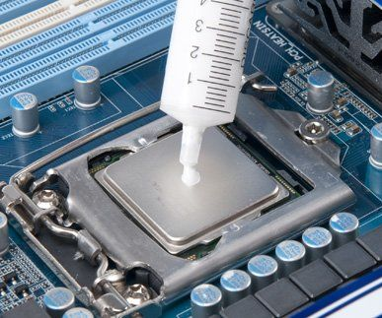

After cleaning the old paste, put a little dot on the CPU and spread it over the CPU. Be careful not to spread down the sides. You can use a paper to spread the paste onto the CPU.

## Graphical Process Unit (GPU) Maintenance

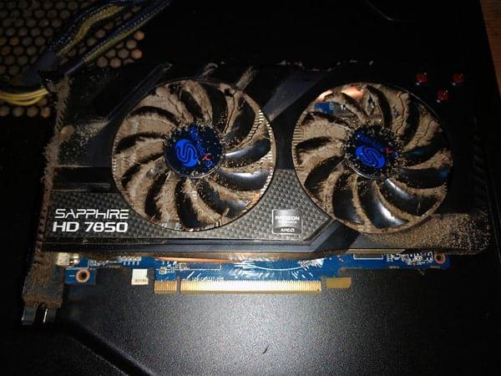

Gpu maintenance can be tricky. You may encounter the visible dust inside the fans of the GPU and afraid of breaking the fans while cleaning. You do not need to be afraid of because they can be dismountable too.

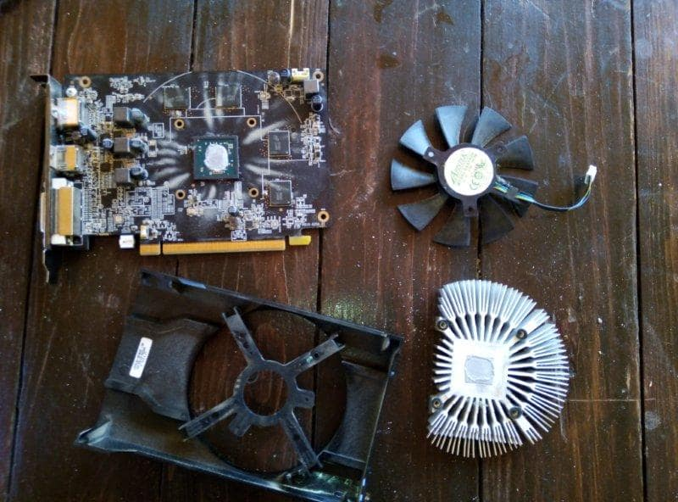All GPUs basically be formed of two components. The cards itself and the cooler block which contains the fans. The fan has a plug on the card. You should unplug it from the GPU. Then turn around the card and find four bolts exactly like you did on the CPU fan. Dismount them with a screwdriver and now you have succesfully dismount the GPU from its cooler block. You can now easily clean the fans with a airblower sprey or a brush. Gpu usually does not require any thermal past renewing but if its dry on the chipset of the GPU, you should put a little bit of thermal paste before gathering the GPU into one piece again.

## Random Access Memory (RAM) Maintenance

Random Access Memories usually does nor require any cleaning because there is no fan on them so they do not pull the dust to themselves. But even if they do not, they might still get dirty and in the longterm it can be damage the component. They can be cleaned in the same way other components does. RAMs has joints which goes in Memory Slots. This joints are what is important but you may want to clean the memory blocks on the RAM if there is visible dust.

You can clean the RAMs like the image below if you have the sticks using isopropyl alcohol.

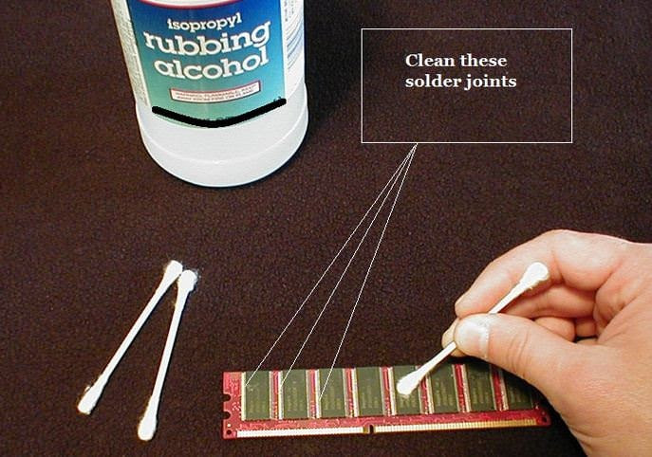

## Hard Disk (HDD) and Solid State Drive (SSD) Maintenance

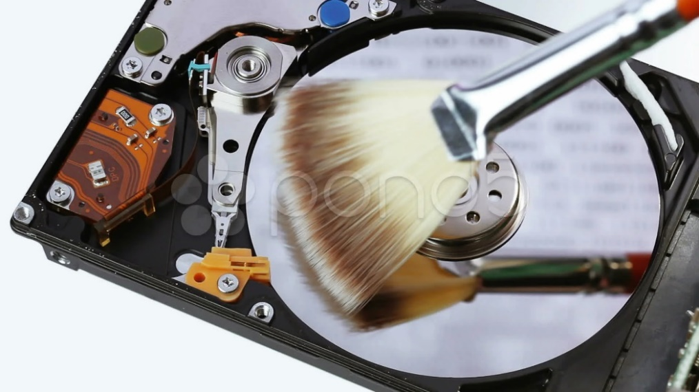

Firstly, hard drives does not require harsh cleaning usually. Just dismounting them and cleaning the visible dust at the SATA connection port is enough for cleaning the hard disk, but if you want; you can open the hard drive’s cover and clean disk very carefully in order not to stratch it. If you do, your data may be lost forever.

Same rules counts for the sata SSDs, but they cannot be open because SSDs does not have a disk in them.

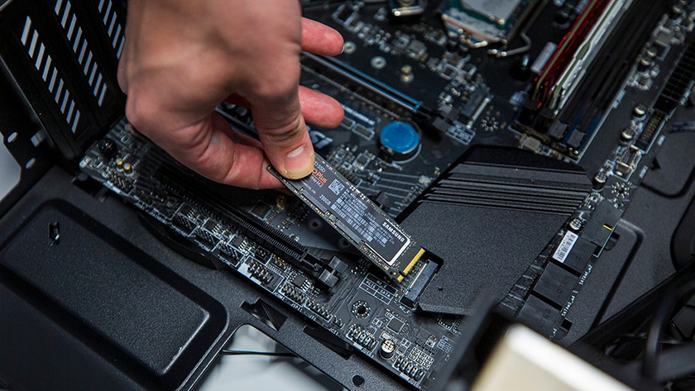M2. SSDs are different. They do not have bigger sizes like HDDs and Sata SSDs. It is because they do not need cleaning on their own. They sometimes heat but they do not need cooling. Some motherboards has passive cooler on them, if you do, you can clean the passive cooler just dismounting and lying it into the isopropyl alcohol.

## Power Supply (PSU) Maintenance

The power supply is a hardware component that provides electricity to all of the other components. It is usually located in the case and is responsible for converting AC power from the wall outlet into DC power that can be used by the computer. So it is tricky to clean. After cleaning, the tiniest wetness on the PSU can be lead your computer to its death. So, be careful with cleaning inside it.

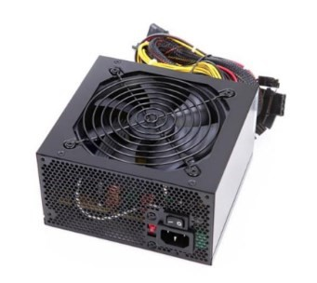

I do not recommend any of cleaning with fluids because it may be damage the power supply later. First you need to use a screwdriver to open the case of the PSU. You can use a brush if there is visible dust. Be gentle with the brush, you may damage the transistors inside the Power Supply otherwise.