**CEIT 207 Design and Use of Instructional Material**

**Fall 2022**

**Term Project Documentation - Final Report**

**Learner Analysis**

* **Identify general characteristics of your learners (Include information about the Piaget’s stages of cognitive development for you age group)**
  + **According to Piaget’s stages, our students fit into the formal operational stage. The formal operational stage of cognitive development occurs during adolescence and continues into adulthood. At this point, individuals are able to think abstractly and manipulate ideas in their mind without needing to rely on concrete physical objects.**
  + **Our students will be Turkish high school students, approximately 14-18 years old.**
* **Identify specific entry competencies of your learners**

1. **The ability to use the basic toolbox ( screwdriver etc.)**
2. **The ability to identify input and output ports on a motherboard**
3. **Compelling desire for learning**
4. **Interest in mechanics**

* **Identify learning styles of learners**

**o According to Gardner’s learning style: Linguistic-Verbal/Mathematical-Logical/Intrapersonal.**

* **Linguistic intelligence: People with strong linguistic intelligence are skilled at using language to communicate and express themselves. They may excel at writing, public speaking, and learning new languages. Examples of careers that may utilize linguistic intelligence include writers, journalists, and lawyers.**
* **Logical-mathematical intelligence: People with strong logical-mathematical intelligence are good at thinking logically and solving problems using math. They may excel at scientific and mathematical subjects, and may be drawn to careers in fields such as computer science or engineering.**
* **Intrapersonal intelligence: People with strong intrapersonal intelligence are skilled at understanding and introspectively analyzing their own thoughts and feelings. They may excel at self-reflection and self-motivation, and may be drawn to careers such as therapists or spiritual leaders.**

**o According to Gregorc’s learning style: Concrete sequential/Abstract sequential**

**o According to Kolbs’ learning style: Converging.**

* **Concrete sequential learning style refers to a preference for learning in a step-by-step, linear fashion using concrete, observable data. People with a concrete sequential learning style may prefer to learn through hands-on, experiential activities that involve manipulating physical objects or following clear procedures. They may be more comfortable with learning material that is presented in a structured, orderly way.**

**Examples of activities that might be particularly well-suited for someone with a concrete sequential learning style include:**

**Following a recipe to cook a meal**

**Building a model or puzzle**

* **Abstract sequential learning style refers to a preference for learning in a step-by-step, linear fashion using abstract, conceptual ideas. People with an abstract sequential learning style may prefer to learn through reading, writing, and thinking about ideas rather than through hands-on activities. They may be more comfortable with learning material that is presented in a logical, organized way.**
  1. **Examples of activities that might be particularly well-suited for someone with an abstract sequential learning style include:**

**Reading a textbook or a set of instructions and completing related activities or exercises.**

**Content Analysis**

* **State the main topics and the sub-topics you included in your instruction. Present these chunks logically in a task tree or concept map.**

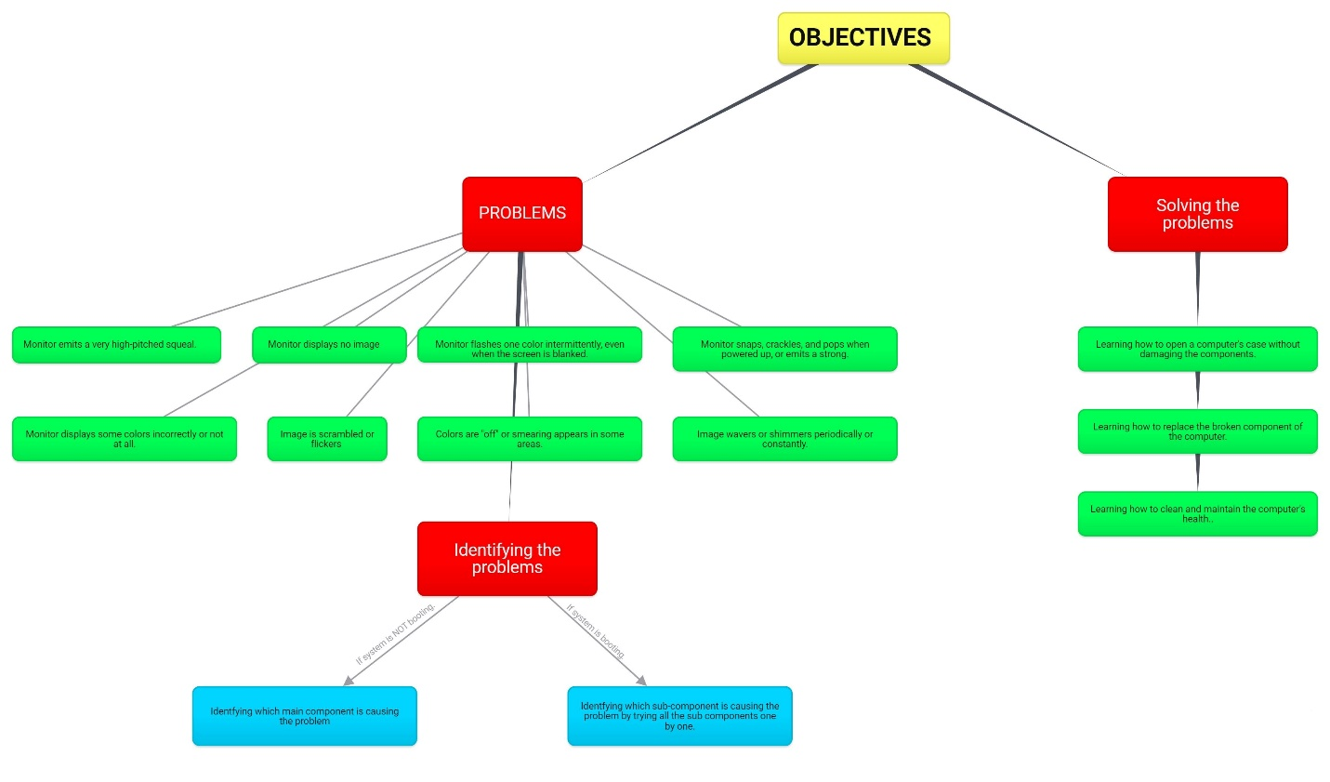

* **Write your instructional goal & objectives**
  + How to detect a problem on a computer
    - Basics of computer mechanics
    - Learners will demonstrate knowledge of how to check if the system boots or not without its battery connected.
      * If it does not boot, check what is not working according to the error message of BIOS (Cpu, Gpu, Ram, Hard-Disk, motherboard)
      * Learners will learn to check all sub-parts of the computer to identify the problematic component
  + How to fix basic mechanical problems on a computer
    - Learners will demonstrate how to open a laptop’s main case without damaging the computer
    - Learners will learn illustrate how to replace mechanical parts of a laptop and desktop computers.
    - Learners will show how to clean and maintain the computer’s health.

**Design**

* **Explain the instructional strategies (teacher-centered or/and student-centered) that you will use in your lesson.**

We are planning to use both instructional strategies. However, we will be mainly instructing with a teacher-centered method, for instance, showing how to change the broken RAMs in a computer’s motherboard to the students. Only showing how to do such activities will not be enough for students to understand the concepts. Therefore, in lab sessions, students will be applying the concepts they have learned in the lectures in front of the teacher. So the lab sessions will be more student-centered.

In conclusion, the teacher-centered applications we are going to use are presentation, demonstration, and tutorials; the student-centered applications we will use are discussion, cooperative learning, simulation, discovery, and problem-solving**.**

* **Present the context that the instruction you design will take place. How will be the learning environment?**

Firstly, our main teaching environment will be a class. The class will have at least 20 seats, one seat for every student. The class must have at least three computers, one desktop, one laptop to disassemble, and one computer to show the presentation.

Secondly, in our lab sessions, students will be applying the concepts they have learned in the classes. For example, in class, they learned how to clean a desktop case’s inside to lower the temperatures. There will be two lab sessions in which students will be divided into two and every student will be accepted in only one lab session. Thus, in the lab session, the teacher will be providing 5 computers for 10 students in each lab session (one computer for two students) so that they can apply the concepts. Also, the teacher should provide toolboxes to the students.

Thirdly, online text and video metarials will be provided to the students in order not to forget the concepts. In addition to those metarials, class presentations will also be provided to students.

* **Explain how you are going to implement/use the materials in instructional settings. Describe the actual sequence of events/activities/materials that make up your instruction.**

***Learners’ role: What you expect from the learners before, during, and after the instruction :***

**We expect students to read the online materials (such as instructional videos and texts) we provided a day before the lecture day. Questions will be accepted during the lesson but we want to answer questions in lab sessions particularly in order for the teacher to pay attention to every student individually.After the class, we expect students to apply their knowledge to their own computers in case of need.**

Teacher’s role: What the teacher will do before, during, and after the instruction :

The teacher will be preparing a guide presentation, and computers to assemble/disassemble before the class. Also, video and text materials will be sent to students beforehand. The teacher will be presenting the lecture topic, then demonstrate the application on the computer case. (For example, dismounting the CPU) The teacher will be doing no further application after the class except sending the next class’ materials, text, and video tools.

**Evaluation**

* **Explain how you are going to evaluate the learning? (you are not going to develop assessment materials, you will explain aligned with your objectives)**

After each learning session, we will evaluate the outputs in the laboratory for each group and check if all the groups completed the objective of the week.

* **Evaluate your strategies, technology and media that you used. What changes would you make if you would start from the beginning?**

1. We used different audio-visual materials.

We used different audio-visual materials for each topic, if we start from the beginning maybe we can use more audio-visuals for each sub-topics.

Audio-visuals can provide a way for learners to see demonstrations or examples of concepts in action, which can be particularly helpful for subjects that involve handson or visual learning.

1. We used different textbook materials.

We used different textbook materials for each topic, if we start from the beginning maybe we can use more text materials for each sub-topics. With the textbook, they were able to access much more detailed information, from photographs of how to solve a problem to historical information about the component.

A textbook series provides you with a balanced, chronological presentation of information.

1. We used a blog page that learners can navigate through the topics.

Thanks to the blog page, students knew when they would learn what, and were able to concentrate more easily. If we start from the beginning, we can maybe spend more time on designing the blog’s theme.