CEIT 207 Design and Use of Instructional Material
Fall 2022
Term Project Documentation - Analysis Report

cumali | mansuroğlu
yunus | teke
muhammed | sinan
You can name your topic as: Troubleshooting PC hardware Problems
2.75/5
Learner Analysis
- Identify general characteristics of your learners (Include information about the Piaget’s stages of cognitive development for you age group)

  - According to Piaget’s stages: Formal operational
  - Turkish highschool students – Ages?

- Identify specific entry competencies of your learners
- The ability to use the basic toolbox ( screwdriver etc.)
- The ability to identify input and output ports on a motherboard
- Compelling desire for learning
- Interest in mechanics

- Identify learning styles of learners
o According to Gardner’s learning style: Linguistic-Verbal/Mathematical-Logical/Intrapersonal
o According to Gregorc’s learning style: Concrete sequential/Abstract sequential
o According to Kolbs’ learning style: Converging

Content Analysis
- State the main topics and the sub-topics you included in your instruction. Present these chunks logically in a task tree or concept map.

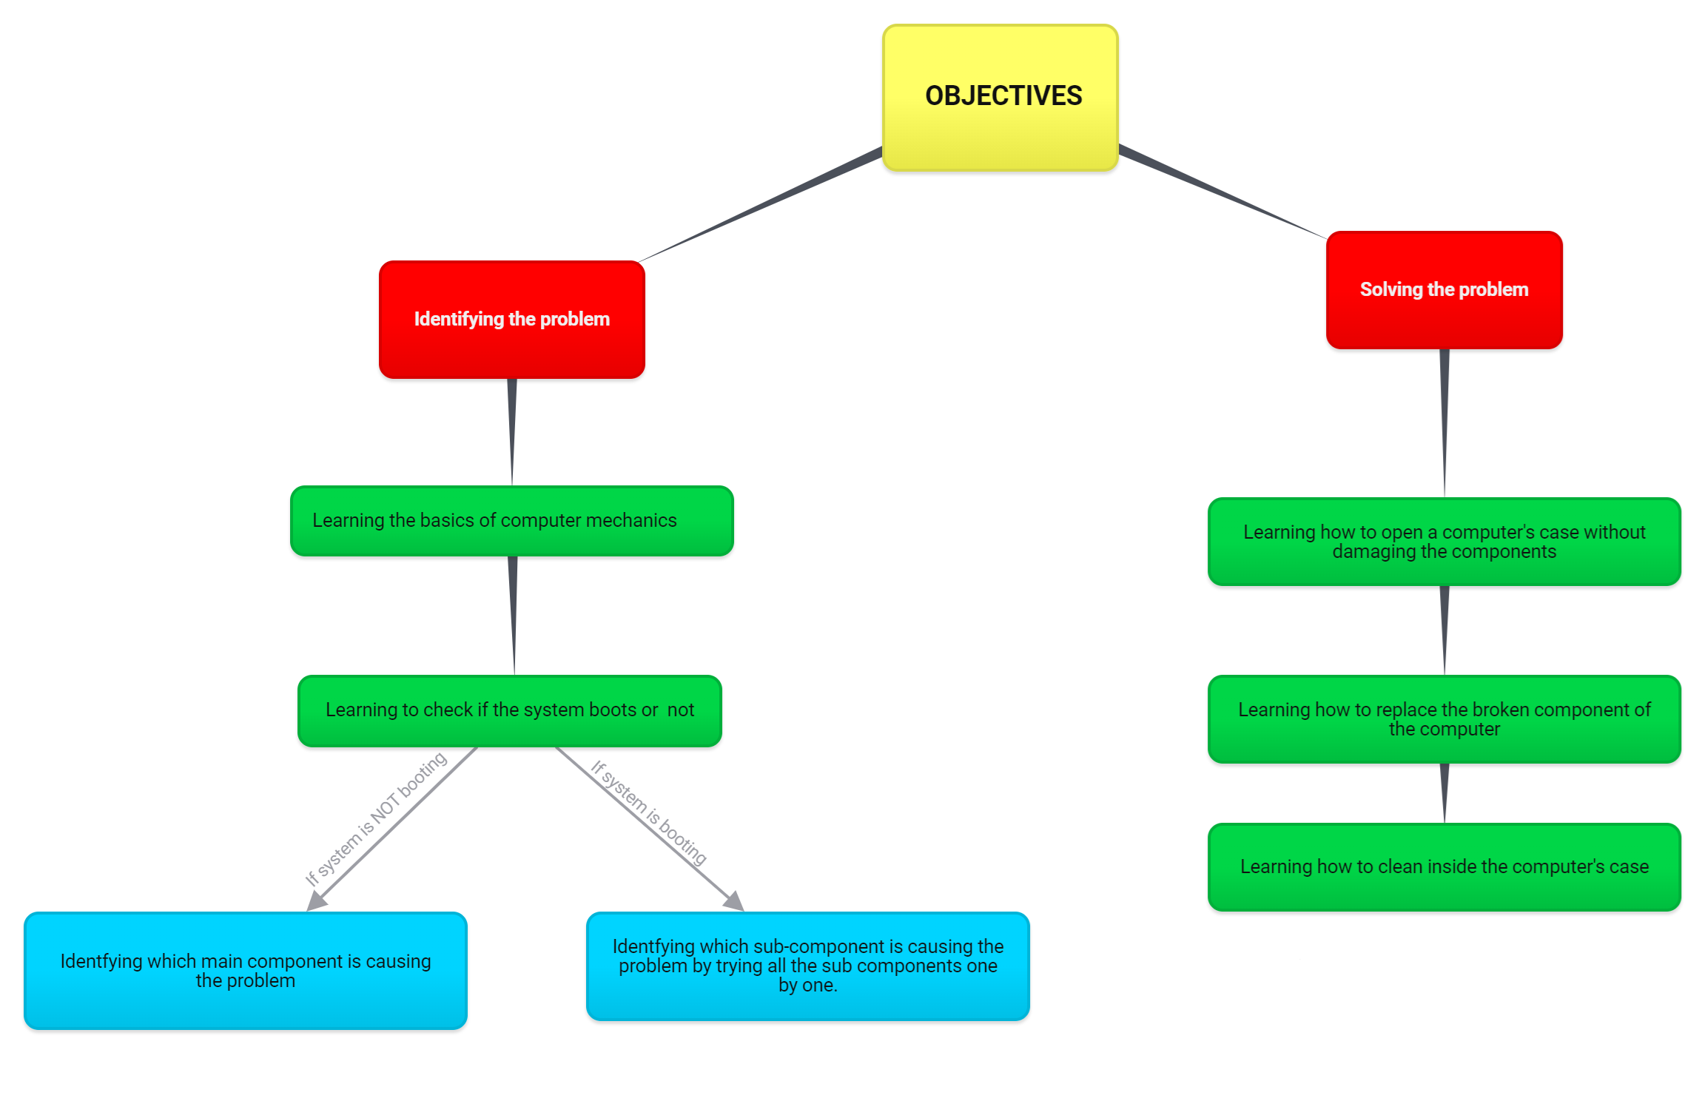

- Write your instructional goal & objectives

  - How to detect a problem on a computer
    - Basics of computer mechanics
    - Learners will learn to check if the system boots or not without its battery connected.
      - If it does not boot, check what is not working according to the error message of BIOS (Cpu, Gpu, Ram, Hard-Disk, motherboard)
      - Learners will learn to check all sub-parts of the computer to identify the problematic component
  - How to fix basic mechanical problems on a computer
    - Learners will learn how to open a laptop’s main case without damaging the computer
    - Learners will learn how to replace mechanical parts of a laptop and desktop computers
    - Learners will learn how to clean the computer

